Placeholder for cover sheet

Introduction: (delete prior to issue)
The following document is intended to provide a practical template for lifting operations with excavators.
Appendix A provides graphical versions of the recommended hand signals included in the OPERC VCOP ‘Hand signals for ‘When Excavators are used as Cranes’ document here

For industry guidance please see the links below to industry documents attending to excavator lifting operations.
Please note this list is not exhaustive

- https://www.cpa.uk.net/downloads/3/SFPSG-Guidance-on-Lifting-with-Excavators.pdf

- https://www.cpa.uk.net/downloads/110/SFPSG-Guidance-on-Ground-Conditions-Published-Document-with-logos.pdf

- https://www.cpa.uk.net/downloads/112/SFPSG-Guidance-on-the-Safe-Use-of-Quickhitches-Published-Document-Third-Revision-a.pdf
A video resource, available online, attending to ‘Lifting with Excavators’ can be found here
------------------------------------------------------------------------------------------------------------------------------------------------------
Please note:
This document has been provided by Sir Robert McAlpine Limited. It has been checked to the best of our ability but may contain unintentional errors. As per BS 7121-1:2016, CDM 2015 and LOLER, it is the user’s responsibility to verify that they understand and have made their own checks before using this document.
The user shall ensure that they properly risk assess and plan their own lifting operations to discharge their legal requirements.
No liability will be accepted for any incidents that result of those using this document.

Lift Plan Details:
Lift Plan Title:
Lift Plan No.: |  | Revision No.:
Prepared By:
Name: |  | Job Title:
Signed: |  | Date:
Accreditation details:

Reviewed By: (delete if not applicable)
Name: |  | Job Title:
Signed: |  | Date:
Accreditation details:

Revision Details:
Revision No.: | Changes made: | Revision by: | Issued date:
Contents:
Section: | Heading:
1 | Supporting Safe System of Work
2 | Location of Lifting Operation
3 | Lifting appliance completing operation
4 | Ground conditions and anticipated loadings of excavator
5 | Competencies and training
6 | Primary communications
7 | Proximity hazards Identified or known to the project
8 | Weather conditions
9 | Lifting procedure
10 | Schedule of common lifts
11 | Change Management & Variations to Lift Plan
12 | Briefing / Communication Record
Appendix A | Hand signals

1. Supporting Safe System of Work:
Risk Assessment & Method Statement[s]:

Associated Drawings:

Other Relevant Documentation: | Industry standards:  - https://www.cpa.uk.net/downloads/3/SFPSG-Guidance-on-Lifting-with-Excavators.pdf  - https://www.cpa.uk.net/downloads/110/SFPSG-Guidance-on-Ground-Conditions-Published-Document-with-logos.pdf  - https://www.cpa.uk.net/downloads/112/SFPSG-Guidance-on-the-Safe-Use-of-Quickhitches-Published-Document-Third-Revision-a.pdf

2. Location of Lifting Operation
Project Address:

3. Lifting appliance completing operation
Make and Model:
Owner/Hirer:

Configuration & main boom length: |  |  |  | Wheeled or tracked:
Lift Height [Height of Quick Hitch]: |  |  |  | Stabilisers / blade:
Counterweight: |  |  |  | Operator visibility
Overload warning device:
Rated capacity indicator & load moment limiter: |  |  |  | Check valves:
Quick Hitch weight and WLL [if applicable]: |  |  |  | Lift radius & WLL:
Excavator duties chart: This should be for the precise configuration used on site – check that the correct length of boom / dipper arm are fitted to match the duty chart.
Excavator report of thorough examination:
Excavator plant/serial no.: |  | 12 monthly report reference no.: | Expiry date: | 6 monthly quick hitch report reference no.: | Expiry date:

4. Ground conditions and anticipated loadings of excavator
Ground conditions: |  | CBR test required [if yes reference the TW Reg no.]

Wheeled Excavator [delete box as applicable] :

Excavator base set up [wheel centre to wheel centre length and width]: |  | Mat area provided by the base set up of the excavator:
Point loadings including weight of load at radius or max. anticipated weight at max radius: | . | Permissible ground bearing pressures of work area:

Tracked Excavator [delete box as applicable] :

Excavator base set up [width and length of tracks from centre of roller to centre of roller]: |  | Bearing area provided by the tracks:
Max. ground bearing pressure including weight of load or max. anticipated weight: |  | Permissible ground bearing pressure of work area / work platform:

Excavator dimensions:

5. Competencies and training:
*Lifting supervisor: CPCS A62 – Crane Supervisor  NPORS N405 - Crane / Lift Supervisor (CSCS Hologram)  *Mandatory on project for excavator lifting operations when classed as ‘Intermediate’ or ‘Complex’ | A62  N405
Slinger-signaller(s): CPCS A40a - ‘All Types All Duties’ incl. of ‘Pick and Carry’ operations.  CPCS A40b – ‘All Types Static Duties’ for static operations only  CPCS A40d – ‘Slinger Signaller – Excavator ’ for excavator only incl. ‘Pick & Carry’ operations  NPORS N402 - Slinger Signaller (CSCS hologram) | a  b  d  N402
Excavator operator – CPCS A58a - Excavator tracked 360 below10 tonnes  CPCS A58b - Excavator wheeled 360 below 10 tonnes  CPCS A58c - Lifting with Excavators  -----------------------------------------------------------------------------------------------------------------------------------------------------------------------------------------------------------------------------------  CPCS A59a - Excavator tracked 360 above 10 tonnes  CPCS A59b - Excavator wheeled 360 above 10 tonnes  CPCS A59c - Lifting with Excavators  Please note:  - CPCS A59 accreditation automatically gives A58 accreditation  ------------------------------------------------------------------------------------------------------  NPORS N202 - Excavator 360 (CSCS hologram)  NPORS N100 - Excavator as a Crane (CSCS hologram) | Below 10 t | Above 10 t
 | 58a  58b  58c | 59a  59b  59c
N202

N100
Vehicle Marshall - A73 - Vehicle Marshall  NPORS N403 - Vehicle Marshal (CSCS Hologram) | A73  N40

6. Primary communications:

Communication procedures: | Hand signals with audible commands - See Appendix A for hand signals explaining their purpose and stance required

7. Proximity hazards Identified or known to the project:

Hazard Type: | Control Measure:
Access/Egress – Site restrictions
Access/Egress – Ground conditions
Working area:
Slopes, unstable or soft ground, including formed batters:
Works area & safety zones:
Adequate lighting:
Overhead electrical cables and or obstructions:
Overhead restrictions required:
Structures / buildings / scaffolding:
Street furniture, lighting columns etc.:
Slew restrictions required:
Underground services / manholes / road scars / other voids:
Adjacent excavation:
Operating on a suspended slab or basement:
Load path & visibility:
Access to load for attaching / detaching lifting accessories:
Other moving plant or vehicles:
Permits required:
Other:

8. Weather conditions:
Maximum wind speed [general guidelines and manufacturer’s guidance MUST be reviewed] | Lifting operations will cease at max. wind gust of ?? mph.  Please note:  Dependant on the load being lifted, operations may cease at a lower wind speed due to area/weight of load  Hold Point:  - All lifting operations will be assessed at the time of operations by the appointed person (if available), lifting supervisor (if required), excavator operator and slinger-signaller.  Assessment to be based on load being lifted, windsail area and local parameters (i.e. is the work area of the excavator in an open exposed area or is it in an enclosed area where wind conditions are muted.)  - Lifting operations must stop during storms or when there is a risk of lightning strikes.  - Indicate how the wind speed will be monitored. e.g., handheld anemometer or Beaufort scale assessment.

9. Lifting procedure:
10. Schedule of common lifts:
Schedule no. | Load to be lifted | Schedule no. | Load to be lifted
1. |  | 2.
3. |  | 4.
5. |  | 6.
7. |  | 8.
9. |  | 10.
11. |  | 12.

Duplicate rows for schedules as required

Load description 1:
 |  |  | Slinging methodology:
Lift Category: | Basic | Intermediate |  |  |  | Complex
Dimensions of load: | mm [l] x mm [w] x mm [h] |  |  |  | Maximum radius lift with a load point height of ?? m
Weight of Load inclusive of Quick Hitch [if applicable]: | Quick hitch @ kg [if applicable], load weight @ t |  |  |  | m over the front (along) with a ?? % utilisation |  | m over the side (across)/360 with a ?? % utilisation
Lifting accessories used with weights of accessories: | From Quick hitch [if applicable]:  Gross weight inc. 10% FOS: t |  |  | WLL x Mode Factor |  |  | Resulting SWL
Lifting accessories used with weights of accessories: |  |  |  |  |  |  | t over all accessories stated for static duties
Safe lifting considerations:

11. Change Management & Variations to Lift Plan:
Variation to this Lift Plan, must be notified to the author before proceeding with the lift. Works must stop. The Lift Supervisor and author must review this Lift Plan and detail all changes on the change log and re-brief the lifting team.

12.Briefing / Communication Record:
Note: Delete sections below that do not apply
Appointed Person: I have checked the training & competency of the deputy appointed person(s) [if applicable], excavator(s) operator(s), lift supervisor(s), lifting operations manager [if applicable] and slinger-signaller(s) and I am satisfied with their ability to undertake & control the lifting operation detailed in this plan.
I have briefed / communicated to the deputy appointed person(s) [if applicable], crane coordinator(s) [if applicable] excavator operator(s), lift supervisor(s) [if applicable] and slinger-signaller(s) of the contents of this lift plan and risk assessment.
Name: | Signature: | Date:

Deputy Appointed Person[s]: I have checked the training & competency of the deputy appointed person(s) [if applicable], excavator(s) operator(s), lift supervisor(s), lifting operations manager [if applicable] and slinger-signaller(s) and I am satisfied with their ability to undertake & control the lifting operation detailed in this plan.
[if briefing - delete if not] I have briefed / communicated to the crane coordinator(s) [if applicable] excavator operator(s), lift supervisor(s)and slinger-signaller(s) of the contents of this lift plan and risk assessment.
Name: | Signature: | Date:

Lifting Supervisor: I am aware of the lifts for which the use of this excavator is authorised, and any limitations imposed. I will ensure that to the best of my ability the excavator is not used outside these limits.
I have checked the training & competency of the excavator operator(s) and slinger-signaller(s) and I am satisfied with their ability to undertake the lifting operation detailed in this plan.
I have briefed / communicated the excavator operator and slinger / signaller(s) of the contents of this lift plan and risk assessment.
Name: | Signature: | Date:

Excavator Operator: I am aware of the lifts for which the use of this excavator is authorised, and any limitations imposed. I will ensure that to the best of my ability the excavator is not used outside these limits.
Name: | Signature: | Date:

Slinger-signaller: I am aware of the lifts for which the use of this excavator is authorised, and any limitations imposed. I will ensure that to the best of my ability the excavator is not used outside these limits.
Name: | Signature: | Date:

Appendix A: Hand signals
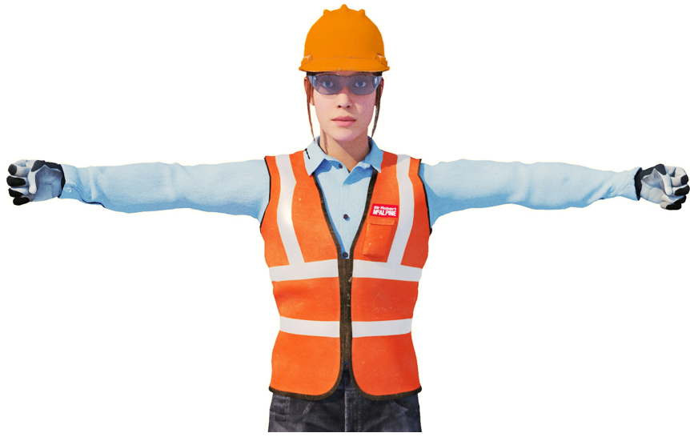Purpose:  START  To notify the operator to commence operations and  follow signalling instructions.  Stance:  Fully extend both arms horizontally to the side of  the body at shoulder height: hands closed into fists,  palms facing forwards | 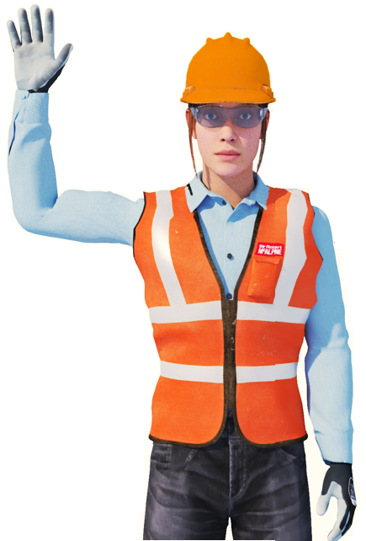  STOP  Purpose:  To stop all motions, stop an individual motion or punctuate between motions.  Stance:  Raise right arm to shoulder height at the side of the body, elbow bent at 90° with forearm pointing upwards: hand open, palm facing forwards. Hold left arm down against the side of  the body.
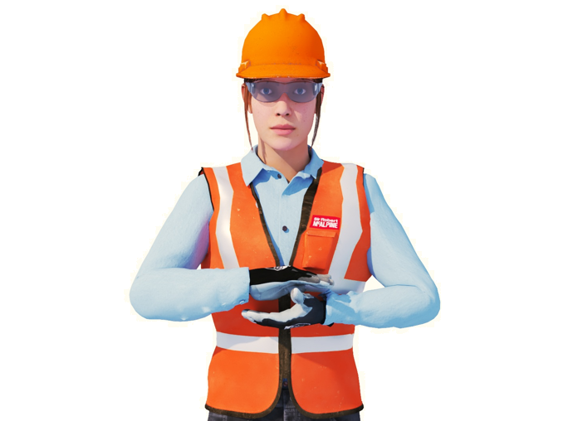Purpose:  END  To notify the operator to end operations, to stop following signalling instructions and isolate the machine  Stance:  Place both hands together in front of the body at chest height, elbows bent | 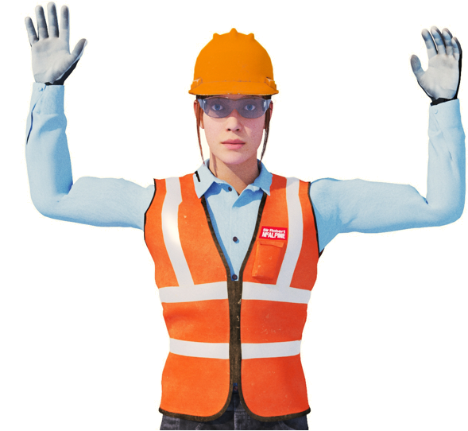  DANGER  Purpose  Cease all operations IMMEDIATELY and isolate the  machine. ANYONE can give this signal if they  observe a dangerous situation arising.  Stance:  Raise both arms horizontally to the side of the body at  shoulder height, elbows bent at 90° with forearms pointing upwards: hands open, palms facing forwards
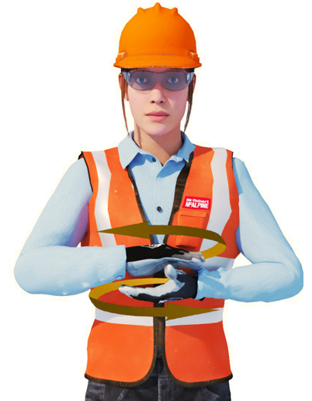
DEAD SLOW

Purpose:
To perform the operation or move the machine at a dead slow pace.

Stance:
Place both hands together in front of the body at chest height, elbows bent, hands open, palms facing each other. Rub palms together in a circular motion.

Appendix A: Hand signals
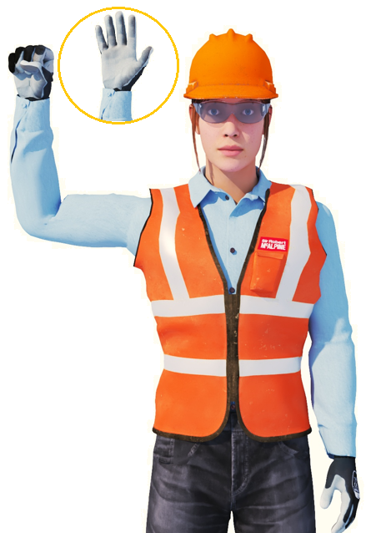
SMALL MOVEMENT

Purpose:
To indicate a small movement of either the travelling machine or of the slewing / movement of the arm geometry

Stance:
Hold left arm down against the side of the body: hand open, palm flat against the hip. Raise right arm to shoulder height at the side of the body, elbow bent at 90° with forearm pointing upwards: hand closed, palm facing forwards. Repeatedly open and close right hand.

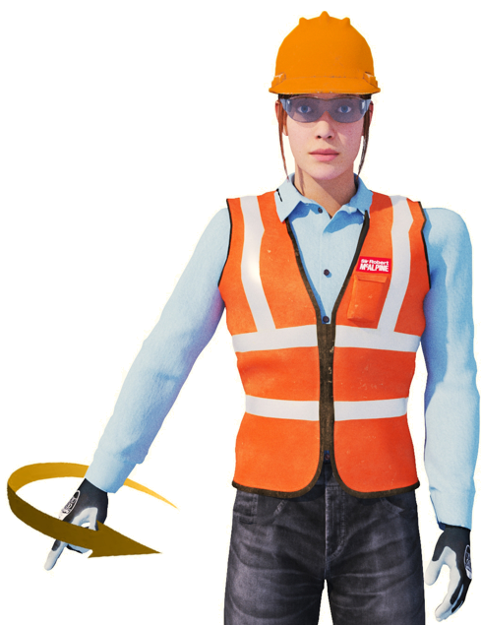
LOWER STEADY

Purpose:
To lower the load/equipment at a steady rate – hoist down.

Stance:
Extend right arm at 45° to the side of the body: hand closed, index finger pointing downwards. Hold left arm down against the side of the body.
Make small circular movements with the right forearm in a ‘cone like’ fashion. The speed of the hand rotation will vary the lowering speed of the
excavator

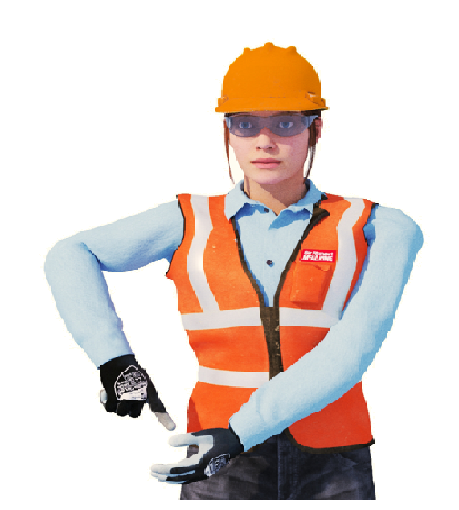
LOWER SLOW

Purpose:
To lower the load/equipment at a slow rate

Stance:
Extend left arm diagonally across the front of the body: hand open, palm facing upwards, motionless. Raise right arm to shoulder height at the side of the body, elbow bent with forearm pointing downwards: hand closed, index finger pointing downwards at left hand.

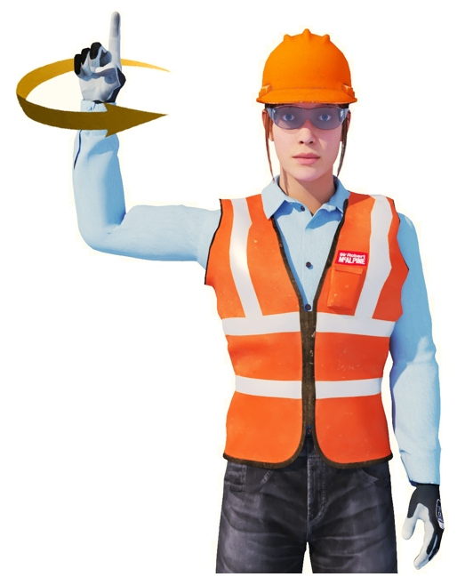
RAISE STEADY

Purpose
To raise/lift the load/equipment at a steady rate

Stance:
Raise right arm to shoulder height at the side of the
body, elbow bent at 90° with forearm pointing upwards, hand closed, palm facing forwards, index finger pointing upwards. Hold left arm down against the side of the body. Make small horizontal, circular movements with the right forearm ‘cone like’

Appendix A: Hand signals
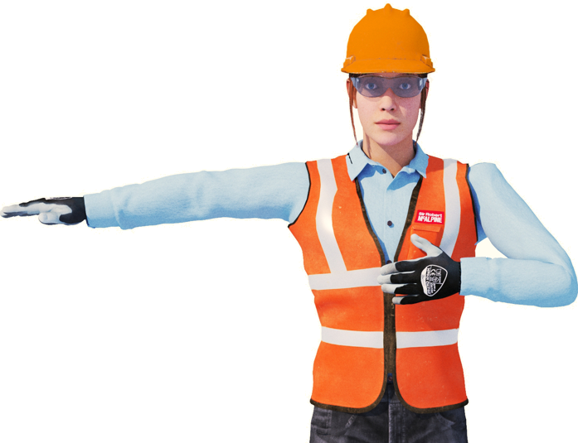  MOVE LEFT  Purpose:  To travel or slew to the operator’s left direction  Stance:  Fully extend right arm horizontally at shoulder  height to the side of the body: hand open, palm  flat and facing downwards. Bend left arm and  place hand on body at chest level: hand open,  palm flat against body |  | 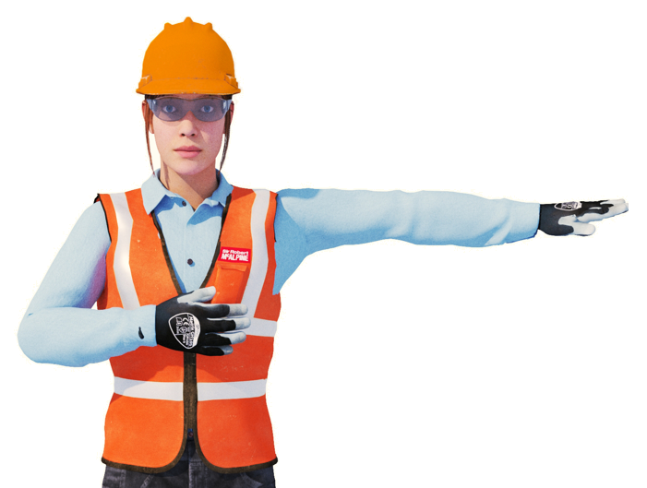  MOVE RIGHT  Purpose:  To travel or slew to the operator’s right direction  Stance:  Fully extend left arm horizontally at shoulder height  to the side of the body: hand open, palm flat and  facing downwards. Bend right arm and place hand  on body at chest level: hand open, palm flat  against body.
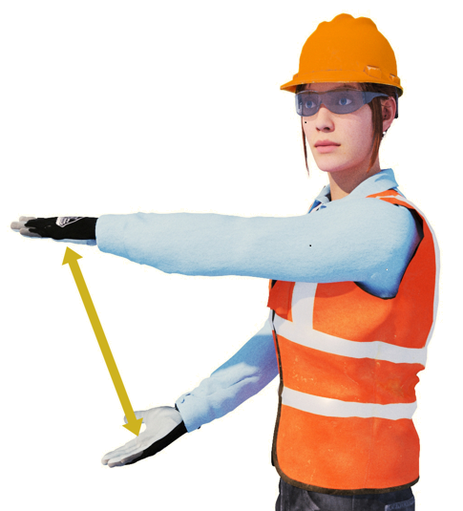  VERTICAL DISTANCE  Purpose:  To indicate the vertical distance that the load or  equipment must be raised or lowered  Stance: (Turn body slightly to the side)  Extend both arms horizontally in front of the body: hands open, palms flat and facing each other. Position arms so that the distance between the palms reflects the vertical distance | 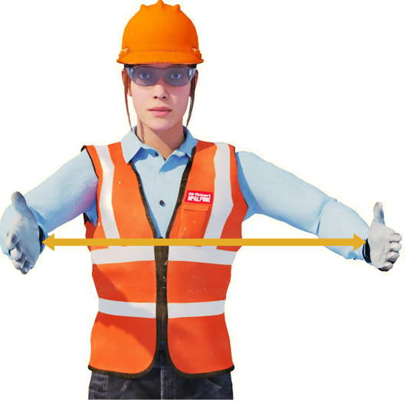  HORIZONTAL DISTANCE  Purpose:  To indicate the horizontal distance that the  machine or arm geometry needs to travel  Stance:  Extend arms at the front of the body at chest  height: hands open, palms facing each other.  Position arms so that the distance between the  palms indicates the horizontal distance.
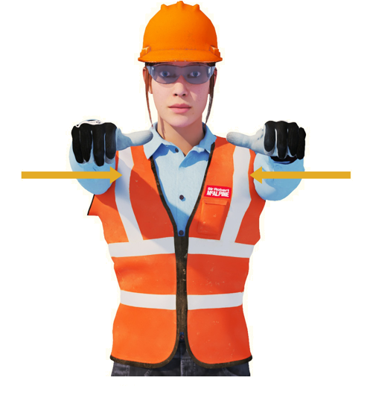
DIPPER ARM RETRACT

Purpose:
To retract the dipper, telescope in.

Stance:
Fully extend both arms in front of the body at shoulder height: hands closed into fists, palms facing DOWNWARDS with thumbs extended and pointing TOWARDS from each other.

Appendix A: Hand signals
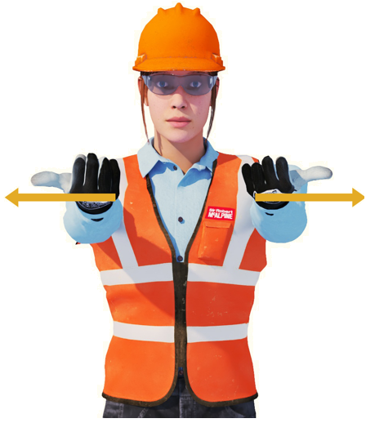
DIPPER ARM EXTEND

Purpose:
To extend the dipper, telescope out.

Stance:
Fully extend both arms in front of the body at shoulder height: hands closed into fists, palms facing UPWARDS with thumbs extended and pointing AWAY from each other.

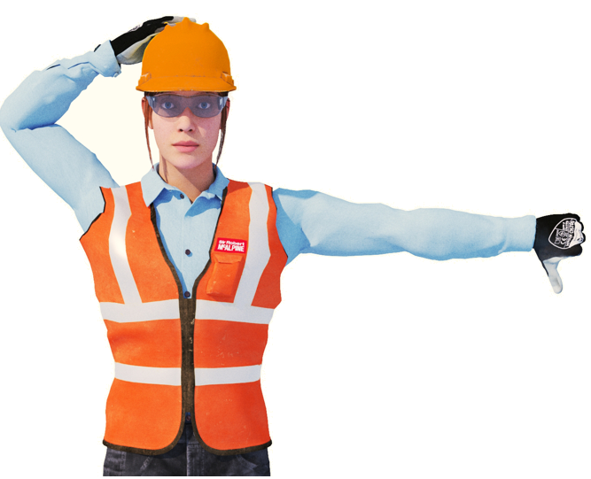  LOWER BOOM  Purpose:  To indicate that the boom must be raised in  towards the body of the machine.  Stance:  Extend right arm upwards and place hand on  head: hand open, palm flat on head. Fully extend  left arm horizontally to the side of the body at shoulder height: hand closed into a fist, thumb extended and pointing downwards. Make small downward movements with the thumb | 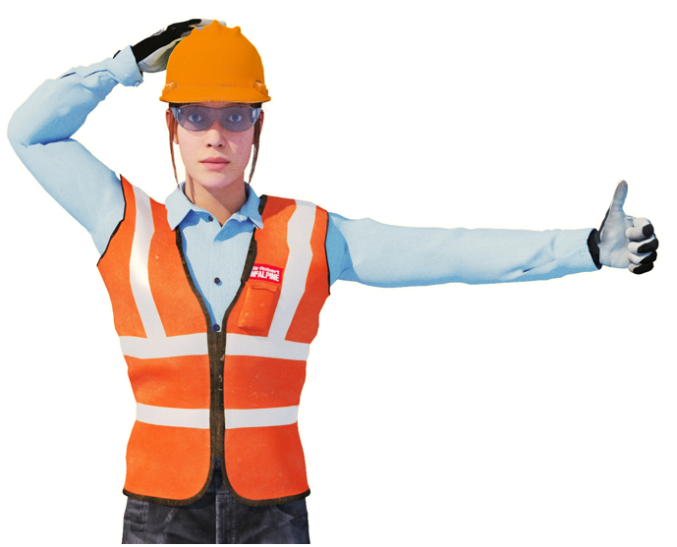  RAISE BOOM  Purpose:  To indicate that the boom must be raised in  towards the body of the machine.  Stance:  Extend right arm upwards and place hand on  head: hand open, palm flat on head. Fully extend  left arm horizontally to the side of the body at shoulder height: hand closed into a fist, thumb  extended and pointing upwards. Make small  upward movements with the thumb.
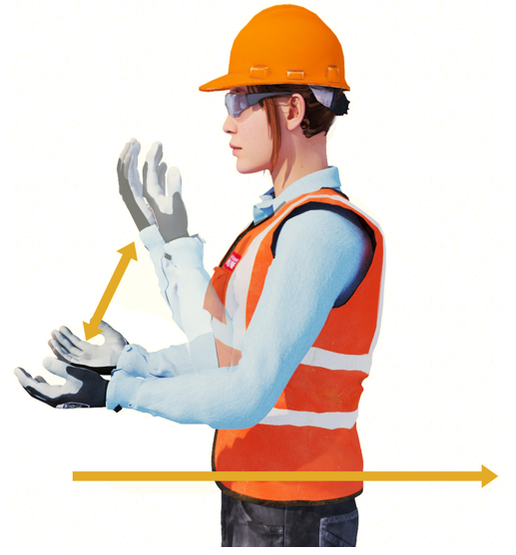
TRAVEL FORWARDS

Purpose:
To travel forwards towards the marshall. Applicable to both wheeled or tracked motions.

Stance:
Place both arms at the side of the body, elbows bent hands open, palms facing upwards. Move forearms together in slow vertical up and down movements towards the body. Repeat until the travel destination is reached

Appendix A: Hand signals
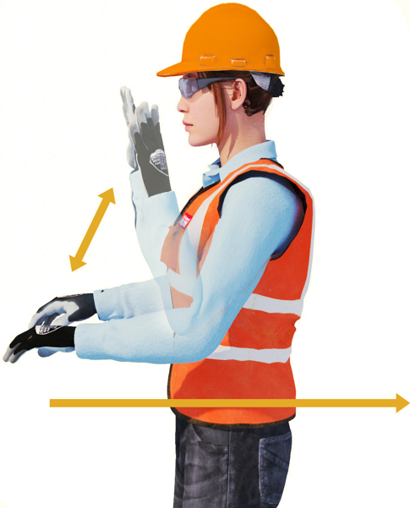
TRAVEL BACKWARDS

Purpose:
To travel backwards away from the vehicle marshall. Applicable to both wheeled or tracked motions

Stance:
Place both arms at the side of the body, elbows bent: hands open, palms facing downwards. Move forearms together in slow vertical up and down movements away from the body. Repeat until the travel destination is reached.

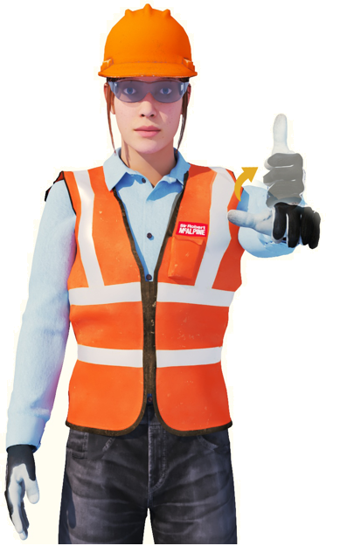  CROWD IN  Purpose:  To indicate that the dipper (or stick) should move in  and towards the machine.  Stance:  Hold right arm down against the side of the body.  Fully extend left arm horizontally in front of the  body: hand closed into fist, thumb extended. Rotate  arm to move thumb from horizontal position to  pointing upwards. | 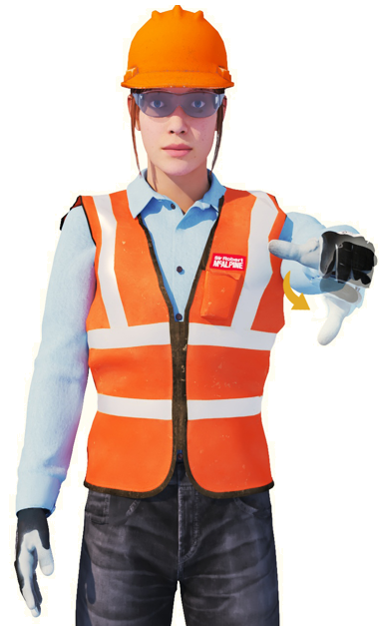  CROWD OUT  Purpose:  To indicate that the dipper (or stick) should move  out and away from the machine.  Stance:  Hold right arm down against the side of the body.  Fully extend left arm horizontally in front of the  body: hand closed into fist, thumb extended. Rotate  arm to move thumb from horizontal position to  pointing downwards
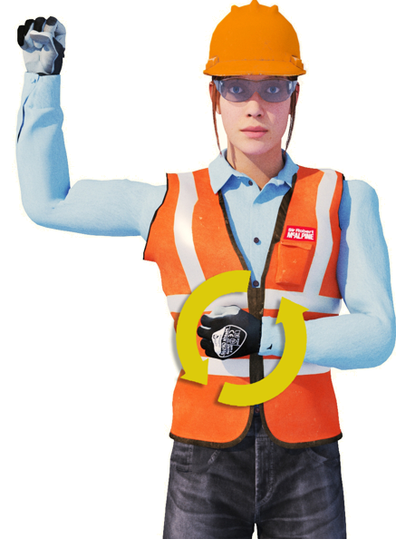
TRAVEL – ONE TRACK

Purpose:
To travel forwards or backwards on one track to move the positioning of the machine to the left or the right.

Stance:
Raise left or right arm (to indicate the side of the track which should be locked) to shoulder height at the side of the body, elbow bent at 90° with forearm pointing upwards: hand closed, palm facing forwards. Place the other hand in front of the body at chest height: hand closed into fist, palm facing body. Rotate fist in front of chest (forwards or backwards) to indicate the direction of travel on the other side of the track

Appendix A: Hand signals
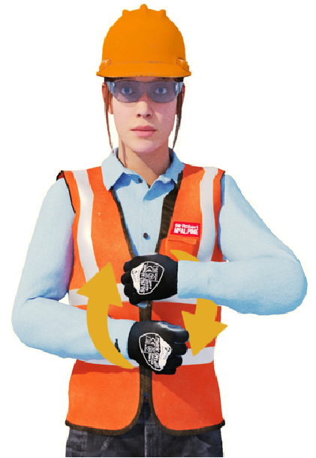
TRAVEL – BOTH TRACKS

Purpose:
To travel forwards or backwards to continue operations.

Stance:
Place both hands in front of the body at chest height, elbows bent hands closed into fists, palms facing body. Rotate fists (forwards or backwards) to indicate the direction of travel

Placeholder for end sheet

