A practical guidance - 4: Schedules 22 to 31
Revision 1 September ‘25

Schedule of lifts for Tower Crane

Please note:
This document has been provided by Sir Robert McAlpine Limited. It has been checked to the best of our ability but may contain unintentional errors. As per BS 7121-1:2016, CDM 2015 and LOLER, it is the user’s responsibility to verify that they understand and have made their own checks before using this document.
The user shall ensure that they properly risk assess and plan their own lifting operations to discharge their legal requirements.
No liability will be accepted for any incidents that result of those using this document.

The schedules
Page | Title:
22. | Containment accessories – FIBC Bags (Fabric bags)
23. | Formwork components – Ledger frames
24. | Formwork components – Primary & secondary Beams
24. | Formwork components – Support legs [outer and inner components]
26. | Formwork components – Panel stacks
27. | Formwork components – ‘Strongback’ bundles
28. | Formwork – Panels with proprietary clamps in use
29. | Formwork – Column boxes with proprietary clamp/attachments
30. | Slab formwork – Tables with proprietary lifting hook - ‘C’ Hook
31. | Precast concrete elements – Kentledge or ‘Kelly’ concrete block
Ref. | Blank template

Loads description: Containment accessories – FIBC Bags (Fabric bags)
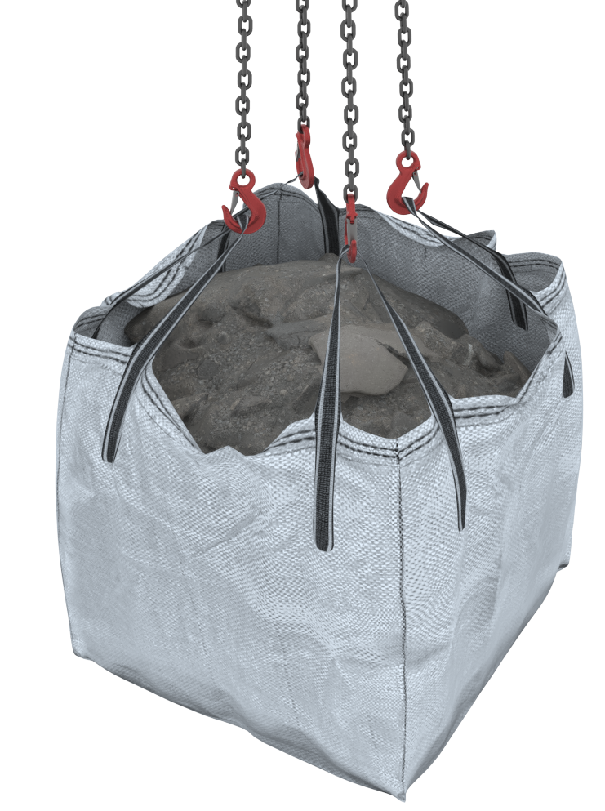 |  | Slinging methodology: Chain sling  - 4 leg chain sling will be attached to the hook block of the crane  - Attach the hooks of the chain sling to the lifting loops of the FIBC situated to each corner of the bag structure  Slinging methodology: Bulk bag Frame  - 4 leg chain sling will be attached to the hook block of the crane. Single leg in use so hang the unused chains back to the mater ring.  - Attach single leg of chain sling to attachment point of frame.  - Attach frame to bag as per manufacturer’s instructions.
Lift Category: | Basic [for lifting FIBC in containment] |  | Intermediate [for lifting the FIBC not in containment – Low level only]
Dimensions of load: | Various dimensions: Typically, 900mm [h] x 900mm [l] x 900mm [w]
Weight of Load | Typically: 1 t for dimensions given.
Lifting accessories used with weights of accessories: | From hook block >  4 Leg chain slings WLL 8.4 t @ 103kg  ---------------------------------------  FiBC [Fabric Bag] @ 5 kg  ---------------------------------------  Bulk bag frame @ 25 kg  Gross weight [full] inc. 10% FOS: 1.219 t [ru] – Chain sling with direct attachment  Gross weight [full] inc. 10% FOS: 1.247 t [ru] – Bulk bag frame being utilised | WLL x Mode Factor |  | Resulting SWL
Lifting accessories used with weights of accessories: |  | 4 leg chain sling as per design use [for single leg use WLL = 2 t ]  ---------------------------------------  FIBC [Fabric bag] as per design use = 1 t  ----------------------------------------  Bulk bag frame as per design use |  | 1 t over accessories stated
Alternative methodology: | 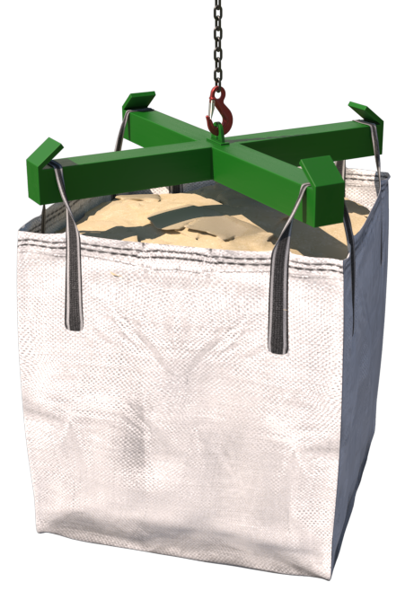  Bulk Bag lifting frames can be utilised if available.  Ensure that the bulk bag frame is used as per manufacturer’s instructions and is of sufficient WLL.  Example:  https://cqegroup.com/uk/wp-content/uploads/sites/5/2018/02/Bulk-Bag-Lifting-Frame-User-Guide-Issue-2.pdf  Please note:  All methodologies described here and above are for Low-Level lifts only.
Ancillary Equipment: | 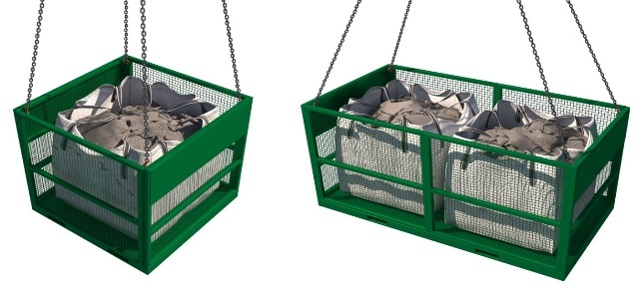  For lifting across projects, the bags MUST be placed in a suitably sized containment accessory of sufficient size to contain the bag c/w an in date RoTE.
Safe lifting considerations: | - All bulk bags have been inspected, prior to lifting, to ensure that they have not been damaged during transit to site.  The inspection should be to the same standard as a that for a lifting accessory such as a fabric sling. The inspection should confirm that:  - The bags have been correctly filled and the contents have not shifted during transport.  - There are no abrasions, nicks, tears to the body of the bag or the lifting loops.  - The contents of the bags are not saturated due to rain and therefore possibly overloaded.  - Checks are made to ensure the bulk bags can be safely lifted with the lifting equipment and accessories available at site.  - The bulk bags are suitable for their intended use at site.  If bulk material is to be discharged from the bottom of the bag, they should  be fitted with a bottom discharge mechanism (spout).  Special Note:  Cutting the underside with a knife is not permitted as this could cause shock loading of the crane as well as positioning someone under the load.  - An inspection of the bag(s) is performed to ensure they have not been contaminated with oils, greases, or chemicals during transport.  - The bulk bags are lifted in line with instructions issued by the manufacturer.  - At no time are the bulk bags to be lifted over persons even when in a suitably sized containment accessory as above  - When stored on site, they are single stacked only.  - 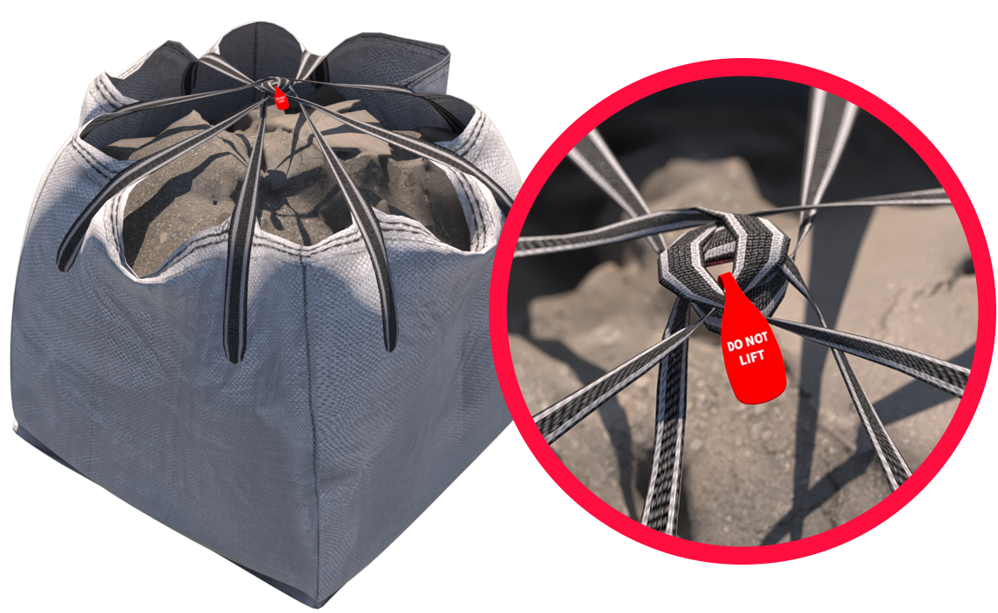Single-trip FIBCs should be treated as ‘single use’ (lifting off a vehicle after delivery), after which they should be destroyed / disposed of as their integrity cannot be guaranteed.  - After arrival at site, Single-trip FIBCs should not be lifted other than to place them into a suitably sized stillage or certified lifting containment accessory.  - When Bulk bags become damaged, they cannot be lifted. They should be isolated, quarantined, and identified as not for lifting. The contents should be placed into a suitably sized stillage or containment accessory as soon as possible. The bag must then be destroyed and disposed of.  It should be assumed that all Single-trip FIBCs, irrespective of content type, are damaged and could fail at any point.

Loads description: Formwork components – Ledger frames
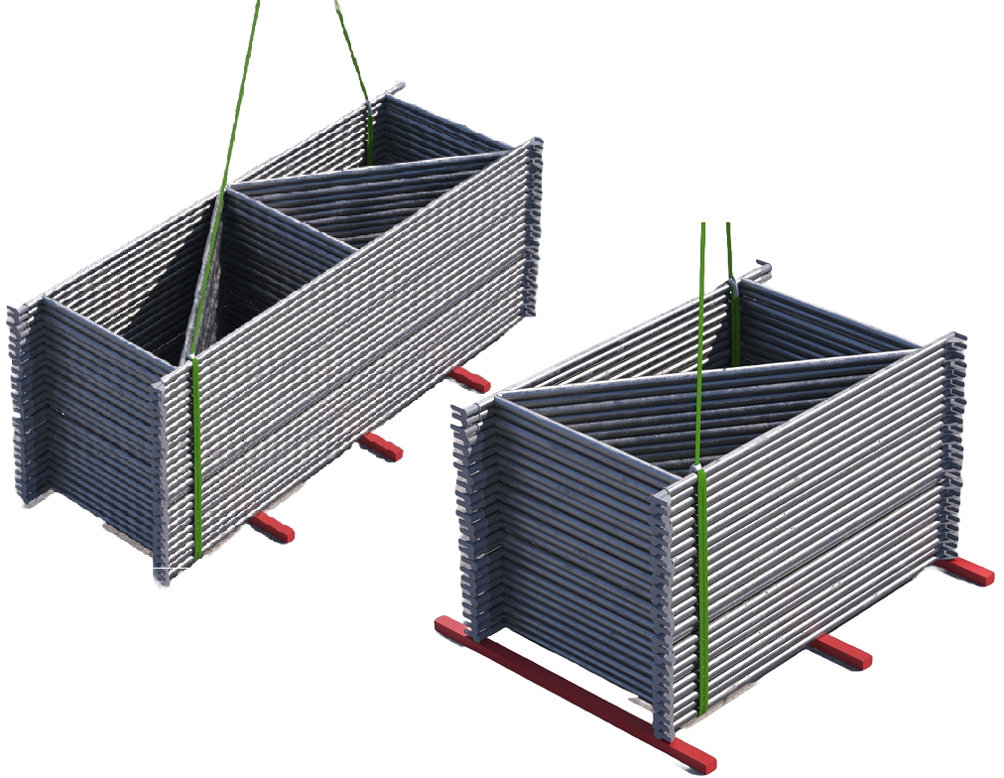 |  | Slinging methodology:  - 2no. Webbing slings min. WLL 2 t will be attached to the frames in a single wrap ‘captured choke’ configuration.  - 4 leg chain sling will be attached to hook block of the crane. Only 2 legs in use so hang the unused chains back up to the master ring.  - Attach the hooks of the chain slings to the loop ends of the webbing slings.
Lift Category: | Basic
Dimensions of load: | Various dimensions:  Typically, 1000mm [w] x 1800mm [l] x 50mm [h] – ‘Single’ frames  Typically, 1000mm [w] x 3000mm [l] x 50mm [h] – ‘Double’ frames
Weight of Load | Typically, 260 kg for a stack of 25 ‘Single’ frames  Typically, 400kg for a stack of 25 ‘Double’ frames
Lifting accessories used with weights of accessories: | From hook block >  4 Leg chain slings WLL 8.4 t @ 103kg  --------------------------------------------  2no. webbing slings 6m (l) @ 7kg.  Gross weight inc. 10% FOS: 407kg [ru] – 25 no. ‘Single’ frames  Gross weight inc. 10% FOS: 561kg [ru] – 25 no. ‘Double’ frames | WLL x Mode Factor | Resulting SWL
Lifting accessories used with weights of accessories: |  | 4 leg chain sling with 2 legs in use - WLL of 1 sling x 1.4 = 4.41 t  --------------------------------------  2 webbing slings used a set in a choke configuration = [WLL of one sling multiplied by 1.4] x .8 = 2.24 t | 2.24 t over accessories stated
Alternative methodology: | 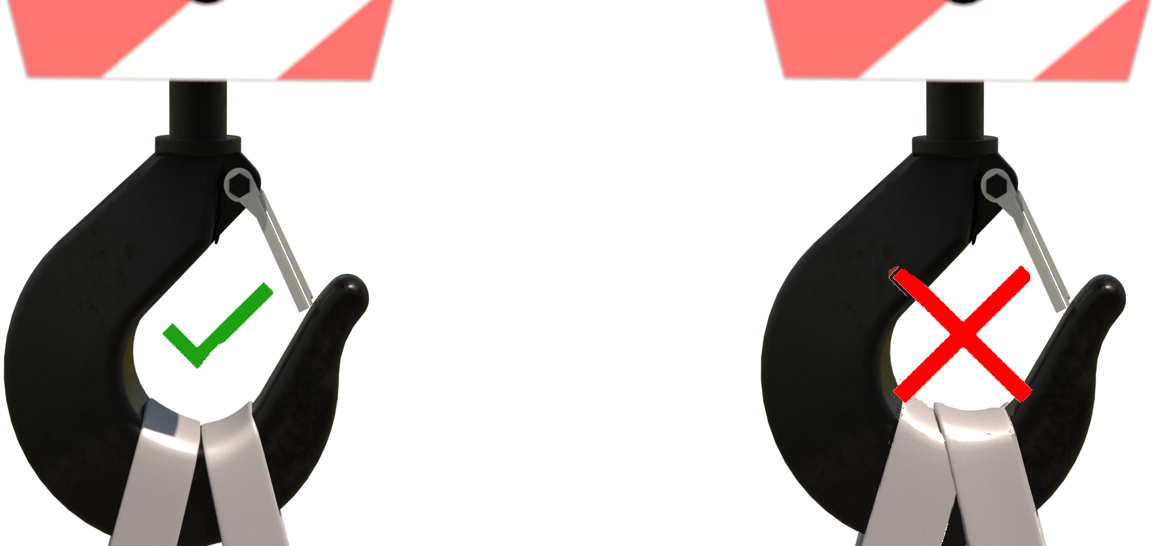Chain slings can be used directly around the load(s) in the same configuration as the webbing slings.  If size of hook block allows, then the webbing slings can be directly attached.  DO NOT OVERCROWD THE BLOCK
Safe lifting considerations: | - Ensure the integrity of the load when landing. Employ banding or a rachet strap around the load.  - When landing the load use suitably sized timber chocks/spacers to negate having to ‘drag’ the accessories from the load.  - Land the load on level ground so that when any securing banding is released the load stays together.

Loads description: Formwork components – Primary & secondary Beams
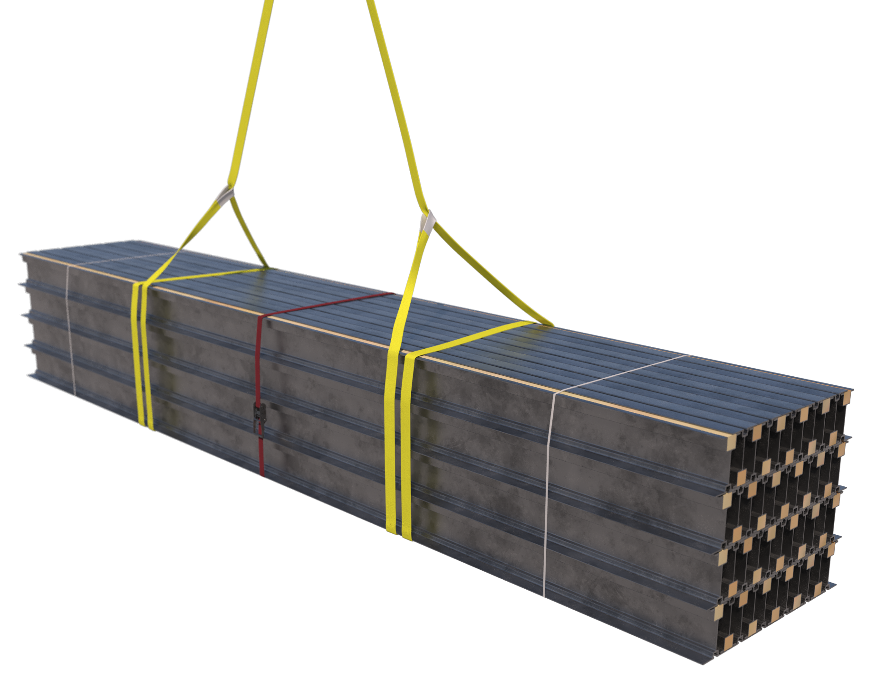 |  | Slinging methodology:  - 2no. Webbing slings Min. WLL 3 t will be attached to the packs of beams in a double wrap ‘choke’ configuration.  - 4 leg chain sling will be attached to hook block of the crane. Only 2 legs of the chain sling are required so hang the unused chains back up to the master ring.  - Attach hooks of chain slings to the lifting loops of the webbing slings.
Lift Category: | Basic
Dimensions of load: | Various dimensions:  Typically, ‘Primary’ beams @ 500mm [w] x 10m [l] x 1125mm [h] – [5 x 5 pack] Typically, Secondary beams @ 750mm [w] x 7.5m [l] x mm [h] – [10 x 5 pack]
Weight of Load | Typically, 2 t for a stack of 25 primary beams  Typically, 1.215 t for a stack of 50 secondary beams
Lifting accessories used with weights of accessories: | From hook block >  4 Leg chain slings WLL 8.4 t @ 103kg  --------------------------------------------  2no. Webbing slings 8m (l) @ 7kg  Gross weight inc. 10% FOS: 2.321 t – 25 no. ‘primary’ beams  Gross weight inc. 10% FOS: 1.48 t [ru] – 50 no. ‘secondary’ beams | WLL x Mode Factor | Resulting SWL
Lifting accessories used with weights of accessories: |  | 4 leg chain sling with 2 legs in use - WLL of 1 sling x 1.4 = 4.41 t  --------------------------------------  2 webbing slings used a set in a choke configuration = [WLL of one sling multiplied by 1.4] x .8 = 3.36 t | 3.36 t over accessories stated
Alternative methodology: | Chain slings can be used directly around the load(s) in the same configuration as the webbing slings.  If size of hook block allows, then the webbing slings can be directly attached.  DO NOT OVERCROWD THE BLOCK
Safe lifting considerations: | - Check load for sharp or burred edges on the beams and if necessary, utilise protective sleeves at the recognised pinch points.  - Ensure the integrity of the load when landing. Employ banding or a rachet strap around the load.  - When landing the load use suitably sized timber chocks/spacers to negate having to ‘drag’ the accessories from the load.  - Land the load on level ground so that when any securing banding is released the load stays together.  - Position slings to suit a level load.

Loads description: – Formwork components – Support legs [outer and inner components]
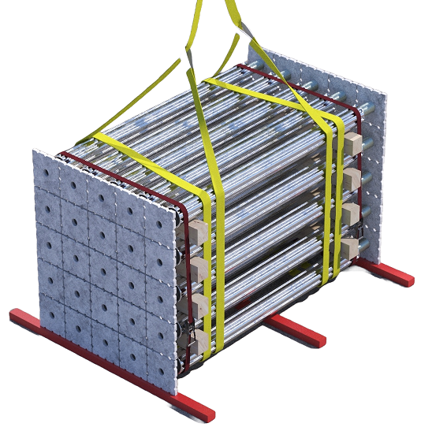 |  | Slinging methodology:  - 2no. Webbing slings min. WLL 2 te. will be attached to the packs of beams in a double wrap ‘choke’ configuration.  - 4 leg chain sling will be attached to hook block of the crane. Only 2 legs of the chain sling are required so hang the unused chains back up to the master ring.  - Attach hooks of chain slings to the lifting loops of the webbing slings.
Lift Category: | Basic
Dimensions of load: | Various dimensions:  Typically, ‘Outer’ components 1000mm [w] x 4670mm [l] x 1000mm [h] – [5 x 5 pack]  Typically, ‘Inner’ components 1000mm [w] 1680x mm [l] x 1000mm [h] – [5 x 5 pack]
Weight of Load | Typically, 566 kg for a stack of 25 ‘outer’ component  Typically, 255 kg for a stack of 25 ‘inner’ components
Lifting accessories used with weights of accessories: | From hook block >  4 Leg chain slings WLL 8.4 t @ 103kg  --------------------------------------------  2no. webbing slings 8 m (l) @ 7kg.  Gross weight inc. 10% FOS: 744 kg [ru] – ‘Outer’ components  Gross weight inc. 10% FOS: 401 kg [ru] – ‘Inner’ components | WLL x Mode Factor | Resulting SWL
Lifting accessories used with weights of accessories: |  | 4 leg chain sling with 2 legs in use - WLL of 1 sling x 1.4 = 4.41 t  --------------------------------------  2 webbing slings used a set in a choke configuration = [WLL of one sling multiplied by 1.4] x .8 = 2.24 t | 2.24 t over accessories stated
Alternative methodology: | Chain slings can be used directly around the load(s) in the same configuration as the webbing slings.  If size of hook block allows, then the webbing slings can be directly attached.  DO NOT OVERCROWD THE BLOCK
Safe lifting considerations: | - Ensure the integrity of the load when landing. Employ banding or a rachet strap around the load.  - When landing the load use suitably sized timber chocks/spacers to negate having to ‘drag’ the accessories from the load.  - Land the load on level ground so that when any securing banding is released the load stays together.  - Position sling to suit a level load.  - Check load for any loose leg components in the middle of the pack.

Loads description: – Formwork components – Panel stacks
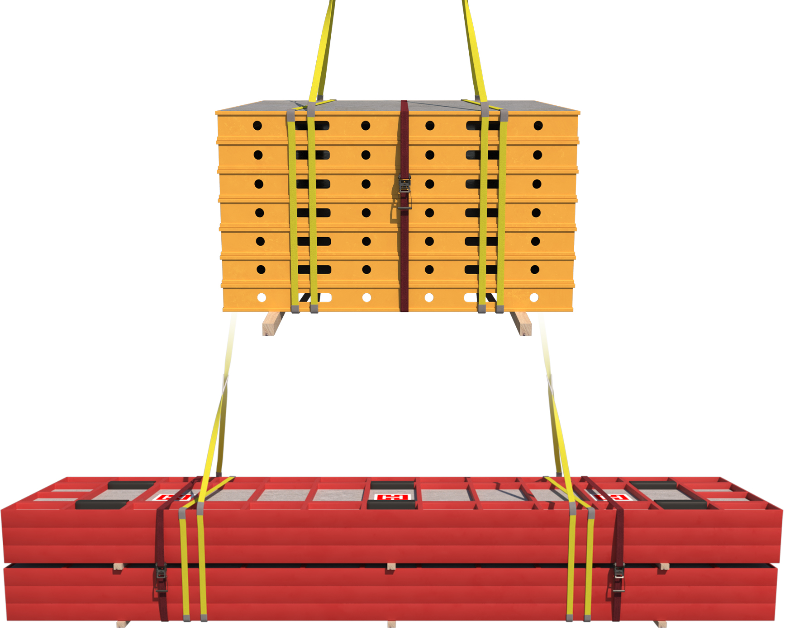 |  | Slinging methodology:  - 2no. webbing slings min. WLL 4 t [wcs] will be attached to the packs of pans in a double wrap ‘choke’ configuration.  - Chain sling[s] will be attached to hook block of the crane. Only 2 legs of the chain sling are required so hang the unused chains back up to the master ring.  - Attach hooks of chain slings to the lifting loops of the webbing slings.
Lift Category: | Basic
Dimensions of load: | Various dimensions but typically:  - TOPMAX 2.4m [w] x 5.4m [l] x .720m [h] [Stack 2 pack of 3] – Largest pans  - TOPEC [Harsco] 1.8m [w] x 1.8m [l] x 1.2m [h] [Stack of 8] – Largest pans  - PERI (Trio) 2.4m [w] x 3.3m [l] x 1.2m [h] [Stack of 8] – Largest pans  Please note:  Above weights and dims are given as typical examples through the industry, for other manufacturer’s dimensions and weights, check with supplier and adjust accessories to suit net weights calculated.
Weight of Load | Typically:  - TOPMAX @ 2.97 t for a stack of 6 [2 packs of 3]  - TOPEC (Harsco) @ 415 kg [ru] for a stack of 8  - PERI (Trio) @ 3.184 t for a stack of 8
Lifting accessories used with weights of accessories: | From hook block >  4 Leg chain slings WLL 8.4 t @ 103kg  --------------------------------------------  2no. webbing slings WLL _ t 10 m [l] [wcs] @ 20kg.  Gross weight inc. 10% FOS: 3.403 t [ru] – TOPMAX  Gross weight inc. 10% FOS: 592 kg [ru] – TOPEC (Harsco)  Gross weight inc. 10% FOS: 3.638 t[ru] – PERI (Trio) | WLL x Mode Factor | Resulting SWL
Lifting accessories used with weights of accessories: |  | 4 leg chain sling with 2 legs in use - WLL of 1 sling x 1.4 = 4.41 t  -------------------------------  2 webbing slings used a set in a choke configuration = [WLL of one sling multiplied by 1.4] x .8 = _ t | 4.48 t over accessories stated
Loads description: – Formwork components – Panel stacks
Alternative methodology: | .  If size of hook block allows, then the webbing slings can be directly attached.  DO NOT OVERCROWD THE BLOCK
Safe lifting considerations: | - Ensure the integrity of the load when landing. Employ banding or a rachet strap around the load.  - When landing the load use suitably sized timber chocks/spacers to negate having to ‘drag’ the accessories from the load.  - Land the load on level ground so that when any securing banding is released the load stays together.  - Position sling to suit a level load.  - Check load for any shorter panels in the stack that aren’t captured by banding or the accessories.  - Protection to be used around the webbing sling if required to protect from sharp or burred edges.  Single pan movement:  When moving single panels in the horizontal i.e., to make up shutters for walls, columns, and tables etc. some formwork systems will use proprietary lifting accessories i.e., transport bolts.  These lifts should be performed at low level and manufacturers recommended methodologies should be followed.  Do not lift pans as a cradled lift, even for short distances

Loads description: Formwork components – ‘Strongback’ bundles
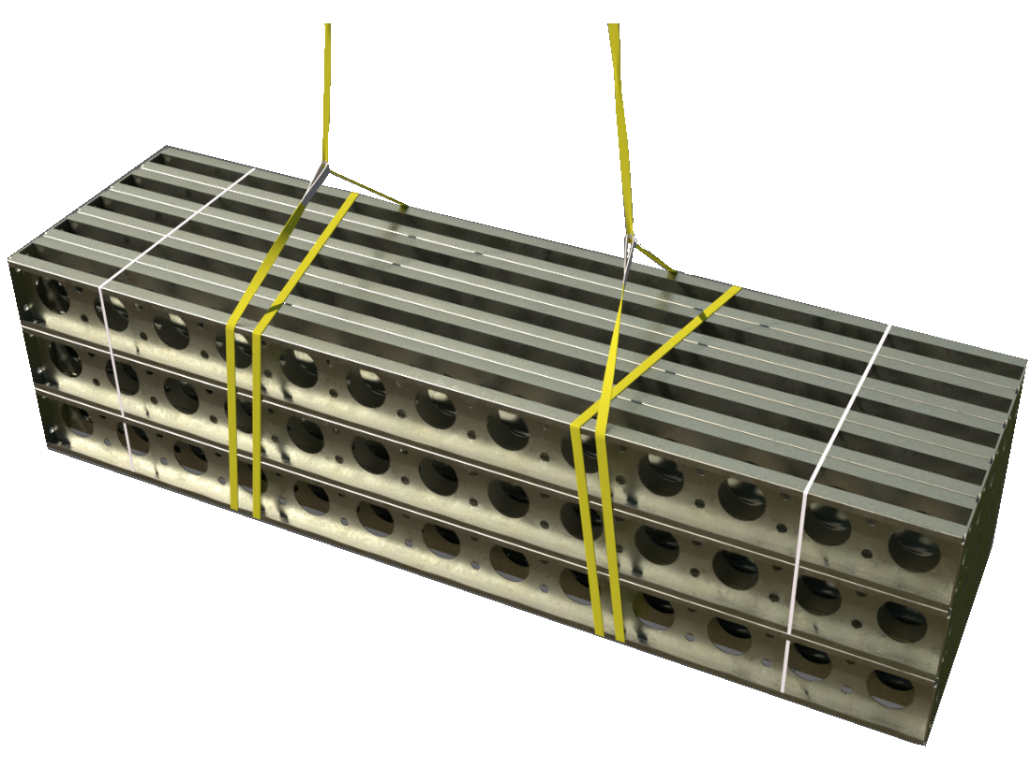 |  | Slinging methodology:  - 4 leg chain slings will be attached to hook block of the crane. 2 legs only required so the unused chains will be hung back to the master ring.  - 2no. webbing slings min WLL 2 t of sufficient length will be attached to the pack of ‘strong backs’ in a double wrap – choke configuration.  - Hooks of chain slings will then be attached to the webbing slings.
Lift Category: | Basic
Dimensions of load: | Various dimensions: Typically, 900mm [w] x 3600 mm [l] x 900mm [h] [pack of 5 x 5]
Weight of Load | Typically, 1.805 t [pack of 5 x 5]
Lifting accessories used with weights of accessories: | From hook block:  4 Leg chain slings WLL 8.4 t @ 103kg  ---------------------------------------------  2no. webbing slings 8 m (l) [wcs] @ 7 kg.  Gross weight inc. 10% FOS: 2.107 t [ru] | WLL x Mode Factor | Resulting SWL
Lifting accessories used with weights of accessories: |  | 4 leg chain slings with 2 legs in use - WLL of one leg multiplied by 1.4 = 4.41 t  --------------------------------------  2 webbing slings used a set in a choke configuration = [WLL of one sling multiplied by 1.4] x .8 = 2.24 t | 2.24 t over accessories stated
Alternative methodology:  Alternative methodology  contd.: | Chain sling[s] can be used in a single wrap ‘captured choke’ configuration through the load by passing the chain sling through the ‘holes’ in the structure of the bottom row of strong backs – sling to suit a level load.  If size of hook block allows, then the webbing slings can be directly attached.  DO NOT OVERCROWD THE BLOCK  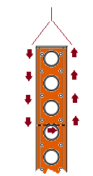Single ‘Strongback’ slinging:  When slinging single ‘strong-backs’ in the vertical for placement, then checks to be made with manufacturer’s instructions as some manufacturers stipulate a proprietary attachment plate or lifting point for this operation.  If none of the above are stipulated, then sling through either the central ‘Tie Rod’ space in the ‘Strongback’ structure in a single wrap ‘captured choke’ configuration.  When slinging in the above arrangement ensure you sling under the first strengthening joint as a minimum.  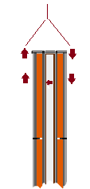  You can also sling through the holes in the structure of the ‘Strongback’ using the same ’captured choke’ configuration.  When slinging in these arrangements the schedule must reflect the changes made to weight of load, use of accessory and mode factors employed.
Safe lifting considerations: | - Check underside of pack for any materials that may have adhered themselves during transit or storage.  - Securing banding or ratchet strap to be used around the bundle.  - Check pack for any shorter lengths of strong backs that have been put in the pack, if found then ensure they are secure. Additional banding or ratchet strap[s] may be required.  - When slinging ensure that all elements of the load are captured by using securing banding around the pack.  - Check integrity of landed load after removal of accessories in case of collapse.  - Load slung to suit a level load.  - When lifting strong backs as part of shoring or propping assemblies, ensure that they are free i.e., not bolted to the shutter or any tilt plates / anchors.

Loads description: Formwork – Panels with proprietary clamps in use
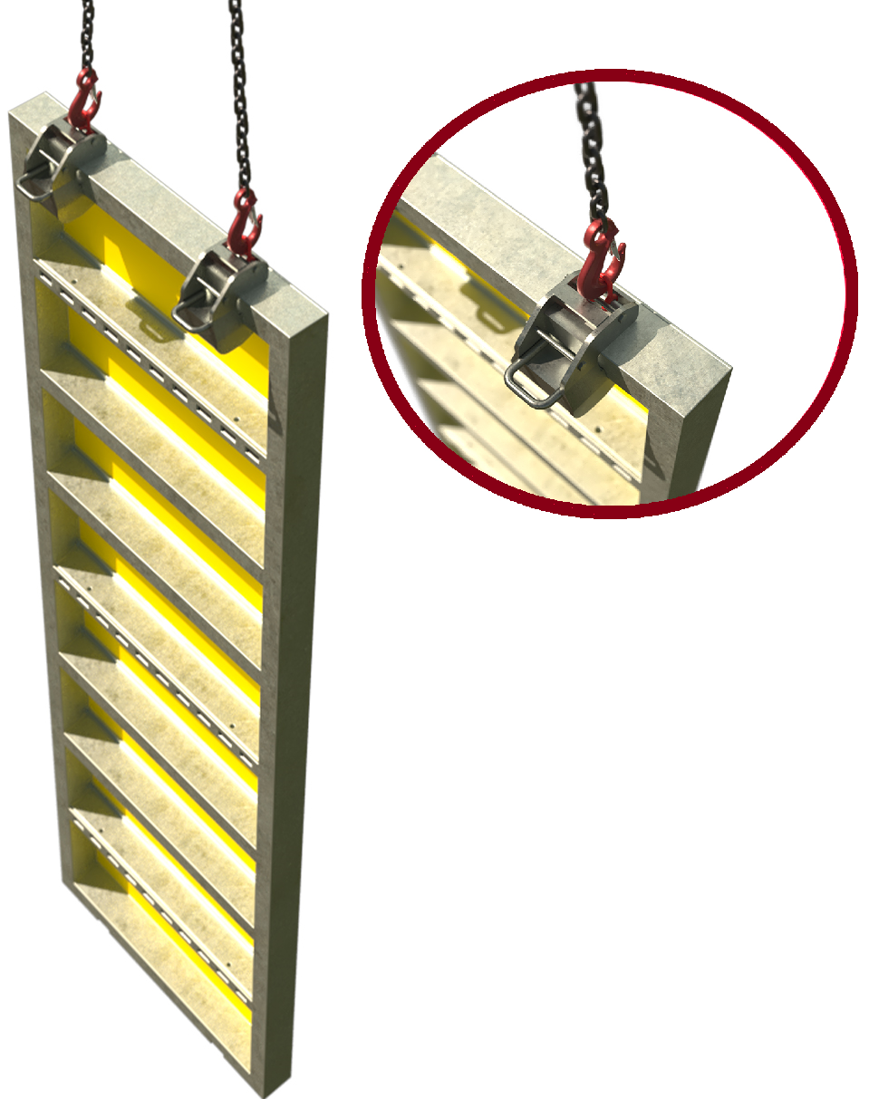 |  | Slinging methodology: - Proprietary clamps  - 4 leg Chain sling[s] will be attached to hook block of the crane. Only 2 legs of the chain sling are required so hang the unused chains back up to the master ring.  - Attach 2no. proprietary clamps to the shutter as per manufacturer’s instructions.  - Attach hooks of the chain slings to the attachment points of the proprietary clamps
Lift Category: | Intermediate
Dimensions of load: | Various dimensions & weights: See manufacturer’s instructions for max. weights and size of shuttering make up for safe lifting.
Weight of Load
Lifting accessories used with weights of accessories: | From hook block >  4 Leg chain slings WLL 8.4 t @ 103kg  ---------------------------------------------  2no. proprietary clamps WLL 1.5 t @ 20 kg  Gross weight inc. 10% FOS: _ t [ru] | WLL x Mode Factor | Resulting SWL
Lifting accessories used with weights of accessories: |  | 4 leg chain slings with 2 legs in use - WLL of one leg multiplied by 1.4 = 4.41 t  -------------------------------------  2 proprietary clamps used as per manufacturer’s instructions | 3 t over accessories stated [based on 1.5t clamps being used]
Alternative methodology: | Single clamp use:  Check manufacturer’s literature for ‘Single’ clamp use, the clamps are limited to single pans only.  Multi clamp use on ‘Box shutters’ and larger area shutters  Again, check manufacturer’s literature for permissible angles of sling when using multi clamp configurations.  Please note:  A lifting beam may need to be employed to suit multi clamp use on larger area shutters
Safe lifting considerations:  Safe lifting considerations contd.: | 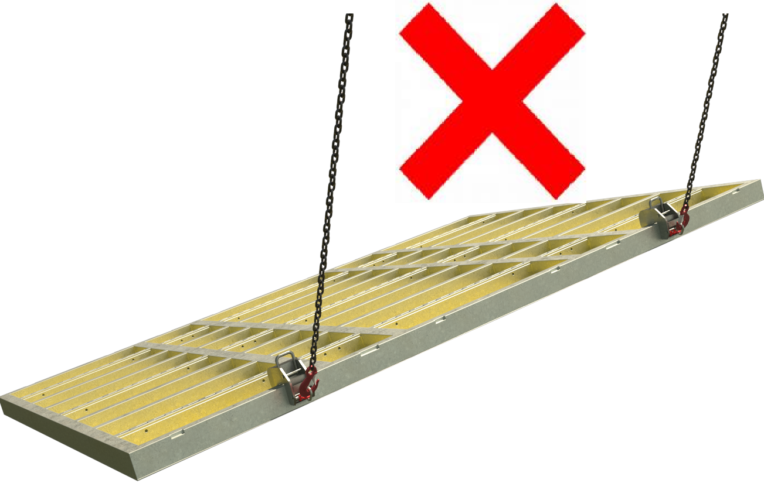  - Do not lift shutters to the vertical with the face of the shutter to the slab/floor unless manufacturer’s guidance allows.  - Position the lifting hooks where they cannot slip or secure the lifting hooks so that they cannot slip sideways.  - Ensure that the lifting clamp attachment ring is seated correctly in the hook of the chain sling.  - 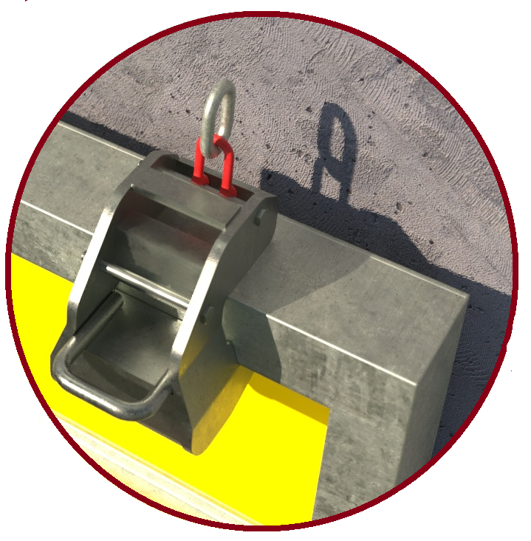Always ensure when removing ‘shutter’ from formed concrete that you do not use the crane to ‘pull’ the shutter away. Instead ensure the shutter is  released and is clear to lift free. Pulling the ‘shutter’ from the formed concrete may impose forces on the clamps that are greater than the stated WLL.  Check the shutter is free to remove – do not use the crane to release the shutter.  - Establish weight of shutter prior to lifting for install or removal.  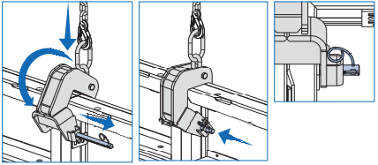  - If relevant ensure all locking pins are in place.  - Slinger to have been familiarised and briefed on the safe use of the proprietary clamp.  - When landing shutter into the horizontal, ensure suitably sized timbers are placed beneath the shutter to allow safe removal of the clamps.  - Never use the lifting clamps to lift the shutter in the ‘Horizontal’ across project. The clamps are only designed for ‘Vertical’ & ‘Horizontal to Vertical’ use only.  - When standing the shutter from horizontal to the vertical monitor the position of the block in relation to the bottom of the wall section so as to keep the wall section from ‘swinging’ when fully raised.  - Preparation/construction area of the formwork should be as close to the install area as practicable.  Special note:  The maximum allowable wind speed for lifting of shutters needs to be assessed on a case by case basis. Consideration should also be given to the route of the lifting operation, noting any zones of wind funnelling / buffeting.
Additional information:  Additional information: contd. | Examples of manufacturer sling angles to be employed:  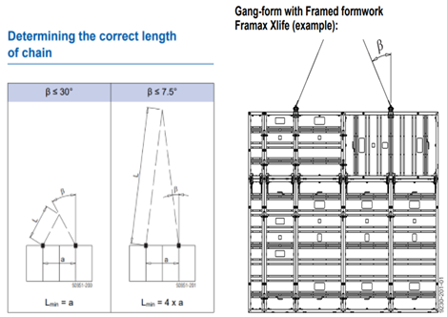  Framax lifting hook [DOKA]:  Framax lifting hook [DOKA] contd.  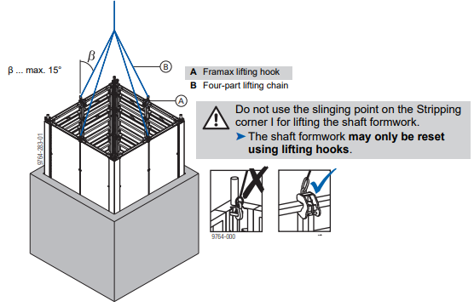Shaft formwork example  Lifting hook Trio [PERI]:  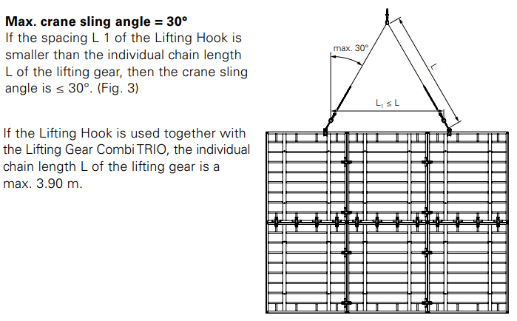  Special note:  Always refer to manufacturer’s operating instructions and literature for permissible weights to be lifted & allowable angles of use of the lifting clamps.

Loads description: Formwork – Column boxes with proprietary clamp/attachments
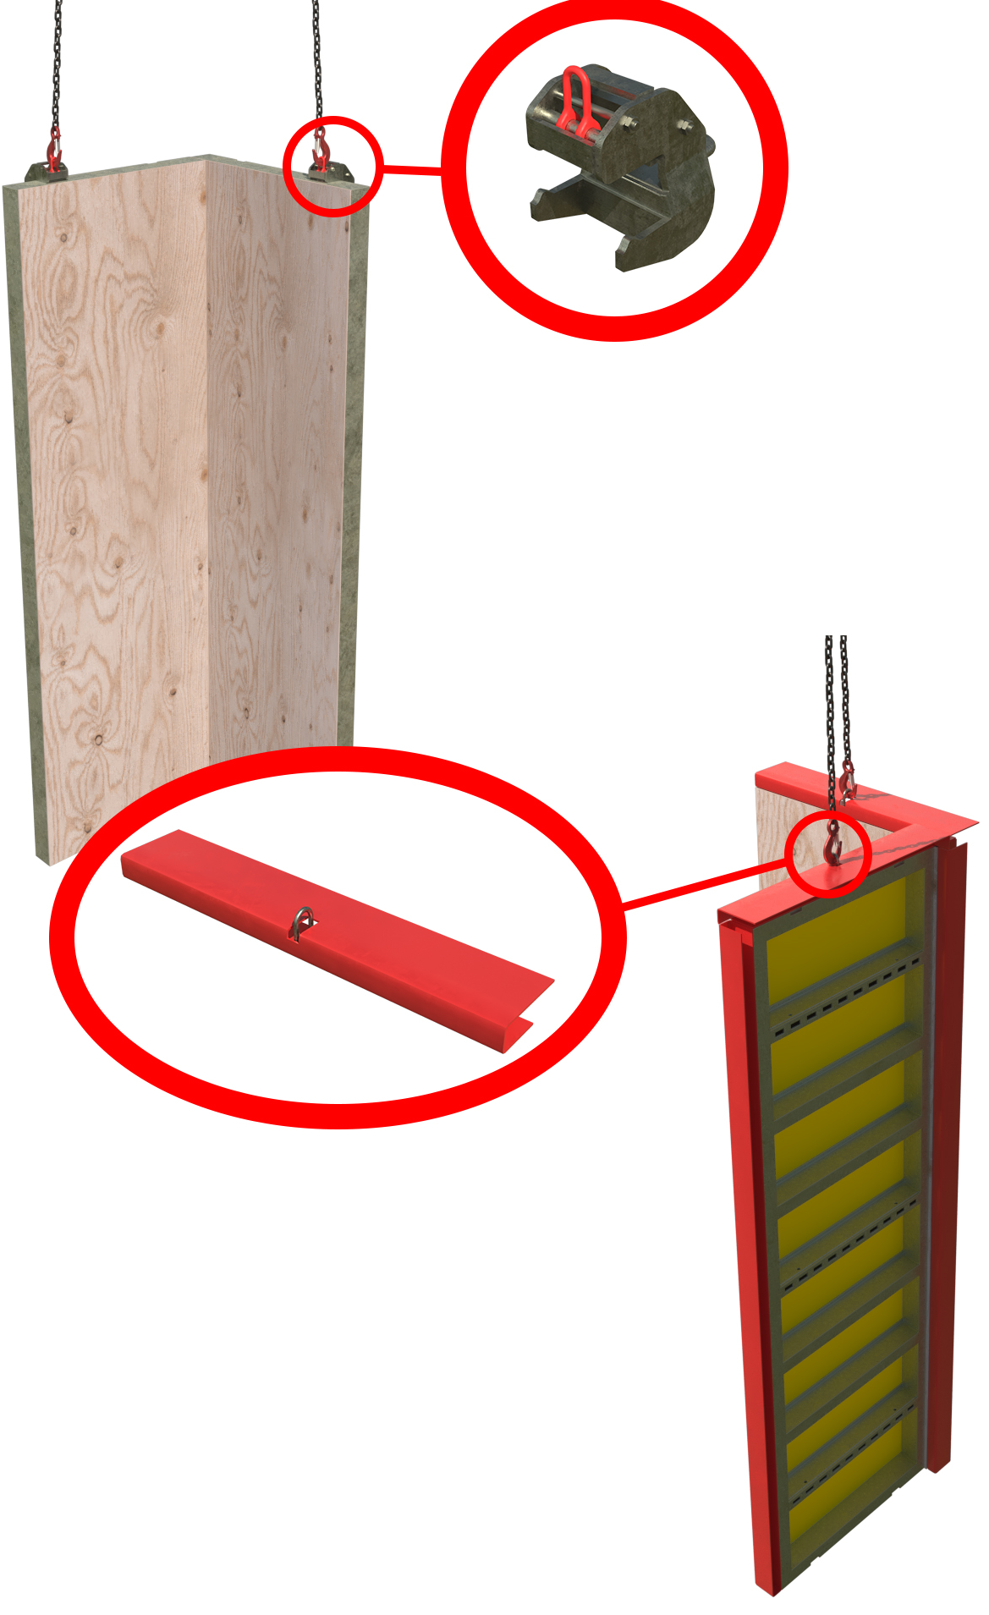  Proprietary attachment  Proprietary clamp |  | Slinging methodology: -Proprietary clamps/attachments  - 4 leg chain sling will be attached to hook block of the crane. Only 2 legs of the chain sling are required so hang the unused chains back up to the master ring  - Attach 2no. proprietary clamps/attachment points to the column shutter as per manufacturer’s instructions and to suit a level load.  - Attach hooks of the chain slings to the attachment points of the proprietary clamps/integral lifting points  Please note for clarity:  - Proprietary clamp: A lifting accessory specifically designed for the formwork shuttering – LOLER applies, so RoTE, daily, and weekly check required.  - Proprietary attachment: An integral component of the formwork shuttering structure that enables lifting – PUWER applies, so daily check required.
Lift Category: | Intermediate
Dimensions of load: | Various dimensions & weights: See manufacturer’s instructions for max. weights and dimensions of column boxes permitted to be lifted.
Weight of Load
Lifting accessories used with weights of accessories: | From hook block >  4 Leg chain slings WLL 8.4 t @ 103kg  -------------------------------------------  2no. proprietary clamps WLL _t @ 20 kg  Gross weight inc. 10% FOS: _ t [ru] | WLL x Mode Factor | Resulting SWL
Lifting accessories used with weights of accessories: |  | 4 leg chain slings with 2 legs in use - WLL of one leg multiplied by 1.4 = 4.41 t  -------------------------------------  2 proprietary clamps used as per manufacturer’s instructions | _t over accessories stated
Alternative methodology:  Alternative methodology: contd.: | There are various methodologies of lifting column formwork and their associated components.  Some manufacturers allow component parts i.e., Access platforms, once attached to the column structure to form lifting points to allow placement /removal of the column box. Others allow the column boxes to be lifted with proprietary support struts attached  Please note:  When lifting column boxes with proprietary push-pulls then ensure integrity of the attachment. If 3rd party [not proprietary] push-pulls are being used, then these must be removed prior to lifting the column box. [see following page]  Examples of manufacturer’s components used for lifting:  DOKA access platform lifting points:  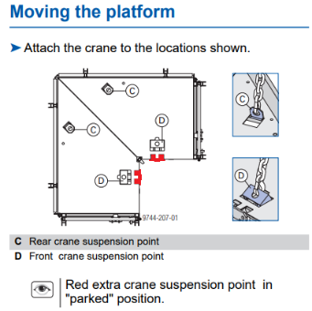  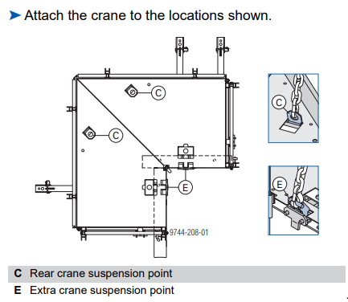  The above example shows DOKA guidance on lifting points for their access platform.  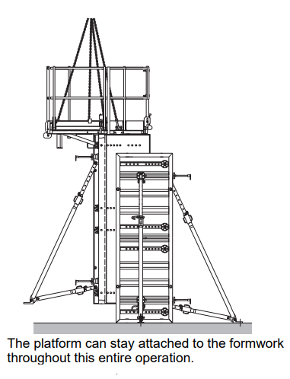The first image is for placing the platform, the second image shows the lifting points for removal. Note how the lifting points have changed!  Opposite is composite graphic showing column box being lifted with proprietary support struts.  Lifting with proprietary support struts attached is subject to a TW’s review and sign off and only permissible if the project Appointed Person allows.  Lifting with 3rd party support struts is forbidden and these must be removed prior to lifting  PERI access platform lifting points:  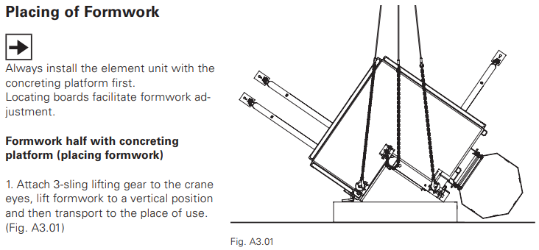  Above shows guidance provided for lifting column formwork utilising system access platform.  Always refer to manufacturer’s literature and guidance when using these methodologies
Safe lifting considerations: | - Lifting methodology to follow manufacturer’s instructions for safe use.  - If integral attachments are being used, then ensure these are clearly identified and briefed to the lift team.  - Ensure lifting methodology allows a safe landing of the column boxes whether it is being installed around column skeleton or being removed from completed structure.  - Do not ‘pull’ the column box from the completed structure. Ensure the column is free for removal. Pulling the column box from the formed concrete may impose forces on the clamps/attachment used that are greater than the stated WLL.  - Slinger to have been familiarised and briefed on the safe use of the proprietary clamp/proprietary attachment.  - When standing the shutter from horizontal to the vertical monitor the position of the block in relation to the bottom of the column section so as to keep the wall section from ‘swinging’ when fully raised.  - Preparation/construction area of the formwork should be as close to the install area as practicable.  Special note:  The maximum allowable wind speed for lifting of shuttering columns needs to be assessed on a case by case basis. Consideration should also be given to the route of the lifting operation, noting any zones of wind funnelling / buffeting.

Loads description: Slab formwork – Tables with proprietary lifting hook - ‘C’ Hook
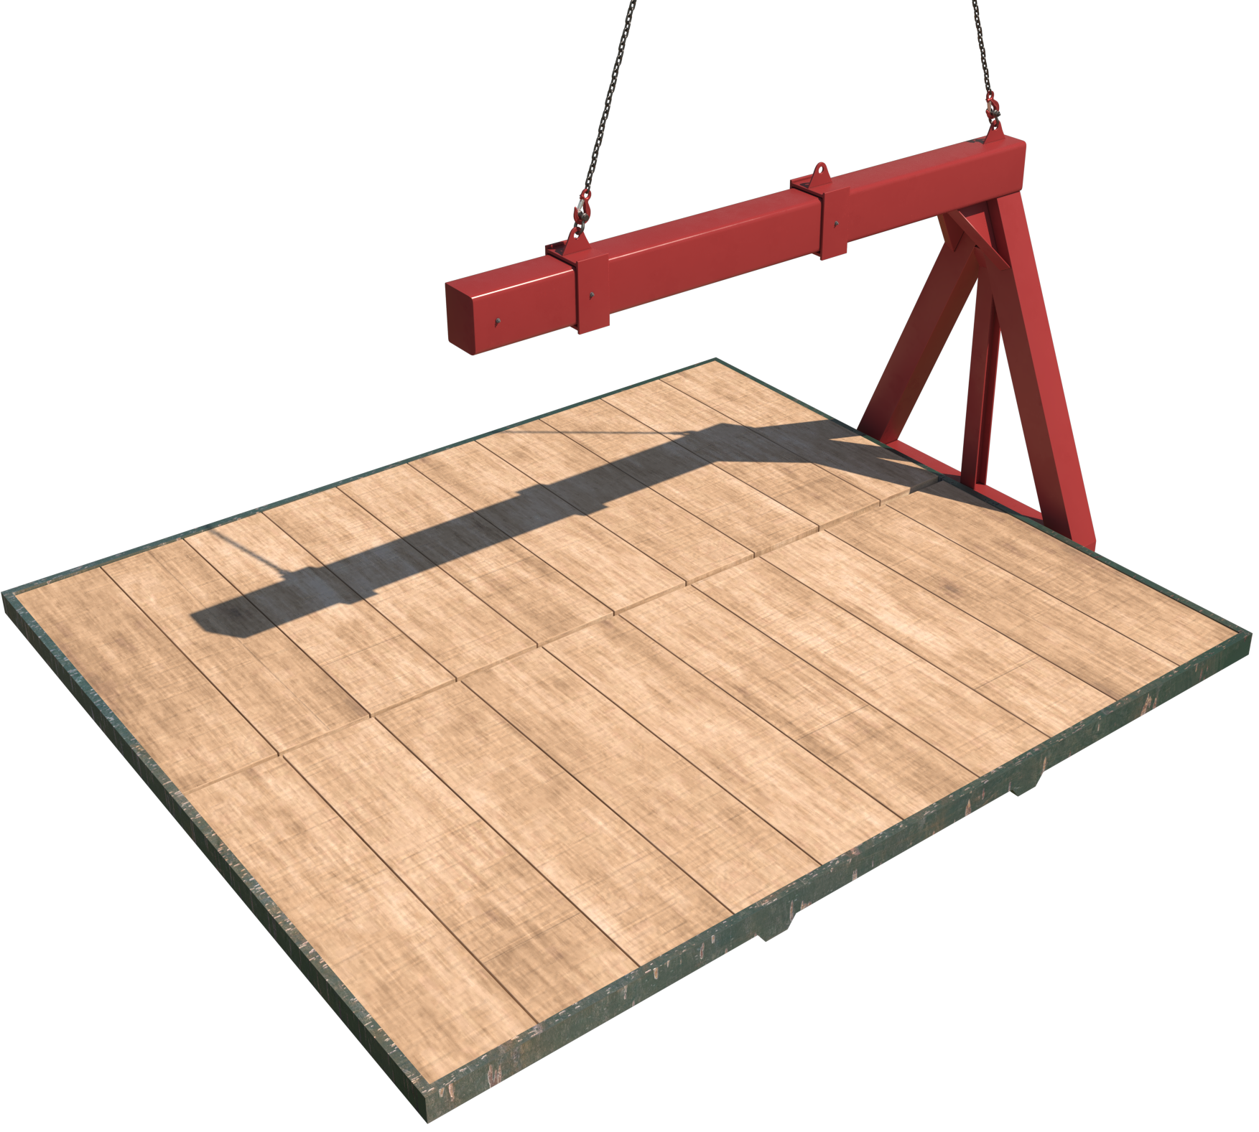Please note:  Images above and through the schedule are representational only of a typical methodology |  | Slinging methodology:  - 4 leg chain slings will be attached to hook block of the crane. 2 legs only required so the unused chains will be hung back to the master ring.  - 2 legs of chain sling will be attached to the lifting points on the C – Hook.  - If applicable the ‘forks’ of the C -Hook will be adjusted.  Please note:  Lifting points and, if applicable, ‘forks’ of the C–Hook will be positioned to suit CoG & sizing of table formation.  - C-Hook arrangement will be raised and placed under the table formation required for lifting.  - Table formation will then be attached to C- Hook as per manufacturer’s instructions/safe use guide.
Lift Category: | Intermediate
Dimensions of load: | Various dimensions to suit sizing capacity of proprietary hook – see manufacturer’s guidance.
Weight of Load | Various dimensions to suit WLL of proprietary hook with FOS considered – see manufacturer’s guidance.
Lifting accessories used with weights of accessories: | From hook block:  4 Leg chain slings WLL 8.4 t @ 103kg  ---------------------------------------------  C – Hook WLL @ _t  Gross weight inc. 10% FOS: _t [ru] | WLL x Mode Factor | Resulting SWL
Lifting accessories used with weights of accessories: |  | 4 leg chain slings with 2 legs in use - WLL of one leg multiplied by 1.4 = 4.41 t  --------------------------------------  Proprietary lifting hook, ‘C-Hook’, as per design use. | _t over all accessories stated
Alternative methodology: | 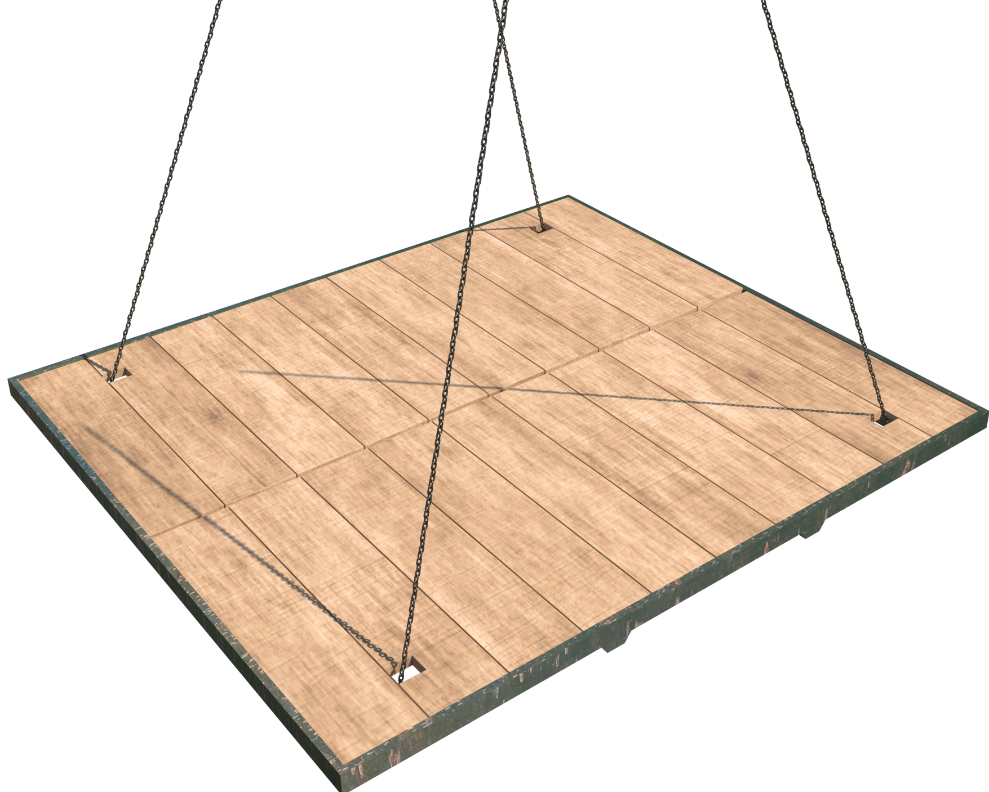  Attachment utilising chain sling:  Chain sling[s] can be used in a single wrap ‘captured choke’ configuration through the load by passing the chain sling through cut ‘holes’ in the top timber structure of the ‘table’ and ‘choked around the primary & secondary beams to suit a level load.
Safe lifting considerations: | - A specific Risk Assessment and method statement must be authored to suit the lifting of the table formation, from preparation of the arrangement thru to final install and release of C-Hook/accessories.  - Care is to be taken in the planning stage when specifying the positioning of not only the lift team members but of the install/removal team as well, through the lifting operation.  - Use of proprietary lifting hooks must follow the manufacturers safe use guide and operating manual.  - 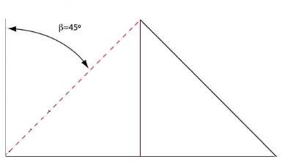When using proprietary lifting hooks [C- Hooks], ensure the install/removal team, slinger[s] and lifting supervisor[s] are familiarised on the safe use of the hook to ensure correct attachment through the lifting/placing process.  - When attaching the chain slings to the table formation in the ‘choke’ configuration , the length of the slings must be sufficient to allow for the chain to be within a 0 to 45 deg. excluded angle.  - 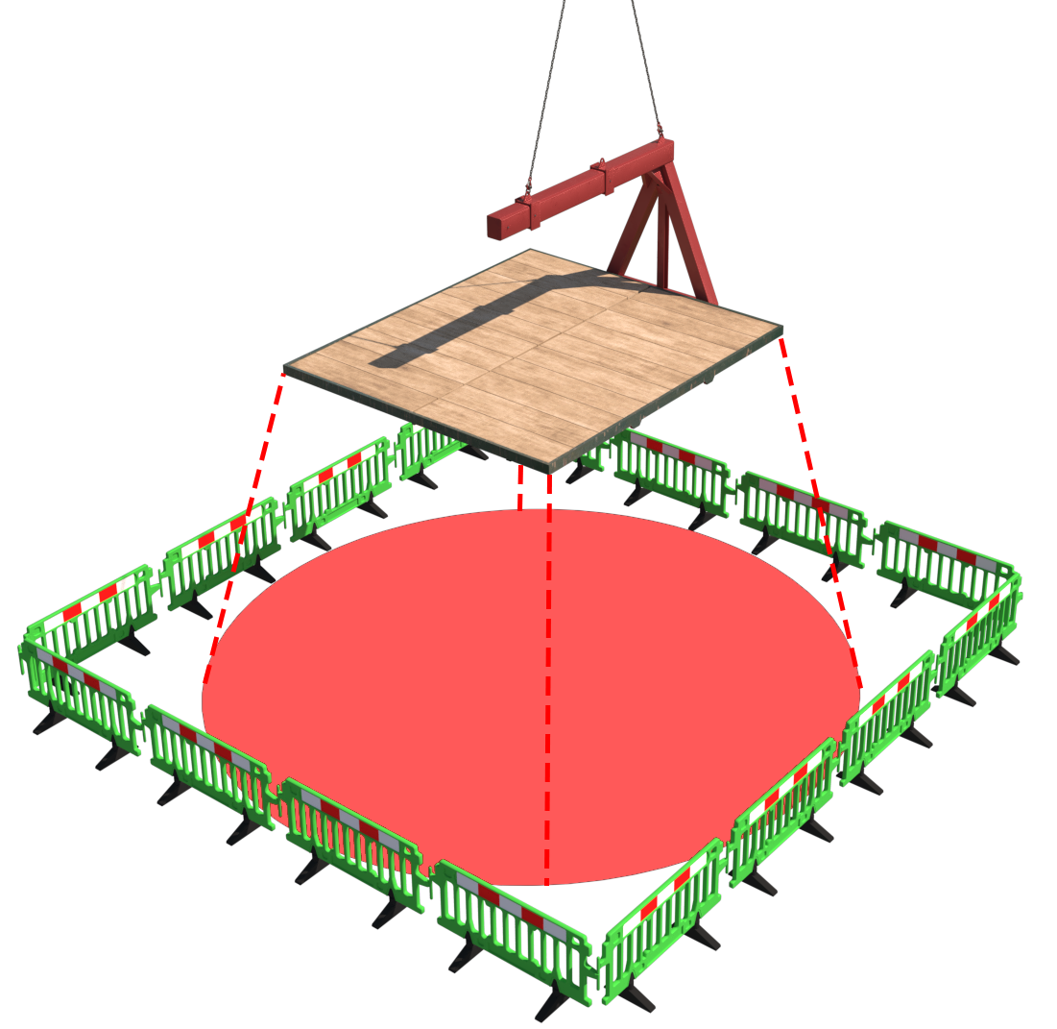Exclusion and restricted ‘zones’ must be in place around the immediate install/removal areas and directly beneath the work area. These zones shall be suitably marshalled with appropriate signage. Area of works and timings [where practicable], must be communicated to work force in immediate and adjacent areas in DABs or specifically held toolbox talks.  Please note:  When setting up exclusion and restricted zones around the area beneath the lifting operation, an allowance must be made for falling objects and the anticipated trajectory of fall.  - Prior to lifting table formation ensure that all support ‘legs’ are secured in the correct manner utilising manufacturer’s recommend methodologies of securing.  - If the table formations are to be lifted inclusive of edge protection, then these attachments are subject to a TW ‘s confirmation to be able to lift.  These attachments must be included in the weight of the table and assessment of revised balance of the load.

Loads description: – Precast concrete elements – Kentledge or ‘Kelly’ concrete block
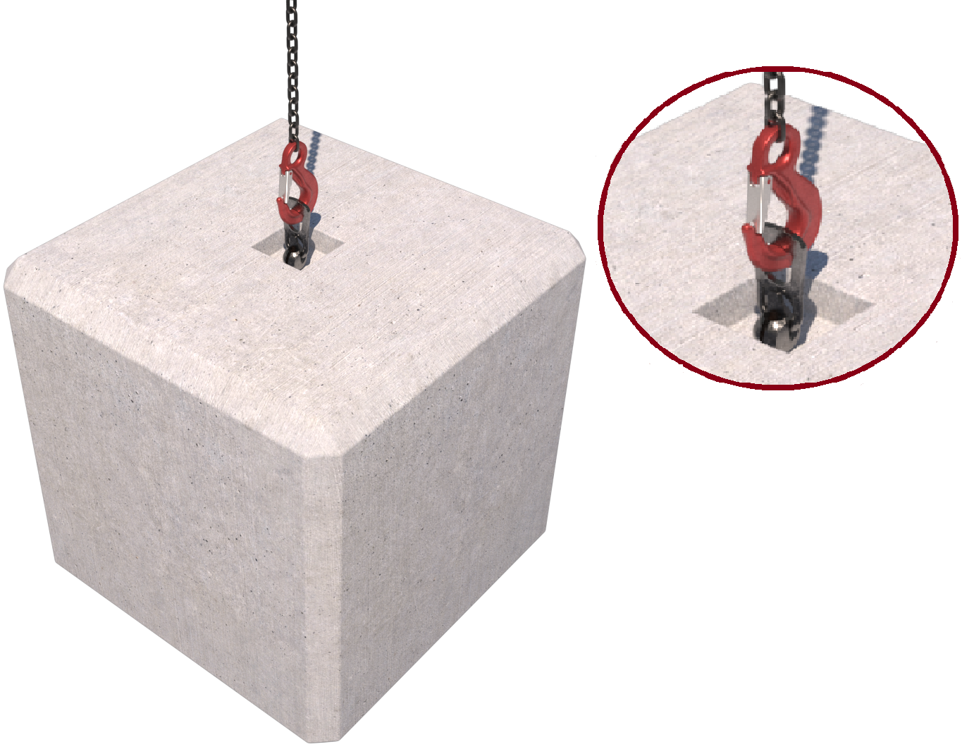 |  | Slinging methodology – Precast anchor point  - Single leg chain sling will be attached to hook block of the crane.  - Attach precast lifting accessory min WLL 2 t to the cast in anchor point.  - Hook of chain sling will then be attached to the anchor point of the concrete block.  Slinging methodology – Embedded anchor point  - Single leg chain sling will be attached to hook block of the crane.  - Hook of chain sling will then be attached to the embedded anchor point of the concrete block.  Special note:  Temporary works verification of anchor point required in both above methodologies.  Slinging methodology – ‘Through’ the block  - 4 leg chain sling will be attached to the hook block of the crane. Only 2 legs in use so hang the unused chains back up to the Master ring.  - Feed the chains though the attachment holes in the block and utilise in a single wrap ‘captured choke’ configuration.  Slinging methodology – ‘Around’ the block  - 4 leg chain sling will be attached to the hook block of the crane. Only 2 legs in use so hang the unused chains back up to the Master ring.  - Feed the chains under the block in single wrap choke configuration.  Special note:  Only blocks with ‘slinging’ notches in the bottom of the block to be lifted this way as the notches form a ‘captured choke’.
Lift Category: | Basic
Dimensions of load: | Various dimensions: Typically, 800mm [w] x 800mm [l] x 800mm [h]
Weight of Load | Typically, max. 1800kg for dimensions given
Lifting accessories used with weights of accessories: | Please note:  The following is for the worst-case scenario [wcs] mode factors used in the shown configurations – ‘Choked chains around block’  From hook block:  4 Leg chain slings WLL 8.4 t @ 103kg  Gross weight inc. 10% FOS: 2.094 t [ru] | WLL x Mode Factor | Resulting SWL
Lifting accessories used with weights of accessories: |  | Multi leg chain sling with 2 legs in use in ‘choke’ configuration – [WLL of one leg multiplied by 1.4] x .8 = 4.48 t | 4.48 t over accessories stated
Alternative methodology: | Attachment to anchor points: Single leg of a multi leg chain sling can be used if of sufficient WLL. Hang unused chains back up to the master ring.  Choke attachment: Webbing slings can be employed in the same configuration of the chain slings.  If size of hook block allows, then the webbing slings can be directly attached.  DO NOT OVERCROWD THE BLOCK
Safe lifting considerations: | - When lifting from a precast or embedded attachment point a Temporary Works check should be performed to ensure integrity of the lifting point.  - Check condition of the lifting point, check for any cracks around the immediate area.  - Ensure that any threads are clean, and the lifting accessory is fully engaged / bearing on the insert / block.  - Check underside of the block in test lift for any adhered materials.  - If utilising webbing slings, ensure there is adequate protection of the webbing slings in case of sharp edges on the block can affect the integrity of the attachment.  - When attaching ‘through’ or ‘around’ the block, ensure the accessories are of sufficient length so that the angle of the chains doesn’t require a reduction of the SWL in the configuration being used.  - Check prior to lifting that any attachment holes or notches are of sufficient size to allow the hook of the chain sling to pass through without using excessive force.

Loads description: Template
Slinging methodology:

.
Lift Category: | Basic | Intermediate |  | Complex
Dimensions of load:
Weight of Load
Lifting accessories used with weights of accessories: | From hook block >  Gross weight inc. 10% FOS: t [ru] |  | WLL x Mode Factor |  | Resulting SWL
Lifting accessories used with weights of accessories: |  |  |  |  | over accessories stated
Alternative methodology:
Safe lifting considerations:

