A practical guidance - 6: Schedules 36 to 48
Revision 1 September ‘25

Schedule of lifts for Tower Crane

Please note:
This document has been provided by Sir Robert McAlpine Limited. It has been checked to the best of our ability but may contain unintentional errors. As per BS 7121-1:2016, CDM 2015 and LOLER, it is the user’s responsibility to verify that they understand and have made their own checks before using this document.
The user shall ensure that they properly risk assess and plan their own lifting operations to discharge their legal requirements.
No liability will be accepted for any incidents that result of those using this document.

The schedules
No. | Title:
36. | Precast concrete elements – Stair units
37. | Precast concrete elements – Intermediate landing units] / Capping slab units
38. | Precast concrete elements – Concrete drainage pipes [Single]
39. | Clay pipe [drainage] - Bundle
40. | Steel pipe [drainage] - Bundle
41. | Scaffolding tubes – Stillages 5’ to 10’ only
42. | Scaffold tubes – Bundles 7’ to 21’ only
43. | Site plant – Mobile tower lights
44. | Site plant - Compressors
45. | Site plant – Welding set generator
46. | Site plant – Compactor plate
47. | Site plant – Drum Roller
48. | Site plant – Power trowel [float]
Ref. | Blank template

Loads description: Precast concrete elements – Stair units
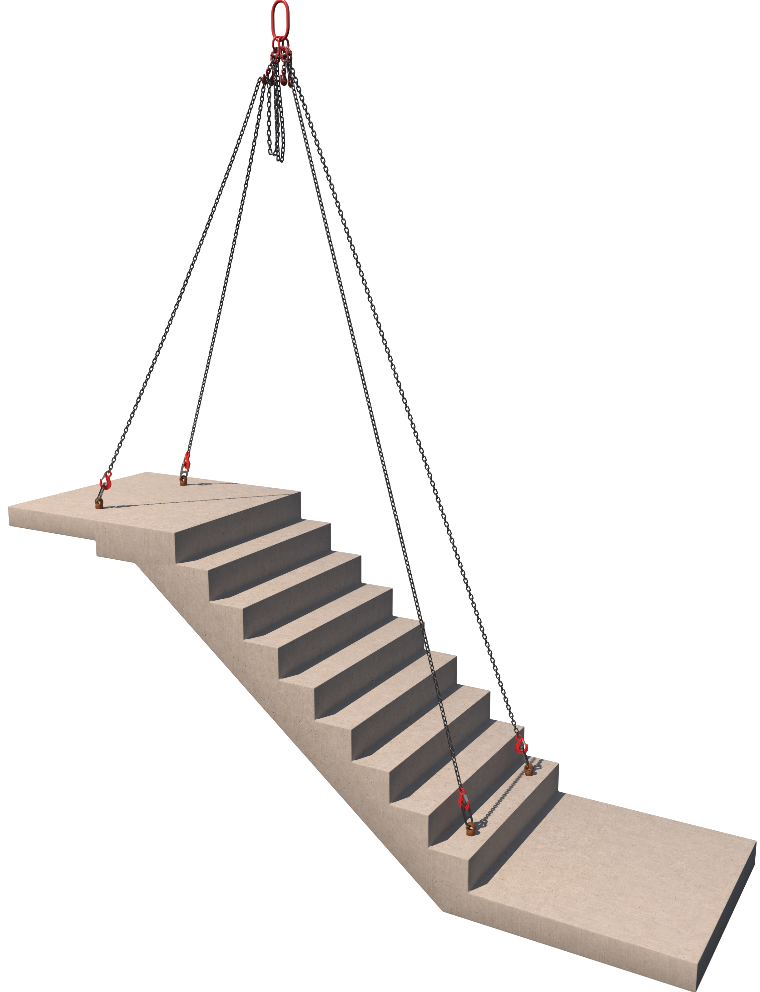 |  | Slinging methodology:  Direct attachment of chain slings to cast in anchor points…  - Lifting anchors shall be attached to the cast in lifting points as per manufacturer’s instructions.  - 4 leg chain sling will then be attached to the hook block of the crane.  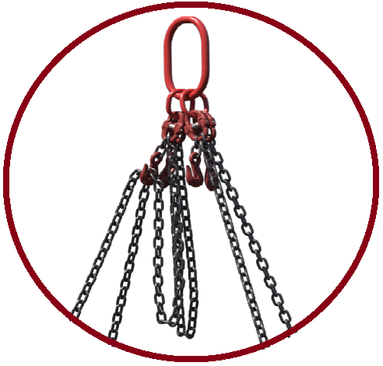  - Chain-sling will then be arranged to suit ‘placement’ of stair unit.  - Hooks of chain sling will then be attached to the Lifting anchors  Please note:  Configuration of chains to be identified in the lift plan and not ‘worked’ out at point of lift.
Lift Category: | Intermediate [as a minimum] |  | Complex [dependant on localised parameters and hazards]
Dimensions of load: | 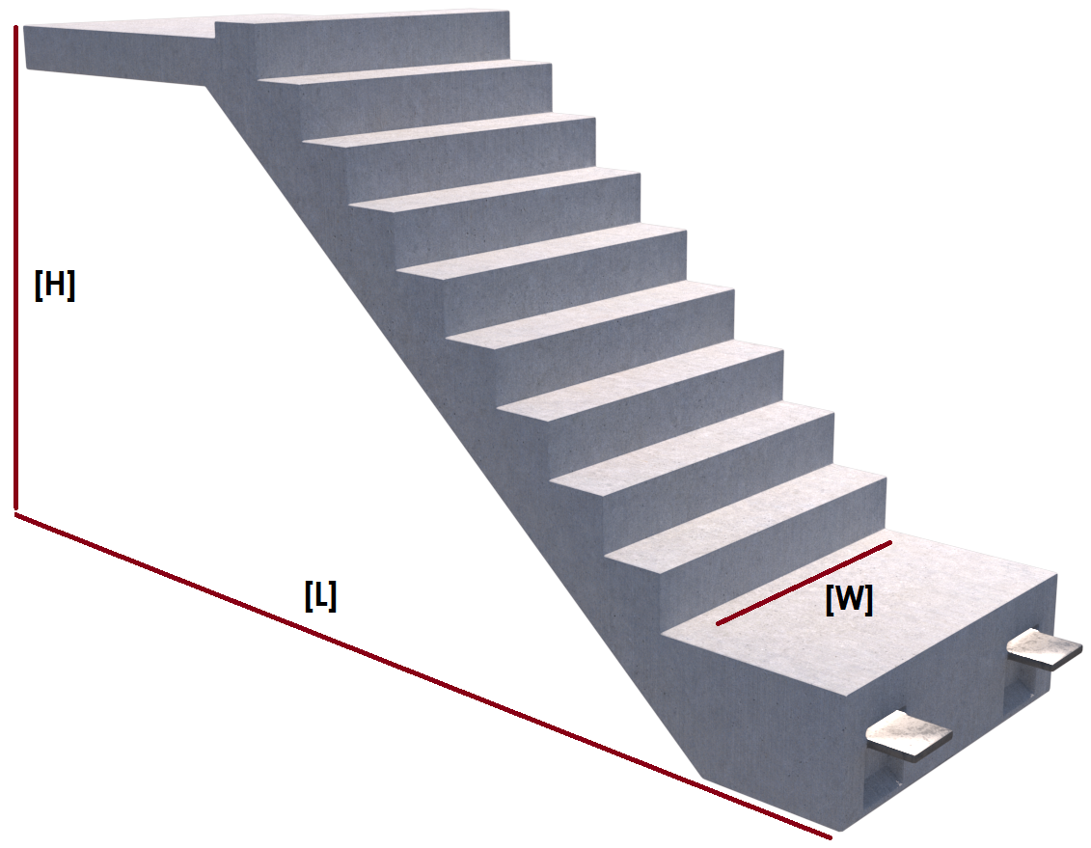  Various dimensions: When stating sizing of the stairs give the size as per ‘Install’ configuration  See example opposite
Weight of Load | Various weights over different designs
Lifting accessories used with weights of accessories: | From hook block >  4 Leg chain slings WLL 8.4 t @ 103kg  ---------------------------------------------  Precast attachment point anchors Min. WLL to suit weight of stairs as per design.  ---------------------------------------------  Additional accessories Min. WLL to suit methodology of use in the lifting arrangement.  Gross weight inc. 10% FOS: _ t [ru] | WLL x Mode Factor |  | Resulting SWL
Lifting accessories used with weights of accessories: |  | 4 leg chain slings per designed use  --------------------------------------  Precast attachment anchors WLL as per TW design attending to stair weight  --------------------------------------  Additional accessory [description here] Min. WLL |  | _t over accessories stated will be to suit design weight of stair units with mode factors considered for required use in the methodology.
Alternative methodology: | 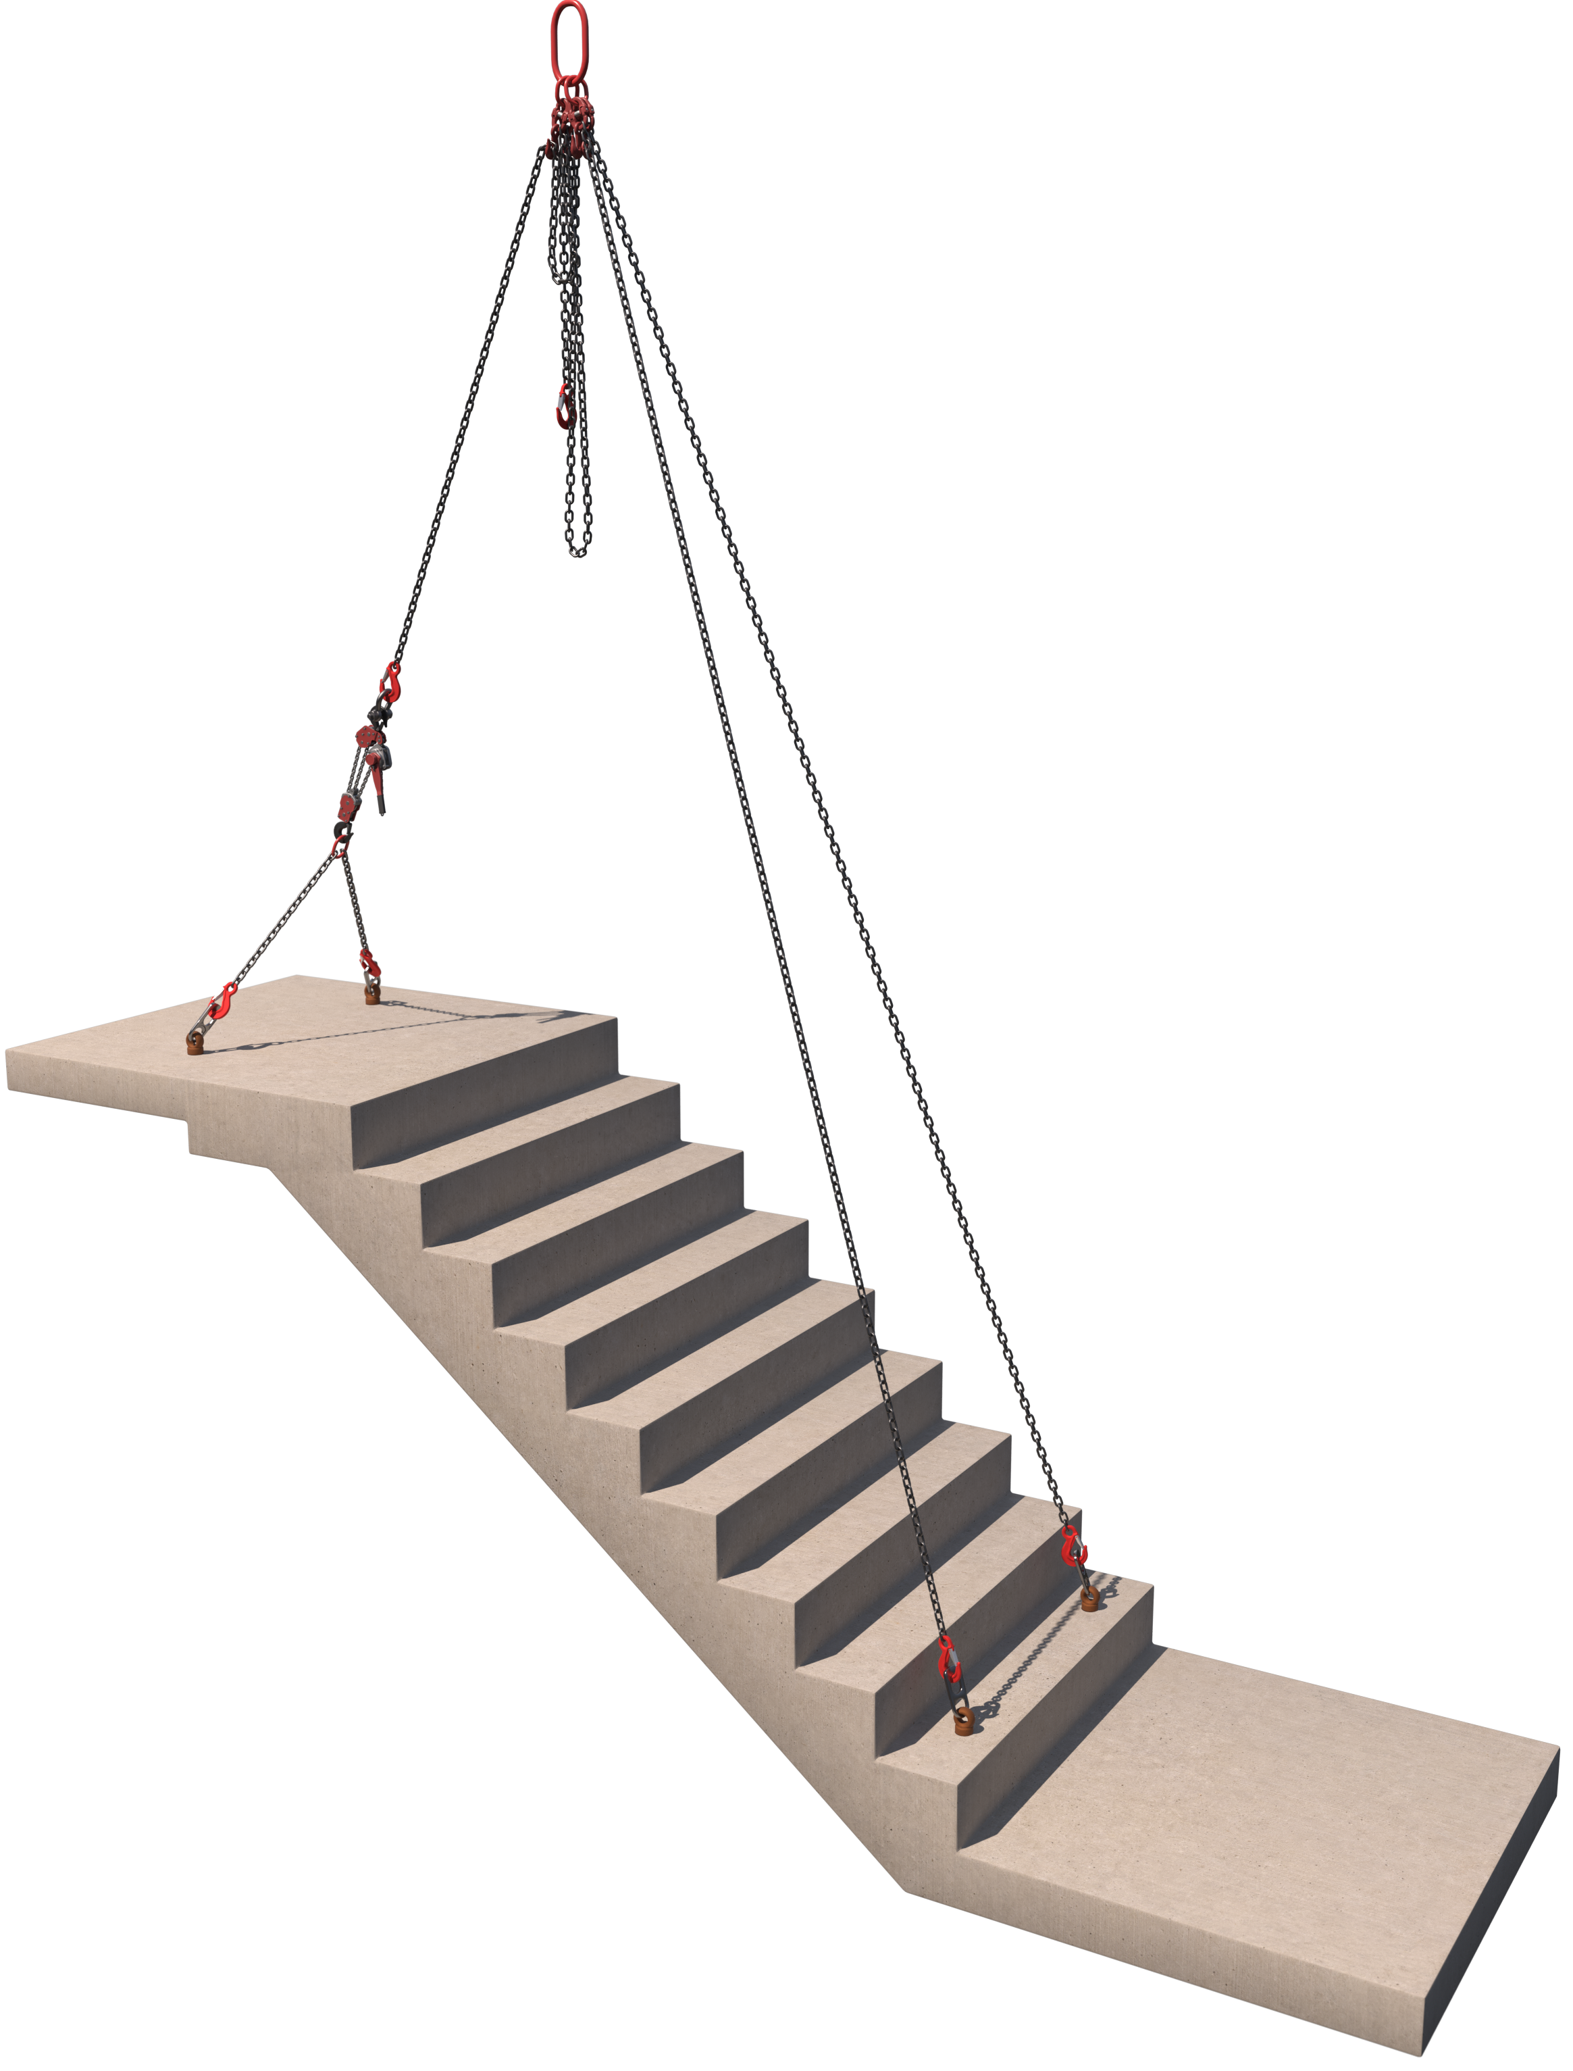  Additional accessories i.e., chain blocks, lever hoists can be employed to assist in manipulating the load orientation prior to install.  When using these ‘additional’ accessories the WLL of ALL accessories should be assessed to factor in all considered mode factors.  Ensure that the ‘additional’ accessories are used within their own working parameters by referring to the manufacturer’s instructions as evidence they are being used as intended  Example opposite shows a lever hoist being used on the ‘upper’ section of stairs to aid configuring the stairs into an ‘install’ orientation.  Revision note:  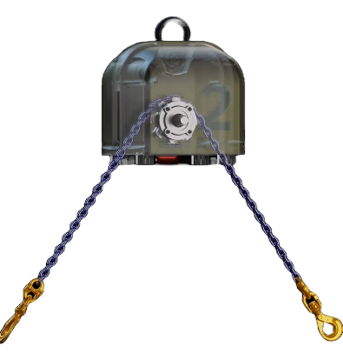  The Ganterud is an example of an alternative methodology that uses technology to assist in the rotation or levelling of loads, including precast units.  The Ganterud is controlled by remote control, removing the need to be close to the load to manually adjust chain blocks to alter the angle of the load.  The remote control enables adjustments to the load's pitch and/or tilt, which is crucial for positioning precast units—such as stairs, beams, or wall panels.  The Appointed Person should consider this alternative technology as it offers a safer and quicker method when compared with current methods, noting that the lift team should be suitably trained in the safe use of the equipment
Safe lifting considerations:  Safe lifting considerations contd.: | - A specific risk assessment and method statement must be authored to suit the lifting of the stair unit from preparation of the arrangement thru to final install and release of accessories.  - Care is to be taken in the planning stage when attending to the positioning of not only the lift team members but of the installation team as well, through the lifting operation.  - Stair unit installation historically takes place in restrictive areas with limited identifiable ‘Safe Spaces’.  Safe ‘emergency’ egress must be identified in the planning stage and prior to submittal.  - When lifting ‘blind’ a robust communication strategy must be in place.  - Preparation area of the lifting arrangement should be as close to the install area as practicable. A lifting corridor should be planned and briefed to all the work force in the localised and adjacent work areas.  - Any additional ‘furniture’ to the stair units i.e., handrails etc. are to be included in the weight of the load and subject to a TW review & confirmation of permissible attachment.  - Seek advice from manufacturers guidance and literature for the safe use and implementation of the precast lifting accessories. This will include [but not exhaustive of] :  Following graphics are typical examples.  Safe and correct attachment:  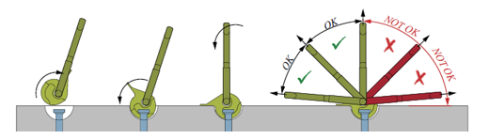  Angles of use: ‘Wear’ limits of the anchors:  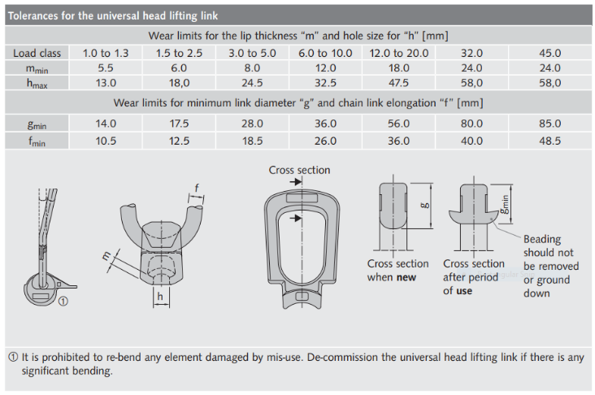  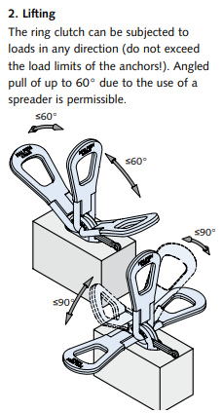  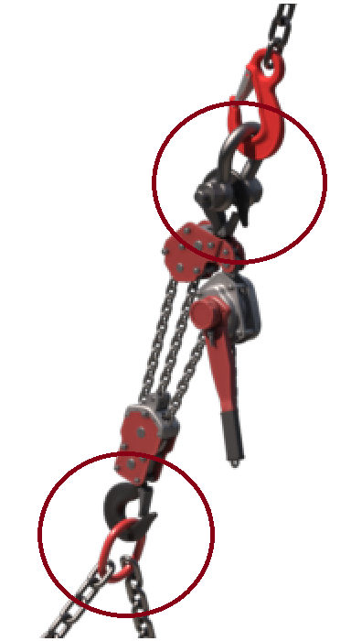When using additional accessories, ensure the attachment for ‘in line’ use is realised using appropriate attachment accessories.  Revision note:  When using manual mechanical/rigging appliances & accessories in crane lifting arrangements, the AP should consider the suitability of the equipment for the task.  - Review selected equipment’s Instructions for use for any limitations and principles for safe use such as working load limit, permitted angles of use, and any resulting safe working load due to angle reductions, some equipment also has a minimum working load for the clutch to engage.  Note:  Historically this equipment has been mis-used, and it has resulted in incidents which could have been avoided.  - ‘Make and model specific’ familiarisation and industry recognised training is required for the lift team members.  - The Appointed Person may require additional training to assist in the planning of these operations where this is beyond their current knowledge, experience & training.  - The lift classification will often change due to the additional risks in using this type of equipment and their resulting control measures. Additional supervision and use of lift teams with the relevant training may be required.  Useful links:  - LEEA Pocket book

Loads description: Precast concrete elements – ILU’s [Intermediate ‘landing’ units] / Capping slab units
Slinging methodology:

- Lifting anchors shall be attached to the cast in lifting points as per manufacturer’s instructions.

- 4 leg chain sling will then be attached to the hook block of the crane.

- Hooks of chain sling will then be attached to the Lifting anchors

Lift Category: | Intermediate [as minimum] |  | Complex [dependant on localised parameters and hazards]
Dimensions of load: | Various dimensions over assorted designs
Weight of Load | Various weights over assorted designs
Lifting accessories used with weights of accessories: | From hook block >  4 Leg chain slings WLL 8.4 t @ 103kg  ---------------------------------------------  Precast attachment point anchors Min. WLL to suit weight of units as per design.  Gross weight inc. 10% FOS: _t [ru] | WLL x Mode Factor |  | Resulting SWL
Lifting accessories used with weights of accessories: |  | 4 leg chain slings per designed use  --------------------------------------  Precast attachment anchors WLL as per TW design attending to unit weight |  | _t accessories stated  [This will be to suit design weight of the units with mode factors considered for required use in the methodology]
Safe lifting considerations:  Safe lifting considerations contd.: | - A specific risk assessment and method statement must be authored to suit the lifting of the landing/capping slab unit from preparation of the arrangement through to final install and release of accessories.  - Care is to be taken in the planning stage when attending to the positioning of not only the lift team members but of the installation team as well, through the lifting operation.  - Intermediate ‘landing’ units. These lifts historically take place in restrictive areas with limited identifiable ‘Safe Spaces’. Safe ‘emergency’ egress must be identified in the planning stage.  - Capping slabs. Historically performed at height, so again, safe ‘emergency’ egress and ‘safe spaces’ must be identified, as well as working from height management, in the planning stage.  - When lifting ‘blind’, which isn’t uncommon especially in the placement of landing sections, then a robust communication strategy must be in place.  - Preparation area of the lifting arrangement should be as close to the install area as practicable. A lifting corridor should be planned and briefed to all the work force in the localised and adjacent work areas.  - Any additional ‘furniture’ to units i.e., handrails etc. are to be included in the weight of the load and subject to a TW review & confirmation of permissible attachment.  - Seek advice from manufacturer’s guidance and literature for the safe use and implementation of the precast lifting accessories. This will include [but not exhaustive of]:  Following graphics are typical examples.  Safe and correct attachment: example graphic below  Angles of use: ‘Wear’ limits of the anchors:

Loads description: Precast concrete elements – Concrete drainage pipes [Single]
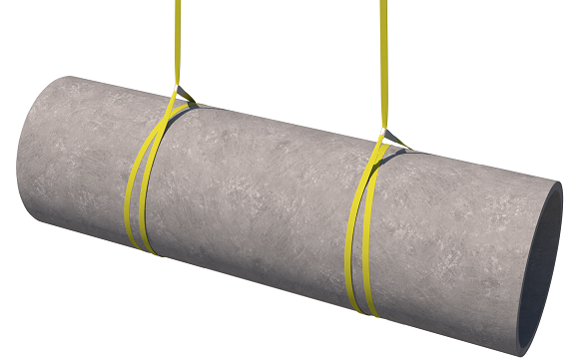  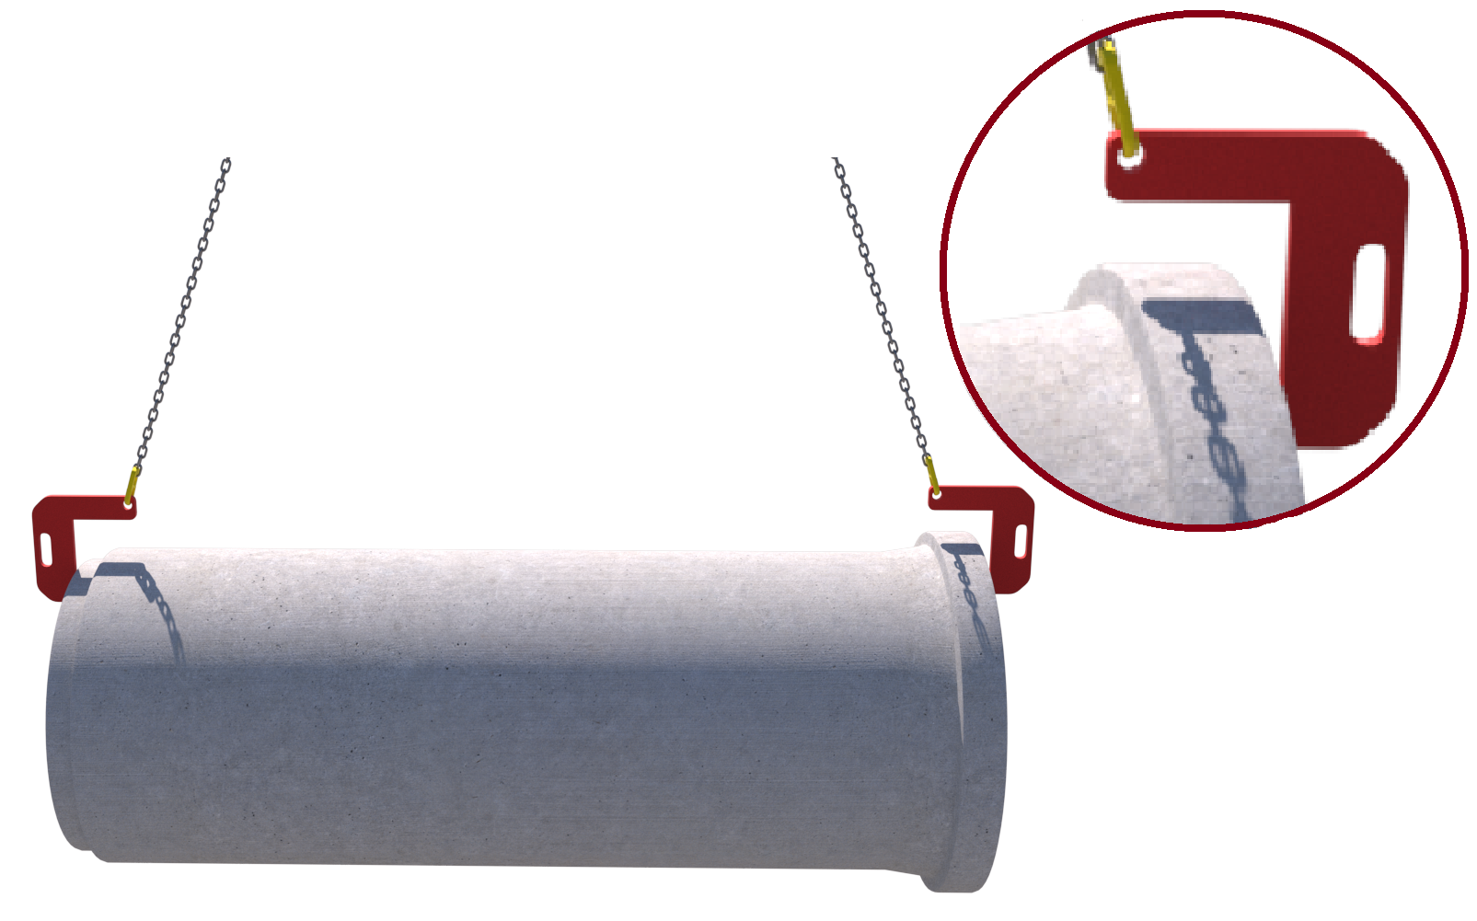 |  | Slinging methodology: - Choked slings  - 4 leg chain slings will be attached to hook block of the crane. 2 legs in use so hang the unused chains back to the master ring.  - 2no. webbing slings min WLL 3 t of sufficient length will be attached to the stillage in a double wrap – choke configuration.  - Hooks of chain slings will then be attached to the webbing slings.  Slinging methodology: - Pipe lifter  - Pipe lifter chain will be attached to hook block of the crane.  - Lifting hook attachments will now be placed at the pipe ends as per manufacturer’s instructions.  Please note:  Pipe lifting chain set is only to be used as a low-level lifting accessory for placing.
Lift Category: | Basic
Dimensions of load: | Various dimensions: Typically: 1080mm [d] x 2500mm [l]
Weight of Load | Typically, 2.057 t for dimensions given
Lifting accessories used with weights of accessories: | Webbing Sling methodology:  From hook block >  4 Leg chain slings WLL 8.4 t @ 103kg  ---------------------------------------------  2no webbing slings 8m [l] @ 7kg  Gross weight inc. 10% FOS: 2.384 t [ru] | WLL x Mode Factor | Resulting SWL
Lifting accessories used with weights of accessories: |  | 4 leg chain slings with 2 legs in use - WLL of one leg multiplied by 1.4 = 4.41 t  -------------------------------------  2 webbing slings used a set in a choke configuration = [WLL of one sling multiplied by 1.4] x .8 = 3.36 t | 3.36 t over accessories stated
Lifting accessories used with weights of accessories: | Pipe Lifting Chain Sling methodology:  From hook block >  Pipe Lifting Chain Sling WLL 2.5 t @ 60kg  Gross weight inc. 10% FOS: 2.33 t [ru] | Pipe lifting chain sling as per designed use | 2.5 t over accessories stated
Alternative methodology: | 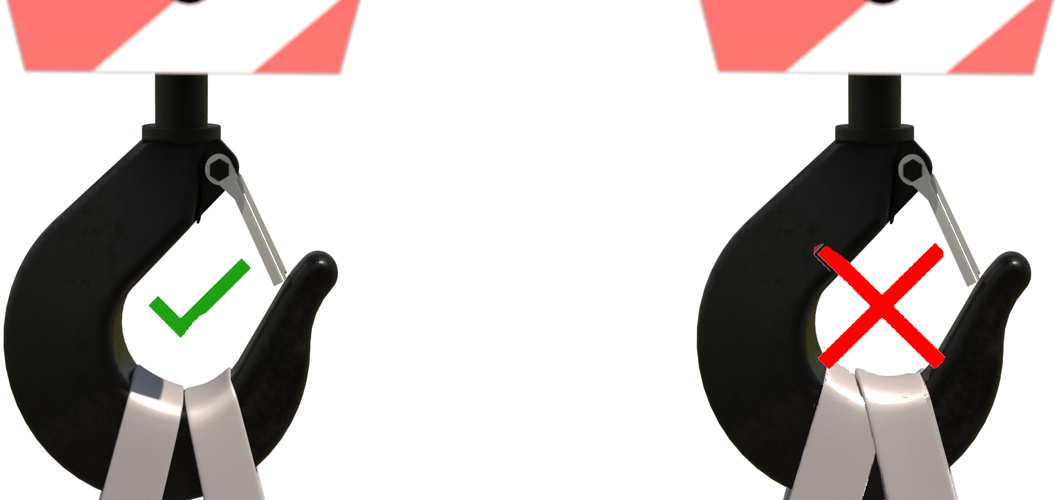Webbing Sling methodology:  If size of hook block allows, then the webbing slings can be directly attached.  DO NOT OVERCROWD THE BLOCK  Pipe Lifting Chain Sling methodology:  If the master ring of the pipe lifting chain set does not have a correct seating arrangement to the ‘bowl ‘of the hook of the crane, then a suitably sized shackle of sufficient WLL can be used between hook block of crane and master ring.
Safe lifting considerations: | - Ensure the pipe lifting chain sling master ring is of sufficient size to attach to the ‘bowl’ of the hook of the crane.  - When using pipe lifting chain sets, these should be of low-level lifts only. If required to lift over shoulder height then these operations are subject to a specific risk assessment being authored and should be performed in a sterile area i.e., restricted zones with physically barriered exclusion zones that are suitably marshalled, and sign posted.  - All lifts with pipe lifting chain sets are to be of a slow and steady manner.  - During the test lift check underside of the pipe for any adhered materials.  - Place accessories to suit a level load.  - Check pipe for any cracks or signs of damage that could affect the integrity of the pipe.  - When landing the pipe for storage ensure that suitably sized timbers or spacers chocks are employed to negate having to drag accessories from under the load.  - Employ stop blocks or similar to base/bottom the load to stop any rolling after accessories have been removed.

Loads description: Clay pipe [drainage] - Bundle
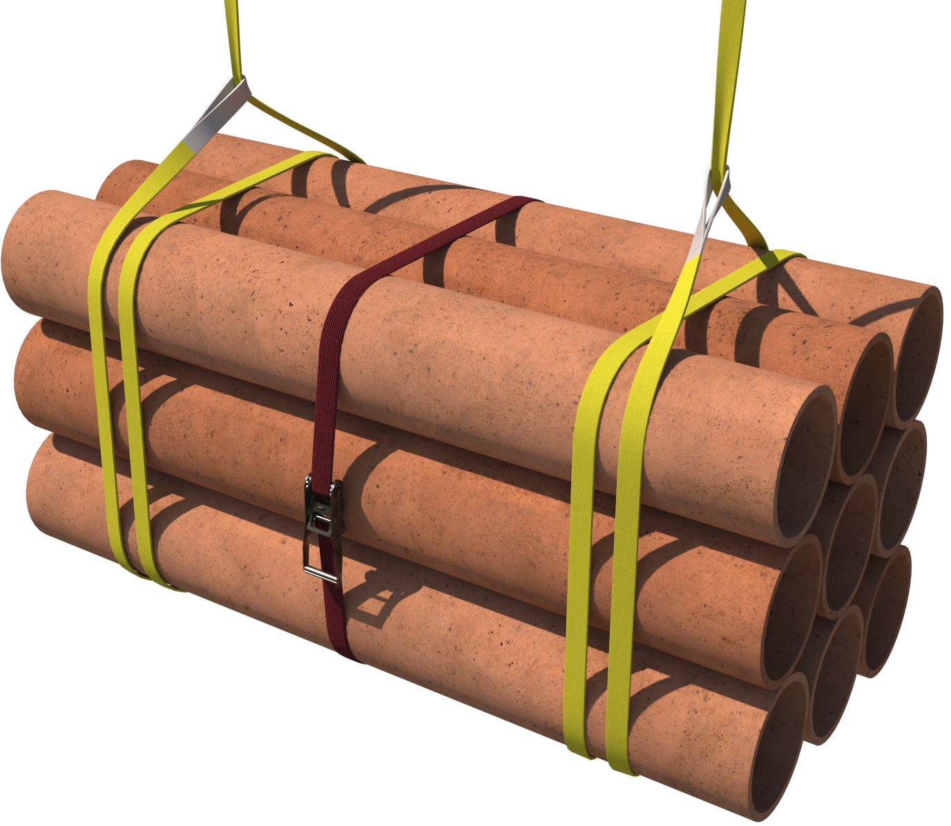 |  | Slinging methodology:  - 4 leg chain slings will be attached to hook block of the crane. 2 legs in use so hang the unused chains back to the master ring.  - 2no. webbing slings min WLL 2 t of sufficient length will be attached to the stillage in a double wrap – choke configuration.  - Hooks of chain slings will then be attached to the webbing slings.
Lift Category: | Basic
Dimensions of load: | Various dimensions: Typically, 1000mm [w] x 1000mm [h] x 2000mm [l] for pack of 9 plain ended pipes. 300mm in diameter @ 2000mm in length @ 78.3kg p/m [ru]
Weight of Load | Typically, 1.41 t [ru] for dimensions and specification given above
Lifting accessories used with weights of accessories: | From hook block >  4 Leg chain slings WLL 8.4 t @ 103kg  ---------------------------------------------  2no webbing slings 8m [l] @ 7kg  Gross weight inc. 10% FOS: _t 1.672 t | WLL x Mode Factor | Resulting SWL
Lifting accessories used with weights of accessories: |  | 4 leg chain slings with 2 legs in use - WLL of one leg multiplied by 1.4 = 4.41 t  -------------------------------------  2 webbing slings used a set in a choke configuration = [WLL of one sling multiplied by 1.4] x .8 = 2.24 t | 2.24 t over accessories stated
Alternative methodology: | If size of hook block allows, then the webbing slings can be directly attached.  DO NOT OVERCROWD THE BLOCK
Safe lifting considerations:  Safe lifting considerations contd.: | - Check underside of pack for any materials that may have adhered themselves during transit or storage.  - Securing banding or ratchet strap to be used around the bundle.  - Check pack for any shorter lengths of pipe that have been put in the pack, if found then ensure they are secure. Additional banding or ratchet strap[s] may be required.  - When slinging ensure that all elements of the load are captured by using securing banding around the pack.  - Check integrity of landed load after removal of accessories in case of collapse.  - Load slung to suit a level load.  - Ensure timber packing is used between levels of pipes to aid integrity & stability of load when landed.  - After the test lift, lower the load to the floor without releasing the weight of the load and, if required, retighten the ratchet strap to ensure integrity of the encasement of the load

Loads description: Steel pipe [drainage] - Bundle
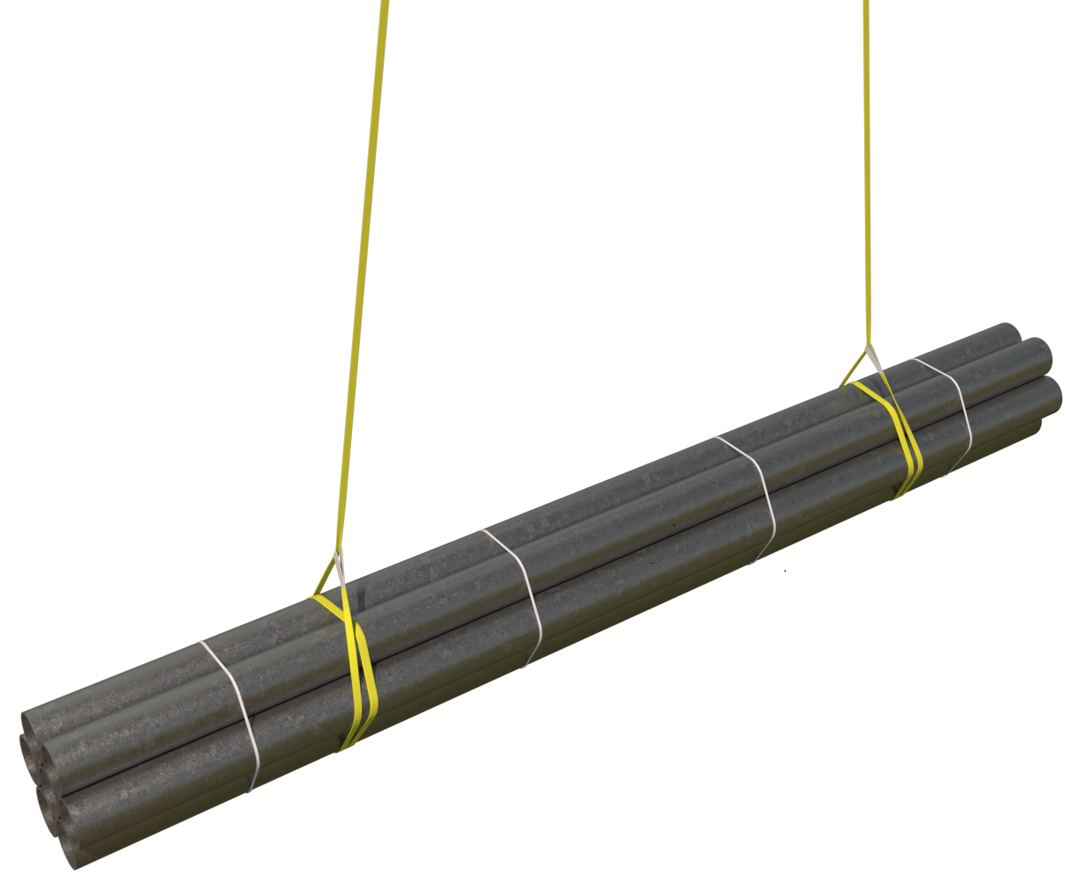 |  | Slinging methodology:  - 4 leg chain slings will be attached to hook block of the crane. 2 legs in use so hang the unused chains back to the master ring.  - 2no. endless webbing slings min WLL 2 t of sufficient length will be attached to the stillage in a double wrap – choke configuration.  - Hooks of chain slings will then be attached to the webbing slings.
Lift Category: | Basic
Dimensions of load: | Various dimension: Typically, 440mm [w] x 440mm [h] x 3000mm [l] for a pack of 16 drainage pipes - Single pipe @ 110mm diameter, 6mm wall thickness and 3000mm in length @ 16.17kg p/m [based on a standard drainage pipe cast in raft slabs]
Weight of Load | Typically, 777 kg [ru] for specification and dimensions above
Lifting accessories used with weights of accessories: | From hook block >  4 Leg chain slings WLL 8.4 t @ 103kg  ---------------------------------------------  2no webbing slings 8m [l] @ 7kg  Gross weight inc. 10% FOS: 976 kg [ru] | WLL x Mode Factor | Resulting SWL
Lifting accessories used with weights of accessories: |  | 4 leg chain slings with 2 legs in use - WLL of one leg multiplied by 1.4 = 4.41 t  -------------------------------------  2 webbing slings used a set in a choke configuration = [WLL of one sling multiplied by 1.4] x .8 = 2.24 t | 2.24 t over accessories stated
Alternative methodology: | If size of hook block allows, then the webbing slings can be directly attached.  DO NOT OVERCROWD THE BLOCK
Safe lifting considerations:  Safe lifting considerations contd.: | - Best practice is to use endless round slings when slinging steel tubes, the slings encase and grip the load better than flatwoven. If using flatwoven, ensure it exerts a force uniformly on to the outside of the bundle, ensuring all items within cannot move around or fall out.  - Check underside of bundle for any materials that may have adhered themselves during transit or storage.  - Securing banding or ratchet strap to be used around the bundle.  - Check bundle for any shorter lengths of pipe that have been put in the pack, if found then ensure they are secure. Additional banding or ratchet strap[s] may be required.  - When slinging ensure that all elements of the load are captured by using securing banding around the bundle.  - Check integrity of landed load after removal of accessories in case of collapse.  - Load slung to suit a level load.  - Ensure timber packing is used between levels of pipes to aid integrity & stability of load when landed.  - After the test lift lower the load to the floor without releasing the weight of the load and, if required, retighten the ratchet strap to ensure integrity of the encasement of the load

Loads description: Scaffolding tubes – Stillages 5’ to 10’ only
Note:  Image is representational only and not to scale for length of scaffold tubes |  | Slinging methodology:  - 4 leg chain slings will be attached to hook block of the crane. 2 legs in use so hang the unused chains back to the master ring.  - 2no. webbing slings min WLL 2 t of sufficient length will be attached to the stillage in a double wrap – choke configuration.  - Hooks of chain slings will then be attached to the webbing slings.
Lift Category: | Basic
Dimensions of load: | Various dimensions but typically: 1020mm [w] x 600mm [h] x Max. 10’ [l]
Weight of Load | Typically, 1 t for a full stillage [based on standard stillage WLL]
Lifting accessories used with weights of accessories: | From hook block >  4 Leg chain slings WLL 8.4 t @ 103kg  ---------------------------------------------  2no webbing slings 8m [l] @ 7kg  Gross weight inc. 10% FOS: 1.23 t [ru] | WLL x Mode Factor | Resulting SWL
Lifting accessories used with weights of accessories: |  | 4 leg chain slings with 2 legs in use - WLL of one leg multiplied by 1.4 = 4.41 t  -------------------------------------  2 webbing slings used a set in a choke configuration = [WLL of one sling multiplied by 1.4] x .8 = 2.24 t | 2.24 t over accessories stated
Alternative methodology: | If size of hook block allows, then the webbing slings  can be directly attached.  DO NOT OVERCROWD THE BLOCK
Safe lifting considerations:  Safe lifting considerations contd.: | - Sling positions to suit a level load.  - Check condition of the stillage prior to lifting.  - Check integrity of the feet to ensure the stillage doesn’t collapse on landing.  - Splits, dents, and creases that could affect the integrity of the structure when slinging?  - Always check the feet of the stillage to just make sure that stones or mud etc./haven’t adhered themselves to the inside of the feet.  - Check inside the confines of the legs for any small objects, length of rebar/Dywidag etc. that could fall out once stillage is raised.  - Ensure that all lengths of the tubes are of similar length and remove any short lengths prior to lifting.  - Ensure that there are no loose tubes that can slide out of the middle of the bundle during the lifting operation.  - Ratchet strap must be employed around the stillage, so it encases the bundle of tubes. After the test lift, lower the stillage to the floor without releasing the weight of the load and, if required, retighten the ratchet strap to ensure integrity of the encasement of the load.
Additional information: | All weights based on 4.5kg per metre and rounded up thru each calculation.  For example:  10’ scaffold tube @ 3.048m so…3.048 x 4.5 = 13.716 ru. to 13.8 x 61 (tubes) = 841.8 kg ru. to 842kg
  Reference weights: | Tube length [m/foot]
   | 1.52m/5’ | 1.829m/6’ | 2.439m/8’ | 3.048m/10’
  1no. tube [kg] | 6.84 kg | 8.24 kg [ru] | 11 kg [ru] | 13.8 kg [ru]
  Bundle of 61no. [kg] | 418 kg [ru] | 503 kg [ru] | 671 kg | 842 kg [ru]

Loads description: Scaffold tubes – Bundles 7’ to 21’ only
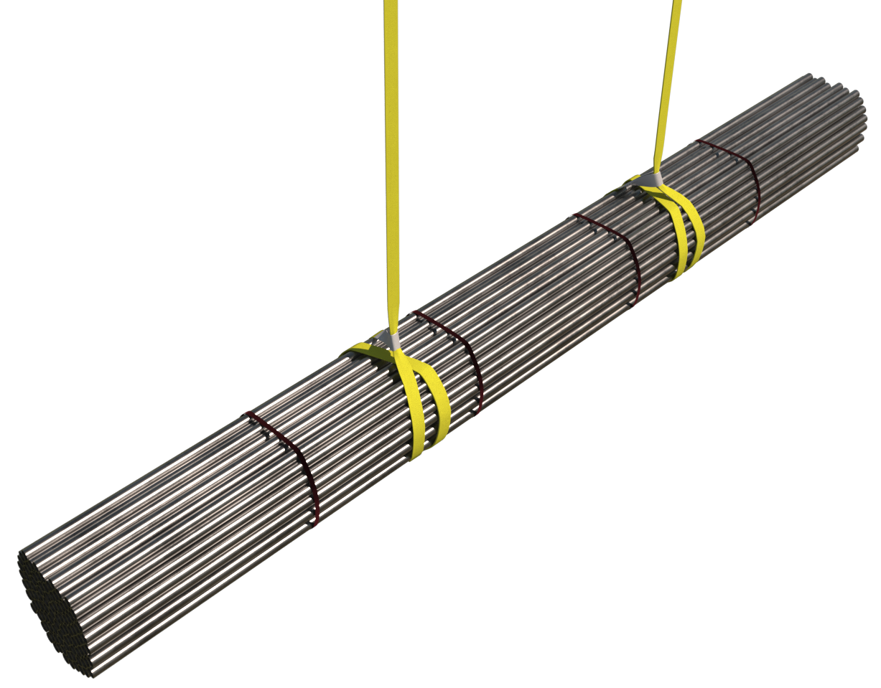 |  | Slinging methodology:  - 4 leg chain slings will be attached to hook block of the crane. 2 legs in use so hang the unused chains back to the master ring.  - 2no. webbing slings min WLL 2 t of sufficient length will be attached to the bundle in a double wrap – choke configuration.  - Hooks of chain slings will then be attached to the webbing slings.
Lift Category: | Basic
Dimensions of load: | Various dimensions: Typically, (for a bundle of 61 x 21’ tubes) 435 mm [w] x 6410 mm [21’] [l] x 435 mm [h]
Weight of Load | Typically, 1.72 t [wcs] for a pack of 61 x 21’ tubes
Lifting accessories used with weights of accessories: | From hook block >  4 Leg chain slings WLL 8.4 t @ 103kg  ---------------------------------------------  2no. webbing slings @ min 3.5m (l) @ 5kg  Gross weight inc. 10% FOS: 2.1 t [ru] | WLL x Mode Factor | Resulting SWL
Lifting accessories used with weights of accessories: |  | 4 leg chain slings with 2 legs in use - WLL of one leg multiplied by 1.4 = 4.41 t  -------------------------------------  2 webbing slings used a set in a choke configuration = [WLL of one sling multiplied by 1.4] x .8 = 2.24 t | 2.24 t over accessories stated
Alternative methodology: | If size of hook block allows, then the webbing slings can be directly attached.  DO NOT OVERCROWD THE BLOCK
Safe lifting considerations:  Safe lifting considerations contd. | - Best practice is to use endless round slings when slinging scaffold tubes, the slings encase and grip the load better than flatwoven.  If using flatwoven, ensure it exerts a force uniformly on to the outside of the bundle, ensuring all items within cannot move around or fall out.  - When slinging the scaffold tubes with webbing slings, keep the length of the slings down to a minimum. With other bundled loads, longer slings are required to enable a double wrap. With scaffold tubes, the circumference of a manufacturer’s bundle of 61 tubes is approx. 1.74m so to enable a double wrap only 3.5m of sling is required. Keeping the slings to a minimum will help negate the swing of the load.  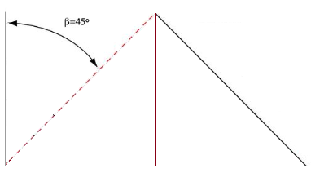Special note:  When directly attaching webbing slings to the block, the length of the slings must be sufficient to keep within a 0 to 45 deg. excluded angle.  - Ensure that all lengths of the tubes are of similar length and remove any short lengths prior to lifting.  - Place slings to suit a level load.  - Securing banding or ratchet strap to be used around the bundle.
Additional information: | All weights based on 4.5kg per metre and rounded up thru each calculation.  For example:  10’ scaffold tube @ 3.048m so… 3.048 x 4.5 = 13.716 ru. to 13.8 x 61 (tubes) = 841.8 kg ru. to 842kg
  Reference weights: | Tube length [m/foot]
   | 1.52m/5’ | 1.829m/6’ | 2.439m/8’ | 3.048m/10’
  1no. tube [kg] | 6.84 kg | 8.24 kg [ru] | 11 kg [ru] | 13.8 kg [ru]
  Bundle of 61no. [kg] | 418 kg [ru] | 503 kg [ru] | 671 kg | 842 kg [ru]

Loads description: Site plant – Mobile tower lights
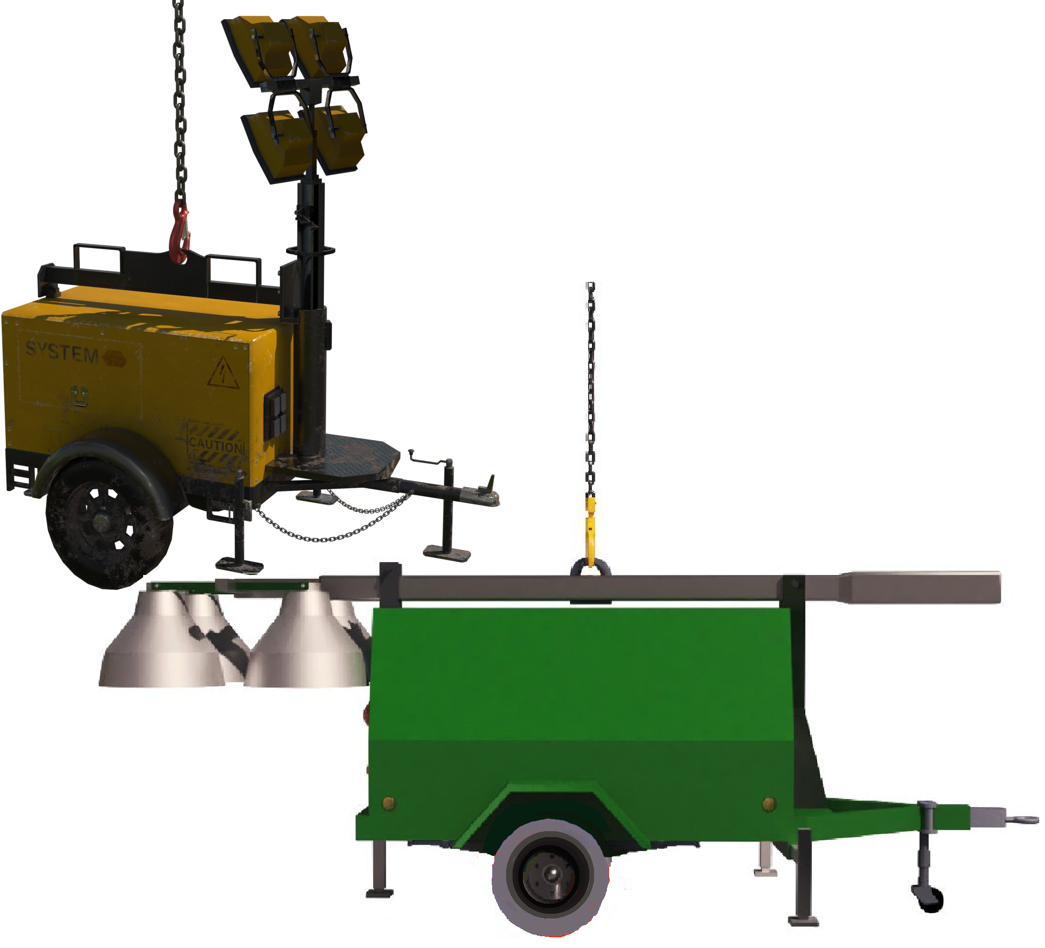 |  | Slinging methodology:  - Configure the lighting set mast for lifting as per manufacturer’s instructions.  - Attach single leg chain sling to hook block of the crane.  - 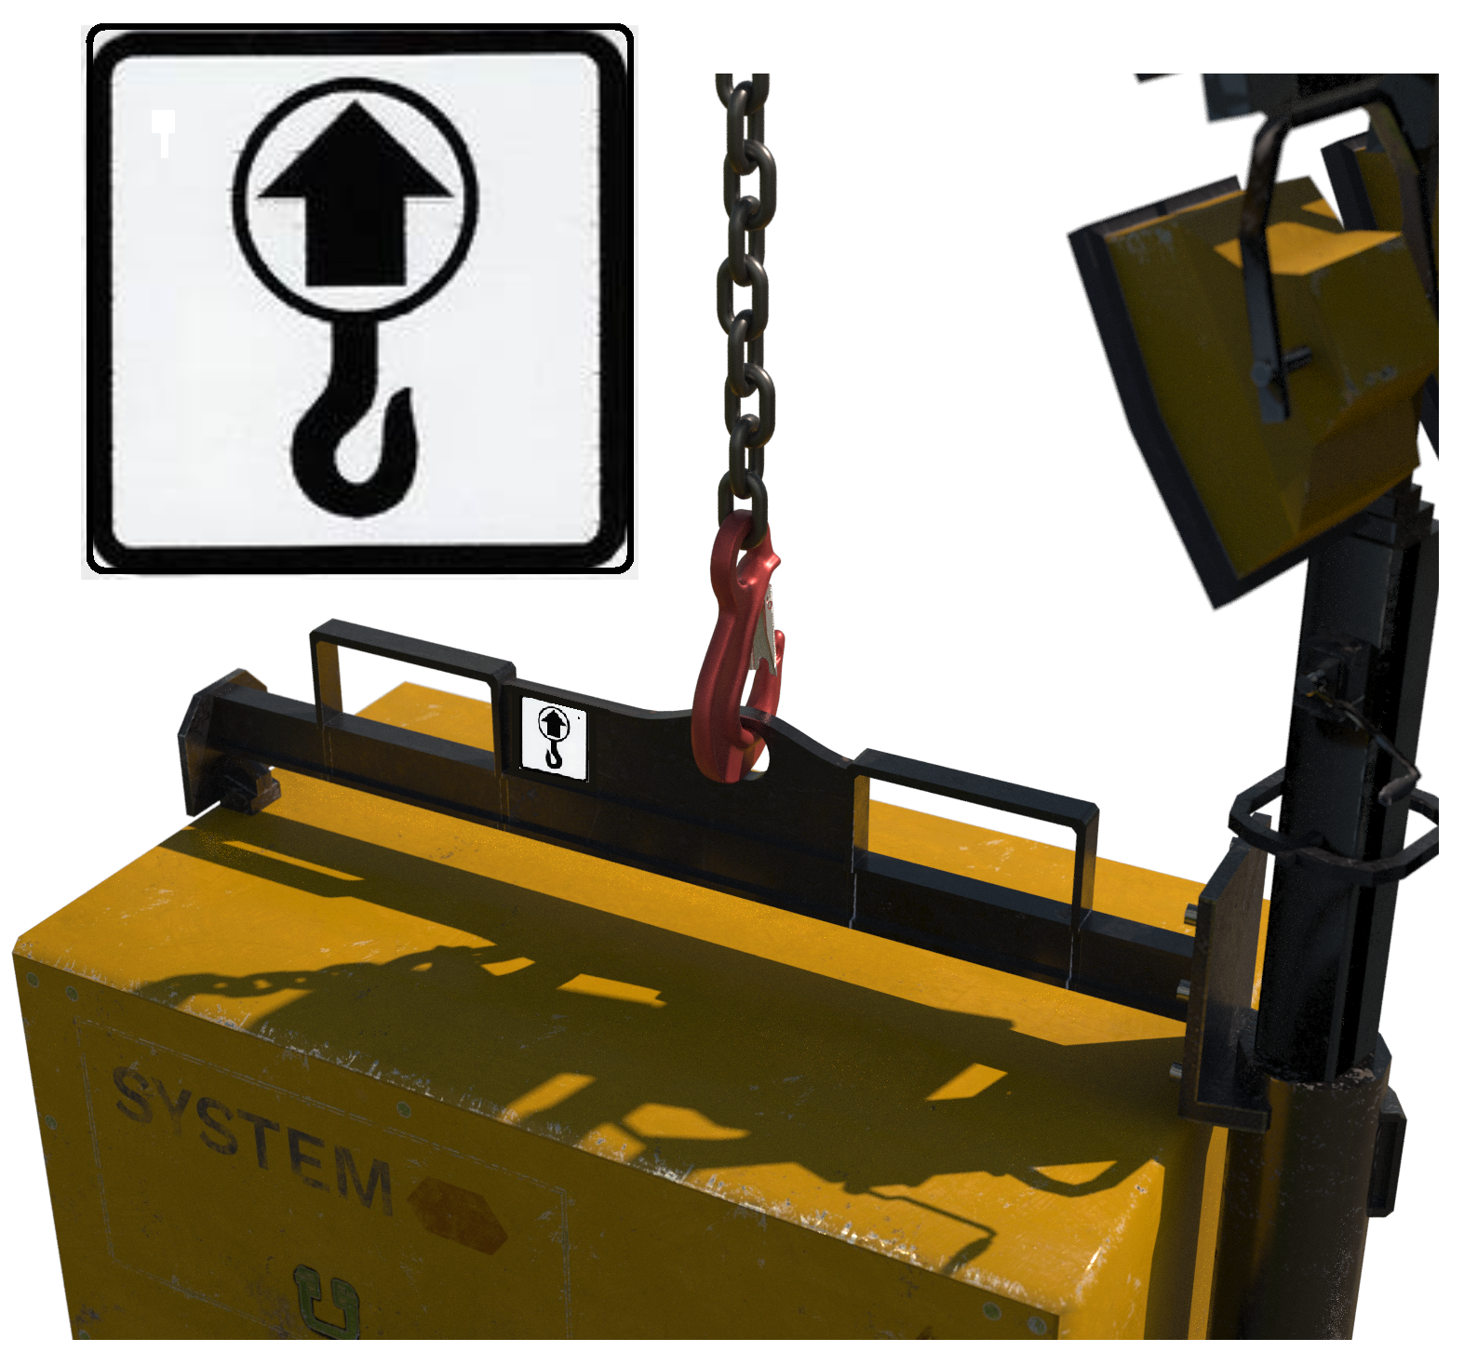Attach hook of chain sling to the identified lifting point of the anchor point.  Please note:  Lifting points are usually identified by the mark shown opposite  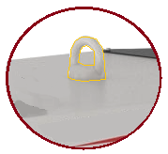Where lifting points are not marked then consult the operating manual – see opposite for typical non - marked lifting point.
Lift Category: | Basic
Dimensions of load: | Various dimensions but typically: 1380mm [w] x 2420mm [h] x 2320mm [l]
Weight of Load | Typically, 1 t for dimensions given
Lifting accessories used with weights of accessories: | From hook block >  Single leg chain sling WLL 2 t @ 25 kg  Gross weight inc. 10% FOS: 1.128 t [ru] | WLL x Mode Factor | Resulting SWL
Lifting accessories used with weights of accessories: |  | Single leg chain sling as per designed use | 2 t over accessories stated
Alternative methodology: | Single leg of a multileg chain sling of sufficient WLL can be used with the unused legs hung back to the master ring.
Safe lifting considerations: | - 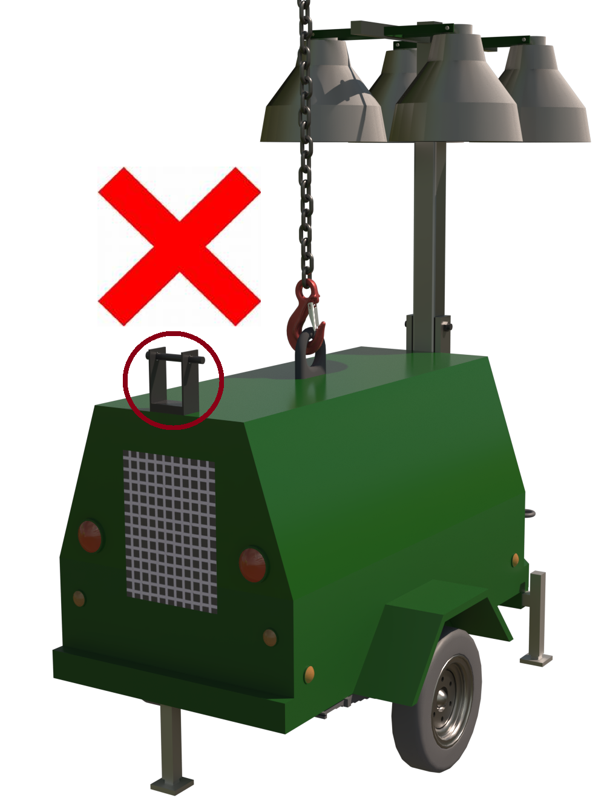Prior to lifting check all jockey wheels and outriggers [If applicable] are secure.  - Check housing of the lighting set for any loose materials or tools that could be stored within.  - Check engine compartment for oil or fuel leaks  - Check mast section is locked and configured for lifting. Do not lift without the mast section detracted or suitably stowed as per manufacturer’s instructions  - 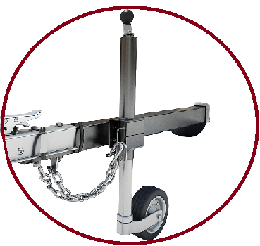Check jockey wheel condition to allow safe landing of the lighting set  - Check glass on light frames to ensure there are no cracks that could affect the integrity of the housing of the glass once lifted.  - Check integrity of the lifting point for deformities.

Loads description: Site plant - Compressors
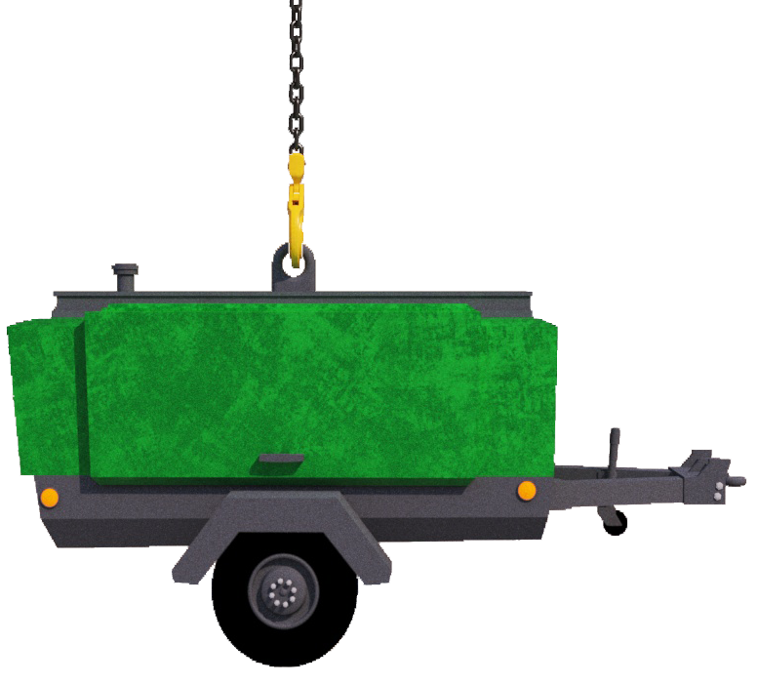 |  | Slinging methodology:  - Attach single leg chain sling to hook block of the crane.  - Attach hook of chain sling to the integral lifting point of the compressor anchor point.
Lift Category: | Basic
Dimensions of load: | Various dimensions: Typically, 1700mm [w] x 1545mm [h] x 3565mm [l] for 4 tool compressor
Weight of Load | Typically, 1.3 t for 4 tool compressor
Lifting accessories used with weights of accessories: | From hook block >  Single leg chain sling WLL 2 t @ 25kg  Gross weight inc. 10% FOS: 1.458 t [ru] | WLL x Mode Factor | Resulting SWL
Lifting accessories used with weights of accessories: |  | Single leg chain sling as per designed use | 2 t over accessories stated
Alternative methodology: | Single leg of a multileg chain sling of sufficient WLL can be used with the unused legs hung back to the master ring.  Special note:  Where the lifting point appears to be corroded / unsound for lifting, consult the lifting supervisor / appointed person to assess lifting with chains / slings around the chassis.
Safe lifting considerations: | 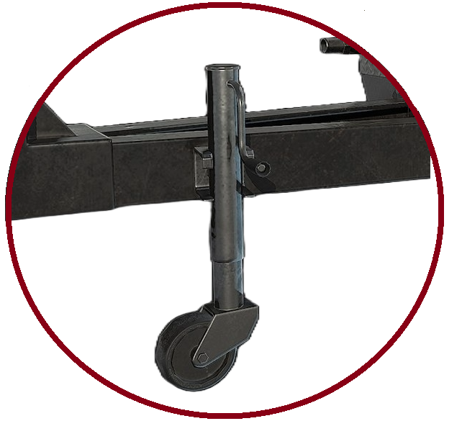  - Prior to lifting check jockey wheel is secure.  - Check jockey wheel condition to allow safe landing of the compressor.  - Check housing of the lighting set for any loose materials or tools that could be stored within.  - Check compressor for oil or fuel leaks- Utilize a ‘plant nappy’ under the compressor once landed safely.  - Check integrity of the lifting point for deformities.  - Ensure compressor is switched off.  - Do not lift with any coiled hoses attached to the structure of the compressor

Loads description: Site plant – Welding set generator
Slinging methodology:

- Attach single leg chain sling to hook block of the crane.

- Attach hook of chain sling to the integral lifting point of the compressor anchor point.

.
Lift Category: | Basic
Dimensions of load: | Various dimensions: Typically, 785 mm [w] x 890 mm [h] x 1270 mm [l]
Weight of Load | Typically, 250 kg for dimensions given
Lifting accessories used with weights of accessories: | From hook block >  Single leg chain sling WLL 2 t @ 25kg  Gross weight inc. 10% FOS: 303kg [ru] | WLL x Mode Factor | Resulting SWL
Lifting accessories used with weights of accessories: |  | Single leg chain sling as per designed use | 2 t over accessories stated
Alternative methodology: | Single leg of a multileg chain sling of sufficient WLL can be used with the unused legs hung back to the master ring.  Special note:  Where the lifting point appears to be corroded / unsound for lifting, consult the lifting supervisor / appointed person to assess lifting with chains / slings around the chassis.
Safe lifting considerations: | - 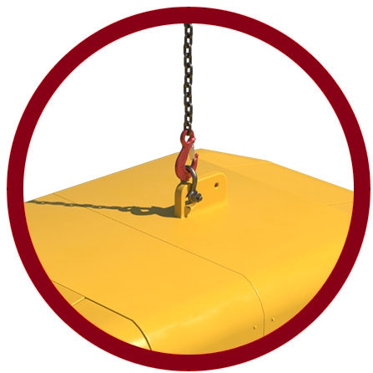Check integrity of the lifting point for any deformities.  - Check that the hook of the chain sling fits into the lifting point, if needed a bow shackle of a suitable WLL can be employed between the hook of the chain sling and the attachment point.  - Ensure that all compartments are secure and that any cables are either secured or removed prior to lifting.  - Check generator for oil or fuel leaks – Utilize a ‘plant nappy’ under the generator once landed safely.  - Check generator is switched off.

Loads description: Site plant – Compactor plate
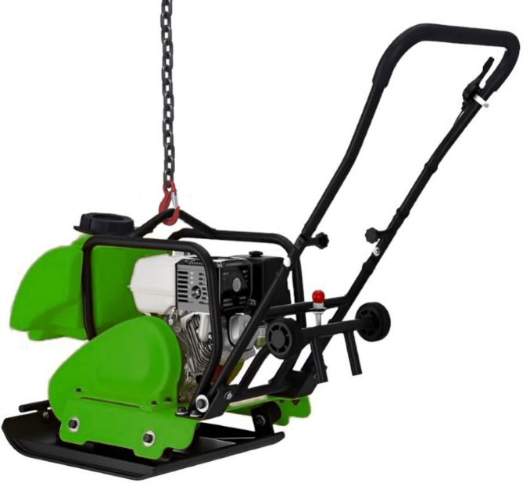 |  | Slinging methodology:  - Attach single leg chain sling to hook block of the crane.  - Attach hook of chain sling to the integral lifting point of the compactor plate
Lift Category: | Basic
Dimensions of load: | Various dimensions: Typically, 600 mm [w] x 1264 mm [h] x 809 mm[l] overall length with handle up
Weight of Load | Typically, 200kg for dimensions given
Lifting accessories used with weights of accessories: | From hook block >  Single leg chain sling WLL 1.4 t @ 25 kg  Gross weight inc. 10% FOS: 248 kg [ru] | WLL x Mode Factor | Resulting SWL
Lifting accessories used with weights of accessories: |  | Single leg chain sling as per designed use | 1.4 t over accessories stated
Alternative methodology: | Single leg of a multileg chain sling of sufficient WLL can be used with the unused legs hung back to the master ring.
Safe lifting considerations: | - Check compactor to ensure that all components are secure.  - Ensure centre of gravity prior to lifting.  - Check integral lifting eye for deformities.  - Ensure the compactor is free from oil and fuel leaks.  - Check the ‘plate’ for any loose stones or mud that could fall when lifted.  - Ensure the compactor is turned off.

Loads description: Site plant – Drum Roller
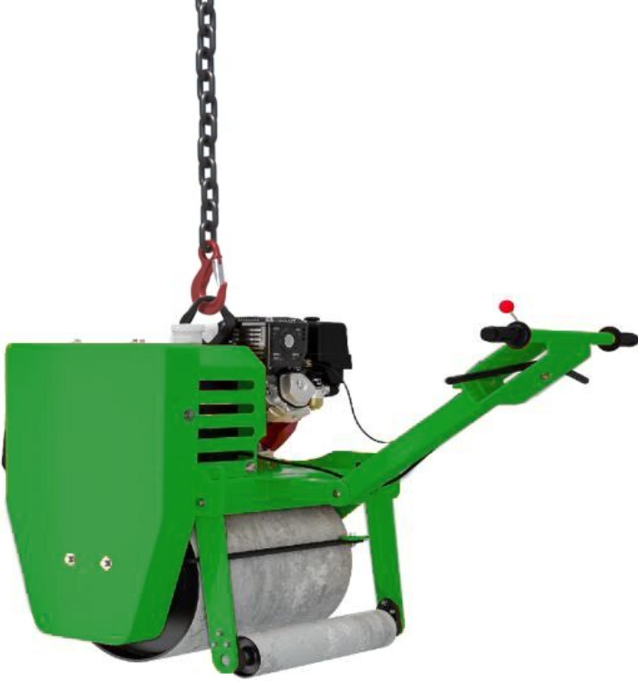 |  | Slinging methodology:  - Attach single leg chain sling to hook block of the crane.  - Attach hook of chain sling to the integral lifting point of the compactor plate
Lift Category: | Basic
Dimensions of load: | Various dimensions: Typically, 770 mm [w] x 1220 mm [h] x 870 mm [l]
Weight of Load | Typically, 266 kg for dimensions given
Lifting accessories used with weights of accessories: | From hook block >  Single leg chain sling WLL 1.4 t @ 25kg  Gross weight inc. 10% FOS: 321 kg [ru] | WLL x Mode Factor | Resulting SWL
Lifting accessories used with weights of accessories: |  | Single leg chain sling as per designed use | 1.4 t over accessories stated
Alternative methodology: | Single leg of a multileg chain sling of sufficient WLL can be used with the unused legs hung back to the master ring.
Safe lifting considerations: | - Check roller structure to ensure that all components are secure.  - Ensure centre of gravity prior to lifting.  - Check integral lifting eye for deformities.  - Ensure the roller is free from oil and fuel leaks.  - Check the ‘rollers’ for any loose stones or mud that could fall when lifted.  - Ensure the roller is turned off.

Loads description: Site plant – Power trowel [float]
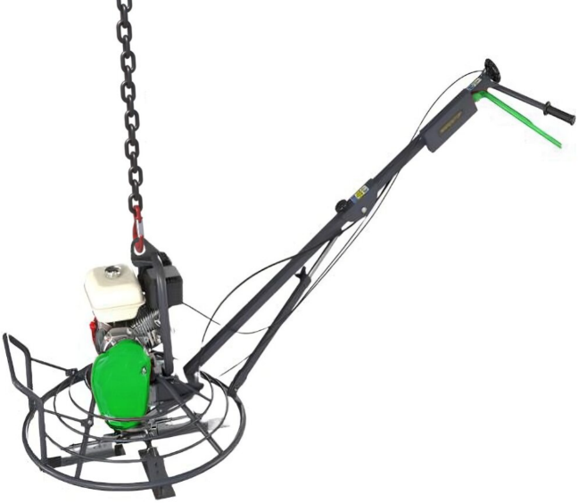 |  | Slinging methodology:  - Attach single leg chain sling to hook block of the crane.  - Attach hook of chain sling to the integral lifting point of the power trowel  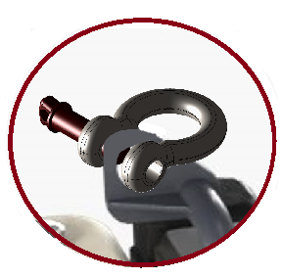  Please note:  Ensure the hook of the chain sling fits the lifting aperture. If required a bow shackle of a suitable WLL can be used to ensure integrity of attachment
Lift Category: | Basic
Dimensions of load: | Various dimensions: Typically, __mm [d] x __mm [h] x __mm [l]
Weight of Load | Typically, ___kg for dimensions given
Lifting accessories used with weights of accessories: | From hook block >  Single leg chain sling WLL 1.4 t @ 25 kg  Gross weight inc. 10% FOS: ____kg / t [ru] | WLL x Mode Factor | Resulting SWL
Lifting accessories used with weights of accessories: |  | Single leg chain sling as per designed use | 1.4 t over accessories stated
Alternative methodology: | Single leg of a multileg chain sling of sufficient WLL can be used with the unused legs hung back to the master ring.  Please note:  Some power trowels have multi-lifting eyes around the circumference of the blade housing framework; therefore, a multi-leg chain sling must be employed of the sufficient WLL. Consult the operator’s manual for correct configuration of the lifting arrangement.  Any unused chains are to be hung back to the master ring
Safe lifting considerations: | - Check power trowel structure to ensure that all components are secure.  - Check integral lifting eye for deformities.  - Ensure the power trowel is free from oil and fuel leaks.  - Check the ‘blades’ for any loose stones or mud that could fall when lifted.  - Ensure the power trowel is turned off

Loads description: Template
Slinging methodology:

.
Lift Category: | Basic | Intermediate |  | Complex
Dimensions of load:
Weight of Load
Lifting accessories used with weights of accessories: | From hook block >  Gross weight inc. 10% FOS: t [ru] |  | WLL x Mode Factor |  | Resulting SWL
Lifting accessories used with weights of accessories: |  |  |  |  | over accessories stated
Alternative methodology:
Safe lifting considerations:

