Schedule of lifts for Tower Crane
A practical guidance – 1: Intro Section
Revision 1 September ‘25

Contents:
1. | Introduction ……………………………………………………………………… 2
2. | Acronyms used through the document ……………………………………….. 2
3. | Requirements of a schedule ……………………………………………………. 3
4. | Lift classifications ……………………………………………………………….. 3
5. | Lifting information alerts ……………………………………………………..... 3
6. | Notes on accessories ……………………………………………………………. 4
7. | Ratings charts ………………………………………………………………….... 4
8. | Communications ………………………………………………………………... 6
9. | Wind Assessment ……………………………………………………………….. 11
10. | General safe considerations …………………………………………………… 12

Please note:
This document has been provided by Sir Robert McAlpine Limited. It has been checked to the best of our ability but may contain unintentional errors. As per BS 7121-1:2016, CDM 2015 and LOLER, it is the user’s responsibility to verify that they understand and have made their own checks before using this document.
The user shall ensure that they properly risk assess and plan their own lifting operations to discharge their legal requirements.
No liability will be accepted for any incidents that result of those using this document.

- Introduction:

This document has been produced to not only assist and provide guidance on industry accepted methodologies for tower crane lifting operations but also to provide a simple benchmark template that is easy to complete, containing all required information for a schedule of lifts.

All weights & dimensions in the schedules are representative only of standard/common measures throughout the industry and are shown in red italicized text. Where specific lifts exceed any of these then simply adjust gross weights, WLL of accessories and considered mode factors as necessary to perform the lifting operation in a safe manner.

The document follows the LEEA convention of 1000kg is equivalent to 1 tonne and the unit used is ‘t’. Where weights are < 1 t then the unit used will be kg.

Where underscores are used instead of numeric symbols i.e., _ t or _ mm then these are to be completed locally as the variation in the dimensions and weights [net or gross] are too great to cover generically in this document.

Please be aware that this document is not intended to replace appropriate planning of lifting operations by an appointed person. All lifting operations must be planned and managed by a competent person. The document is only to be used by people who have the appropriate training and competence for lift planning operations

Additionally, sector specific working restrictions have not been considered, e.g. exceptional hazard sites (nuclear, petrochemical etc.), working adjacent to railways etc.

The weight and geometry of loads has not been assessed in relation to any maximum safe wind speeds for the lifting operation (i.e. any sail effects on the loads).

Revision note:

This document’s focus, as the title suggests, is for lifting operations with tower cranes but can easily be adjusted to suit mobile/tracked crane operations.

While mobile/tracked cranes have their own specific considerations when formulating a schedule of lifts, i.e. the need for the inclusion of hook blocks, falls or rope etc. in the load weight, the methodologies shown through the schedule would, for the most part remain the same, so making the schedule document a useful tool for the Appointed Person when planning.

- Acronyms used through the document:

- FOS – Factor of Safety  - SWL – Safe Working Load  - WLL – Working Load Limit  - wcs – Worst [worse] Case Scenario  - [ru] – Rounded up  - t – Tonne  - kg – Kilogram[s]  - c/w – Complete with  - Min. – Minimum  - EWL - Effective Working Length  - DABs – Daily activity briefings | - [l] – Length  - [h] - Height  - [w] – Width  - [d] – Diameter  - Inc. – Including or inclusive of  - no. – Number  - mm – Millimetre  - m – Metre  - RoTE – Report of thorough examination  - @ - at /of  - POWRA – Point of work risk assessment

- Requirements of a Schedule:

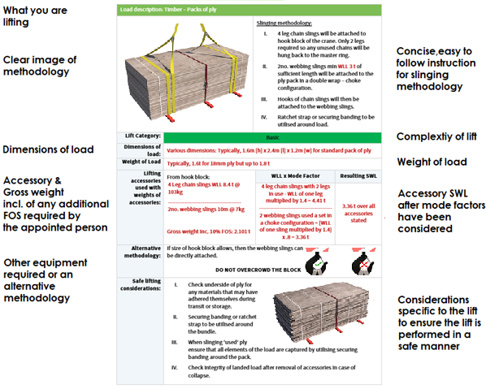
- Lift classifications:
The lift classifications stated throughout the document are based on all lifts being performed in full view of the crane operator with known weights, and for the simplest of lifting arrangements used.

The planning appointed person should assess each lift and classify accordingly to suit local lifting operation parameters.

Please note:
Lifting operations that are basic can be undertaken once the slinger-signaller has been briefed on the contents of the lift plan and has signed up to it. Intermediate lifting operations should only commence when the lifting supervisor is present until confident of the slinger-signaller's ability and the uniformity of the load being lifted. Complex lifting operations will require the Lifting Supervisor to be present at point of lift to monitor the lifting operation with the appointed person present on the project to brief the lifting operation to be performed.

Refer to: BS 7121 – 1: 2016 4.3.2 for guidance
- Notes on accessories:
It is assumed that Grade 10 8.4 t 4 leg chain slings with an EWL of 6m will be used as standard on the tower crane and therefore have been referenced throughout the lifting arrangements.

Where accessories are identified in the schedule ‘as per design use’, it is assumed that suitable FOS’s have been designed into the accessory and as such need no further mode factors employed for that accessory.

When choosing accessories ensure that after mode factors have been used, the accessory is not used past 90% utilisation for the weight of load to be lifted. This produces a 10% safety margin which the user may choose to increase.

All accessory lengths given are so that the accessory is used within an ‘excluded’ angle of 0-45 Deg.[off

the ]

- Ratings charts:

Flatwoven/ Endless round slings

Ratings for single and multi-leg use of flat woven slings and endless round slings within 90 Deg.
Please note:
SWL for ‘Choker’ hitch mode factors in each configuration given are shown in and have been reduced by the required 0.8 factor.

Flatwoven
Straight lift with direct attachment  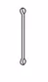 | 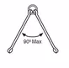  2 slings Direct attachment | 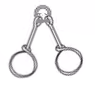  2 slings Choked | 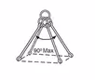  3 or 4 slings with Direct attachment | 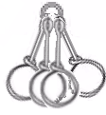  3 or 4 slings Choked
Endless (round)
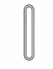 | 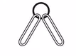 | 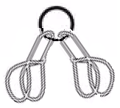 | 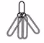 | 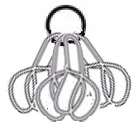
1 t | 1.4 t | 1.12 t | 2.1 t | 1.68 t
2 t | 2.8 t | 2.24 t | 4.2 t | 3.36 t
3 t | 4.2 t | 3.36 t | 6.3 t | 5.04 t
4 t | 5.6 t | 4.48 t | 8.4 t | 6.72 t
5 t | 7 t | 5.6 t | 10.5 t | 8.4 t
6 t | 8.4 t | 6.72 t | 12.6 t | 10.08 t
8 t | 11.2 t | 8.96 t | 16.8 t | 13.44 t
10 t | 14 t | 11.2 t | 21 t | 16.8 t

Grade 8 chain slings

Ratings for single and multi-leg chain slings within 60 Deg. Grade 8 chains slings
Please note:
SWL for ‘Choker’ hitch mode factors in each configuration given are shown in and have been reduced by the required 0.8 factor

Chain sling details and configuration chart
Chain  Diameter | 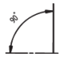  Straight lift with direct attachment | 2 slings Direct attachment  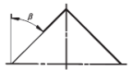 |  | 3 or 4 slings with Direct attachment  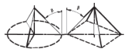
Chain  Diameter |  | Angle of leg from vertical |  | Angle of leg from vertical
Chain  Diameter |  | 0-45 deg. | 45-60 deg. | 0-45 deg. | 45-60 deg.
7mm | 1.5 t | 2.12 t | 1.5 t | 3.15t t | 2.24 t
7mm | 1.2 t | 1.69 t | 1.2 t | 2.52 t | 1.79 t
8mm | 2 t | 2.8 t | 2 t | 4.2 t | 3 t
8mm | 1.6 t | 2.24 t | 1.6 t | 3.36 t | 2.4 t
10mm | 3.15 t | 4.25 t | 3.15 t | 6.7 t | 4.75 t
10mm | 2.52 t | 3.4 t | 2.52 t | 5.36 t | 3.8 t
13mm | 5.3 t | 7.5 t | 5.3 t | 11.2 t | 8 t
13mm | 4.24 t | 6 t | 4.24 t | 8.96 t | 6.4 t
16mm | 8 t | 11.2 t | 8 t | 17 t | 11.8 t
16mm | 6.4 t | 8.96 t | 6.4 t | 13.6 t | 9.44 t
19mm | 11.2 t | 17 t | 11.2 t | 23.6 t | 17 t
19mm | 8.96 t | 13.6 t | 8.96 t | 18.88 t | 13.6 t

Grade 10 chain slings

Ratings for single and multi-leg chain slings within 60 Deg. Grade 10 chain slings
Please note:
SWL for ‘Choker’ hitch mode factors in each configuration given are shown in and have been reduced by the required 0.8 factor

Chain sling details and configuration chart – Grade 10 Chains
Chain  Diameter | Straight lift with direct attachment | 2 slings Direct attachment |  | 3 or 4 slings with Direct attachment
Chain  Diameter |  | Angle of leg from vertical |  | Angle of leg from vertical
Chain  Diameter |  | 0-45 deg. | 45-60 deg. | 0-45 deg. | 45-60 deg.
6mm | 1.4 t | 2 t | 1.4 t | 2.9 t | 2.1 t
6mm | 1.12 t | 1.6 t | 1.12 t | 2.32 t | 1.68 t
8mm | 2.5 t | 3.5 t | 2.5 t | 5.3 t | 3.8 t
8mm | 2 t | 2.8 t | 2 t | 4.24 t | 3.04 t
10mm | 4 t | 5.6 t | 4 t | 8.4 t | 6 te.
10mm | 3.15 t | 4.48 t | 3.2 t | 6.72 t | 4.8 t
13mm | 6.7 t | 10.6 t | 9.5 t | 14 t | 10 t
13mm | 5.3 t | 8.48 t | 7.6 t | 11.2 t | 8 t
16mm | 10 t | 14 t | 10 t | 21 t | 15 t
16mm | 8 t | 11.2 t | 8 t | 16.8 t | 12 t
20mm | 16 t | 22.4 t | 16 t | 33.6 t | 24 t
20mm | 12.8 t | 17.92 t | 12.8 t | 26.88 t | 19.2 t

- Communications:
Note: The hand signals in the following pages are CGI representational of those found in BS 7121
Primary communication used for tower crane operations will be via radios. (See 4C’s of communication guidance following the graphics of the hand signals to be used)

See link to CPA TIN 017 for detailed information regarding the correct selection and use of.

In case of failure of radios then the following hand signals will be used to communicate with the tower crane operator

Hand signals:

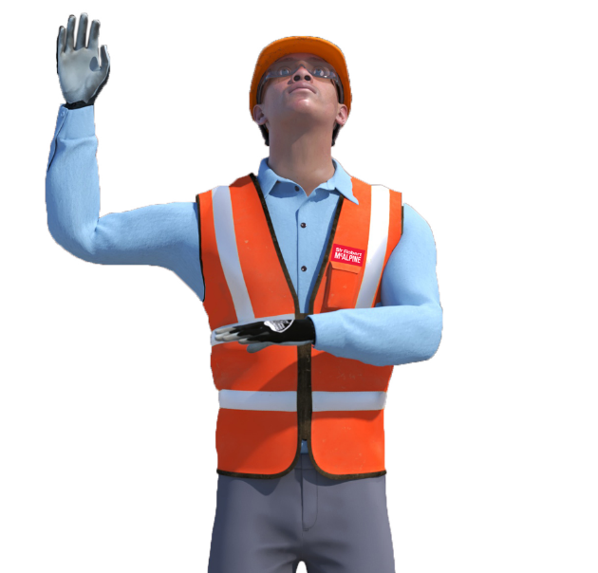
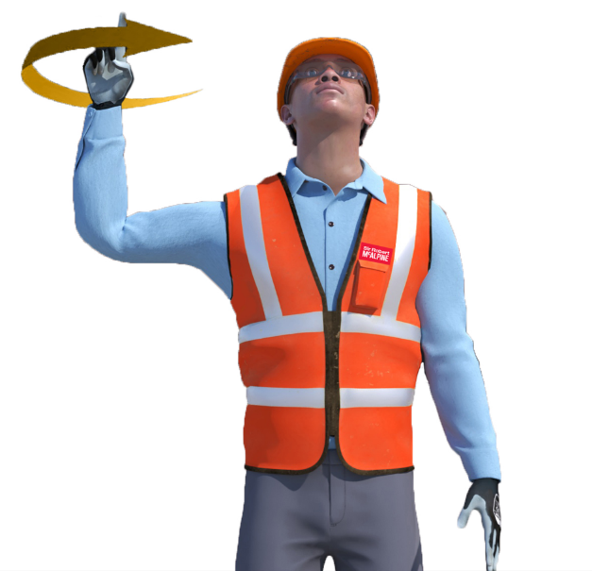
Hoist:
To hoist the load, the slinger-signaller should raise a fist above the head with their index finger pointed upwards, spinning in small circles.
Operations start:
The slinger-signaller should raise their right hand with palm facing forward with the other hand perpendicular to the torso, palm down.

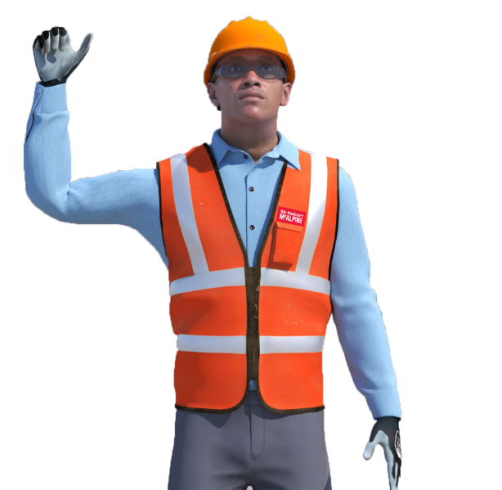
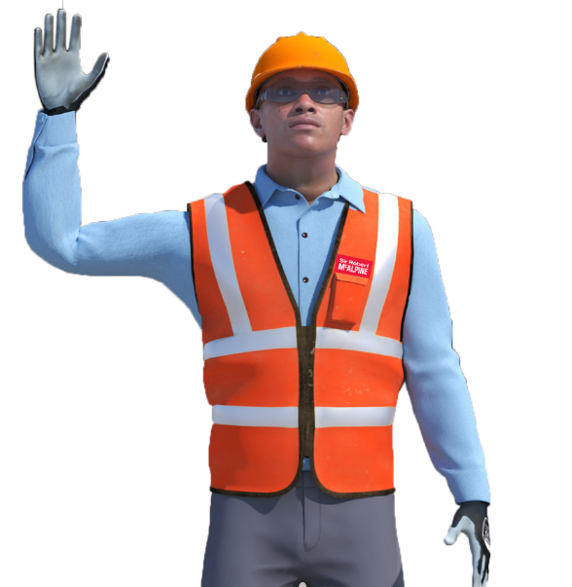

Hand unclenched
Hand clenched

‘Inch’ the load:
‘Inching’ the load refers to slowly lifting the load.
To inch the load the slinger-signaller will raise their hand to head height & will clench and unclench their fist.

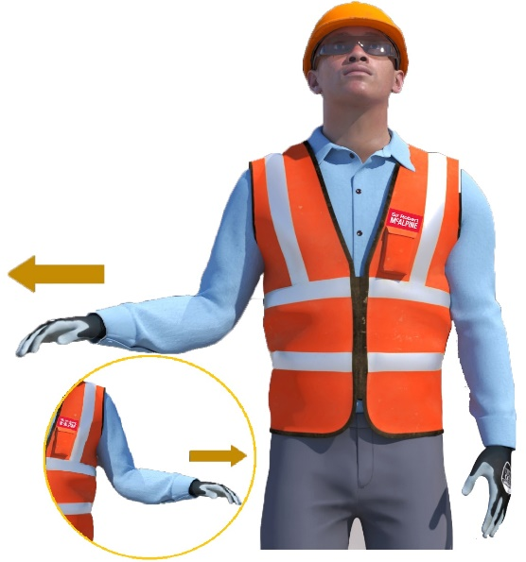
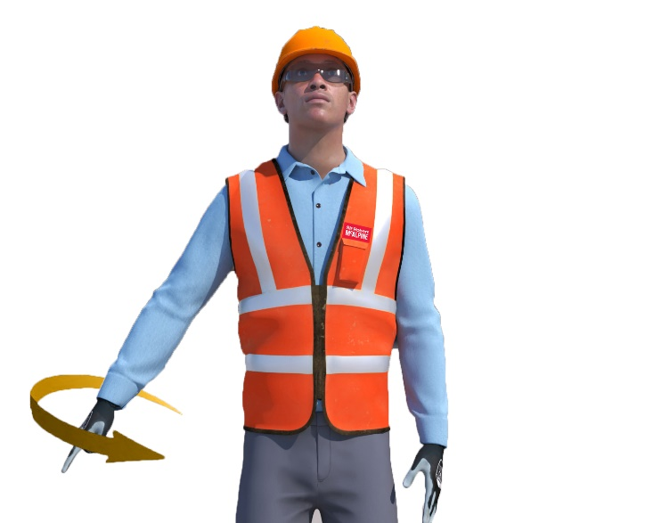
Hand signals:

Slew in direction indicated:
To instruct the crane operator to slew the crane, the slinger-signaller should raise their forearm from the side of their body and holding the handout at elbow height with the palm facing downwards in left or right motion.
Lower steady:
To instruct the crane operator to lower the load at a steady rate, hold one arm down against the side of the body. Extend the other arm to the side of the body @ approx. 45 deg., hand closed, index finger pointing downwards & make circular movements with the forearm.

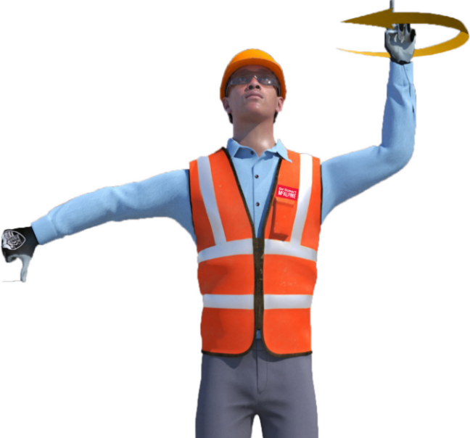
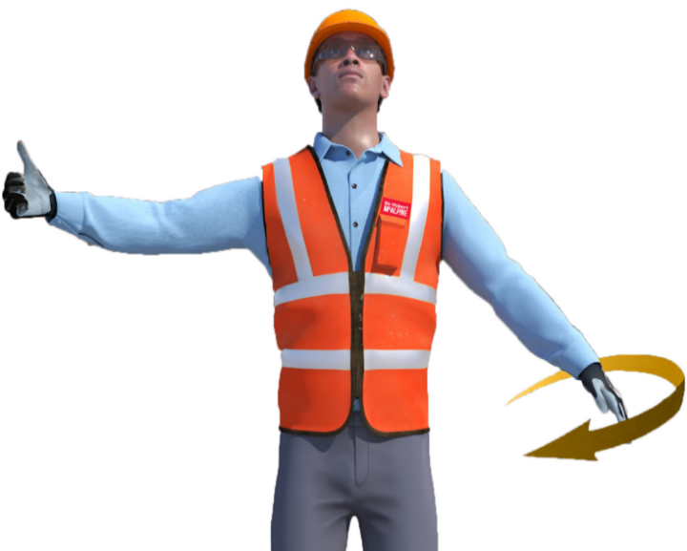
‘Luffing’ jib only signal:
Raising boom while lowering load:
‘Floating the load’
To instruct the crane operator to maintain the height of the load while raising the boom i.e., bringing the load towards the crane. Extend one arm to the side with hand clenched and thumb pointing upwards and extend the other arm to the side of the body @ 45 deg., hand closed, index finger pointing downwards while making circular movements with the forearm.
Lowering boom while raising load:
‘Floating the load’
To instruct the crane operator to maintain the height of the load while lowering the boom i.e., sending the load away from the crane. Extend one arm to the side with hand clenched and thumb pointing downwards, while raising the other arm above shoulder height with hand clenched and index finger pointed up while making small circular movement with the forearm.

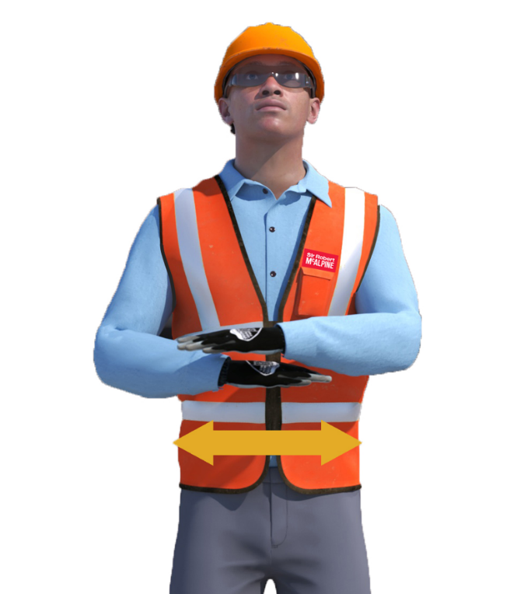
Hand signals:

Operations Cease:
The cease operations signal is performed by extending the arms outwards and bringing them both to the centre of the torso and back out again.
Note:
‘Operations cease’ is to notify the crane operator that the lifting operation has been completed.

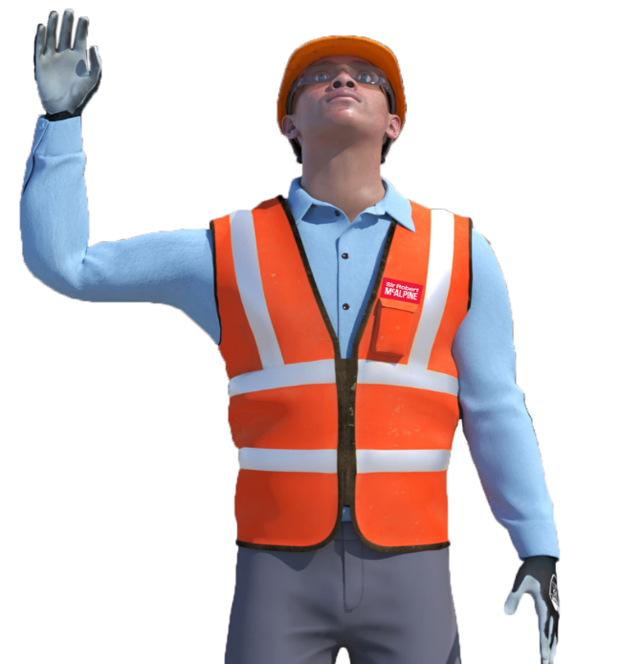

Operations stop:
To indicate that the crane operator should stop, raise one hand just above head height with the palm open and the other hand at the side of the body.
Note:
‘Operations stop’ is used during a procedure and is usually followed by another instruction i.e., stop –
slew in the direction indicated – stop – lower the load – stop

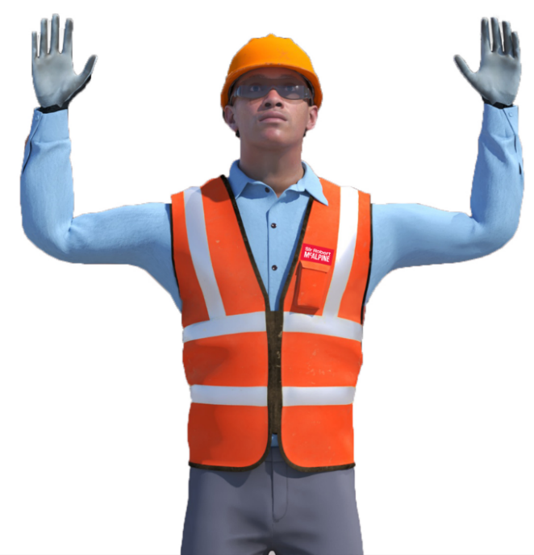

Emergency stop:
To stop all operations immediately, raise both hands above the head with the palms open and facing forwards.

Hand signals

‘Trolley’ jib only movement:

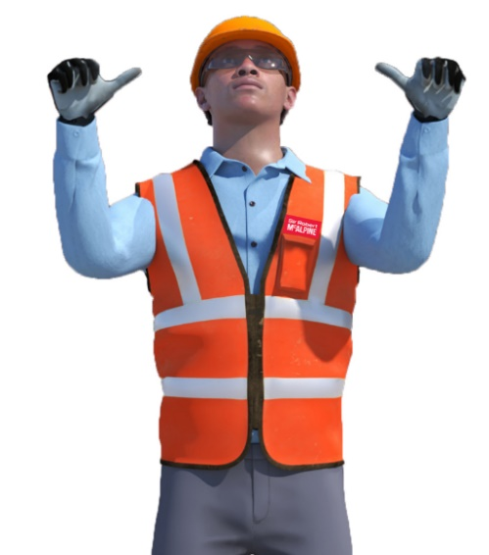
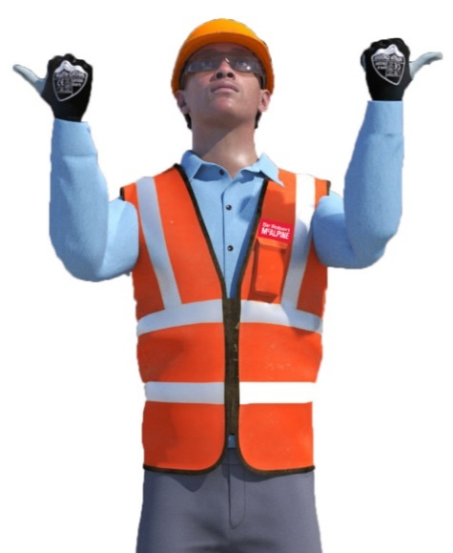

Trolley out:
To instruct the crane operator to move the trolley ‘out’ along the jib, the slinger will raise forearms to shoulder level and point thumbs ‘outward’ & away from each other.

Trolley in:
To instruct the crane operator to move the trolley ‘in’ along the jib, the slinger will raise fore arms to shoulder level and point thumbs ‘inward’ & towards each other.

‘Luffing’ jib only movement:
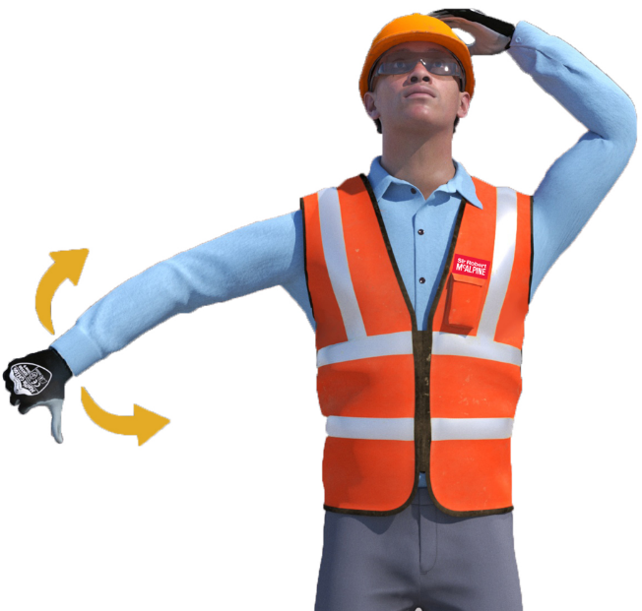
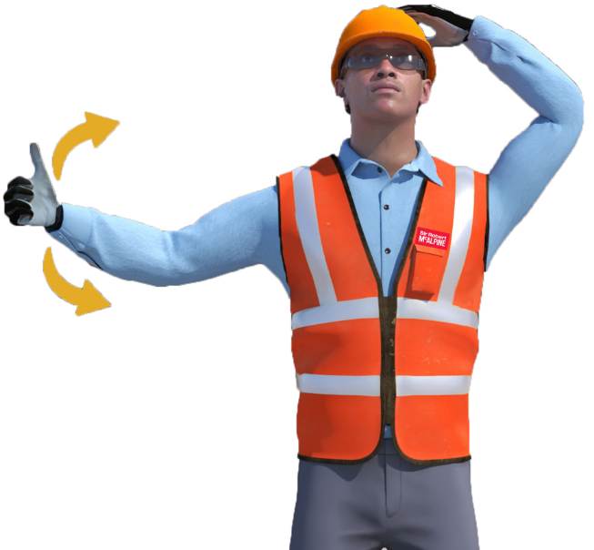

‘Jib’ Down:
To instruct the crane operator to move the ‘head’ or ‘jib’ of the crane to a lower position the slinger will tap the head with one arm, extend the other with their thumb out & down, & move it in an ‘down & up’ motion.
‘Jib’ Up:
To instruct the crane operator to move the ‘head’ or ‘jib’ of the crane to a higher position the slinger will tap the head with one arm, extend the other with their thumb out & up, & move it in a ‘up & down’ motion.

Radio comms – A suggested protocol:
Where the crane operator cannot observe the load during a lifting operation, it is considered a 'blind' lift. In these scenarios reliable radio communication is essential.
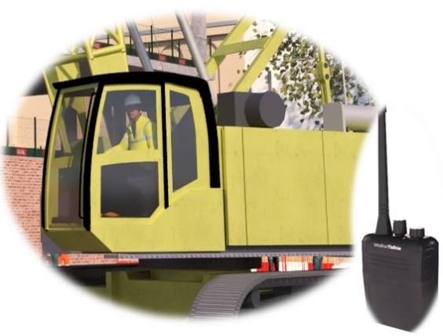
Potential issues include:
- Signal loss - Leading to uncontrolled movements and loss of load management.

- External interference - Causing miscommunication or directing commands to the wrong operator.
- Misinterpretation - Resulting in hazards like premature lifting, collisions with structures, unintended load movement, incorrect placement, or load drops.

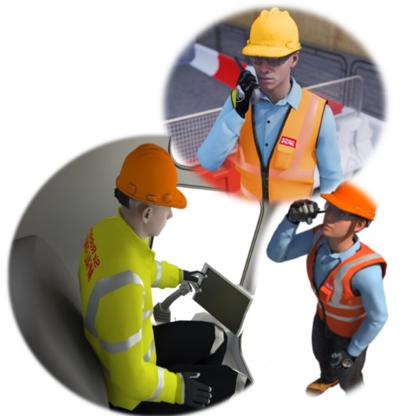
These risks highlight the necessity for clear, standardised radio communication procedures in all lifting operations.
Protocol of communications:
Check those comms!
Lifting incidents are often triggered by inadequate radio discipline and procedural lapses. To mitigate miscommunication between lifting team members, the following 7 measures can be implemented:
- Pre-operation radio verification - A comprehensive radio check involving all personnel must be conducted before initiating any lifting activity.

Note: Check that radio comms work at the extremities of the lift, before starting, the comms can be affected by the distance between the signaller and plant /crane operator, working within metallic structures & working at depth/height, etc.

- Structured message delivery - Utilise a "press, pause, speak" technique to ensure complete and clear transmission of information.

- Shared language proficiency - All members of lift teams must possess a sufficient command of the English language to facilitate unambiguous and clear communication.

- Distinct team member identification - Use each other’s names before, or during, each command or communication, if two of the team have the same name then use nicknames, the purpose is everyone knows who is speaking to who during the course of the operation.

Note:
To reinforce the importance of clarity of the ‘who’, Plant/Crane operators should only execute commands (excluding ‘stop’) where they can clearly identify that the direction is for themselves.
‘Can you repeat?’
- Instruction confirmation – Where the Plant/Crane operator isn’t sure of the direction given, they should ask for a repeat of the instruction to assure the confirmation of direction.
‘Did you get that?’
- Single-source command authority - Voice commands should be issued exclusively by one designated individual, at any given time.
Note:
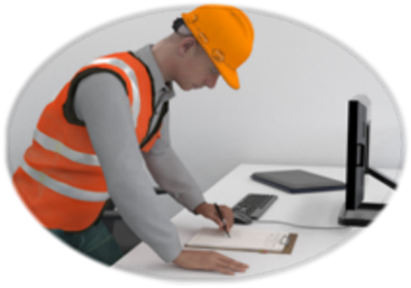
If the lifting operation requires two individuals to give direction/instruction during the lifting operation then ensure the procedure for a ‘handover’ of comms is authored into the lift plan, briefed to all members of the lifting team and understood.
Procedure for handover?
Brief the comms protocol in the lift plan

- Standardized voice commands - Use agreed-upon voice commands that align with established lifting signal standards.

What do good radio comms sound like?
A typical ‘benchmark’ radio comms procedure:
- Check the radio and confirm clear communication

- Describe the task to the operator

- State the current location of the load to the operator

- Specify the load's destination to the operator

- Advise the operator of the load's weight

- Point out any proximity hazards relevant to the lifting area(s) for the operator

- Describe the anticipated load path to the operator

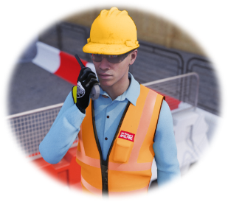
Sounds all very formal and a lot to for you to do each lift. However, it can be achieved in conversation, by communicating in a style similar to the following example:
Lead slinger (you) - ‘…TC1, (operator name), it’s (your name), radio check, can you hear me ok?...’

Operator - ‘…Alright (your name), yeah coming through ok, what you after?...’

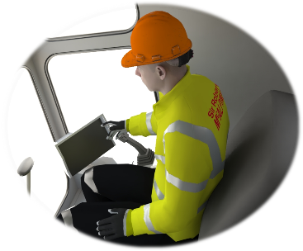
Lead slinger (you) - ‘…(operator name), I’m down to your right in Pit lane 1, about 30m out, got a stillage of scaff clips to go up to level 6 on the far side of the south core, full one so it’s about a tonne, (ancillary slinger name)’s up there prepping the area to land, (ancillary slinger name) can you hear us ok?...’

Ancillary slinger - ‘… (your name), yep all good, just moved a few scaff tubes out of the way, I’m ready up here, (Operator name) you getting me ok? Look over to your left, to the far side of the core, I’ll give you a wave…’

Operator – ‘… (ancillary slinger name) …hearing you fine and I see you. Is that where you want the stillage?...’

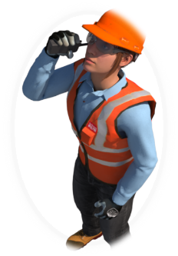
Ancillary slinger - ‘…Not quite, (operator name), it’s just going behind the core, so if you bring the stillage up and trolley out to where you see me now, I’ll lower you off and then slew to your left about 5m behind the core to land, it’s all clear round there. it’s only a tonne, happy with that?...’

Operator – ‘… (ancillary slinger name), yep fine, fine, I’ll get about 4 out there to where you’re stood. Tell you what though (ancillary slinger name), have the craic with those chippies behind you, they’re making a racket pulling that column together, if we’re blind and they’re banging away, I’m going to have trouble hearing you…’

Ancillary slinger - ‘…No problem (operator name) ...on it…’

Operator – ‘… (your name) You ready for me now?...’

Lead slinger (you) – ‘…Yes, (operator name), just keep an eye on Tc2 at the Gate 2 end of the pit lane, they’re picking off that rebar wagon in between standing shutters, I’ve let the lift supervisor there know, they’re holding ‘til we’re clear…’

Operator – ‘… (your name), already seen and already got hold of Tc2 on the ‘Crash’ to let them know we’re coming in for the stillage, they’ve confirmed holding there until we’re clear away…’

Lead slinger (you) – ‘…Nice one (operator name), when we’re clear of the pit lane, as you pass level 4 I’ll handover to (ancillary slinger name) they’ll have better eyes on you than me, is that all good?..’

Operator – ‘…Sounds like a plan (your name) …’

Lead slinger (you) – ‘…Ok (operator name) slew right and round to me, stillage is at the Gate 3 end of the pit lane….’

Operator – ‘…Gate 3 end…on my way (your name) …’

While the load is being lifted to the destination, the slinger is responsible for providing the operator with continuous updates regarding its position relative to the surrounding area of the load at any given time, in this case from hoisting the lift from the pit lane to the handover point, so it is imperative that constant communication is given throughout. The slinger-signaller should keep the load away from the adjacent structure / obstructions, especially where it could rotate and snag with the building when the tagline is unguided
Once handover is completed as detailed in the lift plan, again the constant comms is required until the load reaches the final landing. If there is ever silence beyond a second or two, the lifting operation should stop.
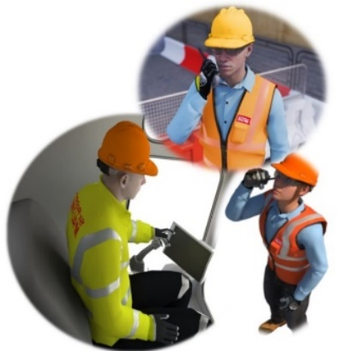
Ancillary slinger - ‘…Alright (operator name) , trolley out another 5m and I’ll lower you off, keep the trolley coming out and start lowering, you’re about 10m from slab level, hold the trolley but keep lowering, about 5m from slab, keep lowering, about 3m to go, 2m to go …and stop, hold it there, you’re about waist height now (operator name), let me just get the tagline…’
Keep the information flowing…silence leads to confusion
Operator – ‘… (ancillary slinger name), we still going behind the core?...’
Ancillary slinger – ‘…Yep, still going there (operator name) …going to slew you now, ok?...’
Operator – ‘…All good (ancillary slinger name), ready when you are…’
Ancillary - ‘…Ok (operator name), start slewing to your left, nice and slow, keep it slewing left, about 3m to go on the slew, keep slewing left, keep slewing left, a metre to go…and stop. You’re about a metre from the slab (operator name), so start lowering off nice and slow, 500mm to go, 300mm to go...just going to touch down…you’re down, keep lowering another metre…and stop. Nice one (operator name), I’ll just take the chains off…’
Operator – ‘...Ok (ancillary slinger name) …’
Using concise, clear & constant instructions, not only did the slinger landing the load keep the operator informed of heights and distances throughout the lifting operation, but they also let them know exactly what was going on even when they had stopped the crane. In turn, the operator was confirming they knew what was happening throughout.
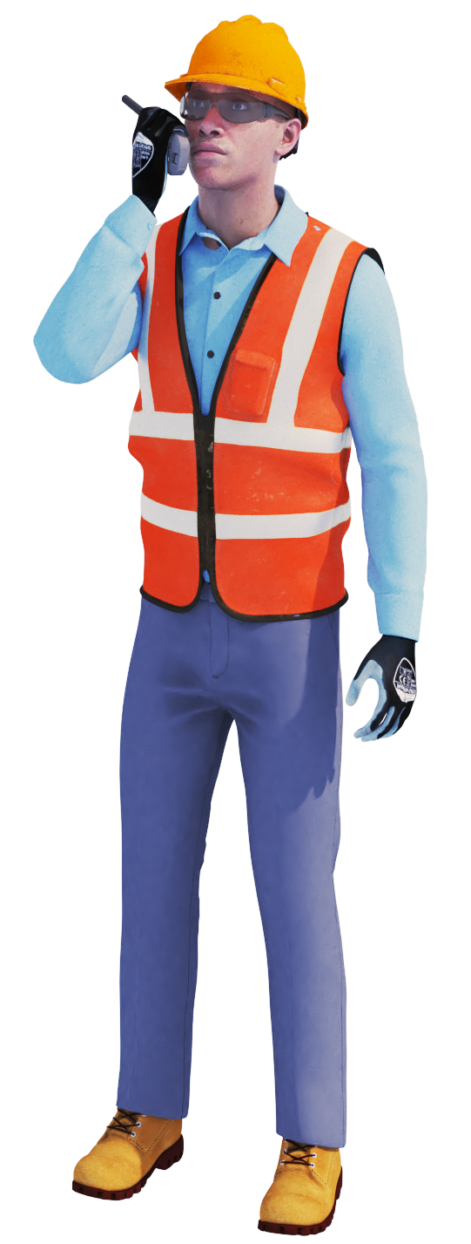Utilising the 7-step approach in the Protocols of Communication in lifting operations, will not only give lift teams a robust structure on how to approach clear communications but will assist in implementing the 4 C’s of communication.
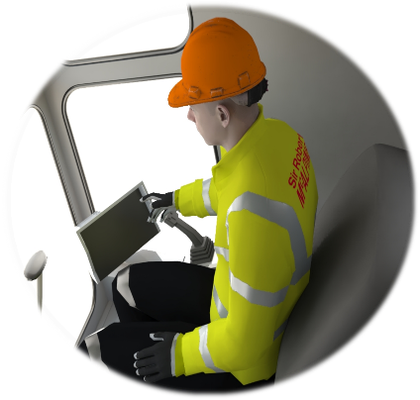
- Clear: All lift team members must have a sufficient understanding of English to ensure that clear, unambiguous communication can take place.
Just one person at a time on the comms channel and ensure that all of what you say is heard – Remember

‘Press, pause, speak’
- Concise: Limit the instructional conversation to the lifting operation, what you had for dinner the previous night or the terrible film that everybody raved about won’t make the lifting operation any safer and only encourages idle chit chat.

This is a comms channel used for a high risk activity –

Show it respect

- Constant: Keep the flow of communication going throughout the lifting operation. Silence, when expecting a response, leads to confusion. Keep describing, keep giving heights, distances, keep informing…

- Confirmation: Let each other you know what’s going on, confirm that weight can be put there, confirm you know what each other are doing, confirm you’re aware of the handover. It doesn’t take much to simply state ‘Yeah, I got that’ or ‘Understood’

- Wind Assessment:

The following is to be used as a ‘General’ guidance for wind assessment and by no means replaces site specific weather parameters or control measures stated in lift plans, schedules, and associated risk assessments.

When assessing the max. wind speeds and the effect on loads there are too many variables that need to be taken into consideration to allow definitive wind speeds for each load to be stated in this document.

Size, design & weight are just a few considerations that must be planned for.

The day’s weather forecast must form part of the morning DABs

More often than not project lifting teams will need to complete an informal POWRA if the weather is unsettled.

When reviewing the safety of the lift in unsettled conditions the following points are to be considered (non- exhaustive):
- Weather conditions at time of lift – What is the wind speed? Is there a chance of lightning or weather worsening during the anticipated time scale of the lift? Does the weather look like improving which would allow the lift to be performed at a later time during the working day?

- Path of the of the load and distance travelled – Will the load be lifted in close proximity to temporary, permanent structures or sensitive areas i.e., Network Rail property etc. Is the load being lifted over a great distance so increasing the time it is ‘in the air’?

- Height of the load when lifted – Will the load become problematic based on the height it is being lifted from or to?

- Area of the load - Is the load of a great area that could cause a ‘windsail’ effect?

- Weight & physical make-up of the load – Is the load of such a weight that it can be ’taken’ by the wind, conversely is the load of such a weight that it will become dangerous & uncontrollable if the wind causes ‘spinning’.

- Configuration of the load – Will the load require turning prior to delivery/install? Are there components of the lift that require calm conditions to achieve a safe install i.e., Cladding panel attachment?

- Configuration of the accessory arrangement – Are the accessories of such a length that could cause a pendulum effect in unsettled conditions? Are there any engineering control methods involved that have their own max. wind speed limits i.e., Mechanical load control equipment

- Controlling the load – Will additional load controls i.e., more taglines or operatives be required? Are these controls or operatives readily available? With the additional taglines or manual control measures, will this increase existing hazards and/or introduce new problems?

For industry guidance on tower cranes and wind conditions:
- TCIG TIN 020 - The Effect of Wind on Tower Cranes in Service

- TCIG TIN 025 - Luffing Jib Tower Cranes - Precautions for Operators Working at or near Minimum Radius in Strong Winds

- TCIG TIN 027 - Tower Crane Out-of-Service Wind Speeds

- CIG/TCIG TIN 110 - Planning Control of Lifting Operations in Wind V1 July 2025

- CIG 2507 Planning Control of Lifting Operations in Wind V1 July 2025

- Liebherr - Influence of wind on crane operations

- General safety considerations:

Please note:

The following is to be used as a ‘General’ guidance for all lifting operations and by no means replaces site specific safety considerations or control measures stated in lift plans, schedules, and associated risk assessments.

The work area set up:

- Refer to the lift plan and form an exclusion zone(s) and/or restricted zone(s) as required around lifting & delivery areas. Ensure all third parties are removed from lifting operations work area.
- Ensure that any exclusion zone and/or restricted zones are clearly identified using correct signage, segregated using physical barriers and, if required, suitably marshalled.
- As far as is practicable ensure that all background noise is kept to a minimum. If necessary, stop all noisy works during the lifting operation while communicating with the Tower Crane operator.

- Lifting to and from delivery vehicles [inclusive of points above]:

- Before mounting the vehicle make sure there is a suitable access/egress point.

- Check that the edge protection is of a suitable height to allow the lifting operation to be performed without slinger’s position being compromised, i.e., slinger being above the handrail.

- Ensure only the accessories required are taken onto the vehicle. If necessary, have someone on hand to pass accessories to the slinger to negate multiple accessories being taken onto the wagon forming potential trip hazards when stored on the vehicle or the slinger having hand’s full whilst attempting to gain access to the vehicle

- Slingers are to familiarise themselves with the work area to be aware of their positioning in relation to:

- The raising and lowering of any load – A safe space to stand.

- Potential obstacles.

- Escape routes in case they must ‘get out of the way’ quickly if the load spins or doesn’t act as anticipated i.e., Bundled loads gathering, loads ‘turning’ when taking from the horizontal to the vertical, hook block & accessories not correctly sited over the centre of gravity.

The load:
- Only lift loads that are in the project approved Schedule of Lifts - if unsure, consult the Lifting Supervisor or Appointed person so that the relevant information can be provided.

- Assess the weight & CoG of the load – if unsure, again, consult the Lifting Supervisor or Appointed person so that the relevant information can be provided.
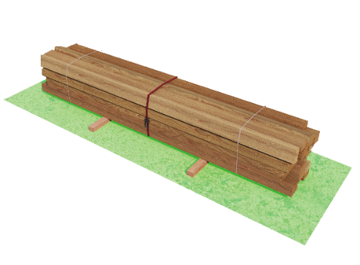
- Path of the load to be planned to ensure that the lifting operation is performed in a timely manner to negate the load being ‘in the air’ for any longer that it must

- Ensure the load will stay together during lifting operations and that all loose materials are removed from load or housed and retained securely within the load prior to lift.

- Ensure the load is stable when lowered and landed, prior to releasing the weight and lowering fully. i.e., employ a ratchet strap around the load to negate ‘tipping’ or ‘spreading’ [see opposite].

- If the load is repeatedly lifted, ensure there is sufficient space round the load to facilitate safe re-slinging

- When landing loads near pedestrian walkways be mindful of the possible ‘fall’ area of the load if it were to collapse after accessories have been removed.
- If the load requires to be landed on timbers or spacer ‘chocks’, make sure they are of such a size to allow a safe removal of the accessories. Do not drag accessories free from any load.
The accessories:
- All accessories used must have a current RoTE and must be suitably identified as per industry regulations.

- Prior to attachment and after removal of the accessories, they must be visually checked for any deformation or damage that could affect their continued safe use. If any damage is found then the Lifting Supervisor is to be informed, the accessory removed from service, tagged as ‘Not for use’ and stored away in a suitable ‘Quarantine box’.
- Ensure the correct accessory is used for the lifting operation– if the correct accessory is not available then do not attempt the lift with ‘other’ accessories and consult your Lift supervisor and/or Appointed person.

- Check that the accessories to be used are equal to or greater than the WLL stated for use as per the lifting schedule or plan.

- Verify that the angle of use of the accessory is within an ‘excluded or beta’ angle of 0-45 Deg.

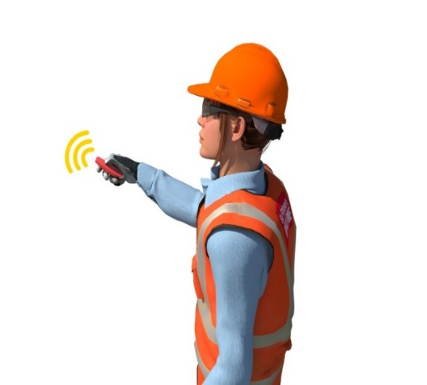
- As far as practicable, protect lifting accessories to ensure they are not damaged by sharp or burred edges and that they are free to align correctly.
The lift:

- Clear a safe lifting path across the project. Lifting over the head of personnel should be minimised as far as is reasonably practicable

- Make sure operatives nearby are aware that the lift is being performed. Issue audible [electronic whistles etc.] and verbal warnings to those in the immediate areas.

- Check that all operatives are clear of the path of the load.

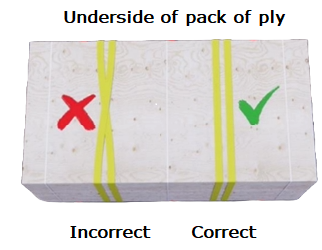
- Attach the accessories to the load as per the lift plan. If it is found that the planned lifting arrangement is not workable, inform the Lifting Supervisor and Appointed person for further guidance and instruction. Do not attempt the lift!

Note:
When double wrapping ensure you ‘lay’ the accessories ‘side by side’ and ensure they don’t cross over on the underside of the load.

- Conduct a ‘test’ lift of the load prior to movement across the project to check balance, centre of gravity, stability and attachment of accessories is suitable to ensure a safe lift across the project

- Sling the load to suit a level lift

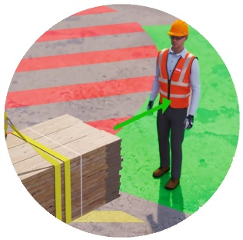

- Keep hands, fingers, and limbs free from the lifting accessories and choke points during hoisting – Hands Off!
- Prior to lifting the load, move away from the load to ensure clothing and any tools that may be carried do not become entangled – Step Away!

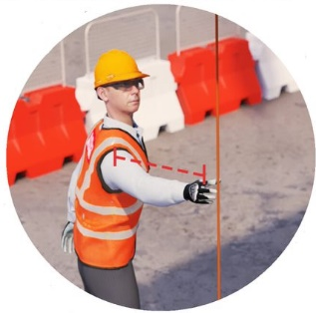
- When lifting or landing loads do not stand under the load or in any area where there is a danger of being struck or trapped by load when lowering – Safe Space!

- If required apply load control measures [taglines/push-pull poles] to assist in configuration of the loads

Please note:
When using taglines never wrap them around your hand, wrist, or body to assist in control of the load.

- Hands Off – Step Away - Safe space:
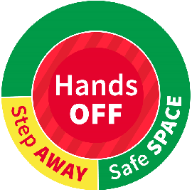

Hands off, Step Away, Safe Space [HOSASS] is an industry initiative concerning, primarily, the historical behaviour of slingers and ‘other’ operatives in and around lifting operations and reducing, via various control measures, the physical interface between lift team members and the load.

The aim is to highlight to all lift team members the considerations required, from the conception of the works though to final realisation of a lifting operation, for the safe positioning, and the positioning of others, when:
- Slinging loads – what actions are to be taken in the immediate area around the load and the control measures to be implemented.
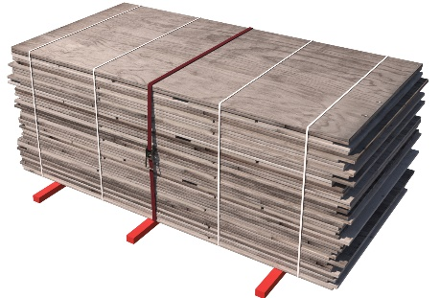
- Hoisting loads – considerations of physical position in relation the load so to reduce the risk of being struck due to unexpected load movement from the test lift through to the final hoisting.
- Controlling the configuration of the load – how to, when to and what with.
- Lowering and landing the load – identifying at what point to approach and how to guide the load to final delivery area.
- Leaving the load – ensuring integrity of stability before ‘walking away’.

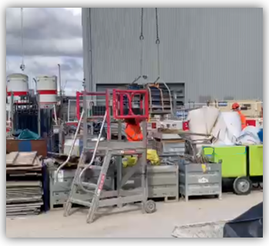
It is not a new concept to avoid putting yourself in harm’s way.
Despite this, it is common to see people involved in lifting operations placing themselves in locations where, if something went wrong, they could easily be hurt, or worse.

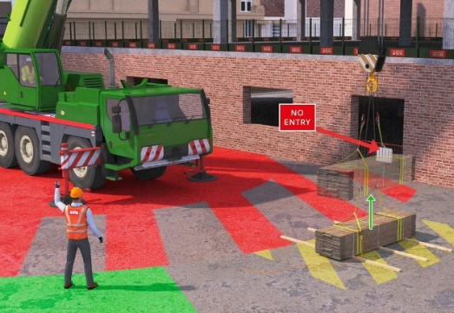
If something appears to be going wrong, it is also common to see people acting instinctively to try and sort the issue, thereby exposing themselves to further danger, rather than stopping the lift and remaining in a safe place until the load is safe to approach.
Loads are more likely to move unexpectedly during the initial stages of a lifting operation, particularly when first lifted up (including for trial lift), compared to later stages of a lift.

HOSASS works on the simple principle of personnel assessing their surroundings, identifying hazards nearby, and moving to a place of safety, whenever reasonably practicable away from the load before loads are lifted up.

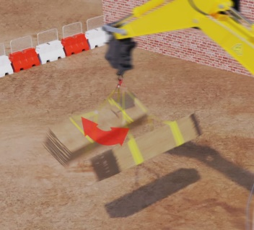
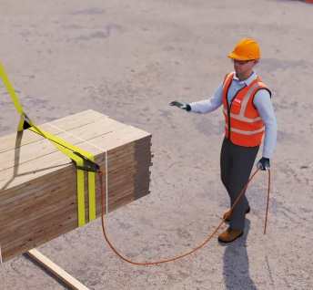
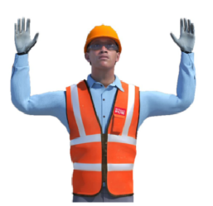
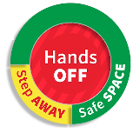
Personnel should only ever have their hands on a load through necessity, and not habit.
Wait – Wait for the load to become steady
Stop - Stand in a safe space and stop the lift
Safe? – Only approach if it is safe to do so
Before raising the load
Stand in a ‘Safe Space’ before giving direction to the operator
‘Step away’ from the load
After slinging the load take yo take your ‘Hands Off’
Prior to starting

Assess your surroundings and identify potential nearby hazards, for example any potential for slips, trips, and falls, crushing zones, falling objects, adjacent plant and activities, and areas where you may not be visible to others. Focus on eliminating hazards at source.
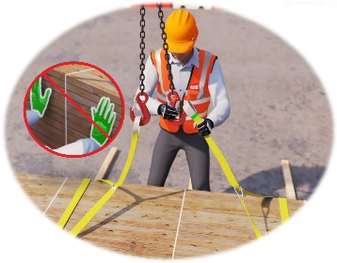
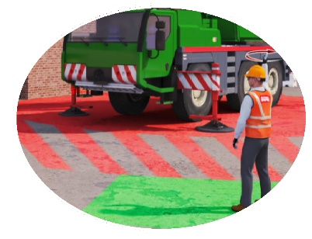
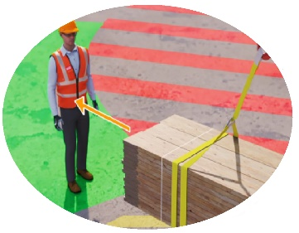
If there’s a problem during the lift




Link to the ILLAPG resource section attending to ‘Hands Off – Step Away – Safe Space’ here

Hands Off, Step Away, Safe Space
A practical guidance note
Hands Off – Step Away – Safe Space
A practical guidance note

What:
HOSASS - Hands off, Step Away, Safe Space:
This is a practical guidance note to explain industry expectations relating to people/load interface and addresses the safe positioning & behaviours of lifting team members, and other operatives, whilst undertaking lifting operations.
This guidance will assist when planning your works addressing any anticipated people – load interface to all involved with and working around lifting operations continue to be safe.
-------------------------------------------------------------------------------------------------------------------------------------------------------
Hands off, Step Away, Safe Space [HOSASS] is an industry initiative concerning, primarily, the historical behaviour of slingers and ‘other’ operatives in and around lifting operations and reducing, via various control measures, the physical interface between lift team members and the load.
The aim is to highlight to all lifting team members the importance of their safe positioning, and the positioning of others. This is only achieved through careful lift planning and then execution of the planned lifting operation. This planning should consider the following:

- Slinging loads – what actions are to be taken in the immediate area around the load and the control measures to be implemented?

- Hoisting loads – considerations of physical position in relation the load so to reduce the risk of being struck due to unexpected load movement from the test lift through to the final hoisting.

- Controlling the configuration of the load – how to, when to and what with.

- Lowering and landing the load – identifying at what point to approach and how to guide the load to final delivery area.

- Leaving the load – ensuring integrity of stability before walking away.

Why:
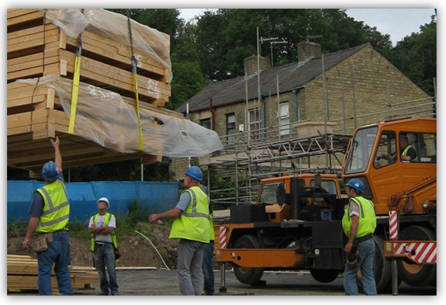
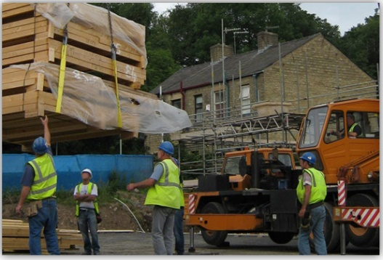

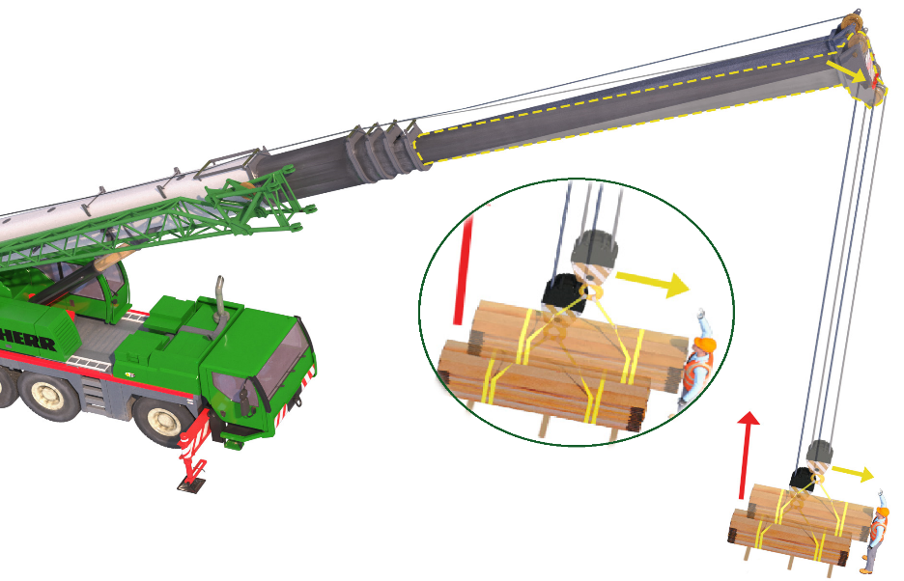
The image opposite shows the slinger-signaller [?] is standing directly under a slung load and reaching up to control.

Other operatives are shown in proximity, either just stood watching [do they need to be there?] or approaching to assist in landing.

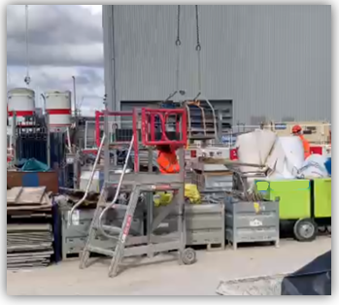

Again, the slinger-signaller is standing directly under the load.
The work area is cluttered with no real ‘escape’ route or ‘safe space’. – Where does he go if the accessories fail or load catches on any of the surrounding obstacles?

Why:
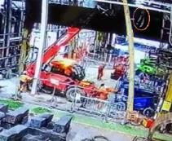
The images opposite are taken from a video of an incident in the winter of 2023.

A steel erecting contractor was installing a segregation wall to provide an enclosed CDM area.

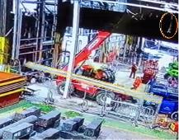
During the lifting operation, the accessory failed resulting in the steel column falling to the ground damaging equipment and live services, narrowly missing one operative in the immediate area.

Please note:
The steel being erected has been highlighted in yellow to show position through the incident with the accessories highlighted within an orange oval.

Note the positioning of the three operatives in the first image [marked with a numbered circle]

All three are stood between the telehandler and the steel column, directly under the boom!

By taking up this position they were putting themselves at risk to:

- Boom collapse due to hydraulic failure.

- Unexpected forward movement of the telehandler due to Equipment/appliance malfunction or operator error.

- Collapse of load due to equipment or accessory failure [as was the case].

Details:
When is the slinger-load interface?

Slinger-signaller-load interface will occur during the following phases of a lift procedure:

- The initial slinging of the load and subsequent test lift
- Any required mid-lift checks.
- The final delivery/install and landing of the load.

During these phases the slinger-signaller(s), and any assisting operatives, are often close to a lifted item and are at an increased risk of being struck by the load - particularly if it moves unexpectedly for any reason.
Why and when a load will move:

Load movements, for the purposes of clarity in this document, are split into 2 categories: unanticipated movement - movement which is not expected and is caused by insufficient planning, incorrect slinging techniques, environmental or local conditions, lack of monitoring of load movement, appliance behaviour & anticipated movement - movement which the lifting know is going to happen, and the team should be aware and allow for this when planning and undertaking the lifting operation.

Details:
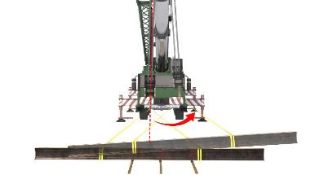
Examples of ‘Unanticipated movements’

- Centre of gravity not directly under the end of the crane jib, rope, block & accessories not correctly sited over the centre of gravity, or the centre of gravity being incorrectly identified in the planning stage or the contents of containment accessories shifting during lift i.e., fluids or unsecured materials.
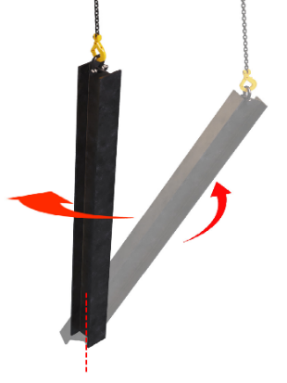

- Pitching of loads – The centre of gravity of the load can move along distance when using this lifting methodology, as the load passes from horizontal to vertical. The load will align beneath the suspension point, under the top sheave of the crane. However, as the weight of the load comes off of the support point at the base of the load and since the centre of gravity may not be directly under the top sheave of the crane, the load may pivot.
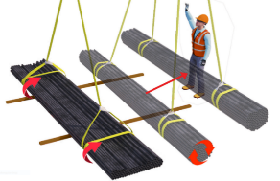

- Loads ‘gathering’ on initial raising & ‘spreading’ when being landed – Some loads will ‘come together’ when picked up, [e.g., loose bundles of scaffold tubes or reinforcement]. As the load gathers within the accessories, it may shift and cause a swing movement as the centre of gravity shifts.

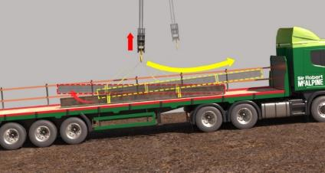
- Lifting a balanced load from a sloping deck – This allows one end of the load to lift whilst the other remains in contact with the deck, meaning the load is likely to pivot around the ground bearing end or lift and then swing.

Details:
- Obstructions and snags – Over-hanging or nearby structures etc. may catch loads, leading to risks of crushing, unexpected rotation of loads & overloading of equipment or appliances, causing catastrophic failure. Loads with outriggers not properly stowed i.e., Tower lights etc. will pivot as the outrigger touches the floor.

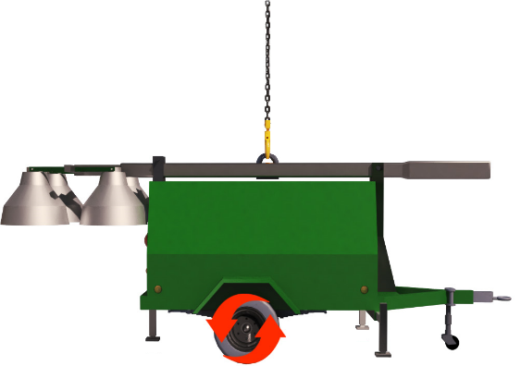
- Dynamic factors - Equipment & appliances moving faster than expected [slewing, hoisting, derricking etc.]. Wind catching the load causing it to swing, sway or spin. A rapid emptying of a concrete skip or rollover skip will also cause the load to move.

- Travelling of loads – Loads that are wheeled i.e., tower lights, compressors, jetwash & fuel bowsers, if locks aren’t engaged to wheels or jockey wheels, they can engage upon landing causing the load to move across the floor. Rounded spacer chocks or insufficiently sized chocks can, again, allow the load to move either by travelling [rounded chocks] or collapse

Examples of ‘Anticipated movements:

- Parts of a load that may be designed to rotate or roll for example, ancillary parts of the load may move, e.g., bale arm skips. These can fall on personnel if not used or stowed correctly. Some loads, for example concrete skips, by design, have radiused parts so they will ‘roll’ and pivot when initially being raised and when landed.
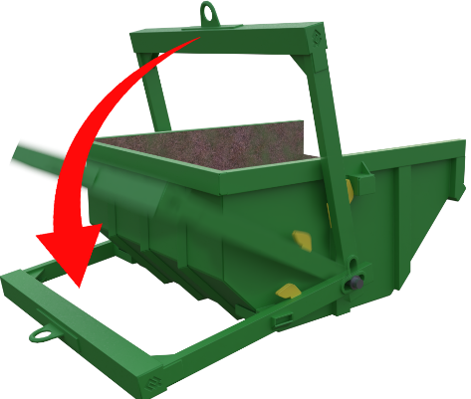
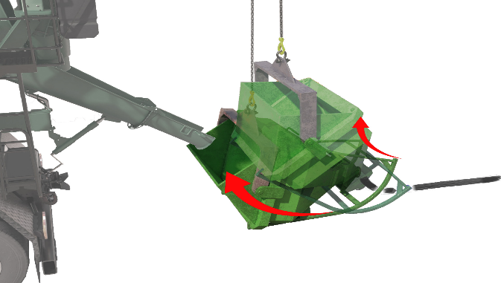

- 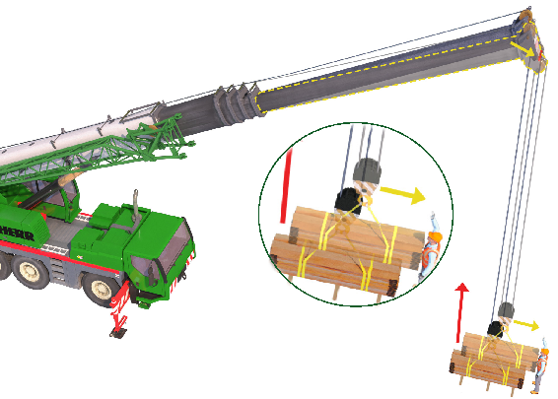Appliance deflection. All lifting appliances will deflect under load – The amount of deflection depends on boom configuration (e.g., length) and weight of load.
Note on boom deflection:

With experienced lift teams, deflection is expected and would be allowed for in the initial raising of the load and the taking of the full weight. For others in and around the lifting operation [e.g., joiners, steel fixers etc.] the movement may not be expected, which underlines a requirement for only ‘essential operatives’ to be within the vicinity of the lift.

Details:
Controlling load movement:

Loads which are fragile, easily damaged, close to sensitive assets or being lifted from/delivered into confined areas and needing fine positioning, would require load control. Included would be long loads or loads that are tall or of irregular bulk.

Other loads may not require load control i.e., where the tagline would have no benefit to the lifting operation.

Wherever reasonably practicable, the lift procedure should be planned, and the working area organised with the aim to eliminate the need for personnel to directly control the load.

Manual control measures [Mcm’s] e.g., non-tangle taglines and push-pull poles:
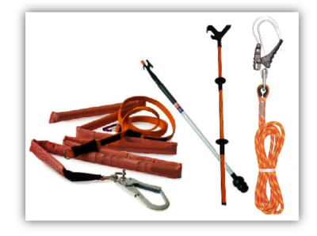
Non-tangle taglines are used to control the rotation of long loads and any loads that require to be lifted to or from areas where clearances are restricted. Longer loads may require more than one tagline to ensure correct alignment and to help avoid over-correction of rotation from pulling on one end only.

Push-pull poles allow one operative to have greater control of a load at low level, allowing the operative to push the load away or pull the load closer to its point of landing.

Note:
A suspended load must never be pulled or pushed from its centre of gravity, as it will be very difficult to move.
Examples of mcm devices

An mcm should never be used to gain control over a swinging load after control has been lost.

A mcm should be readily available and in sufficient numbers to suit complexity of the lifting operation and/or size of load / project.

When assessing the load in the planning stage, the appointed person should consider the use of a mcm, including where to attach it, and the numbers to be used, based on size/bulk of load and area of works.

It is also acceptable for the lifting supervisor to perform a point of work risk assessment to ascertain the control measures required and put them to use if not attended to in the associated plan or schedule.

If taglines are to be utilised, then:

- The tagline must be of sufficient length and strength to control lifting and landing of the load. The selection of tagline length is critical to the control of the specific load - Generally, a 5m length would be utilised for general lifting operations, whilst 10m in length would be employed for loads to be lifted or lowered where proximity hazards warrant it. A vertical tagline will not provide any control for the load.

- The tagline must be inspected before use to ensure it is not damaged, knotted or looped etc.

- The slinger-signaller is to be aware of any obstructions that could cause the tagline to become entangled.

- The slinger-signaller is to be familiarised in the correct use of the tagline.

The slinger-signaller is to be mindful of their own positioning in relation to the tagline to remove the risk of physical entanglement - The consequences can be fatal!

Details:
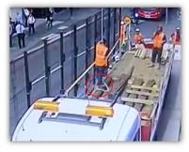
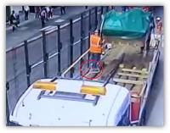
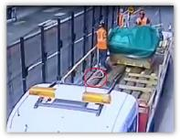
See the following images below of an operative becoming entangled in a tagline

A reinforcement wagon was being unloaded and the FIBC’s on the load were lifted into a general waste skip. As the skip was raised the operative stepped back into the ‘tail’ of the tagline [the ‘tail’ of the tagline has been highlighted in a red circle] that was on the floor of the delivery wagon.
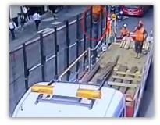
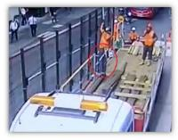
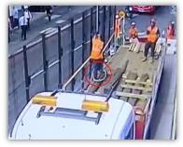
As the load continued to rise, the tagline became entangled around the legs of the operative and effectively ‘wrapped’ him within the ‘tail’. It was only the quick thinking of the operative, to grab the tagline as it raised that stopped him being raised upside down with the potential to slip from the entanglement while being raised. Luckily, the operative was able to be lowered back to the bed of the wagon without injury.

- When unloading deliveries, where practicable, the slinger-signaller will place the tagline over the top handrail of the wagon edge protection, to ensure it does not become entangled.

- When guiding the load using a tagline, the slinger-signaller should take care not to impart any undesirable motion to the load.

- The slinger -signaller is to stay an arm’s length from the tagline when retrieving it, so as not to place themselves directly under the load. Where practicable use a ‘push-pull pole’ to retrieve the tagline.

- Once attached, a tagline becomes part of the load, ensure the tagline is clear of any obstruction prior to confirming with an operator that the load is clear.

- All operatives employed in using taglines are to be familiarised in their use.

- Do not overreach to grab the tag line

Taglines should never be wrapped around limbs or the body to get a better grip & should never be wrapped around a beam, column, handrail etc. to hold the load or redirect the angle of pull.

If push-pull poles are to be utilised, then:

- Always refer to the manufacturer’s instructions of how to use.

- Inspect the item before and after use for any damage that could affect integrity of use or any deformity that has occurred during the load control.

- Avoid using excessive force as this may cause the pole to slip

- Ensure there is room, to the side & behind, to manoeuvre the pole.

Details:
- Do not use the pole to lever the load.

- Do not place the pole in front of body/hand, as the force of the load may be transferred through the pole.

- Beware when using the push-pull pole that where it can be dropped from height, it may need to be tethered to a suitable anchor point.

Technical and engineering control measures:

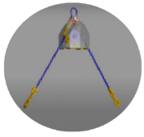
There are various technical & engineering solutions available that can aid in some of the scenarios listed previously – for example:

- Ganterud L is a chain-based block system that attaches to the hook of lifting equipment and allows lifting, levelling, auto levelling and turning of both light and heavy objects. It overcomes the need for chain shorteners and allows slingers to position loads safely and accurately in confined space situations – Video here [Google Chrome}

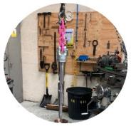

- The Torquer Spear is a steel cylinder that can automatically engage or disengage within a socket that is recessed into a load, forming a tested lifting point. Use of this system can dramatically reduce risk associated with slinging loads – Video here [Google Chrome]

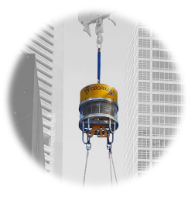
- Roborigger is a remote-controlled robotic device connected to a crane's wire rope by hook. Roborigger controls a load’s orientation and holds it in position regardless of the wind, meaning taglines are no longer needed to manage the spinning or landing of the load – Video here(Google Chrome)

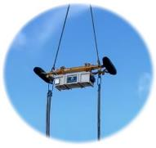
- The Vita Load Navigator is a system that detects load movement in real time and adjusts the load with high powered fans to eliminate spinning and rotations. With four independent thruster spinning up to speeds of 14,000rpm in under a second, it can hold loads within 1 deg. of deviation – Video here [Google Chrome]

If this type of control measure is to be utilised, then:

- Does the appointed person planning the lifting operation understand how it is to be used as per the manufacturer’s instructions, as well as any implication for the lifting equipment handling the load?
- Allow for user-training in the safe use of such equipment.
- Additionally, familiarisation for other operatives that may be installing the load beneath the item. They need to be aware of the anticipated movement of load.

- Check that certification and any maintenance requirements are in place as per the manufacturer’s guidance for the equipment that is chosen.

- Users of remote-control units must be positioned in a place of safety with a good view of the load.

- Perform several practice trial lifts to prove the system works as planned and all involved understand the system and how it works.

- Store and keep equipment used in a safe, clean, and dry environment where possible and ensure those carrying out daily checks are competent to do so.

- If you encounter any technical issues with equipment - you must STOP and re-evaluate its continued use with the appointed person and the supplier / manufacturer before continuing to use it.

Details:

Operational control measures:

Simple everyday behaviours around loads can minimise load movement…

- An initial survey of the raising and lay-down areas to identify potential obstacles and snag points.
Timber wedges used

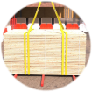
- Slinging loads level & the use of a securing straps around loose bundles or stacks can mean the load not swinging when raised or spreading upon landing. Wedges on timber chocks is a simple way to ensure the integrity of a bundled load once lowered

- Wheels locked and outriggers correctly stowed on wheeled loads can make for a simple static landing.

- Allowances for deflection of jib on initial raising of the load.
Banded stack


- Suitably sized timber chocks or spacers of sufficient strength to be utilised when landing bundled or stacked loads, to allow removal of the lifting accessories.

- The correct use of securing chains on equipment with bale arms etc. to prevent movement of the arm once detached from the lifting accessories.

All are basic procedural & slinging techniques that can prevent unplanned load movement.
Securing chain used

Graphic note:
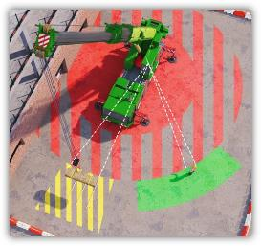
Key to zones:

The following graphics demonstrate examples of restricted/exclusion zones and areas of danger. These are shown using coloured overlays.

Special note:

Restricted access zones are areas that only the slinger-signaller(s), lifting supervisor or appointed person can enter when certain conditions are met prior to entry.

Exclusion zones are ‘no entry’ areas to all persons unless certain conditions are met prior to entry.



Key:
Area of danger: Formed by position of load. Area can only be accessed by lift team members when load is stationary and at such a height to either retrieve tagline [if required], or handle load when, again stationary, and at waist height.
Designated ‘Safe Space’: Either identified in the lift plan or from a POWRA



Restricted access zone: Can only be accessed by lift team members with no load on the hook with hook raised to allow safe thoroughfare. Confirmation of entry into this area must be given by the appliance operator.


Exclusion zone: Can only be accessed by lift team members when there is no load on the hook with the hook raised to allow safe thoroughfare and appliance isolated. Confirmation of entry into this area must be given by the appliance operator.

How:
The Planning – Making it safe:


The Appointed person should aim to negate the ‘Slinger load interface’, as far as is practicable, when planning the lift. This includes considerations for [non-exhaustive]:

- Weather conditions – What’s the seasonal weather conditions – Are they being constantly monitored leading up to the lift?

- Appliance selection – Are they choosing the correct appliance or simply utilising something to hand? Is there an alternative to ‘lifting’?

- Load configuration - How is the load being delivered? Will it need ‘pitching’ or ‘turning’?

- Load positioning – Where’s the load going - Will it be a small, confined space? Are there structural obstacles in the vicinity? Where can the slinger be to always be in sight of the load & the operator? Are ‘Safe spaces[s]’ and escape routes identified – Are they clearly marked & communicated within the lift plan?

- The lifting arrangement - What’s the Cog.? What and where are the accessory attachment points? Can these be engineered to produce a simpler, safer lift’?

- Load movement control measures – Are they required – If so which type? Any training required?

- Load path – What’s the route of the load - Can a lifting corridor be created to minimise lifting overhead? Will the appliance operator be able to see the load though the entirety of the operation?

- The lift team members – What’s the experience within? Have they done the type of lift that’s anticipated before? Will more than one slinger be required - If so what’s the handover procedure?
- Adjacent works - Exclusion & restricted zones should be planned, communicated and provision made for them to be suitably marshalled [if required] & have correct/suitable signage.

Under some circumstances, the need to control a load with a hands on approach may be necessary, i.e., lifting sheeted glass clear of its storage frame etc. in these circumstances then the ‘Slinger load interface’ should be kept to an absolute minimum and suitably risk accessed and communicated

The Supervision – Assurance of methodology:

As with all lifting operations, the level of supervision should align with the complexity of the lifting operation.

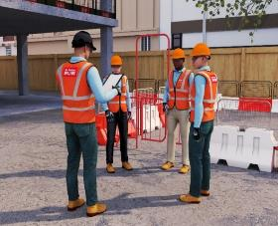
The lifting supervisor must have a thorough understanding of the ‘Hands off – Step away - Safe space’ principle and brief this to the lifting team prior to lifting operations beginning and on a regular basis via toolbox talks etc. to help embed the methodology.

The role of the supervisor is vital in implementing the procedure prepared by the appointed person. Care is required when supervising lifting operations of a generic & repetitive nature i.e., tower crane operations or mobile/crawler cranes performing multiple lifts to a work area etc.

The lifting supervisor must be able to:
- Perform a visual at-point-of-lift risk assessment to identify a safe space & advise members of the lift team accordingly.
- Recognise incorrect behaviour around the lifting operation by the slinger-signaller/others and stop the lift;
- Ensure the hands-off principle is being adhered to.

How:
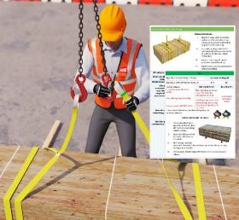
The Procedure - What is expected from the slinger:

Prior to performing any lifting operation, the slinger-signaller will ensure that the immediate work area is clear of other operatives that are not required for the lift. Audible warnings i.e., electronic whistles and/or vocal instruction will be used to alert operatives that a load is being hoisted, moved, or landed.

Initial raising of the load:

- Attach the accessories to the load/item to be lifted as per the lift plan.

- Attach or utilise a mcm that may be required as per the lift plan.

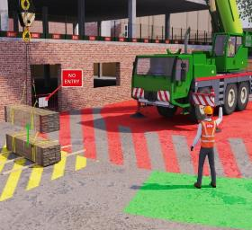
If a tagline is to be attached, then preferably it should be attached securely to the load and only to the arrangement/accessories if it doesn’t affect the integrity of the attachment of the accessories.
The slinger should also be mindful of any trailing ‘tails’ of the tagline to negate any physical entanglement

When utilising mobile/crawler cranes, 360 telehandlers etc., they must always be aware of their positioning to ensure that they are not stood under the boom of the appliance.

- Once the slinging arrangement is attached, along with any securing straps or banding that may be required to ensure the integrity of the load when landed, the slinger should step away from the load to a safe distance – the ‘safe space’.

Many factors will determine a safe distance such as load dimensions, proximity of the load, trip hazards, obstructions, fixed or temporary structures, and environmental conditions.
To establish a safe distance, the slinger-signaller must consider the distance they would be safe if the load failed, noting a fallen load may bounce or roll, before coming to a rest

- Only when the slinger-signaller is at a safe distance can the instruction to raise the load for the test lift be given.

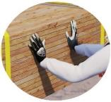
The test lift is to be raised clear of the starting position, this should be no greater than waist height and stopped, whereupon the slinger-signaller can then approach the load to check configuration and slinging arrangement.

If a cause for concern is highlighted during the test lift i.e., load is not level or seems to be loose, then lower the load to the starting position.

When handling the load at this point, the slinger-signaller must be mindful of placing hands and fingers in any potential trapping points.

As a safe practice, hands should be flat to the surface of the load and not around the lifting accessories, eliminating the potential to have any part of the hand trapped.

How:
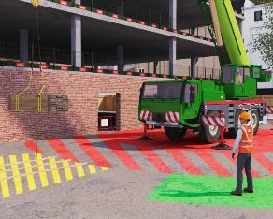

- Once happy with the arrangement, the slinger-signaller should then position themselves in the safe space and instruct the appliance operator to continue with the lifting operation.

When directing the operator through the lifting operation, instructions must be clear and concise, using industry recognised hand signals or audible commands

Where practicable, confirmation of understanding of the command/instruction, from the operator, should be relayed to the slinger

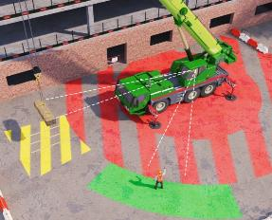
Final positioning or landing the load:

- As the load lowers under direction of the slinger-signaller, they must be mindful to not stand under the load or position themselves [or body part] between a fixed or temporary structure.

The safe space principle should be maintained.

When utilising mobile/crawler cranes, 360 telehandlers etc., they must always be aware of their positioning to ensure that they are not stood under the boom of the appliance.

- If using a mcm, then lower the load to such a height so that these can be retrieved safely.

Stop the lift before approaching the load.

The slinger-signaller should never retrieve a tagline or employ a push-pull pole while the load is in motion. This prevents them inadvertently being under the load, as it can be hard to judge.

Note:
When retrieving taglines, the slinger-signaller will keep an arm’s length away so as not to position themselves under the load. Best practice in this situation would be to retrieve the line with a push-pull pole.

How:
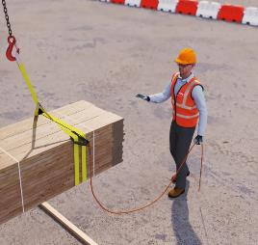
- The load should then be lowered to waist height, where final orientation of the load [if required] can be attended to, to allow a correct and safe landing.

Note:

If the slinger-signaller needs to touch the load at this point, they can but they again, must be mindful of placing hands, fingers, and feet in any potential crush points.
As previously stated, as far as is practicable and dependant on load parameters, hands should be flat to the surface of the load and not around the lifting accessories, eliminating the potential to have any part of the hand trapped.

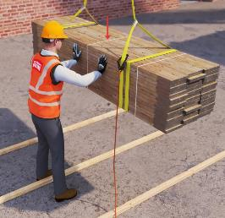

- The load can now be lowered to the final landing position.

- Prior to removing the accessories, the slinger-signaller should check load stability for example:

- Integrity of load – is it secure in its final position?

- If required, have wedges been employed to stop the load rolling after accessories have been removed?

- Can the accessories be removed easily and safely? If not, introduce appropriately sized bites / chocks.

- If the load is repeatedly lifted, is there sufficient space round the load to facilitate safe re-slinging?

Summation:
With ‘Hands off, Step Away, Safe Space’ the primary concern is for the slinger-signaller and those in the vicinity of the point of lift.
Even though industry, employers and appointed persons can create safe procedures, provide the documents and tools for the lift teams to work safely, it is the responsibility of those at the point of lift, to stop and think about handling loads safely. The slinger-signaller needs to ask themselves the following questions:

- What am I going to influence by handling the load?
What difference will I make?

- Do I really need to handle the load?
Am I approaching or handling the load because it is what I have always done?

- Is it safe for me to handle the load?
Am I, by approaching the load to use hands-on control, putting myself in danger?

What we can't control is natural behaviour and this is where this guidance document can prevent injury and save lives.

Darren Biggs - June ‘24

