A practical guidance - 7: Schedules 49 -58
Revision 1 September ‘25

Schedule of lifts for Tower Crane

Please note:
This document has been provided by Sir Robert McAlpine Limited. It has been checked to the best of our ability but may contain unintentional errors. As per BS 7121-1:2016, CDM 2015 and LOLER, it is the user’s responsibility to verify that they understand and have made their own checks before using this document.
The user shall ensure that they properly risk assess and plan their own lifting operations to discharge their legal requirements.
No liability will be accepted for any incidents that result of those using this document.

The schedules
No. | Title:
49. | Steel beams - Girders, H section, I section, U beams, Lintels
50. | Loading platform
51. | Carrying of personnel – Special note
52. | Carrying of personnel - Use of Suspended Personnel Carrier
53. | MEWPs
54. | Toolbox
55. | Transformer box up to 20kva
56. | Pedestrian barriers
57. | Excavator buckets
58. | Timber ‘Ekki’ Mats
Ref. | Blank template

Load description: Steel beams - Girders, H section, I section, U beams, Lintels
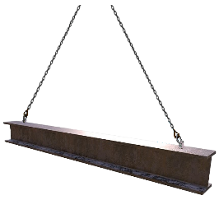  Special note:  Structural steelwork and fabricated steel assemblies shall have designed lifting points or a method for making a positive connection to a removable lifting bracket. |  | Slinging methodology:  - 4 leg chain slings will be attached to hook block of the crane. Only 2 legs required so any unused chains will be hung back to the master ring.  - Attach hooks of chain sling to the integral lifting eyes of the beam.  Please note:  Ensure the hook of the chain sling fits the integral lifting eye.    If required bow shackles of a suitable WLL with mode factors considered can be utilised to ensure integrity of attachment.
Lift Category: | Basic
Dimensions of load: | Various dimensions: __mm [h] x __mm [l] x __mm [w]
Weight of Load | _kg / t for dimensions given
Lifting accessories used with weights of accessories: | From hook block:  4 Leg chain slings WLL 8.4 t @ 103kg  Gross weight inc. 10% FOS: _kg |  | WLL x Mode Factor | Resulting SWL
Lifting accessories used with weights of accessories: |  |  | 4 leg chain slings with 2 legs in use - WLL of one leg multiplied by 1.4 = 4.41 t | 4.41 t over all accessories stated
Alternative methodology:  Alternative methodology:  contd.: | 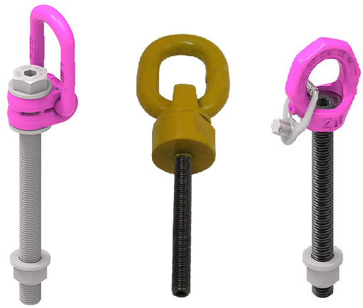Other attachment accessories can also be used to provide a ‘positive’ attachment, much like the integral lifting points, through predrilled holes in the structure of the beams - See examples opposite.  When lifting with these accessories ensure they are used as per manufacturers specification and instructions.  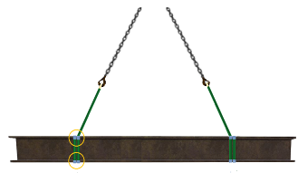  Webbing slings can be used around beams in a double wrap ‘choke’ configuration.  Ensure wear sleeves are used to protects the webbing slings from any sharp or burred edges.  If size of hook block allows, and the EWL of the slings is sufficient enough to allow the webbing sling to be within a 0 to 45 deg. excluded angle , then the webbing can be directly attached.  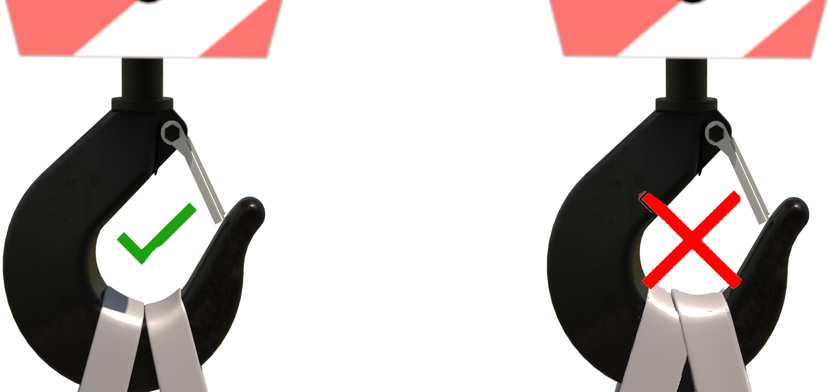  Slings to be placed to suit a level load.  DO NOT OVERCROWD THE BLOCK
Safe lifting considerations: | 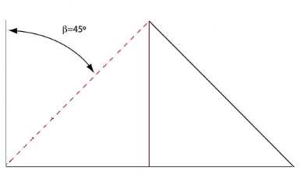  - With direct attachment of the chain sling, ensure the chain sling attaching to the top of the beam is of sufficient length to allow for the chain to be within a 0 to 45 deg. excluded angle.  - A temporary works check on the attachment points to have been completed prior to lifting.  - Tagline[s] to be used to allow configuration of beam to be controlled from initial raising of the beam to final lowering/installation.
Additional information: | Reference weights:  If beams are not marked with the known weight, then always check with manufacturer and design drawings for anticipated weights of beams supplied.  Special note:  Always check with design drawings that any welds, or additional bolted assemblies etc. are included in the weight

Loads description: Loading platform
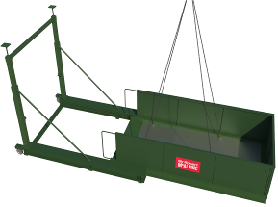  Image above is representational only of a 4 point lift typical of methodology for a loading platform. |  | Slinging methodology:  - Attach 4 leg chain sling to hook block of the crane.  - If required shorten chain slings to suit methodology of install [see operators manual or safe user guide for recommended length of chains]  - Attach hooks of chain sling to the integral lifting points situated to the structure of the platform.  Please note:  See manufacturer’s specification sheet, operating manual, or safe user guide to identify the lifting points recommend for each model of loading platform being lifted.
Lift Category: | Intermediate [as minimum] |  | Complex [dependant on localised parameters and hazards]
Dimensions of load: | Various dimensions but typically: 2410 mm [w] x 1000 mm [h] x 9000 mm [l] for extended telescoping platform [check manufacturer’s specification for ‘other’ model types]
Weight of Load | Typically, 3 t for dimensions given
Lifting accessories used with weights of accessories: | From hook block >  Single leg chain sling WLL 8.4 .t @ 103kg  Gross weight inc. 10% FOS: 3.414 t [ru] | WLL x Mode Factor |  | Resulting SWL
Lifting accessories used with weights of accessories: |  | 4 leg chain sling as per designed use |  | 8.4 t over accessories stated
Alternative methodology: | See manufacturer’s literature to configure the accessories to suit loading platform.  Where required bow shackles may need to be utilised to enable a correct attachment of the hooks of the chain sling to lifting points of the loading platform. Ensure they are of sufficient WLL with mode factors considered.
Safe lifting considerations:  Safe lifting considerations contd.: | - 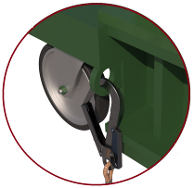A specific risk assessment and method statement must be authored to suit the lifting of the Loading platform from preparation of the arrangement through to final install and release of accessories.  - Prior to lifting ensure checks are made to the loading platform to ensure integrity of attachment of all components. - See list and graphic on next page for details.  - Attach tagline to aid control of configuration of platform through the initial raising process  See below graphic for typical checks to be made to Loading platforms  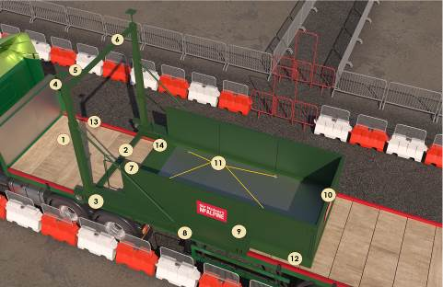The checks are inclusive of ‘Roller’ models of Loading platforms.  Please note:  This is not an exhaustive list and manufacturers checklists are to be obtained, and the checks contained within followed.  - Check base prop & leg assembly [if applicable].  - Check base bar assembly.  - Check that prop legs are plumb.  - Check prop head to spreader beam fixings or prop ‘flat’ head to slab [if applicable].  - Check screw jacks are tight and to the correct height.  - Check top bar assembly  - Check handrail assembly.  - Check all deck plates to inner beam bolt plates are intact and present [if applicable].  - Check the condition of the side structure including all fixing bolts and pins.  - Check the condition of the doors, and again ensure all fixing bolts and pins are present.  - Check condition of lifting eyes and any fixed ‘Bow’ shackles [if applicable]  - Check stoppers and bolts for deformation or signs of fatigue.  - Check rolling action [ Roller platforms only]  - Check Deck locking bolt action [Roller platforms only]  Special note:  Check for any specific requirements when lifting the deck whilst it is extended, sometimes a balancing weight may be required to be fixed to the deck prior to lifting.

Loads description: Carrying of personnel - Use of Suspended Personnel Carrier
Special note for the following schedule:

All crane manufacturer manuals forbid the use of cranes for lifting people as a failure in the hoist rope means the hook and load will fall and should be avoided.

However, if the lifting of personnel is unavoidable, then a stand-alone lift plan must be in place for the operation as per BS 7121-1:2016 which specifies that the lifting of persons should be classified as a ‘Complex lift’, therefore it is essential that each lifting operation involving the lifting of persons is individually planned, taking into account all hazards identified by the risk assessment.

As per BS7121- Part 1 : Section 4: 4.3.2.4 The appointed person responsible for the lifting operation should be present on the project

The inclusion of this lifting operation in a schedule format is to provide a brief overview of the safe lifting considerations for this lifting operation.

The schedule format can be used in the stand-alone lift plan mentioned previously.

-------------------------------------------------------------------------------------------------------------------------------------------------
References:

External:

- LOLER 1998 Lifting Operations and Lifting Equipment Regulations (LOLER) 1998
- TCIG TIN 040 Lifting of Persons with Tower Cranes
- Working at height on Mobile Cranes
- BS7121 Part 1: 20.1 Raising or lowering of personnel
- BS EN 14502-1:2010 - Cranes. Equipment for the lifting of persons Suspended baskets
- The Work at Height Regulations 2005
- HSE – Work at Height

Loads description: Carrying of personnel - Use of Suspended Personnel Carrier
User note:
The following methodology is for a ‘closed’ Suspended Personnel Carrier – The schedule, if used, should be adjusted to suit ‘open’ Suspended Personnel Carrier operations.

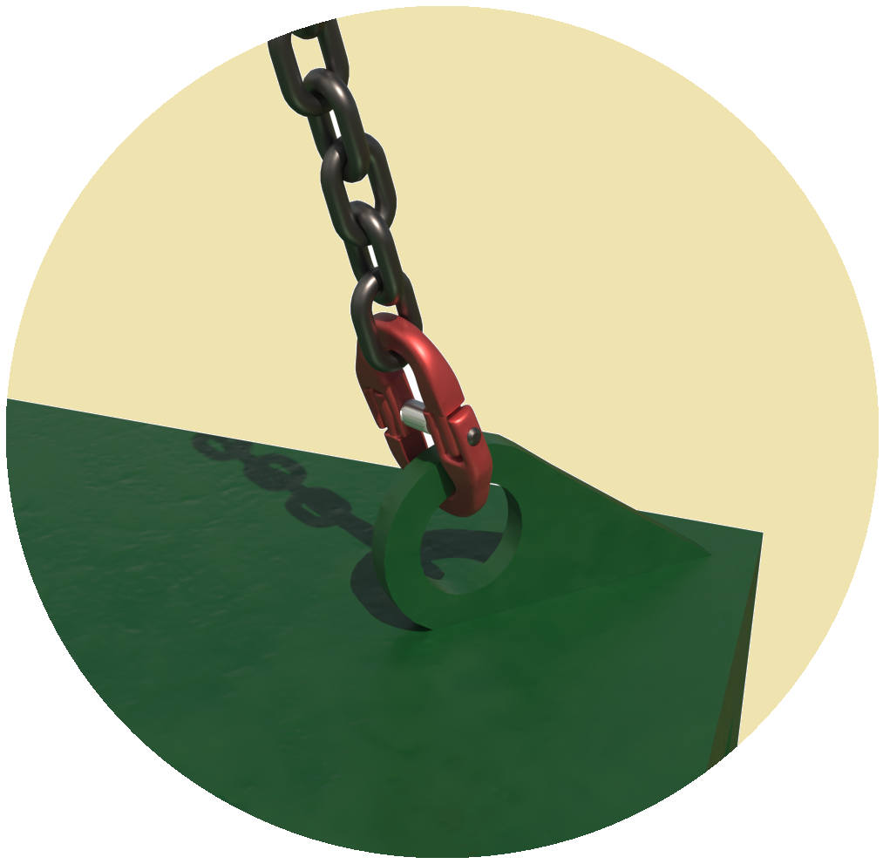 |  | Slinging methodology : - Integral chain/wire sling  - Attach master ring of integral chain sling to the hook block of the crane.  - Once personnel have entered the carrier, close access/egress ‘gate’ and ensure integrity of closure.  Please note:  Ensure the attachment accessories are of such a length, that when suspended from the hook of the crane , the vertical distance between the floor of the carrier and the crane hook is ≥ 3 m  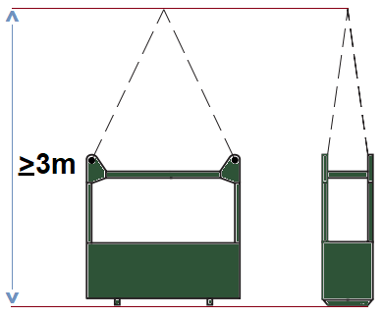
Lift Category: | Complex (requires a stand-alone lift plan – see note on previous page)
Dimensions of load: | Various dimensions: Typically: 700 mm [w] x 2210 mm [h] x 1450 mm [l] [for a 2 person access cage]
Weight of Load | Typically, 640 kg for a 2 person carrier lifting at capacity inc. weight of carrier.
Lifting accessories used with weights of accessories: | From hook block >  Note:  Suspended personnel carriers have integral chain slings attached.  Weight of chains are included in the self-weight of the carrier.  Gross weight inc. 50% FOS: [ru] @ wcs for use of externally supplied chains [for a 2 person carrier] | WLL x Mode Factor | Resulting SWL
Lifting accessories used with weights of accessories: |  | Integral chains as per designed use for carrier used at WLL. | _ kg over accessories stated  [limited to WLL of the carrier utilised]
Safe lifting considerations:  Safe lifting considerations contd.:  Safe lifting considerations contd.:  Safe lifting considerations contd.:  Safe lifting considerations contd.: | Before work taking place ensure a ‘Hierarchy of Control’ has been evaluated & applied at the planning stage:  - Ensure the possibility of MEWPs has been thoroughly investigated and deemed to be impractical  - Plan the works so that temporary or building structures can be utilized rather than resorting to access cage duties.  If the suspended personnel carrier is the only way to provide access to the work face, then:  Ensure the crane is fit for use - Refer to BS7121 – Part 1:2016 & TCIG TIN 040 for detailed crane requirements when lifting personnel.  https://www.cpa.uk.net/downloads/195/CPA-TCIG-TIN-040-Issue-A-140402.pdf  Check the weather forecast - Suspended personnel carrier duties are restricted in wind speeds over 7m/s  Do not attempt to perform the work in a ‘window’ between gusts - plan the works where there is a period of anticipated low wind speeds.  The crane operator must be competent & comfortable with performing the lifting operation.  No lone working. A minimum of 2no. operatives to be always present in the carrier, of which one must be a competent slinger signaller.  Do not enter or exit the carrier unless at ground level and cage is stationary and stable.  Prior to lifting ensure:  - All tools are tethered to relevant personnel or handrails.  - That all operatives are wearing a harness and restraint lanyard.  - That operatives attach their lanyard from the harness to an identified anchorage point.  Checks to be made to the attachment point to ascertain it is fit for use  [Seek manufacturer’s guidance if the information isn’t readily available from official literature.]  - Ensure the length of the lanyard restricts access from the carrier.  Limit the amount of time spent utilising the suspended personnel carrier.  Keep the work short-term.  There must always be a slinger-signaller in the carrier with a radio that has a dedicated crane channel for communication with the crane operator, lift supervisor & appointed person.  In case of radio failure or the battery running out, make sure that you have the operative's phone numbers - Ensure that phones are adequately charged.  Ensure that communications to the crane operator are performed on a licensed Ofcom registered radio frequency channel.  Hold point:  Only use dedicated crane communication radios.  Radio checks to be performed prior to entering the carrier.  Slinger - signaller to be issued with a fully charged ‘spare’ battery  Ensure that there are spare batteries put aside solely for suspended personnel carrier operations if anticipated.  Slinger signaller and crane operator to have a full understanding of the English language so that there is no ambiguity when instructions are given.  Slinger signaller and other operatives to have adequately charged mobile phones as a backup in case of catastrophic communication failure.  Hold point:  All operatives involved to have each other’s mobile number, inclusive of the lift supervisor and appointed person  Personnel in the carrier must be:  - Harness trained in the use of the harness being used.  - Have undergone working at height training  - Of a calm and pragmatic disposition.  - Physically fit.  Whilst in the cage do not:  - Lean from the carrier structure.  - Stand on the guardrails or place materials on platforms, guardrails.  - Use boxes , steps etc. to gain extra height.  - Behave in a way that will cause ‘rocking’ movement of the carrier .  A suitably risk assessed rescue plan to be in place prior to the lifting operation taking place which must consider [non-exhaustive]:  - Operative’s requirements if they find themselves in the carrier for some time due to mechanical failure of the crane  - Placement of a safety rope in the carrier of sufficient length so that food, drink, extra clothing, and rescue equipment can be attached for ‘pulling up’ into the carrier structure.  - The rope should be contained within suitable containment i.e. bag etc. and secured to an identified ‘storage’ point within the confines of the carrier structure that does not hinder the  safe execution of the works being performed  Special note:  Do not load the suspended personnel carrier with rescue items unless there is sufficient room.  This can cause its own hazards while in the confines of the carrier.  - Gauge how long the operatives will be in the carrier - Have conversations with the crane supplier for maximum ‘response times’ that are anticipated for service/repair engineers’ attendance.  Ensure the master ring of the integral chain/wire rope slings, correctly in the bowl of the crane hook  Before attachment of the carrier, ensure that the gate/door to the carrier is secure and works as anticipated & that the integral chains are fit for use and configured correctly.  Hold Point:  Any door or gate for entering or leaving a carrier should always open inwards and must have an automatic catch to prevent it from being opened inadvertently  Check attachment points for the chain/wire rope slings for any signs of deformation that could impede the safe use of the suspended personnel carrier.  Hold point:  Has the carrier undergone painting recently that could hide deformities?  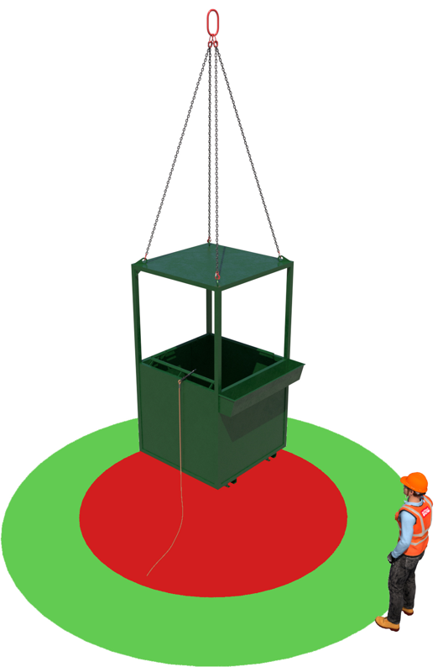  Check inside the structure of the carrier for any loose materials left over from previous use - If found remove.  Check for openings in the carrier that could enable materials or tools to fall from the structure.  Perform a test lift of the carrier for stability & lifting level  Check the underside of the structure to ensure that there isn’t anything adhered/attached to the bottom that could fall off or become dislodged when travelling across the project.  While performing the ‘test’ lift, check the weight of the carrier to ensure it is not overloaded.  Remember the attachment of tagline(s?) to the structure of the carrier to assist in the control and configuration from the initial raising, through to the final lowering of the carrier If practicable.  No standing under the carrier when landing. - Identify a ‘Safe Space’ to stand when landing the load.  Ensure there are full physical exclusion and restricted zones set up directly below the anticipated area of works  Hold point:  When setting up exclusion zones, ensure consideration has been given for an allowance with the zonal parameters for objects falling from within the confines of the carrier attending to and allowing for a worst case scenario trajectory.  See example exclusion set up below:  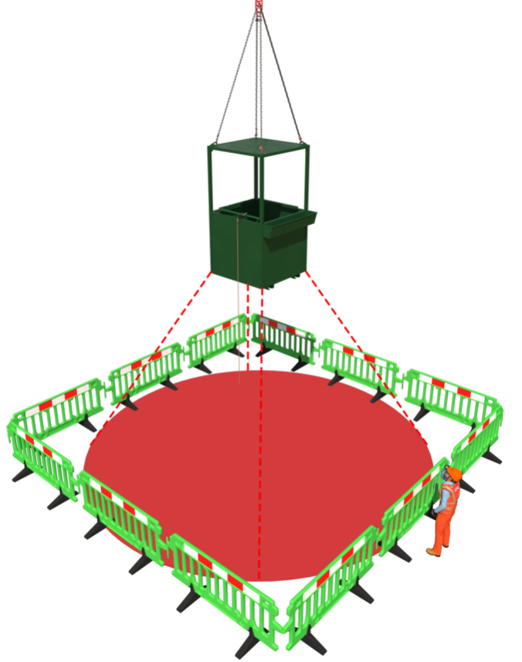

Loads description: MEWPs
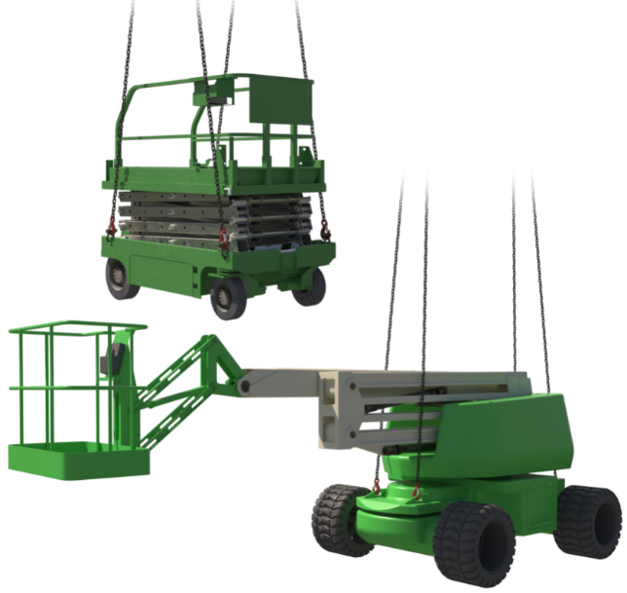  Please note:  Images are representational only - see manufacturer’s literature for lifting arrangement to be used on each model. |  | Slinging methodology:  - 4 leg chain slings will be attached to hook block of the crane.  - Attach hooks of the 4 leg chain sling directly to the identified lifting points of the MEWP  Please note:  - A specific wind speed assessment is required when considering the limiting wind speed when lifting such machines.  - 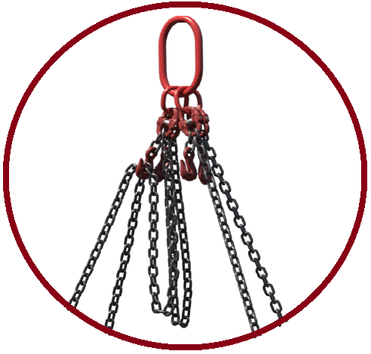Bow shackles may be required between the hooks of the chain sling and the identified lifting point on the MEWP to allow a safe attachment.  - Chain slings may require shortening to suit a level load
Lift Category: | Intermediate [as minimum] |  |  | Complex [dependant on localised parameters and hazards]
Dimensions of load: | Various dimensions and weights over different models. - See manufacturer’s operations manual or contact supplier for information
Weight of Load
Lifting accessories used with weights of accessories: | From hook block >  4 Leg chain slings WLL 8.4 t @ 103kg  ---------------------------------------------  _no. Bow shackles WLL _t @ _kg ea.  Gross weight inc. 10% FOS: _t [ru] |  | WLL x Mode Factor |  | Resulting SWL
Lifting accessories used with weights of accessories: |  |  | 4 leg chain slings as per design use  -----------------------------------  _no. bow shackles used as set = WLL of one multiplied by _._ = _ kg / t |  | _t over accessories stated
Alternative methodology: | Various methodologies use over varying models. – See manufacturer’s operating manuals for guidance on how to lift the MEWP. If the guidance is unclear, then contact the supplying company or manufacturer for definitive information.  Example of manufacturer’s guidance on lifting arrangement:  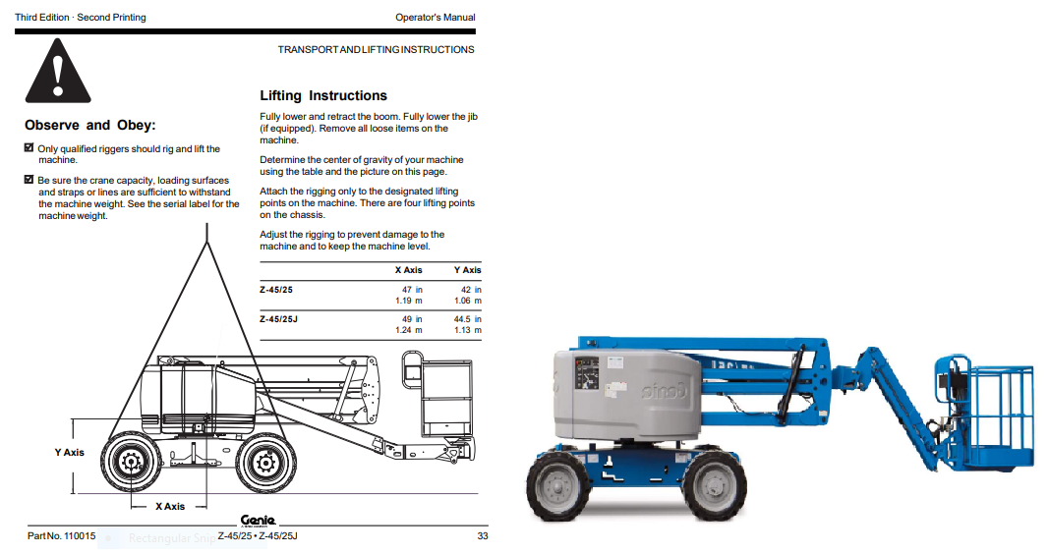
Safe lifting considerations: | - Ensure the machine is switched off prior to lifting  - Verify that the identified lifting points are free from deformities that could affect the integrity of the attachment of the accessories.  - Check structure of the MEWP for any signs of hydraulic leaks.  - Check that the accessories passing near or over any component part or structure of the MEWP that, once weight has been taken, will not subject the MEWP to crushing or undue pressure.  Please note:  Handrails etc. are easily bent meaning the machine will have to be quarantined until any damage repaired.  - Ensure that the platform and structure of the MEWP is free from loose materials and tools. If found, remove.  - During the test lift check the underside and tyres/wheels of the MEWP for any mud etc. that may have adhered.

Loads description: Toolbox
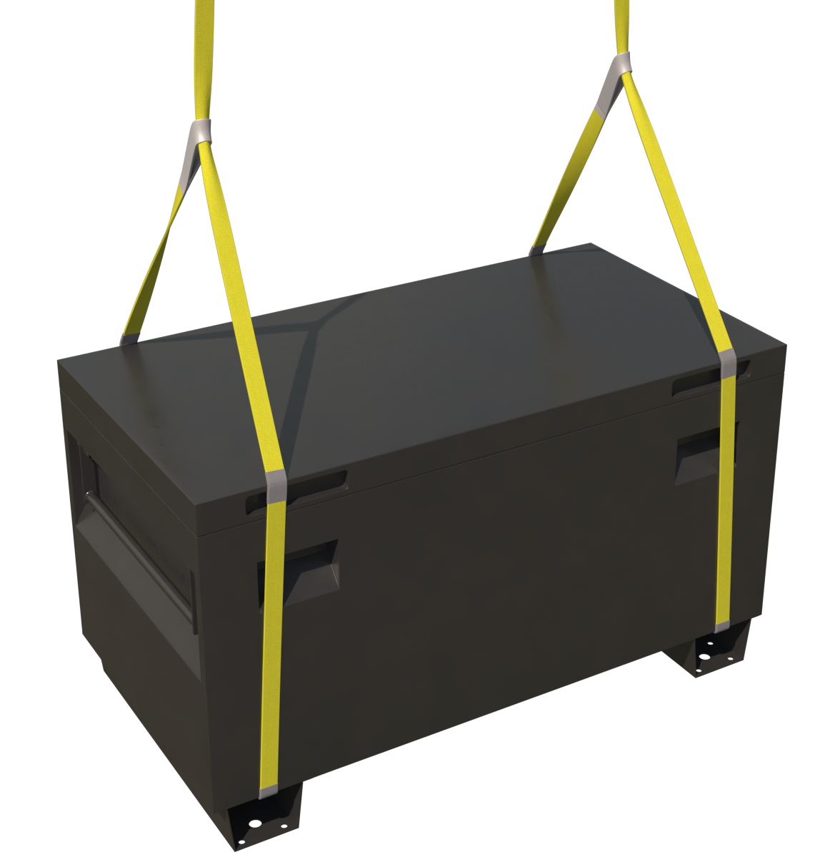 |  | Slinging methodology:  - 4 leg chain slings will be attached to hook block of the crane. Only 2 legs required so any unused chains will be hung back to the master ring.  - Attach webbing slings min WLL 2 t through the fork points of the toolbox and around the structure of the box in a single wrap captured ‘choke’ configuration.  Please note:  If box doesn’t have fork points, then the slings should be double wrapped.
Lift Category: | Basic
Dimensions of load: | Various dimensions: Typically: 550 mm [w] x 590 mm [h] x 1186 mm [l]
Weight of Load | Typically, 75kg empty  Please note:  Typically, toolboxes do not have a WLL.  Max. allowable weight on SRM projects for lifted toolboxes will be 1t unless otherwise stated in manufacturer’s literature
Lifting accessories used with weights of accessories: | From hook block >  4 Leg chain slings WLL 8.4 t @ 103kg  ---------------------------------------------  Webbing slings WLL 2 t Min 6m (l) [for single wrap] & 8m (l) for [the double wrap]. @ 10kg  Gross weight inc. 10% FOS: 1.23 t [ru] for fully laden toolbox with SRM permissible weight | WLL x Mode Factor | Resulting SWL
Lifting accessories used with weights of accessories: |  | 4 leg chain slings with 2 legs in use - WLL of one leg multiplied by 1.4 = 4.41 t  -------------------------------------  2 webbing slings used a set in a choke configuration = [WLL of one sling multiplied by 1.4] x .8 = 2.24 t | 2.24 t over accessories stated
Alternative methodology: | Chain slings can be employed in the same configuration stated for the webbing slings.  Ensure when sling with chain slings that the chains, when tightened, do not affect the integrity of the box i.e., crush or deform the structure  If size of hook block allows, then the webbing slings can be directly attached.  DO NOT OVERCROWD THE BLOCK
Safe lifting considerations:  Safe lifting considerations contd.: | - During test lift, check the underside of the toolbox for any materials, mud etc, that could have adhered itself to the bottom of the box structure. If applicable check the fork points for the same.  - Check structure of box for creases or holes in base and sides that could affect the safe lifting.  - Check load for level.  - Ensure that any materials, tools etc. are secured so that any movement in the box doesn’t affect the CoG through the lift. If there is doubt, then remove prior to lifting.

Loads description: Transformer box up to 20kva
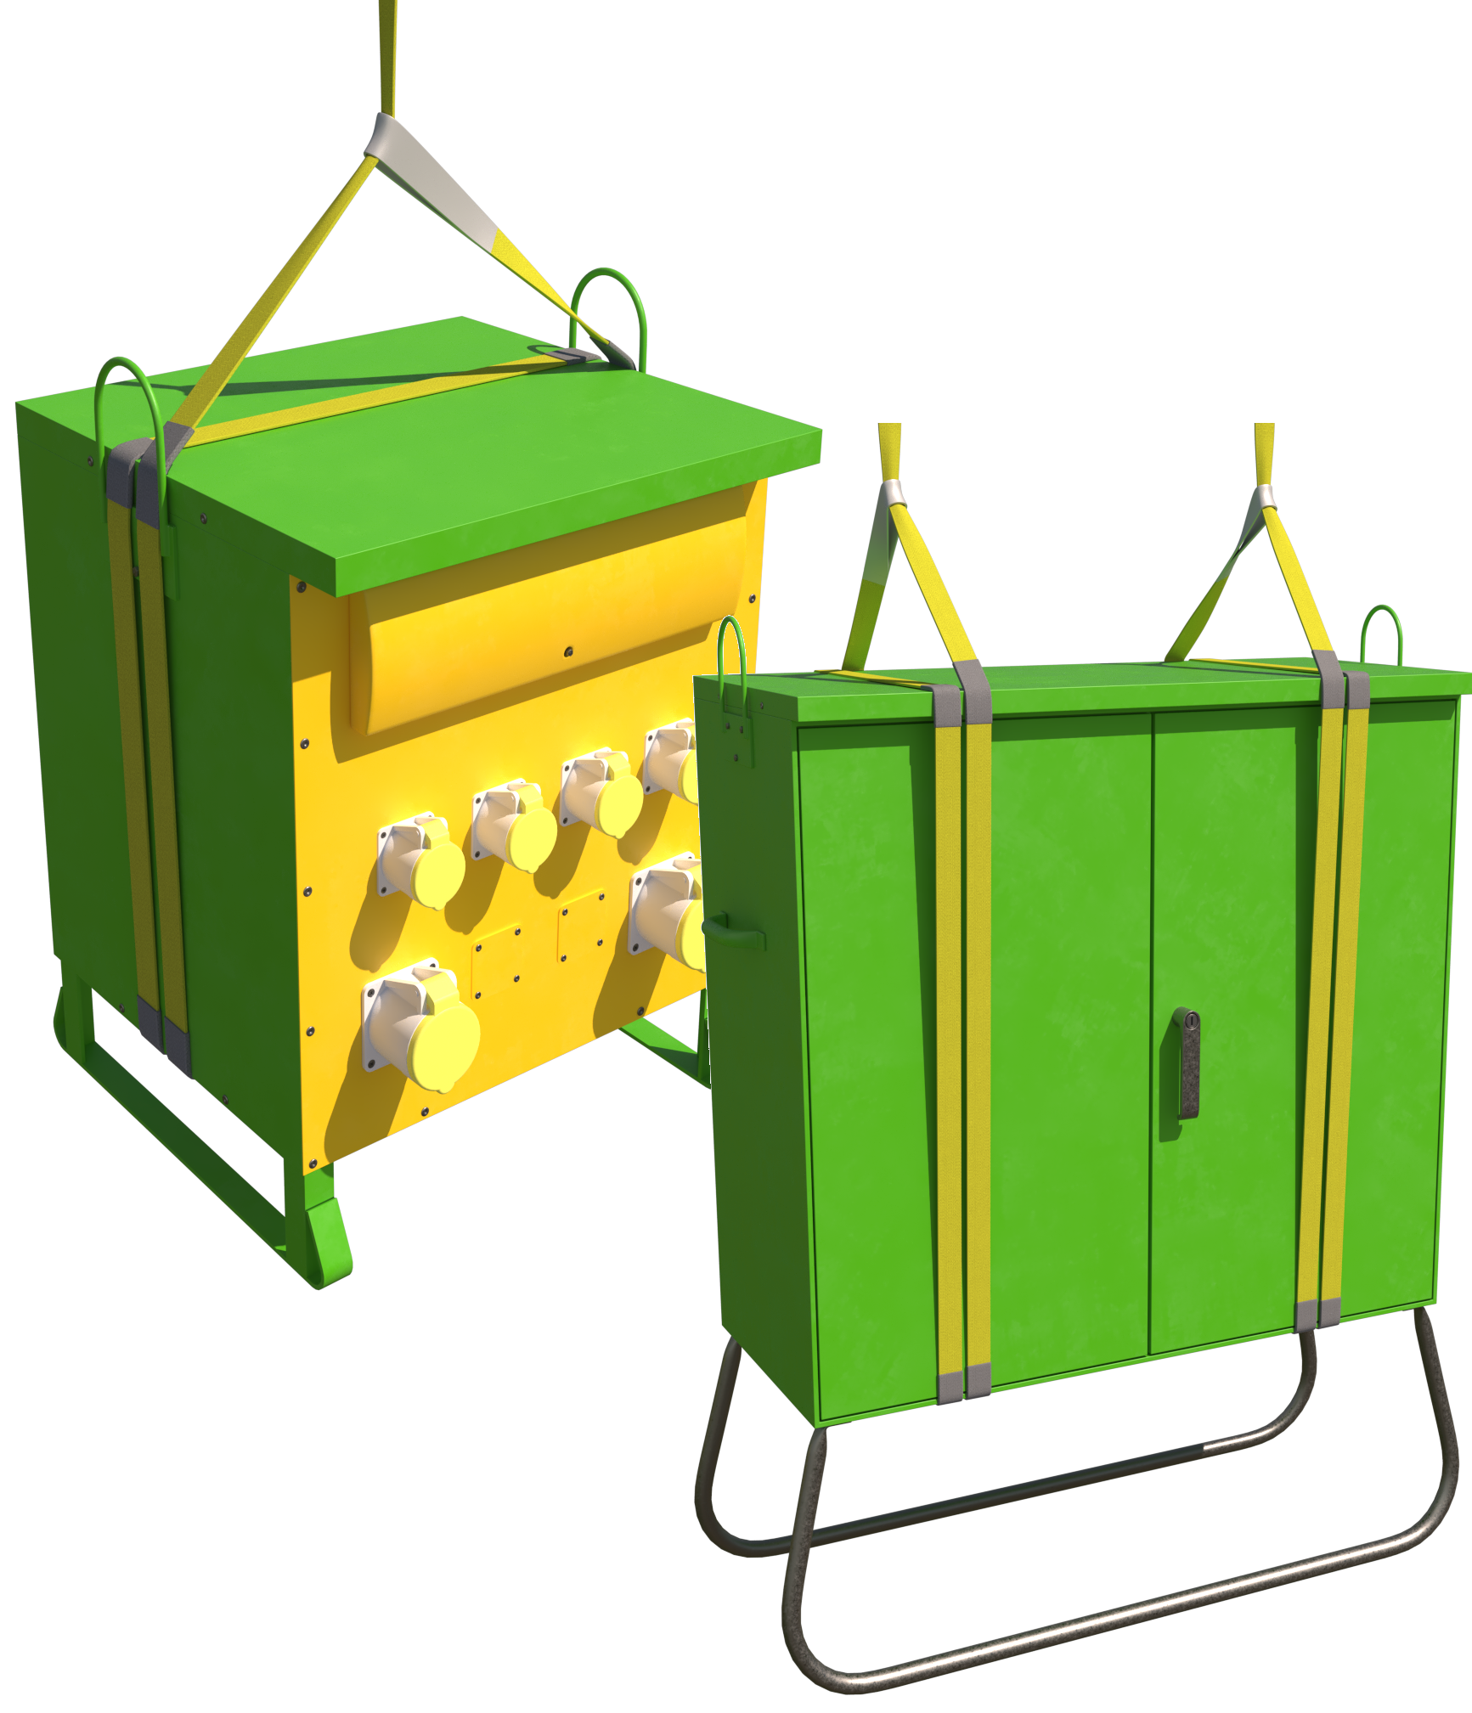 |  | Slinging methodology:  - 4 leg chain slings will be attached to hook block of the crane. Only 2 legs required so any unused chains will be hung back to the master ring.  - Attach 2no. Webbing sings min WLL 2 t around the transformer box in a double wrap ‘choke configuration  Please note:  For smaller transformer boxes a single webbing sling can be used in a double wrap configuration around the box as long as it is fed through the carrying handle situated to top of the box to form a captured ‘choke’
Lift Category: | Basic
Dimensions of load: | Various dimensions: Typically, 640 mm [w] x 950 mm [h] x 1500 mm [l]
Weight of Load | Typically, 300 kg for dimensions given
Lifting accessories used with weights of accessories: | From hook block >  4 Leg chain slings WLL 8.4 t @ 103kg  ---------------------------------------------  Webbing slings WLL 2 t Min 4m (l) @ 10kg  Gross weight inc. 10% FOS: 455 kg [ru] | WLL x Mode Factor | Resulting SWL
Lifting accessories used with weights of accessories: |  | 4 leg chain slings with 2 legs in use - WLL of one leg multiplied by 1.4 = 4.41 t  -------------------------------------  2 webbing slings used a set in a choke configuration = [WLL of one sling multiplied by 1.4] x .8 = 2.24 t | 2.24 t over accessories stated
Alternative methodology: | Chain slings can be used in the same configurations around the boxes as the webbing slings shown.  If size of hook block allows, then the webbing slings can be directly attached.  DO NOT OVERCROWD THE BLOCK
Safe lifting considerations: | - Check structure of box for any lose tools etc. that could fall when lifting.  - Check any compartments for loose tools or equipment that may have been placed inside.  - Check all doors [if applicable] are locked/secured prior to lifting.  - Ensure that any leads/cable have been disconnected.  - Protect the webbing sings from any burrs or sharp edges on the box structure by using wear sleeves at the pinch points  - Check the data plate on the side of the box for weight.  DO NOT LIFT FROM THE MANUAL HANDLES

Loads description: Pedestrian barriers
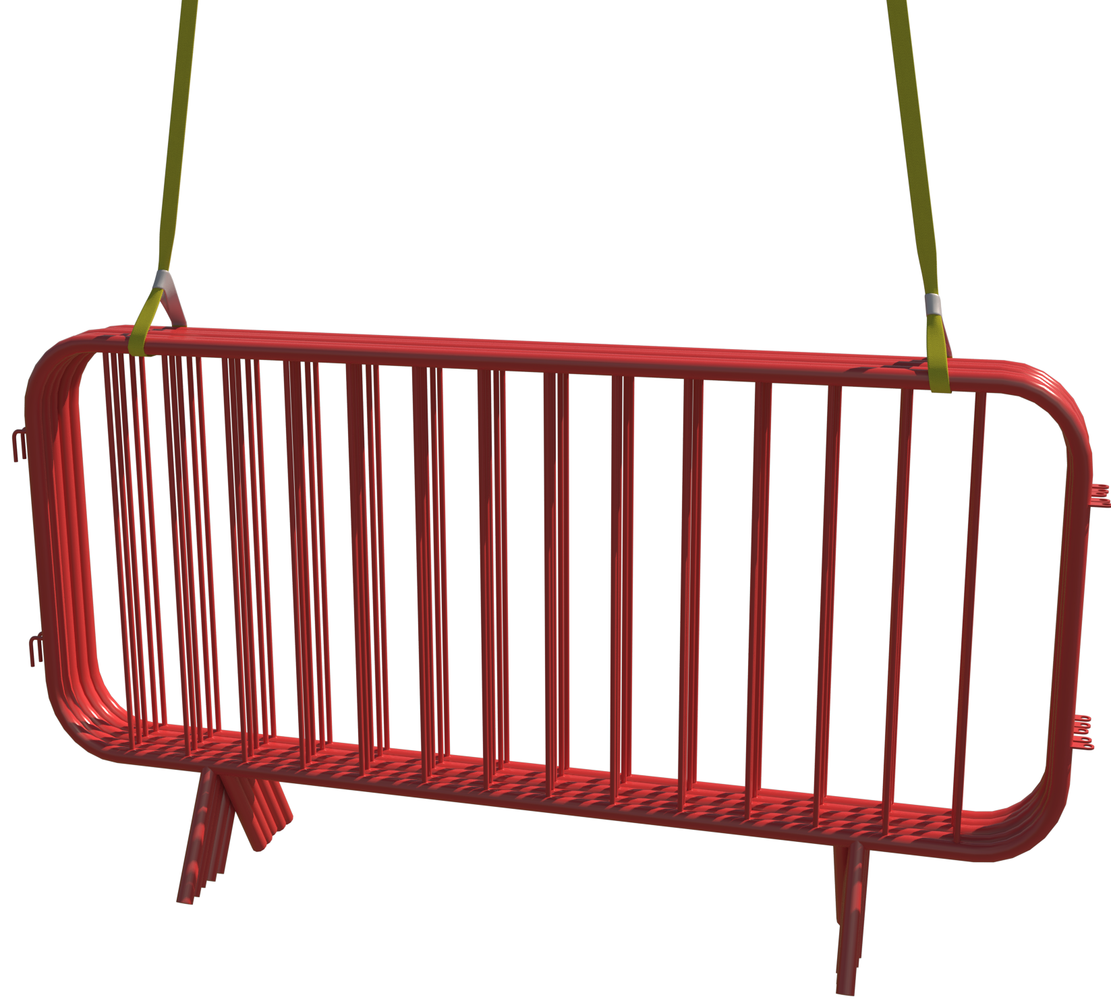 |  | Slinging methodology:  - 4 leg chain slings will be attached to hook block of the crane. Only 2 legs required so any unused chains will be hung back to the master ring.  - Attach 2no. Webbing sings min WLL 2 t through the vertical barrier ‘stack’ in a ‘choke configuration.
Lift Category: | Basic
Dimensions of load: | Various dimensions: Typically, 100 mm [w] x 1100 mm [h] x 2300 mm [l]
Weight of Load | Typically, 400 kg for vertical ‘stack’ of 25 @ 16 kg ea. barrier
Lifting accessories used with weights of accessories: | From hook block >  4 Leg chain slings WLL 8.4 t @ 103kg  ---------------------------------------------  Webbing slings WLL 2 t Min 4m (l) @ 10 kg  Gross weight inc. 10% FOS: 565 kg [ru] | WLL x Mode Factor | Resulting SWL
Lifting accessories used with weights of accessories: |  | 4 leg chain slings with 2 legs in use - WLL of one leg multiplied by 1.4 = 4.41 t  -------------------------------------  2 webbing slings used a set in a choke configuration = [WLL of one sling multiplied by 1.4] x .8 = 2.24 t | 2.24 t over accessories stated
Alternative methodology: | Chain slings can be used in the same configuration as the webbing slings.  If size of hook block allows, then the webbing slings can be directly attached.  DO NOT OVERCROWD THE BLOCK
Safe lifting considerations: | - Sling load to allow a safe landing.  - Check the legs of the panels for any mud etc. that could be in the leg from where it was stored or used.

Loads description: Heras fence panels - Stillage & Loose bundles
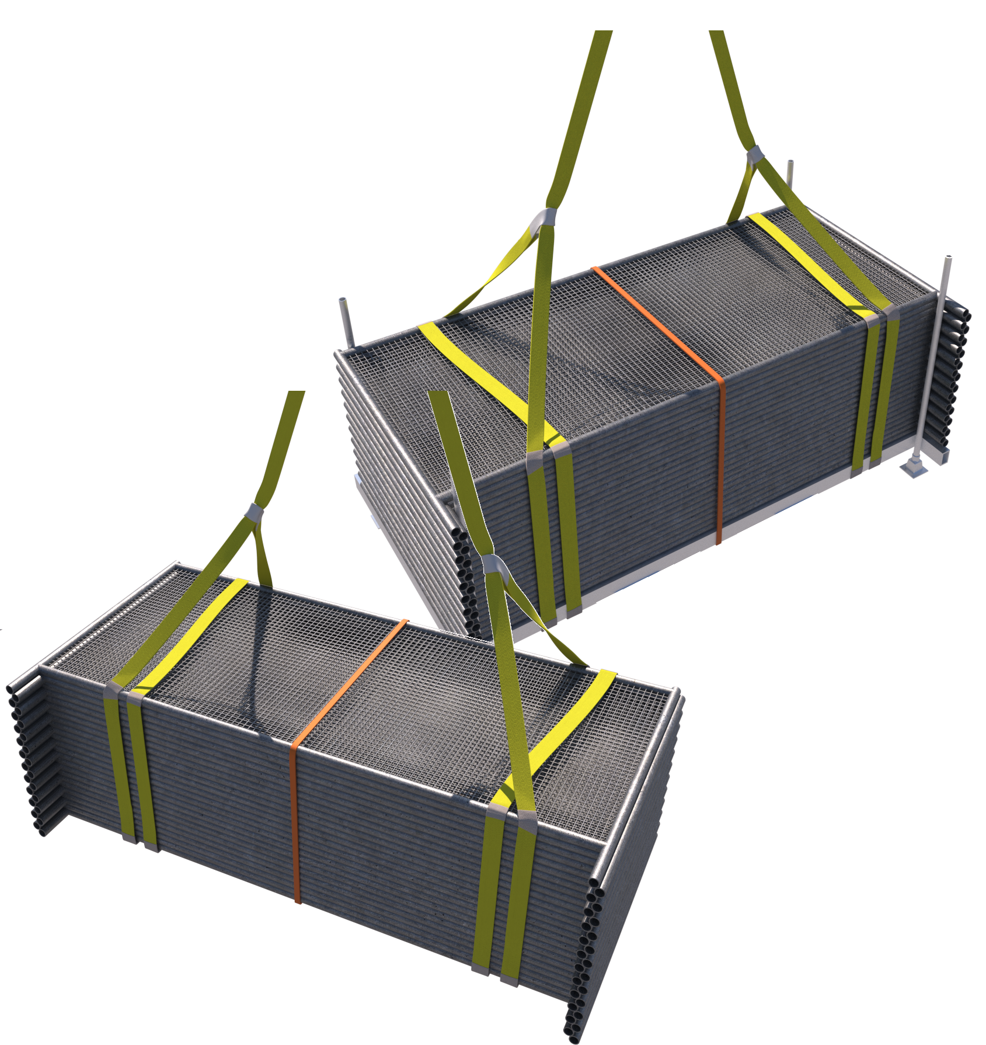 |  | Slinging methodology: - In stillage  - 4 leg chain slings will be attached to hook block of the crane. Only 2 legs required so any unused chains will be hung back to the master ring.  - Attach 2no. Webbing sings min WLL 2 t around the stillage in a double wrap ‘choke’ configuration.  Slinging methodology: - Loose  - 4 leg chain slings will be attached to hook block of the crane. Only 2 legs required so any unused chains will be hung back to the master ring.  - Attach 2no. Webbing sings min WLL 2 t around the panel stack in a double wrap ‘choke’ configuration.
Lift Category: | Basic
Dimensions of load: | Various dimensions but typically: 2000mm [w] x 1550mm [h] x 3500mm [l] [in stillage]
Weight of Load | Typically, 624kg [30 panels in stillage] & 420kg [30 panels loose]
Lifting accessories used with weights of accessories: | From hook block >  4 Leg chain slings WLL 8.4 t @ 103kg  ---------------------------------------------  Webbing slings WLL 2te. Min 10m (l) @ 15 kg  Gross weight inc. 10% FOS: 817 kg [ru] wcs in stillage | WLL x Mode Factor | Resulting SWL
Lifting accessories used with weights of accessories: |  | 4 leg chain slings with 2 legs in use - WLL of one leg multiplied by 1.4 = 4.41 t  -------------------------------------  2 webbing slings used a set in a choke configuration = [WLL of one sling multiplied by 1.4] x .8 = 2.24 t | 2.24 t over accessories stated
Alternative methodology: | If size of hook block allows, then the webbing slings can be directly attached.  DO NOT OVERCROWD THE BLOCK
Safe lifting considerations: | - Protect the webbing sings from any burrs or sharp edges on stillage and panel structures by using wear sleeves at the pinch points.  - Check the feet of the stillage for any mud etc. that could be in the leg from where it was stored.  - Ensure the integrity of the load by using a ratchet strap or securing banding around the load.  - Ensure when landing loose panels that timbers/spacers are of sufficient size to allow safe removal of accessories.

Loads description: Excavator buckets
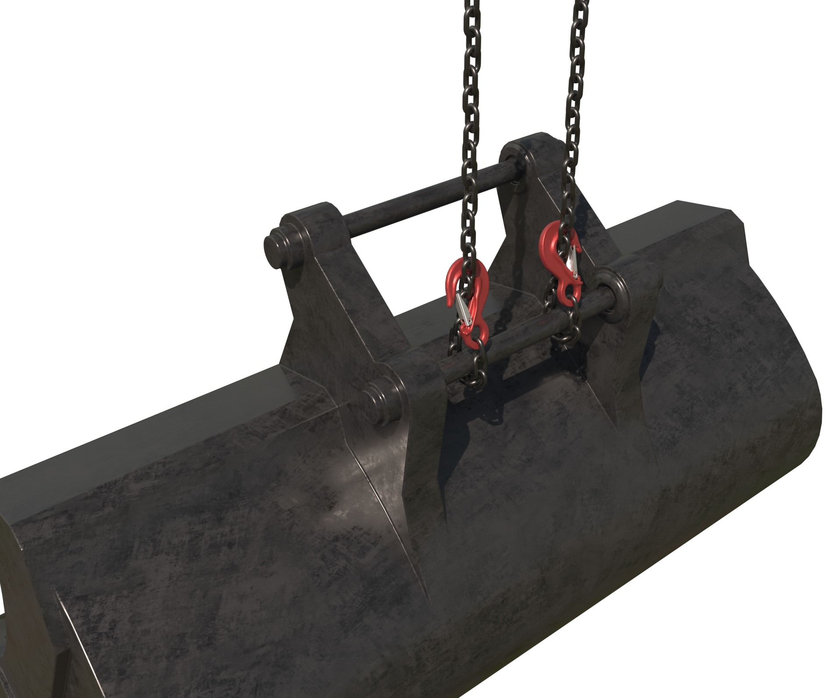 |  | Slinging methodology:  - 4 leg chain slings will be attached to hook block of the crane. Only 2 legs required so any unused chains will be hung back to the master ring.  - Attach the chain slings around the ‘pin’ of the excavator bucket in a single wrap, captured choke configuration.  Please note:  If smaller buckets do not allow room for 2 chains, then a single chain can be attached in the same configuration.
Lift Category: | Basic
Dimensions of load: | Various dimensions: 1200mm [l] x 973mm [l] x 1560mm [d] [for a 22t excavator digging bucket]
Weight of Load | Typically, 1.629 t For given dimensions
Lifting accessories used with weights of accessories: | From hook block >  4 Leg chain slings WLL 8.4 t @ 103kg  Gross weight inc. 10% FOS: 1.906 t [ru] | WLL x Mode Factor | Resulting SWL
Lifting accessories used with weights of accessories: |  | 4 leg chain slings with 2 legs in use - WLL of one leg multiplied by 1.4 = 4.41 t | 4.41 t over accessories stated
Alternative methodology: | 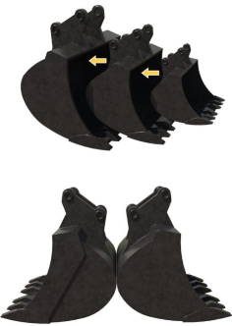  Multiple buckets can be slung together.  When lifting multiple buckets, consider the safe landing of the buckets.  To ensure a safe configuration of landing either sling the buckets in a ‘stack, where the buckets are arranged to fit inside each other or sling the buckets ‘back-to-back’.  In each methodology ensure the chains slings capture all the pins on each bucket.
Safe lifting considerations: | 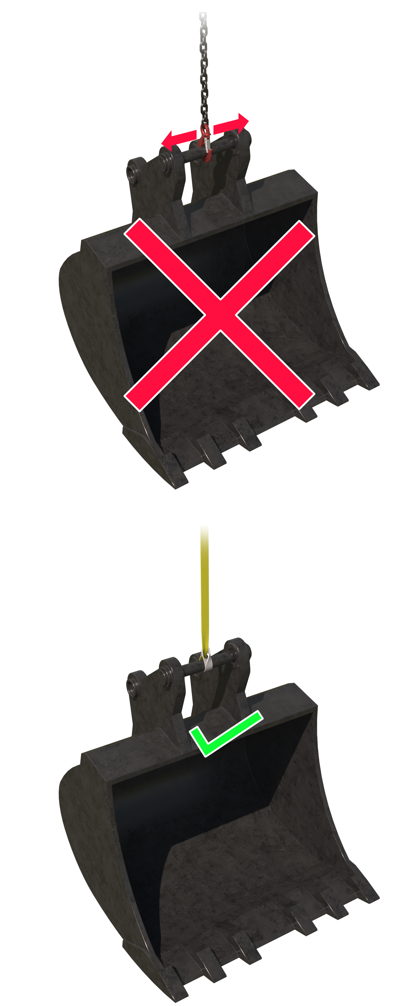  - Check integrity of the ‘pin’ prior to lifting. Check for splits or cracks that could affect the integrity of the attachment  - When slinging smaller buckets, do not sling with direct attachment to the ‘pin’.  The bucket could slide against the hook while travelling and impose side loadings on the hook that may not fail at the time of lift but will affect long term use of the chain.  - If you can’t choke a chain sling around the ‘pin’, then utilise a webbing sling of sufficient WLL in ‘choke configuration.  - Check bucket interior for mud, earth etc. that could fall when lifted.

Loads description: Timber ‘Ekki’ mats
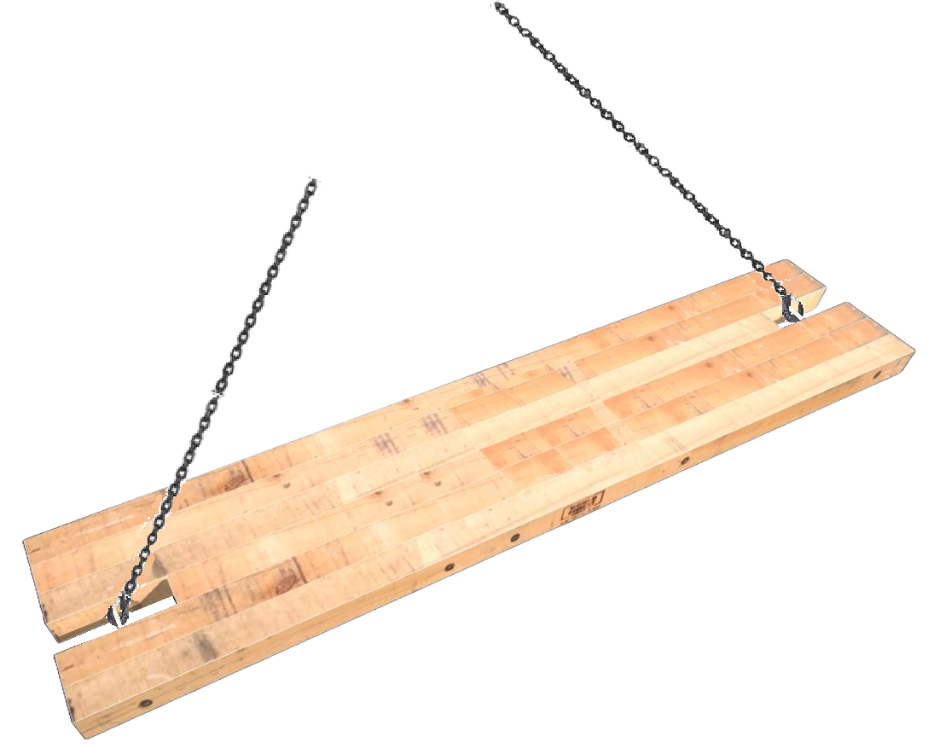 |  | Slinging methodology:  - 4 leg chain slings will be attached to hook block of the crane. Only 2 legs required (see note below) so any unused chains will be hung back to the master ring.  - Attach the hooks of the chain slings to the lifting points.  Please note:  Some timber mats will arrive with 4 ‘notches’ for the attachment points, when lifting these mats ALL lifting points must be used.
Lift Category: | Basic
Dimensions of load: | Various dimensions (but for purposes of schedule) : 5000 mm [l] x 1000 mm [w] x 150 mm [h]
Weight of Load | Typically, .981 tonnes for dimensions given of a hardwood excavator mat
Lifting accessories used with weights of accessories: | From hook block >  4 Leg chain slings WLL 8.4 t @ 103kg  Gross weight inc. 10% FOS: 1.193 t [ru] | WLL x Mode Factor | Resulting SWL
Lifting accessories used with weights of accessories: |  | 4 leg chain slings with 2 legs in use - WLL of one leg multiplied by 1.4 = 4.41 t | 4.41 t over accessories stated
Alternative methodology:  Alternative methodology: | 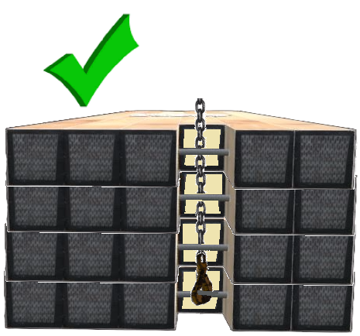Multiple mats can be slung together.  If lifting across project, then the stack or pack of mats should be treated as any other timber pack/bundle and be slung in a double wrap configuration utilising webbing slings of sufficient SWL after the mode factors have been considered. See schedule titled ‘Timber – Bundles’ for details on methodology and safe lifting considerations.  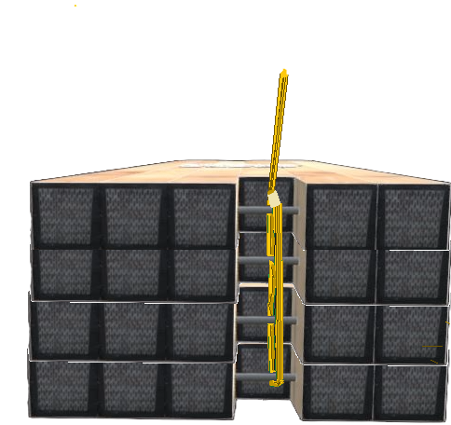It is also acceptable to lift multiple mats together by feeding the hook of a chain sling between the structure of the mats and the attachment points and hooking onto the bottom mat attachment point. Be aware that this methodology can be problematic as size of chain and spacing of aperture may not be suited for this methodology.  Best practice…  Best practice for this methodology would be to use a fabric sling in a captured choke configuration  Hold point:  Always check with the manufacturer or supplier of the mats that this methodology is acceptable and within the capabilities of the attachment points  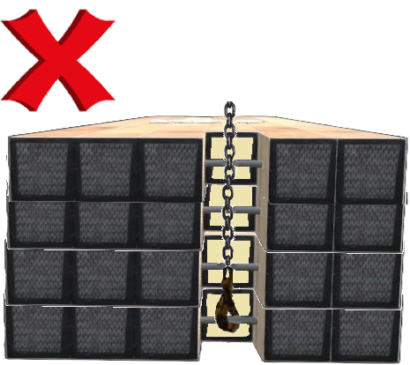Do not lift the stack or pack of mats with the chain sling fed on the outside of the attachment points as:  - The higher layers [above the bottom mat] aren’t captured by the accessories  - When attaching the hook of the chain sling to the lifting point pressure of the lift could be put on the hook that the hook isn’t designed for.  - The load is also at considerable risk of rotating as the centre of gravity of the load is above the load attachment point.  Hold point:  When using a chain sling or webbing sling fed through the attachment aperture for multi mat stacks, this should be a low-level lift for placing only - Only ever lift a maximum of 4no. mats in this configuration.
Safe lifting considerations: | - Check integrity of the attachment point prior to lifting - Check for splits or cracks around the immediate area that could affect the integrity of the attachment  - 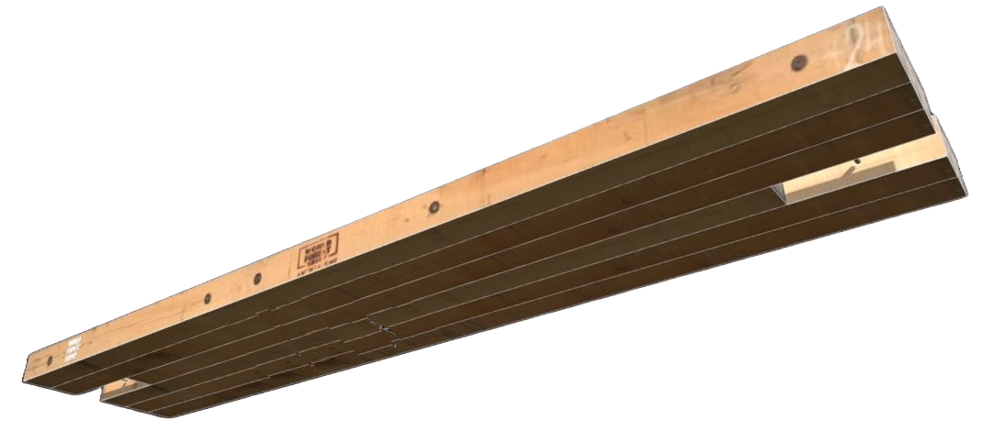Examine the structure of the mat, again for any cracks, splits, deterioration that could be problematic when lifting and bring into doubt the integrity of the load  - Ensure the underside of the mat is free from adhered materials that could fall during travel of the load.  - If required, use webbing sling wear sleeves (or similar) where the mats have sharp edges.  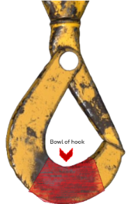  - When slinging in packs ensure securing banding is used around the load to negate any spread of the load when landed.  - Always ensure that the hook of the chain sling can move freely within the confines of the attachment point. Don’t force the hook into the aperture  - After attachment of hook, check the attachment point sits in the bowl of the hook correctly.  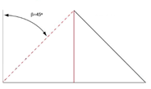  - Ensure the length of the accessories attaching to the mat(s) of sufficient length to allow for accessories used to be within a 0 to 45 deg. excluded angle.

Loads description: Template
Slinging methodology:

.
Lift Category: | Basic | Intermediate |  | Complex
Dimensions of load:
Weight of Load
Lifting accessories used with weights of accessories: | From hook block >  Gross weight inc. 10% FOS: t [ru] |  | WLL x Mode Factor |  | Resulting SWL
Lifting accessories used with weights of accessories: |  |  |  |  | over accessories stated
Alternative methodology:
Safe lifting considerations:

