A practical guidance - 3: Schedules 11 to 21
Revision 1 September ‘25

Schedule of lifts for Tower Crane

Please note:
This document has been provided by Sir Robert McAlpine Limited. It has been checked to the best of our ability but may contain unintentional errors. As per BS 7121-1:2016, CDM 2015 and LOLER, it is the user’s responsibility to verify that they understand and have made their own checks before using this document.
The user shall ensure that they properly risk assess and plan their own lifting operations to discharge their legal requirements.
No liability will be accepted for any incidents that result of those using this document.

The schedules
No. | Title:
11. | Transport stillages – Box/Bin
12. | Transport stillages – Open/Post/Pallett
13. | Containment accessories – Good cages
14. | Containment accessories – Wheeled bins
15. | Containment accessories – Brick Fork cages
16. | Containment accessories – Concrete Skips – Bale Arm
17. | Containment accessories – Waste skips with rated/tested lifting points
18. | Containment accessories – Self Discharge Boat skips
19. | Containment accessories – Gas bottle cages -Single & multi point
20. | Containment accessories – Fuel Bowser Containment accessories – Jetwash Bowser
21. | Containment accessories – Jetwash Bowser
Ref. | Blank template

Loads description: Transport stillages – Box/Bin
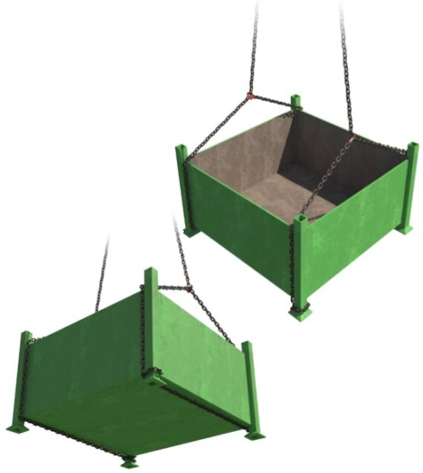 |  | Slinging methodology:  - 4 leg chain slings will be attached to hook block of the crane. Only 2 legs in use so hang the unused chains back to the master ring.  - Attach the chains slings to the stillage by feeding the chain under the stillage and taking a ‘Turn’ around the legs/feet.  - Make sure the ‘turn’ is taken around opposite legs/feet in the diagonal.
Lift Category: | Basic
Dimensions of load: | Various dimensions: Typically, 600mm [h] x 800mm [w] x 800mm [l]
Weight of Load | Typically, no more than 1 t [based on standard stillage WLL]
Lifting accessories used with weights of accessories: | From hook block:  4 Leg chain slings WLL 8.4 t @ 103kg  Gross weight inc. 10% FOS: 1.124 t [ru] | WLL x Mode Factor | Resulting SWL
Lifting accessories used with weights of accessories: |  | 4 leg chain slings with 2 legs in use in a choke configuration – [WLL of one leg multiplied by 1.4] x .8 = 3.528 t | 3.528 t Over all accessories stated
Ancillary Equipment | Use closed mesh netting to negate any lightweight materials being blown from the confines of the stillage. When using a net covering ensure the net is secured to the body of the stillage.
Safe lifting considerations: | 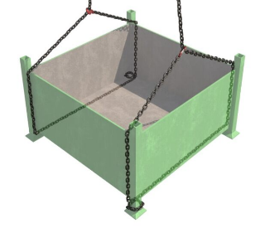  - When taking a turn around the legs/feet ensure that the chain is passed around the structure and then passed over itself. This enables the chain to be adjusted with ease while trying to sling to suit a level load.  - Check condition of the stillage prior to lifting.  - Integrity of the feet?  - Splits, dents, and creases that could affect the integrity of the structure when slinging?  - Base intact?  - Always check the feet of the stillage to just make sure that stones or mud etc./haven’t adhered themselves to the inside of the feet. Check confines of the legs for any loose materials that may be contained within.  Special note:  If lifting double stacked stillages i.e., from the bed of delivery wagon, then this must be a low-level lift only and the stillages separated as soon as possible to negate overloading the bottom stillage.  Checks to be made that not only are any pre slung slings used are of sufficient WLL to take the weight of both stillages, but that in date RoTE’s of the slings have been checked prior to lifting.

Loads description: Transport stillages – Open/Post
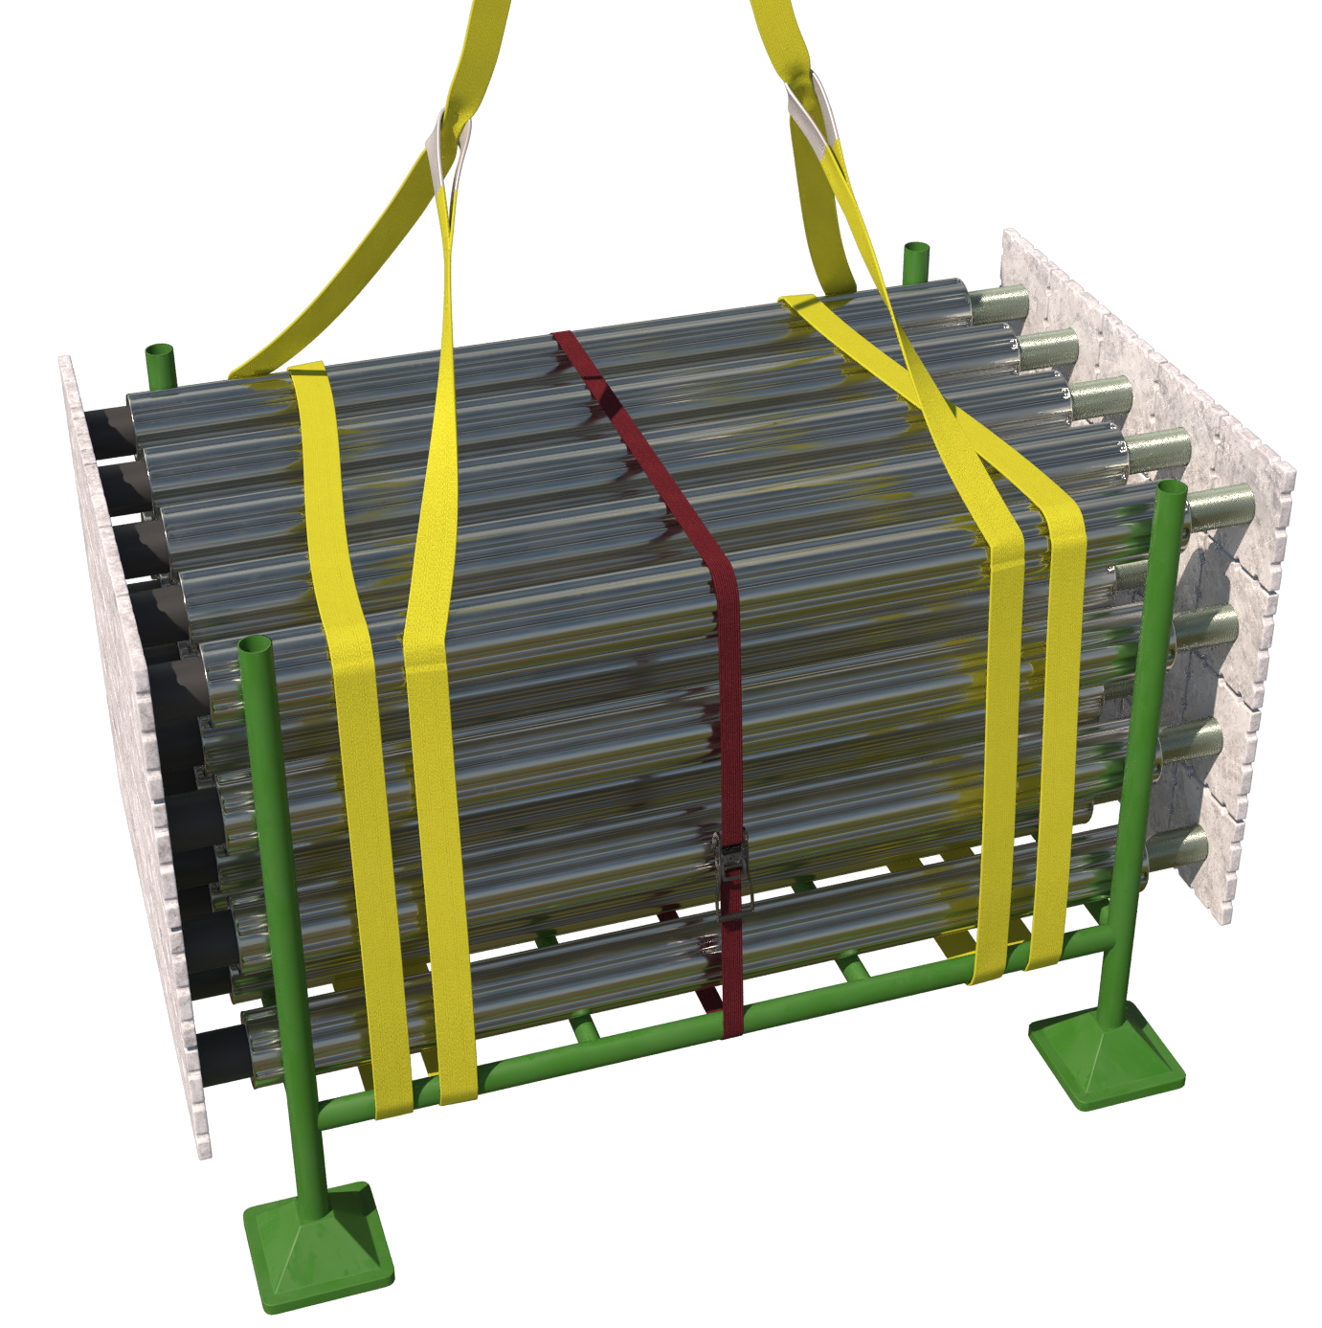 |  | Slinging methodology:  - 4 leg chain slings will be attached to hook block of the crane. Only 2 legs in use so hang the unused chains back to the master ring.  - 2no. webbing slings min WLL 2 t of sufficient length will be attached to the stillage in a double wrap – choke configuration.  - Hooks of chain slings will then be attached to the webbing slings.
Lift Category: | Basic
Dimensions of load: | Various dimensions: Typically for stillage, 1000mm [ h] x 1400mm [w] x 1030mm [l]
Weight of Load | Typically, no more than 1 t [based on standard stillage WLL]
Lifting accessories used with weights of accessories: | From hook block:  4 Leg chain slings WLL 8.4 t @ 103kg  ----------------------------------------  2no. webbing slings 8m @ 7kg  Gross weight inc. 10% FOS: 1.124 t [ru] | WLL x Mode Factor | Resulting SWL
Lifting accessories used with weights of accessories: |  | 4 leg chain slings with 2 legs in use - WLL of one leg multiplied by 1.4 = 4.41 t  -------------------------------------  2 webbing slings used a set in a choke configuration = [WLL of one sling multiplied by 1.4] x .8 = 2.24 t | 2.24 t over all accessories stated
Alternative methodology: | 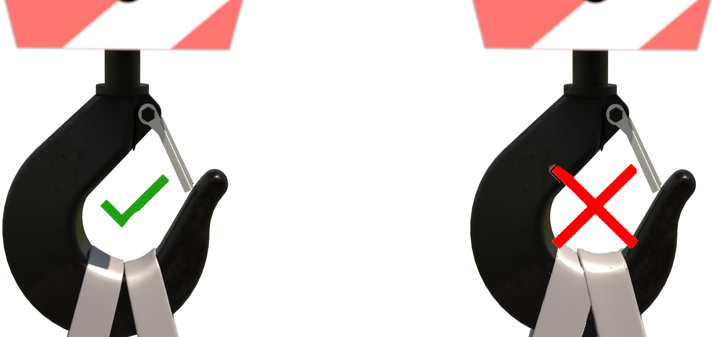  If size of hook block allows, then the webbing slings can be directly attached.  DO NOT OVERCROWD THE BLOCK
Safe lifting considerations: | - Sling positions to suit a level load.  - Securing banding or ratchet strap utilised to ensure integrity of the load.  - Check condition of the stillage prior to lifting.  - Integrity of the feet?  - Splits, dents, and creases that could affect the integrity of the structure when slinging?  - Always check the feet of the stillage to just make sure that stones or mud etc./have not adhered themselves to the inside of the feet.  - Check inside the confines of the legs for any small objects, i.e. lengths of rebar/dywidag etc. that could fall out once stillage is raised.  Special note:  If lifting double stacked stillages i.e., from the bed of delivery wagon, then this should be a low-level lift only and the stillages separated as soon as possible to negate overloading the bottom stillage.  Checks to be made that not only are any pre slung slings used are of sufficient WLL to take the weight of both stillages, but that in date RoTE’s of the slings have been checked prior to lifting.

Loads description: Containment accessories – Good cages
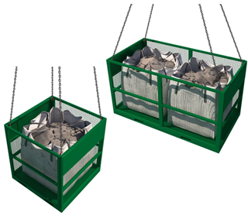 |  | Slinging methodology:  - 4 leg chain slings will be attached to hook block of the crane.  - Hooks of chain slings will then be attached to the designed lifting points of the cage.  - 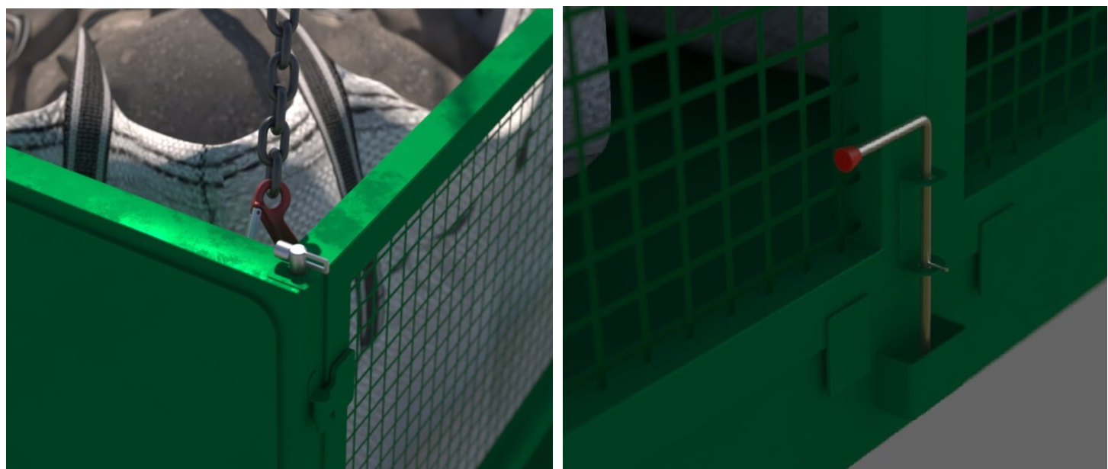Ensure all primary locking and securing mechanisms are being used as per manufacturer’s specifications and/or user guides.
Lift Category: | Basic
Dimensions of load: | Various dimensions:  1.5 t cage typically 1300mm [h] x 1360mm [l] x 1300mm [w]  3 t cage typically 1300mm [h] x 560mm [l] x 1300mm [w]
Weight of Load | Max payload as per WLL of cage utilised.
Lifting accessories used with weights of accessories: | From hook block:  4 Leg chain slings WLL 8.4 t @ 103kg  --------------------------------------------  Cage WLL 1.5 t @ 300kg [wcs]  Cage WLL 3t @ 500kg [wcs]  Gross weight inc.10% FOS: 2.094 t [ru] for 1.5 t cage & 3.964 t [ru] for 3 t cage | WLL x Mode Factor | Resulting SWL
Lifting accessories used with weights of accessories: |  | 4 leg chain slings with 4 legs in use as per design.  -----------------------------------  Goods cage being used as per design. | _t over all accessories stated [limited to WLL of goods cage used]
Ancillary Equipment: | Use close mesh netting to prevent any lightweight materials being blown for within the confines of the cage. When using a net covering ensure the net is secured to the body of the cage.
Safe lifting considerations: | - Check condition of the cage, attachment points and any locking mechanism prior to lifting. - Ensure all primary locking mechanisms on the goods cages are employed as per design use.  - Do not carry materials in the cage that exceed the height of the cage.  - Check underside of the cage for any materials that may have adhered themselves while cage has been stored, especially inside any fork tine points.  - Always use ALL attachment points when lifting.

Loads description: Containment accessories – Wheeled bins
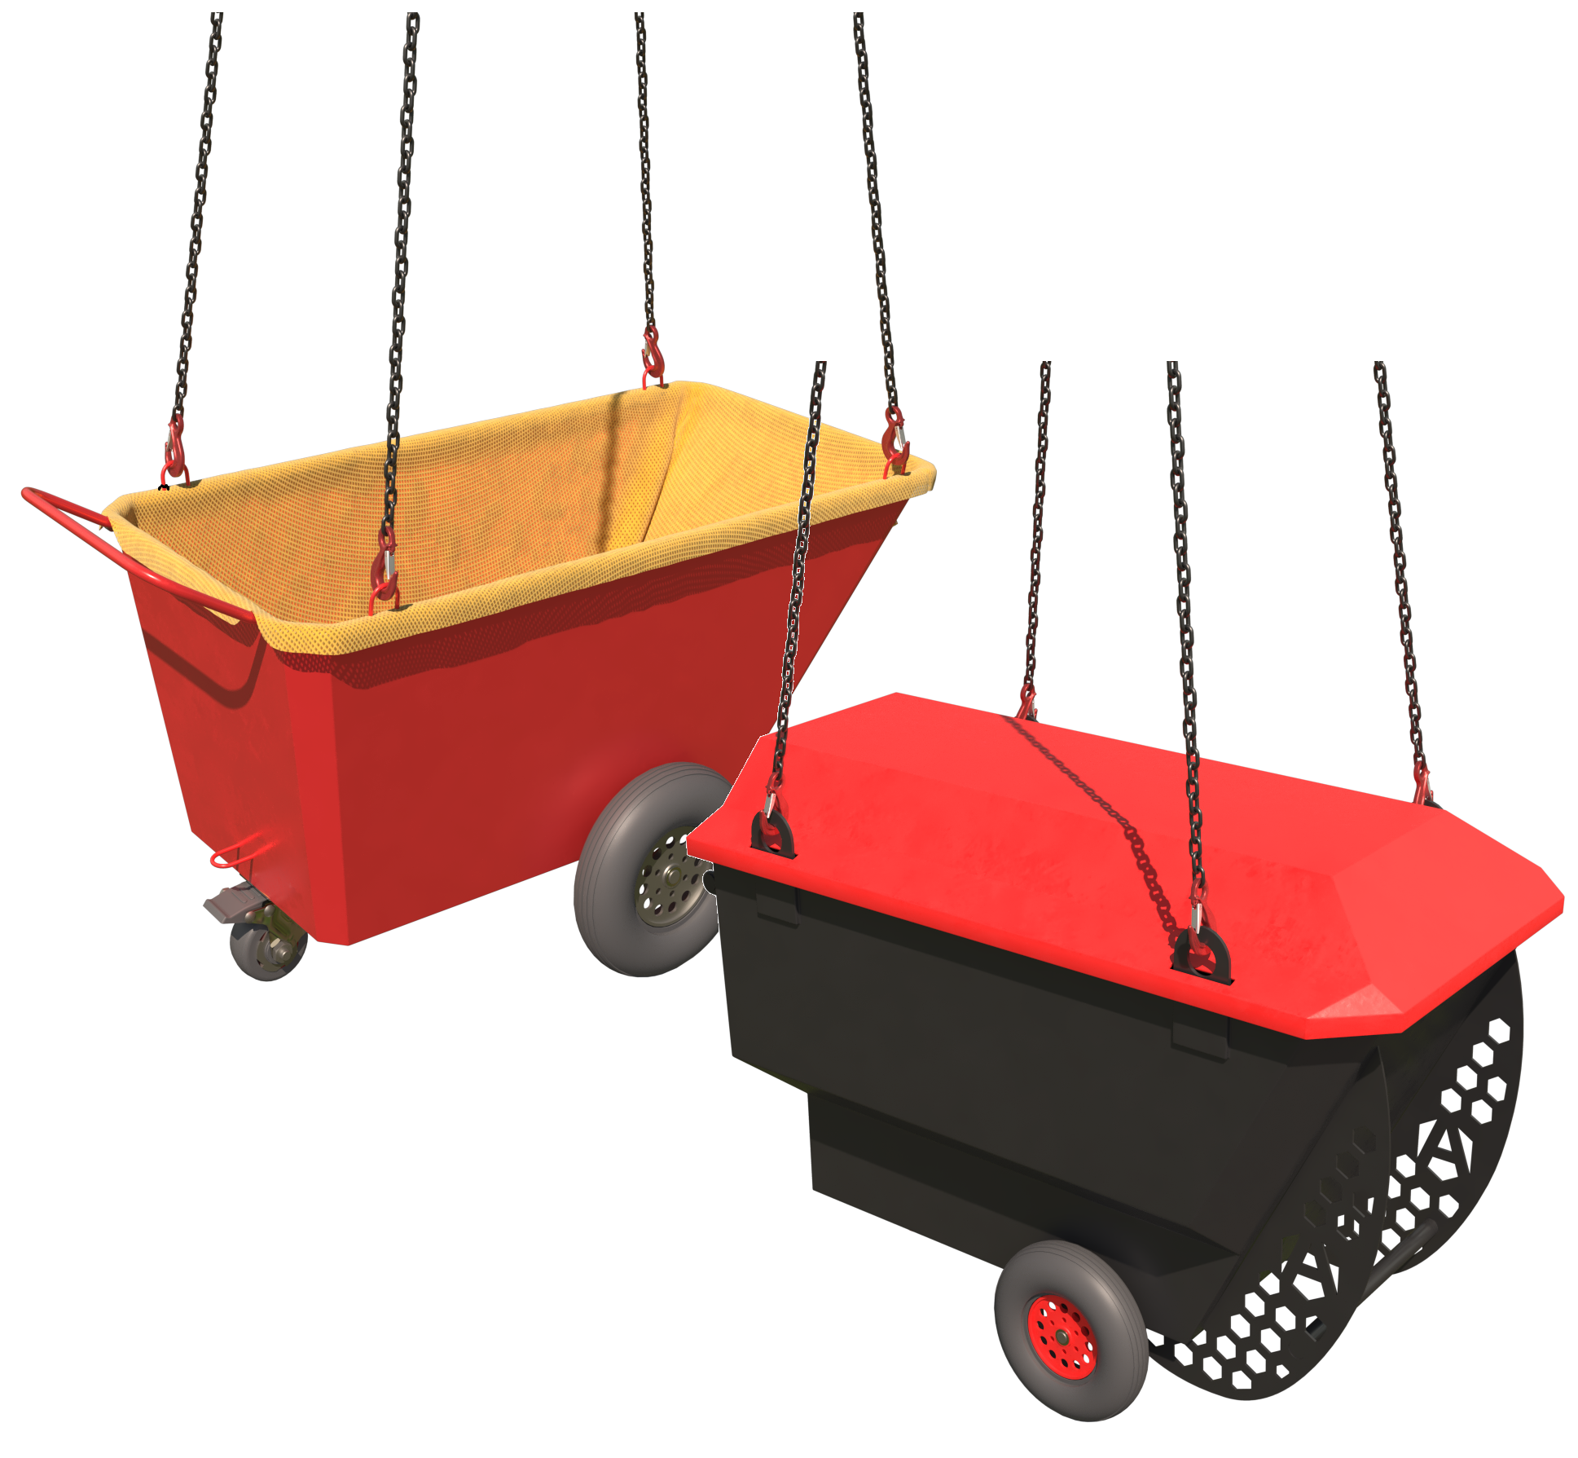 |  | Slinging methodology:  - 4 leg chain slings will be attached to hook block of the crane.  - Hooks of chain slings will then be attached to the designed lifting points of the wheeled bin.  - Use a secured net or designed ‘lid’ to ensure materials remain inside the bin during transit.
Lift Category: | Basic [empty] |  | Intermediate [for carrying load and emptying]
Dimensions of load: | Various dimensions: Typically, 760mm [w] x 1460mm [l] x 855mm [h]
Weight of Load | Typically, max. payload of wheeled bins is 750kg to 1.5 t
Lifting accessories used with weights of accessories: | From hook block:  4 Leg chain slings WLL 8.4 t @ 103kg  --------------------------------------------  Wheeled bin @ 108kg [inclusive of designed lid for some models]  Gross weight inc. 10% FOS: _ t [ru] | WLL x Mode Factor |  | Resulting SWL
Lifting accessories used with weights of accessories: |  | 4 leg chain slings with 4 legs in use as per design.  --------------------------------------  Wheeled bin being used as per design. |  | __kg over all accessories stated.  [limited to WLL of wheeled bin used]
Ancillary Equipment: | 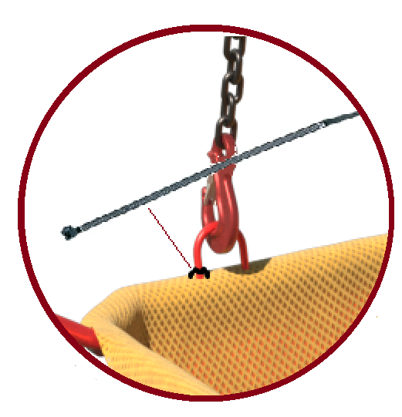  Use proprietary lid (if available for model) or close mesh netting to prevent any lightweight materials being blown from within the confines of the bin.  When using a net covering ensure the net is secured to the body of the bin.
Safe lifting considerations: | - Prior to lifting ensure that all locks to wheels on the bin are in place.  - Check condition of the wheeled bin and attachment points prior to lifting, this includes any proprietary coverings used.  - Do not carry materials in the cage that exceed the height of the bin.  - Always use ALL attachment points when lifting.  - Do not exceed the WLL of the wheeled bin.

Loads description: Containment accessories – Brick Fork cages
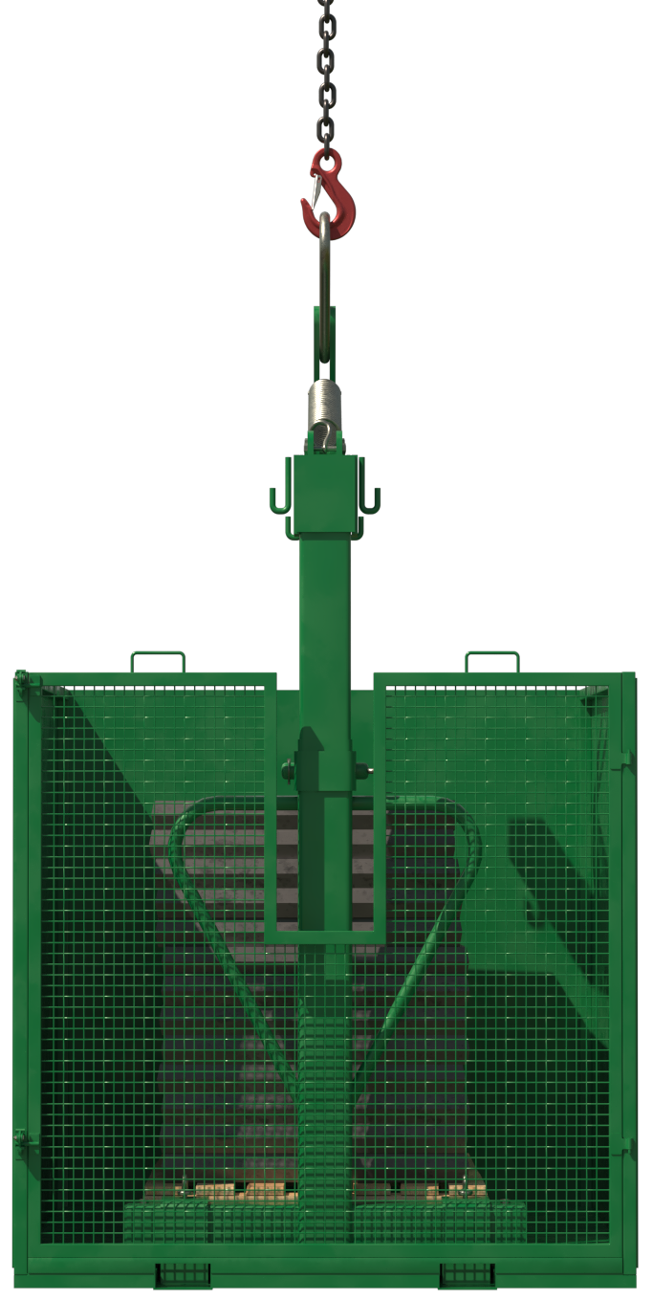 |  | Slinging methodology:  - Single leg chain sling will be attached to hook block of the crane.  - Hook of chain sling will then be attached to the designed lifting point of the fork component of the cage.  - Fork component will be inserted into pallet and pallet loaded into cage.  - Fork component will then be removed from pallet and lowered into the fork retention pockets.  - Mesh gate will be closed and secured as per manufacturer’s instructions.
Lift Category: | Basic
Dimensions of load: | Various dimensions: Typically, 1200mm [w] x 1540mm [l] x 1300mm [h]
Weight of Load | Typically, max. payload of the cages is 2 t
Lifting accessories used with weights of accessories: | From hook block:  Single leg chain sling 6m min WLL 2.5 t @ 10kg [ru]  --------------------------------------------  Brick fork cage @ 440kg  Gross weight inc. 10% FOS: 2.7 t [ru] | WLL x Mode Factor | Resulting SWL
Lifting accessories used with weights of accessories: |  | Single leg chain sling in use as per design.  --------------------------------------  Brick fork cage being used as per design. | 2 t over all accessories stated
Ancillary Equipment: | Pallet truck requirement at loading/unloading point to load/remove pallet from cage.  Please note:  Not essential but will make the operation more time efficient.
Safe lifting considerations: | - Check condition of the cage especially the mesh frontage for any dents and creases that could affect the integrity of the cage.  - Check underside of the cage in test lift for any adhered materials  - 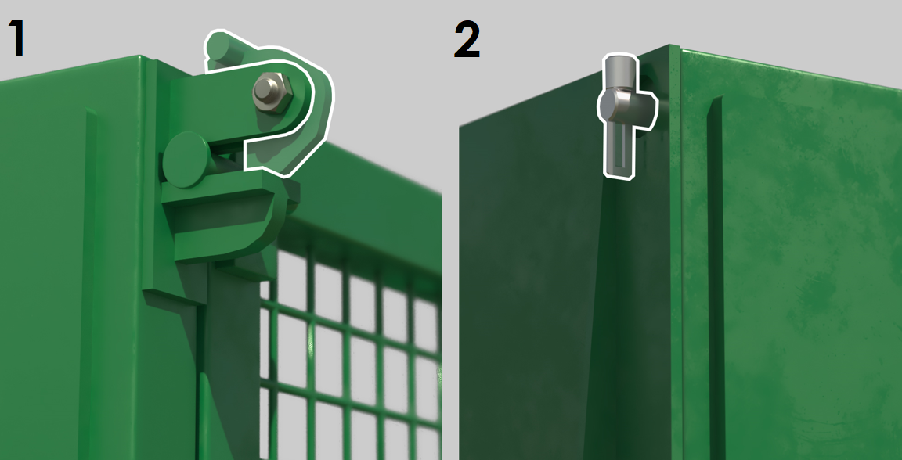 Do not carry materials in the cage that exceed the height of the cage.  - Ensure that door latches are engaged [1] and that the self-locking latch [2] is secured prior to lifting.

Loads description: Containment accessories – Concrete Skips – Bale Arm
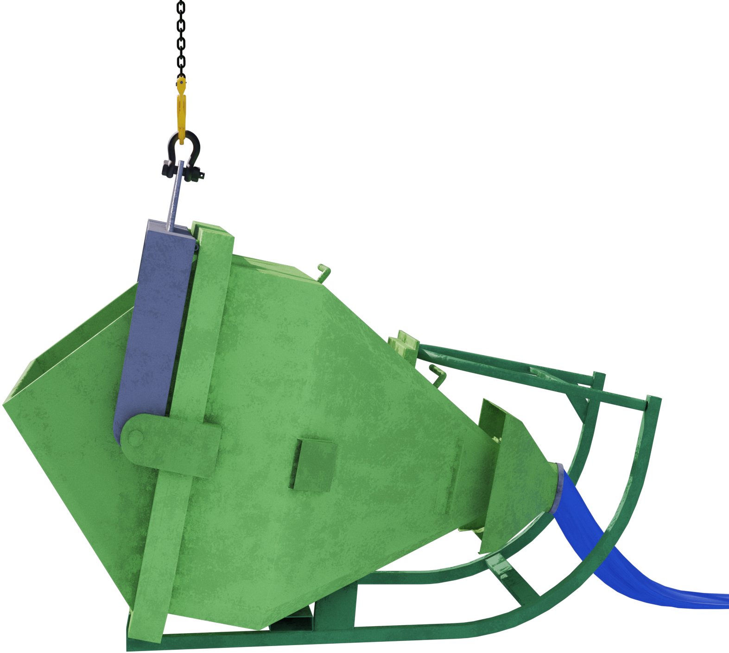 |  | Slinging methodology:  - Single leg chain sling will be attached to hook block of the crane.  - Hook of chain sling will then be attached to the designed lifting point of the concrete skip.  - Once filled, skip will be raised into upright position, tremie pipe secured and arranged so to negate any concrete escaping the pipe.  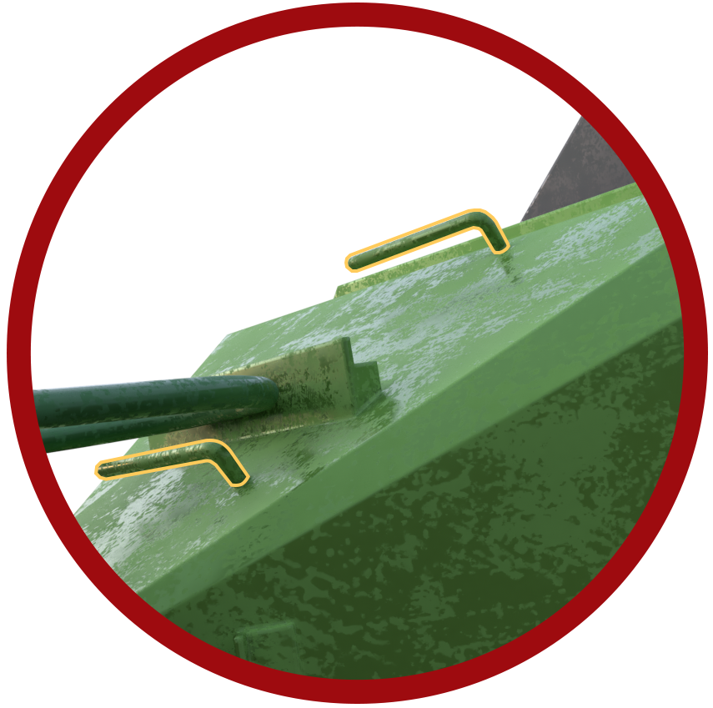Note:  Best practice is to fold the tremie pipe back over the hanger stanchions located to the rear of the skip.
Lift Category: | Basic
Dimensions of load: | Various dimensions: Typically, 1780mm [w] x 2720mm [l] x 3500mm [h] for 2000l skip
Weight of Load | Typically, max. payload of the skips is 6 t
Lifting accessories used with weights of accessories: | From hook block:  Single leg chain sling 2m min WLL 8 t @ 15 kg [ru]  ----------------------------------------------  Concrete skip max weight @ 660kg  Gross weight inc. 10% FOS: 7.35 t [ru] | WLL x Mode Factor | Resulting SWL
Lifting accessories used with weights of accessories: |  | Single leg chain sling in use as per design.  -------------------------------------  Concrete skip being used as per design. | 6 t over all accessories stated
Ancillary Equipment: | For storage on site and to enable a safe washing out procedure, a wash out frame should be employed.
Safe lifting considerations:  Safe lifting considerations contd.: | 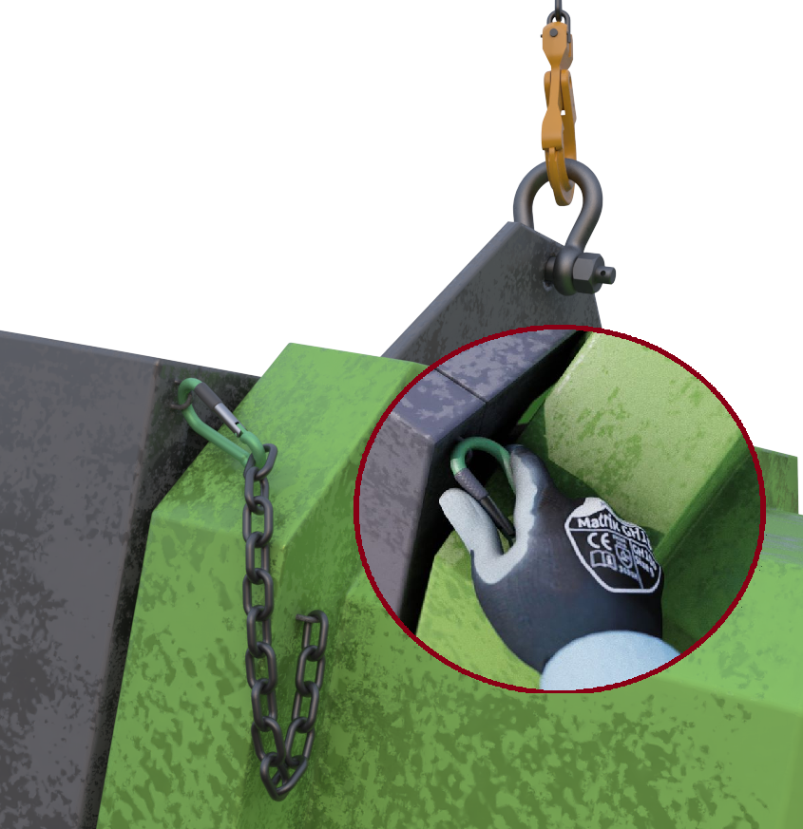  - When landing skip for storage (if wash out frame not employed) then ensure the bale arm securing chain is used.  - Do not use ‘greedy’ blocks under the frame of the skip when filling. This leads to overfilling of the skip and can lead to unintentional emptying of the skip when raised into the vertical configuration.  - Do not stand under the skip on return to concrete filling point.  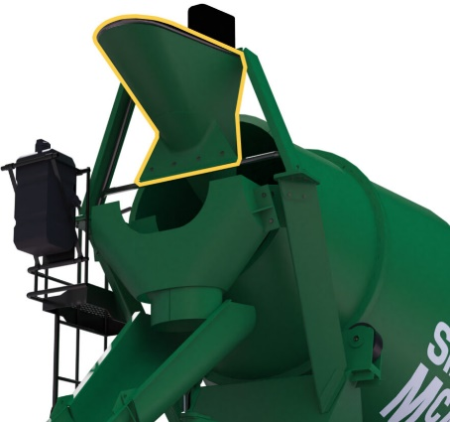  - When landing the skip ready to fill, ensure the concrete wagon has pulled forward to allow safe landing and to negate the chance of the hook block of the crane clashing with the hopper at the rear of the skip.  - On filling the skip, ensure the concrete being put into the skip is being monitored for oversized lumps of concrete that could cause potential blockage of the tremie pipe when emptying at discharge point.  - 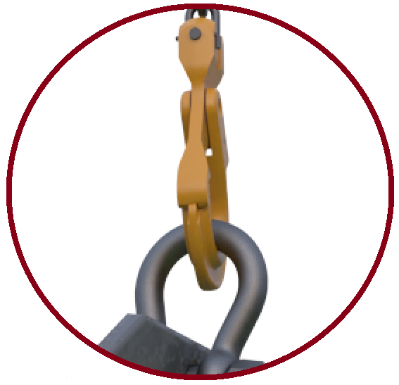When attaching the hook of the chain sling to the lifting point on the bale arm, check if a suitably sized shackle of sufficient WLL for the load to be carried is required/attached to enable safe attachment.  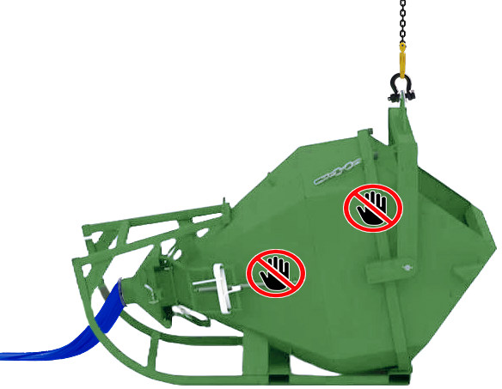  If you attach the chain sling directly to the aperture in the bale arm there is a chance that hook will not have free movement within the aperture, and this could lead to overloading of the hook.  Hold point:  Be aware of hand trap points when landing the skip into the ‘prone position.  See potential hand trap points in graphic opposite.

Loads description: Containment accessories – Waste skips with rated/tested lifting points
Slinging methodology:

- 4 leg chain slings will be attached to hook block of the crane.

- Hooks of chain sling will then be attached to the designed lifting point of the waste skip.

- Ensure the hook of the chain is sitting correctly in the attachment point and that is has free movement.

- Suitable closed mesh netting will now be attached to skip.
Lift Category: | Basic
Dimensions of load: | Various dimensions but typically 1700mm [w] x 3700mm [l] x 1200mm [h] for an 8-yard skip.
Weight of Load | Typically, max. payload of the skips is 6 t (for dimensions given above]
Lifting accessories used with weights of accessories: | From hook block:  4 Leg chain slings WLL 8.4 t @ 103kg  -------------------------------------------  Waste Skip @ 800kg  Gross weight inc. 10% FOS: 7.6 t [ru] | WLL x Mode Factor | Resulting SWL
Lifting accessories used with weights of accessories: |  | 4 leg chain slings in use as per design.  ---------------------------------  Waste skip being used as per design. | __ t [max] over all accessories stated.  [limited to WLL of waste skip used]
Ancillary Equipment: | Close mesh netting to be used as cover for the skip to negate the chance of any lightweight materials being ‘blown’ from within the confines of the skip. When using a net covering ensure the net is secured to the body of the skip
Safe lifting considerations: | - Prior to the skip being allowed on the project the following checks are to be made:  - A report of thorough examination is held with site or produced upon arrival to project.  - Visual checks are made to the base of the skip checking for any cracks to welds, splits, or creases to the base of the skip that would affect the integrity of the containment.  - Deformation to the lift points and welds around the lifting points.  - During the test lift check the underside of the cage any adhered materials.  - Do not carry materials in the skip that exceed the height of the cage.  - Monitor weight of load within the skip, ascertain total load in test lift. If over WLL of skip, put down and do not lift until weight of contents is reduced to WLL limit.

Loads description: Containment accessories – Self Discharge Boat skips
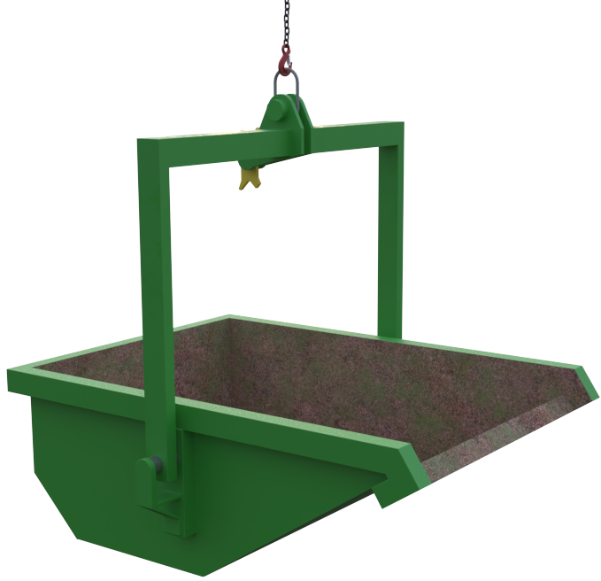 |  | Slinging methodology:  - Single leg chain sling will be attached to hook block of the crane.  - Hook of chain sling will then be attached to the designed lifting point of the boat skip.  - When lowering and raising the skip ensure the ‘Dog-bone’ mechanism or ’Skip Catch’ mechanism[s] are working as anticipated  Note:  See ‘Dog-bone’ and ‘Skip catch’ methodologies detailed in ‘Safe Lifting Considerations’
Lift Category: | Basic [empty] |  | Intermediate [when carrying load and emptying]
Dimensions of load: | Various dimensions: Typically for a 2000 l skip 1835mm [w] x 2555mm [l] x 880mm [h]
Weight of Load | Typically, max. payload of a 2000 l skip is 4 t
Lifting accessories used with weights of accessories: | From hook block:  Single leg chain sling 2m min WLL 5.3 t @ 15 kg [ru]  --------------------------------------------  Boat skip @ 540kg  Gross weight inc. 10% FOS: 5.01 t [ru] | WLL x Mode Factor |  | Resulting SWL
Lifting accessories used with weights of accessories: |  | Single leg chain sling in use as per design.  --------------------------------------  Boat skip being utilised as per design. |  | __t over all accessories stated  [limited to WLL of self-discharge skip utilised]
Ancillary Equipment: | Close mesh netting to be employed as cover for the skip to remove the likelihood of any lightweight materials being ‘blown’ for within the confines of the skip. When using a net covering ensure the net is secured to the body of the skip.
Safe lifting considerations:  Safe lifting considerations contd.:  Safe lifting considerations contd.: | - Check attachment point of the boat skip for any deformation that could affect the integrity of attachment to chain sling.  - Do not carry materials in the skip that exceed the height of the skip walls.  - Ensure load placement into the skip structure does not cause the load to tip – Load weight within the skip must evenly distributed to suit a level lift.  - 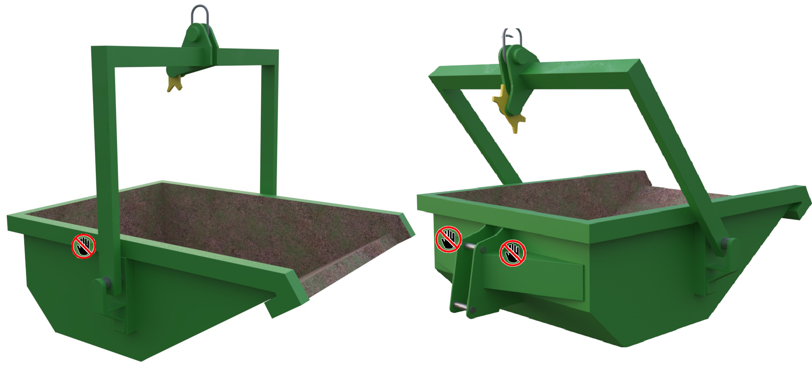Monitor weight of loads being put into skip, ascertain total load in test lift. If over WLL of skip, put down and do not lift until weight of contents is lowered to WLL limit.  - Be aware of hand trap points when using the skip - See potential hand trap points in graphic opposite.  ‘Dog-bone’ catch:  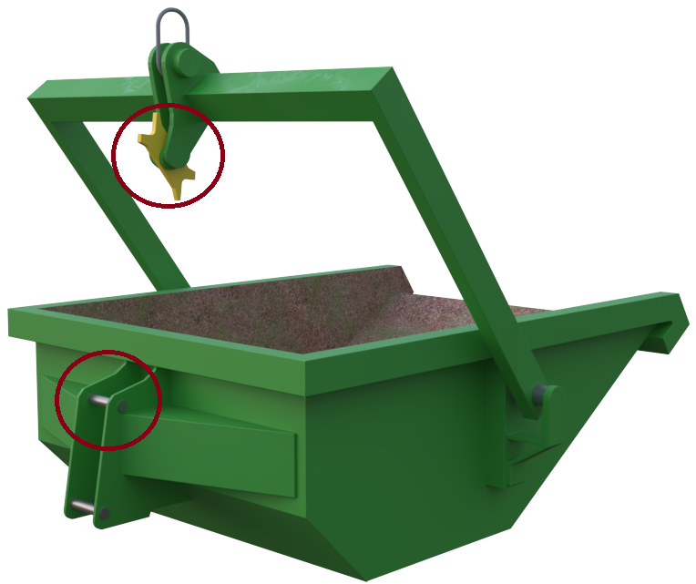Self-discharging skips fitted with a lock and release system.  - The lock is situated at the rear of the skip and engages with the catch fitted to the top of the lifting arm.  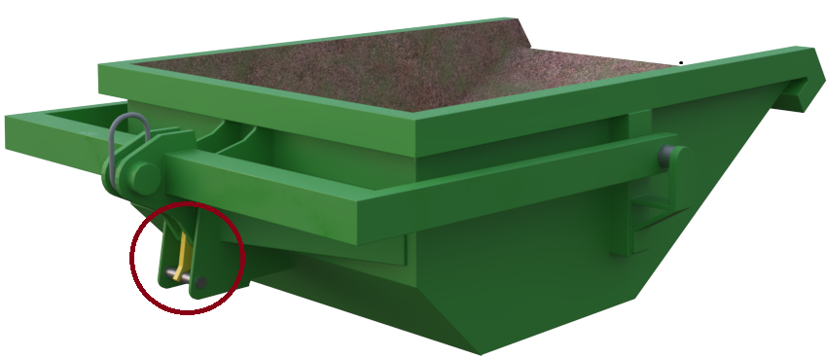  - When the lifting arm is lowered fully, it will engage with the locking system.  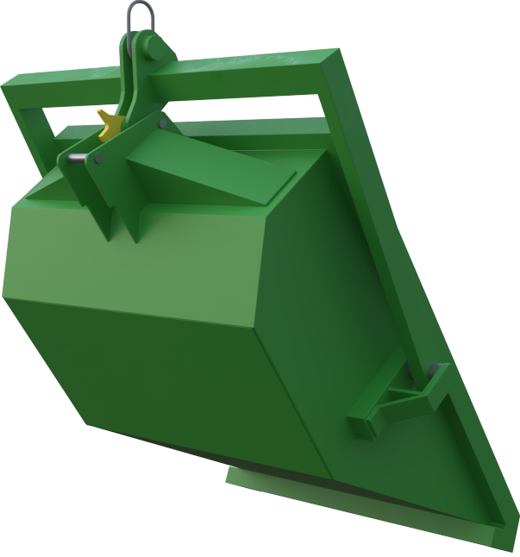  - When next raised, the skip will rise and discharge its load.  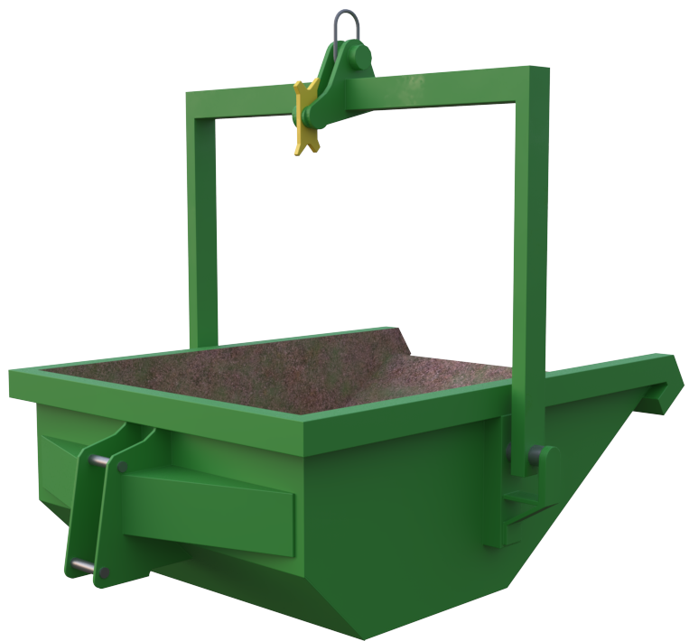  - When fully lowered a second time, the lifting arm will disengage from the locking system allowing the unit to be raised and manoeuvred to required location on site.  Skip- catch:  Self-discharging skips fitted with a hook and catch locking and release system.  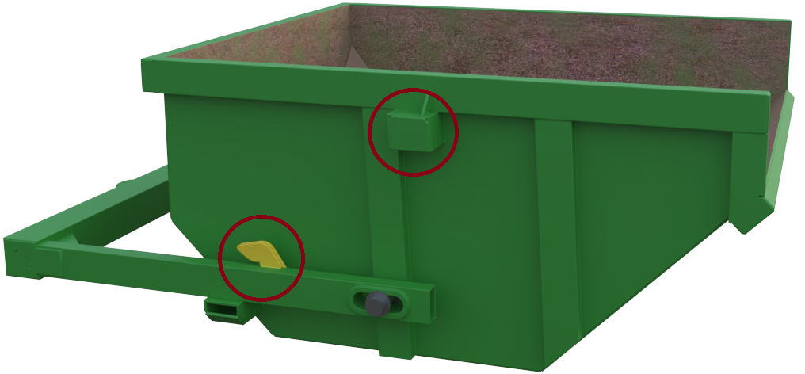  - The hooks are located on both sides of the bale arm and the catches are situated on both sides of the skip body – for clarity only one side shall be shown in the following methodology.  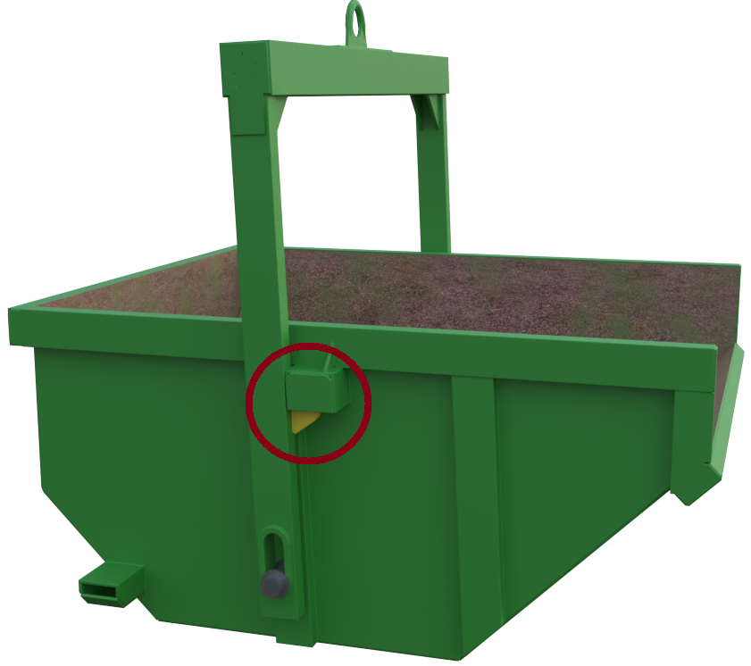  - The hooks engage with the catches as the bale arm is lifted upward and towards the front of the skip and will remain in place until the skip is landed, and the bale arm lowered.  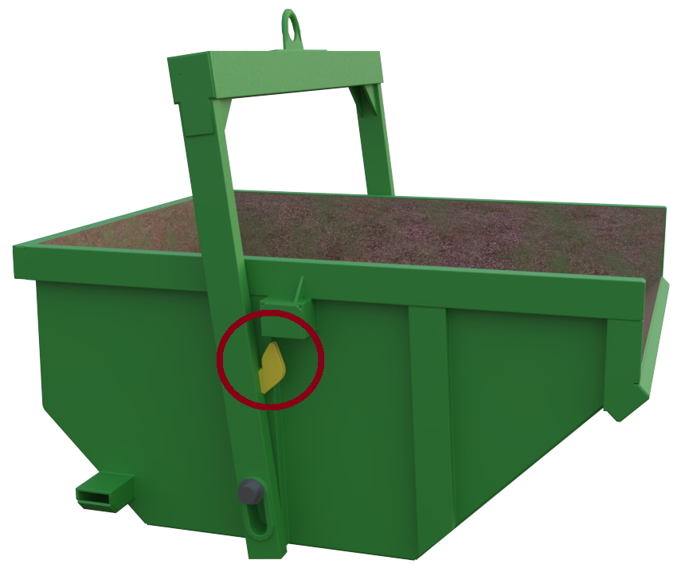  - When the bale arm is lowered, ensure the catch does not engage so that the centre of gravity ensures that the skip will then lift in the tipping position.

Loads description: Containment accessories – Gas bottle cages -Single & multi point
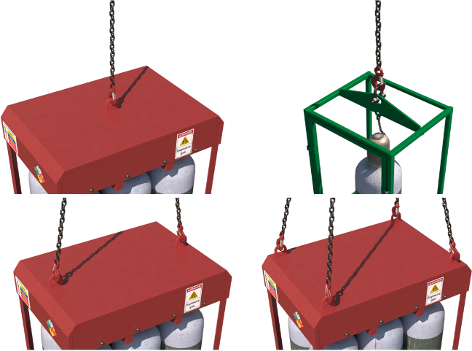 |  | Slinging methodology:  - 4 leg chain sling will be attached to hook block of the crane.  For single point lifting cages, a single leg chain sling is best practice.  - Hook[s]of chain sling will then be attached to the designed lifting point of the containment cage. Any unused chain slings to be hung back to the master ring
Lift Category: | Intermediate
Dimensions of load: | Various dimensions:  Single bottle cage typically 600mm [w] x 515mm [l] x 1900mm [h]  Multi bottle cage typically 1120mm [w] x 850mm [l] x 2000mm [h]
Weight of Load | Typically, max. payload of the cages is 120kg for single bottle carriers and 600kg for multi bottle carriers
Lifting accessories used with weights of accessories: | From hook block:  4 Leg chain slings WLL 8.4 t @ 103kg - For multiple attachment point carriers.  Single leg chain sling WLL 5.3 t @ 10kg [ru] - For single attachment point carriers.  --------------------------------------------  Single Gas bottle cage @ 95kg  Multi gas bottle cage @ 130kg  Gross weight inc. 10% FOS: 350 kg [ru] – Single bottle cage [wcs]  Gross weight inc. 10% FOS: 917 kg [ru] – Multi bottle cage [wcs] | WLL x Mode Factor | Resulting SWL
Lifting accessories used with weights of accessories: |  | 4 leg chain sling with 2 legs in use - WLL of 1 sling x 1.4 = 4.41 t [2no. attachment point carrier]  4 leg chain sling with 4 legs in use – As per design. [4no. attachment point carrier]  Single leg chain sling in use as per design [Single attachment point carrier]  --------------------------------------  Gas bottle cage being used as per designed use. | Single bottle cage @ _t over accessories stated  [limited to WLL of bottle cage used]  ------------------------  Multi bottle cage @ _t over accessories stated  [limited to WLL of bottle cage used]
Alternative methodology: | 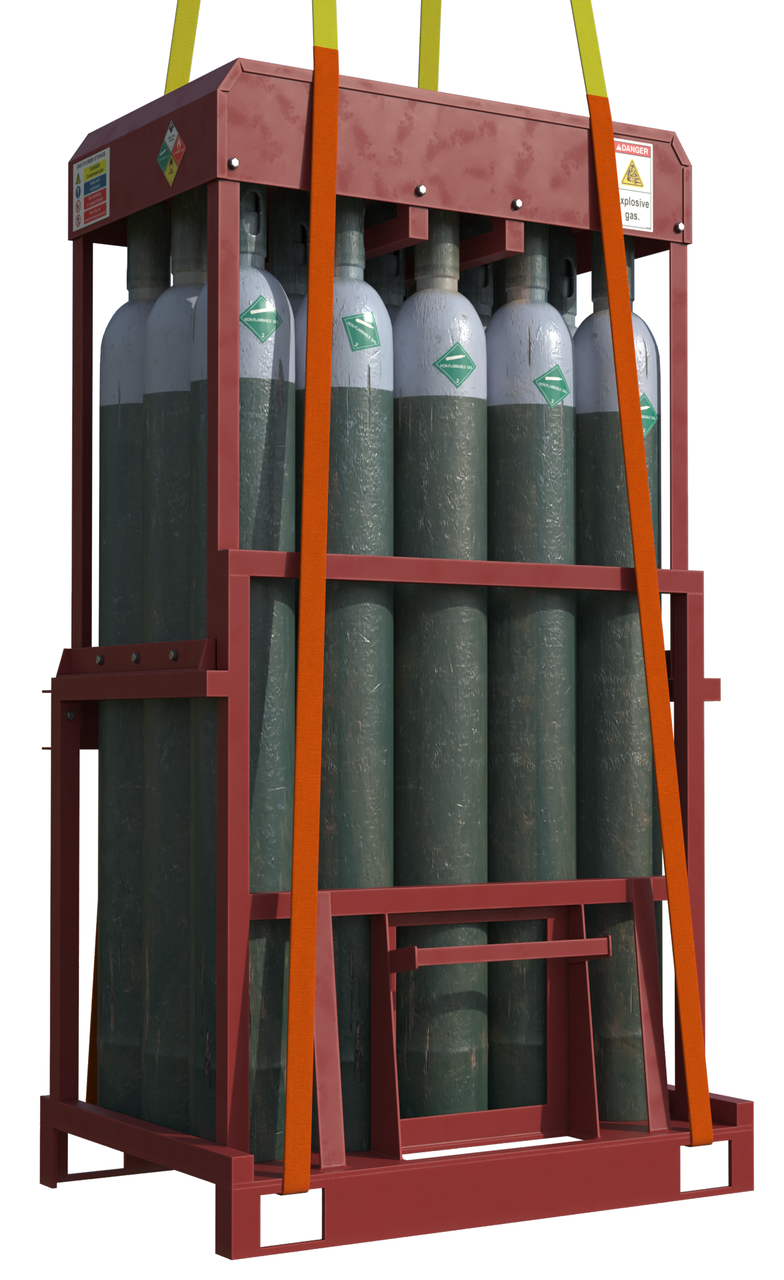Single gas bottle cage - Single leg of a multileg chain sling of sufficient WLL can be used with the unused legs hung back to the master ring.  Special note:  Some cylinder supply companies do not issue a RoTE for their cylinder carriers.  In these cases, the bottle frame should be slung utilising webbing slings in a ‘choke’ configuration with the slings being fed through the fork tines insertion points.  Long wear sleeves are to be used on the slings.  They should be of sufficient length to protect the slings along all ‘pinch’ points anticipated.  Slings are to be kept attached to the bottle carrier if multiple lifts of the carrier are required.
Safe lifting considerations: | - Check condition of the cage for any dents, cracks to weld or creases in sheet metal components that could affect the integrity of the cage.  - Check underside of the cage in test lift for any adhered materials  - Check all securing chains/latches/gates are engaged and working as anticipated prior to lift.  Please note:  In some cases, the integral lifting points may be too small for a chain hook to be attached to. In this case a suitable sized bow shackle of sufficient WLL will be employed between the hook of the chain sling and the integral lifting point.

Loads description: Containment accessories – Fuel Bowser
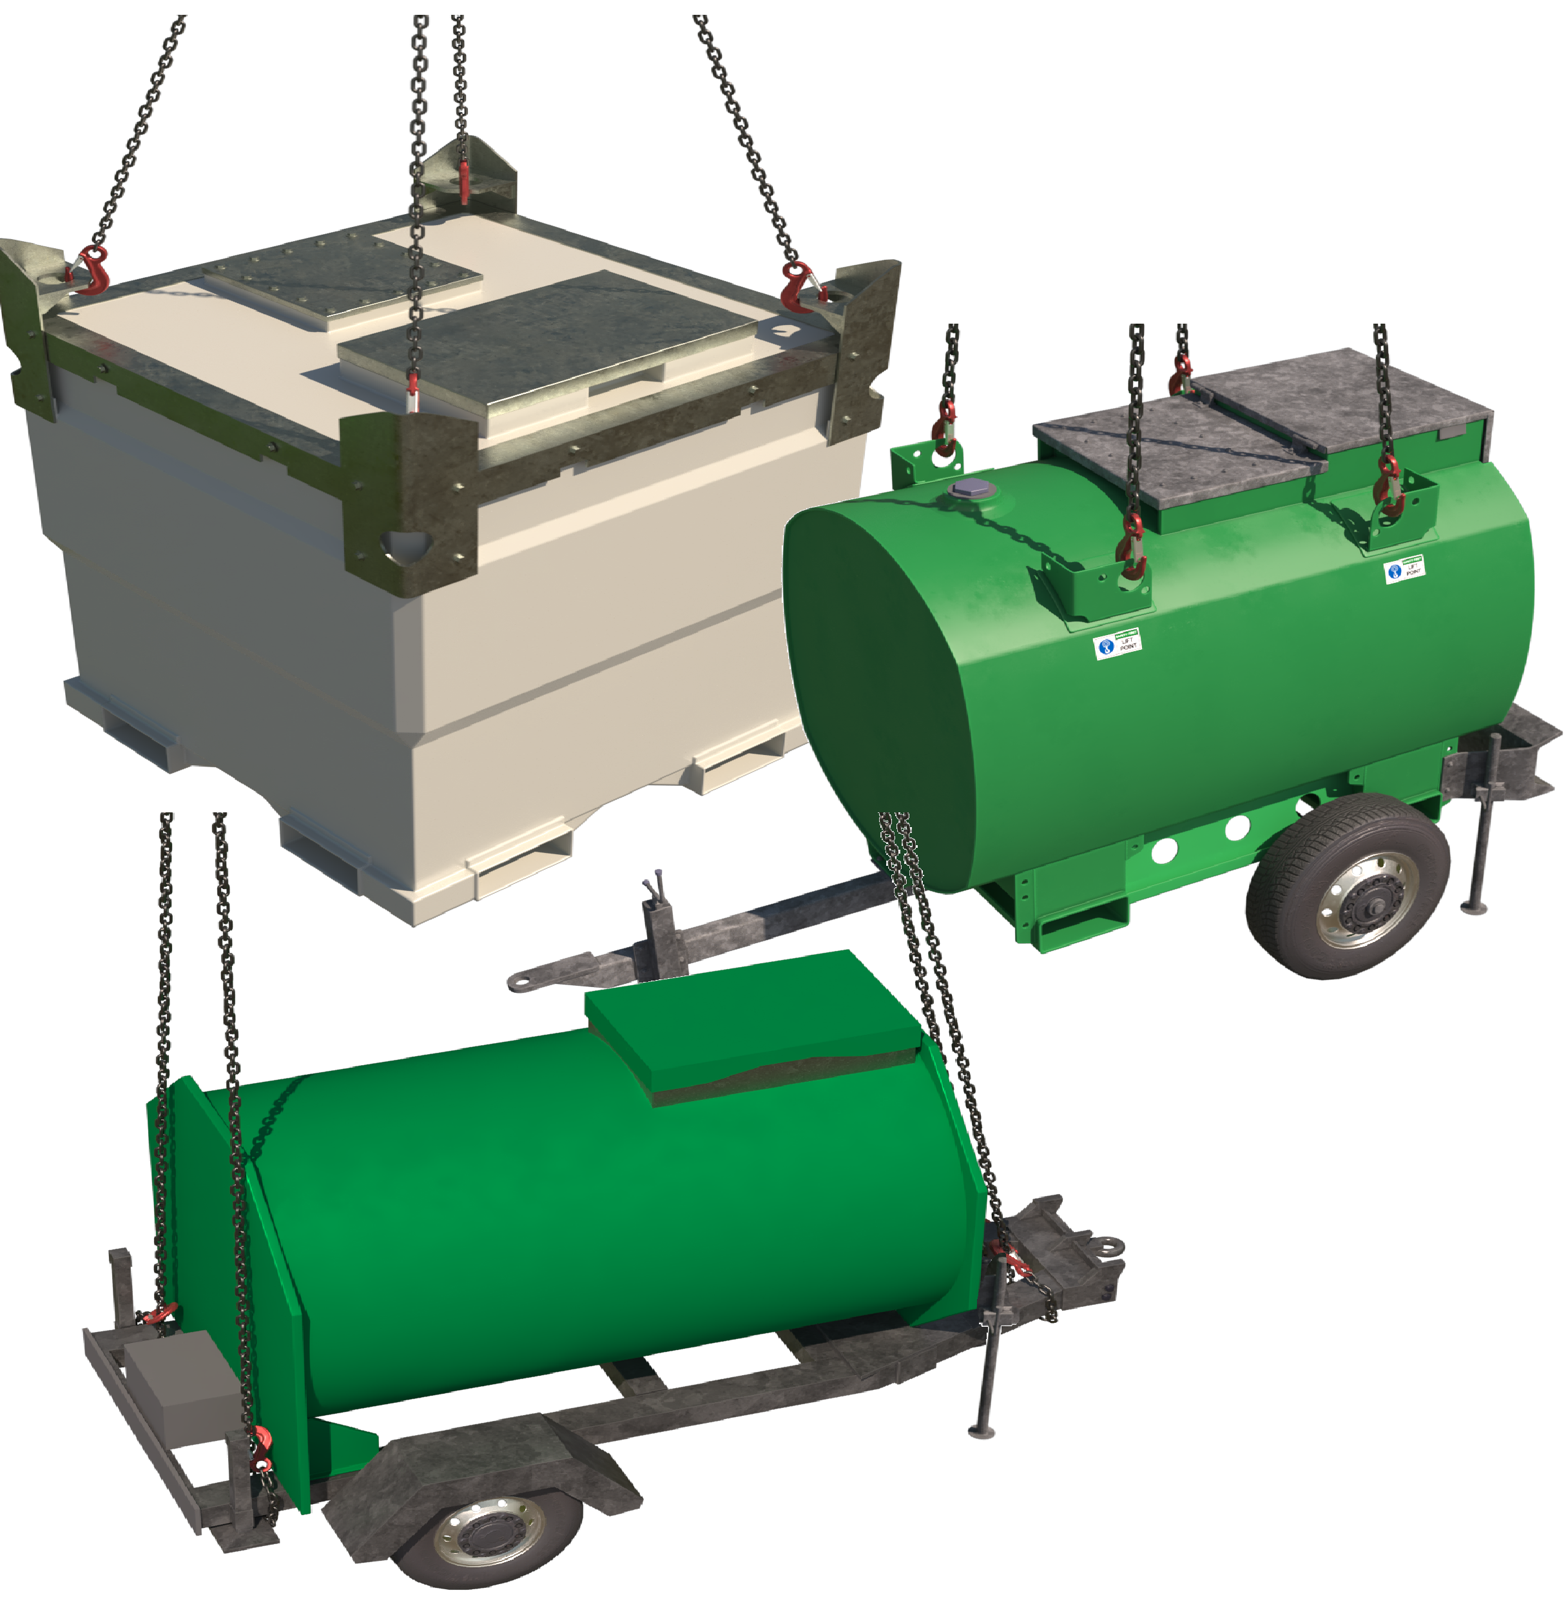 |  | Slinging methodology: Direct attachment to lifting points.  - 4 leg Chain sling will be attached to hook block of the crane.  - Hooks of chain sling will then be attached to the designed lifting point of the fuel bowser.  Slinging methodology: Choke accessories around load  Chains only:  - 4 leg chain sling will be attached to hook block of the crane.  - Hooks of chain sling will then be attached to the bowser in a ‘choke’ configuration around identified points to the substructure of the  bowser.
Lift Category: | Basic [empty ] |  | Intermediate [containment of fluid within]
Dimensions of load: | Various dimensions:  Typically - Transcube bowser @ 2000 l capacity 1150mm [w] x 1320mm [h] x 2280mm [l]  Typically - Towable bowser @ 950 l capacity 1449 mm [w] x 1498mm [h] x 3175mm [l]
Weight of Load | Typically: Transcube 2000 l @ unladen 824kg / full 2.809 t  Typically: Towable Bowser 950 l @ unladen 450kg / full 1.5 t
Lifting accessories used with weights of accessories: | Please note:  Following weights are given for a Transcube bowser full.  Chain slings with direct attachment:  From hook block >  4 Leg chain slings WLL 8.4 t @ 103kg  Bowser WLL _ t @ _ kg  Gross weight inc. 10% FOS: 3.203 t [ru]  ---------------------------------------  Chain slings choked:  From hook block >  4 Leg chain slings WLL 8.4t te. @ 103kg  Gross weight inc. 10% FOS: 3.203 t [ru] | WLL x Mode Factor |  | Resulting SWL
Lifting accessories used with weights of accessories: |  | 4 leg chain sling as per designed use = 8.4 t  -----------------------------------  Bowser as per designed use = _ t  -----------------------------------------  4 leg chain sling with 4 legs in use in a ‘choke’ configuration = 6.72 t |  | _t over accessories stated  [limited to WLL of bowser used]  -----------------------  6.72 t over accessories stated
Alternative methodology: | 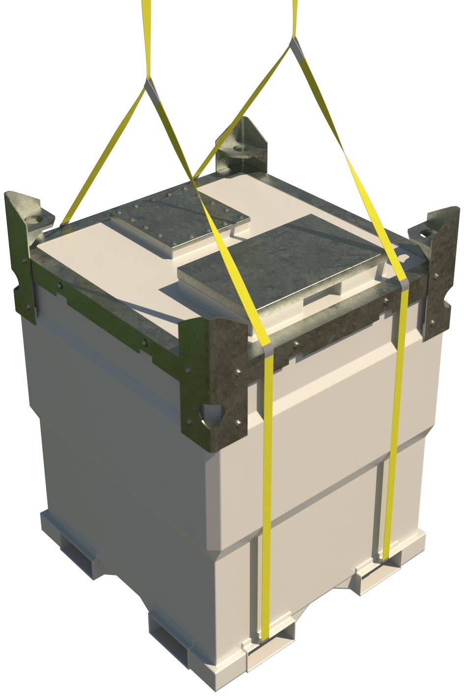  Where fuel bowsers have apertures to the bottom of the structure, ‘Fork’ point etc., webbing slings of a suitable WLL with mode factors considered can be attached around the load in a ‘choke’ configuration.  Employ wear sleeves to identified pinch points on the structure of the fuel bowser.  Please note:  This methodology can only be used where there is deformation to the direct attachment points rendering them unusable  If size of hook block allows, then the webbing slings can be directly attached.  DO NOT OVERCROWD THE BLOCK
Safe lifting considerations: | - Checks to be made with manufacturer regarding bowsers being lifted full.  See data plate on the side of the bowser structure for WLL of bowser with contents if applicable.  - Ensure all jockey wheels and any outriggers are secure if lifting a wheeled bowser. [Towable Bowser]  - Check condition of jockey wheel to ascertain its condition to ensure safe landing of the bowser. [Towable Bowser]  - Check underside of the bowser structure for any loose materials that may have adhered themselves during storage.  - Ensure all lockable access doors are closed and secured.  - Check structure of bowser for any loose materials or tools housed within the structure of the bowser.  - Check lifting points for any deformation that could affect integrity of the attachment and that the sizing of will allow a safe attachment with the hook of the chain sling.  - Ensure that hooks of chain sling move freely within the confines of the attachment point. If not, then use correctly sized shackles of a suitable WLL after mode factor considerations.

Loads description: Containment accessories – Jetwash Bowser
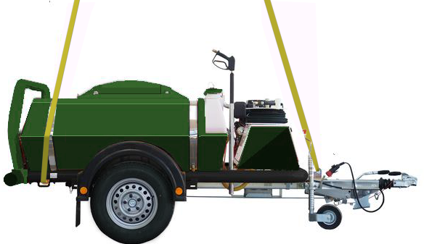  Please note:  Chain slings may need to be shortened to suit a level load |  | Slinging methodology:  - Webbing sling of appropriate length will be fed thru the rear bowser ‘tie’ down points to form a ‘captured cradle’ arrangement.  - Webbing sling, again of appropriate length, will be attached to lifting eye positioned at the front of the bowser structure via suitably sized bow shackle.  - 4 leg chain sling will be attached to the hook block of the crane – 3 legs in use so hang the spare leg back to the master ring.  - Attach the hooks of the chain sling to the end loops of the webbing slings
Lift Category: | Basic [empty] |  | Intermediate [containment of fluid within]
Dimensions of load: | Various dimensions: Typically for a 2000 l 1600mm [h] x 4090mm [l] x 1982mm [w]
Weight of Load | Typically: 2000 l @ unladen 715kg / full 2.8 t
Lifting accessories used with weights of accessories: | From hook block >  4 Leg chain slings WLL 8.4 t @ 103kg  ----------------------------------------  Bow shackle Min. WLL 4.25 t @ 2kg  ----------------------------------------  Webbing slings Min. WLL 3 t of appropriate length @ 7kg [wcs]  Gross weight [full] inc. 10% FOS: 3.21 t [ru] | WLL x Mode Factor |  | Resulting SWL
Lifting accessories used with weights of accessories: |  | 4 leg chain sling with 3 legs directly attached – as per design use = 8.4 t  ------------------------------------  Bow shackle as per designed use = 4.25 t  ------------------------------------  Webbing slings use in a 3- point lift = WLL of one multiplied by 1.4 for only 2 slings used = 4.2 t |  | 4.2 t over accessories stated
Alternative methodology:  Alternative methodology [contd.]: | If size of hook block allows, then the webbing slings can be directly attached.  Ensure webbing sling lengths have been correctly selected to allow the bowser to be slung level.  DO NOT OVERCROWD THE BLOCK  Where the sub-structure of the bowser allows, a 4 leg chain sling can be employed in a ‘choke’ configuration around the sub-structure at the front and rear of the bowser.  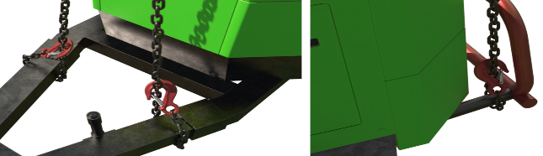
Safe lifting considerations: | - As far as Is reasonably practicable, lift the bowser empty or full. This is to prevent the centre of gravity changing during the lifting operation.  - Ensure all jockey wheels and any outriggers are secure.  - Check condition of jockey wheel to ascertain its condition to ensure safe landing of the bowser.  - Check underside of the bowser structure for any loose materials that may have adhered themselves during storage.  - Check structure of bowser for any loose materials or tools housed within the structure of the bowser.  - Check lifting points for any deformation that could affect integrity of the attachment and that the sizing of will allow a safe attachment with the hook of the chain sling.  - Check for leaks from engine compartment for fuel powered bowsers.  - Do not sling around the containment element of the bowser as this can lead to ‘splitting’ and will affect the integrity of containment.

Loads description: Template
Slinging methodology:

.
Lift Category: | Basic | Intermediate |  | Complex
Dimensions of load:
Weight of Load
Lifting accessories used with weights of accessories: | From hook block >  Gross weight inc. 10% FOS: t [ru] |  | WLL x Mode Factor |  | Resulting SWL
Lifting accessories used with weights of accessories: |  |  |  |  | over accessories stated
Alternative methodology:
Safe lifting considerations:

