A practical guidance - 5: Schedules 32 to 35
Revision 1 September ‘25

Schedule of lifts for Tower Crane

Please note:
This document has been provided by Sir Robert McAlpine Limited. It has been checked to the best of our ability but may contain unintentional errors. As per BS 7121-1:2016, CDM 2015 and LOLER, it is the user’s responsibility to verify that they understand and have made their own checks before using this document.
The user shall ensure that they properly risk assess and plan their own lifting operations to discharge their legal requirements.
No liability will be accepted for any incidents that result of those using this document.

The schedules
No. | Title:
32. | Precast concrete elements – Legato or ‘Lego’ blocks
33. | Precast concrete elements – Access chamber rings
34. | Precast concrete elements – Access chamber cover slabs
35. | Precast concrete elements – Vertical Concrete Barriers/Vehicle Crash Barriers (VCB’s)
Ref. | Blank template

Loads description: – Precast concrete elements – Legato or ‘Lego’ blocks
Slinging methodology – Precast anchor point

- Single leg chain sling will be attached to hook block of the crane.

- Attach precast lifting accessory min WLL 2 t to the cast in anchor point.

- Hook of chain sling will then be attached.
  - to the anchor point of the concrete block.

Slinging methodology – Embedded anchor point

- Single leg chain sling will be attached to hook block of the crane.

- Hook of chain sling will then be attached to the anchor point of the concrete block.

Special note:
Temporary works verification of anchor point required in both above methodologies.

Slinging methodology – ‘Around’ the block

- 4 leg chain sling will be attached to the hook block of the crane. Only 2 legs in use so hang the unused chains back up to the Master ring.

- Feed the chains under the block in single wrap choke configuration.

Special note:
Only blocks with ‘slinging’ notches in the bottom of the block to be lifted this way as the notches form a ‘captured choke’.

Lift Category: | Basic
Dimensions of load: | Various dimensions: Typically, 800mm [w] x 1600mm [l] x 800mm [h]
Weight of Load | Typically, max. 1800kg for dimensions given
Lifting accessories used with weights of accessories: | Please note:  The following is for the worst-case scenario [wcs] mode factors used in the shown configurations – Choked chains around block  From hook block:  4 Leg chain slings WLL 8.4 t @ 103kg  Gross weight inc. 10% FOS: 2.094 t [ru] | WLL x Mode Factor | Resulting SWL
Lifting accessories used with weights of accessories: |  | Multi leg chain sling with 2 legs in use in ‘choke’ configuration – [WLL of one leg multiplied by 1.4] x .8 = 4.48 t | 4.48 t over accessories stated
Alternative methodology: | 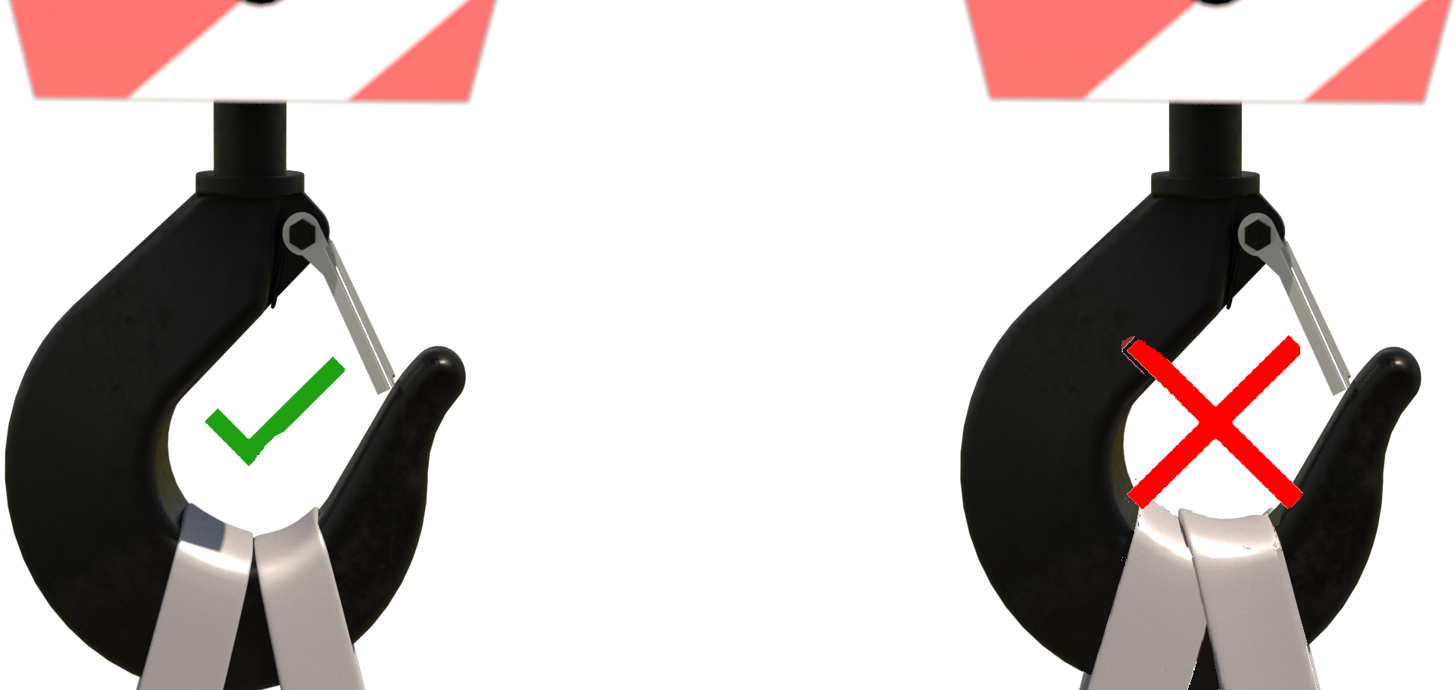Attachment to anchor points: Single leg of a multi leg chain sling can be used if of sufficient WLL. Hang unused chains back up to the master ring.  Choke attachment: Webbing slings can be employed in the same configuration of the chain slings.  If size of hook block allows, then the webbing slings can be directly attached.  DO NOT OVERCROWD THE BLOCK
Safe lifting considerations: | - When lifting from a precast or embedded attachment point a Temporary Works check should be performed to ensure integrity of the lifting point.  - Check condition of the lifting point, check for any cracks around the immediate area.  - Ensure that any threads are clean, and the lifting accessory is fully engaged / bearing on the insert / block.  - Check underside of the block in test lift for any adhered materials.  - If utilising webbing slings, ensure there is adequate protection of the webbing slings in case of sharp edges on the block can affect the integrity of the attachment.  - When attaching ‘through’ or ‘around’ the block, ensure the accessories are of sufficient length so that the angle of the chains doesn’t require a reduction of the SWL in the configuration being used.  - Check prior to lifting that any attachment holes or notches are of sufficient size to allow the hook of the chain sling to pass through without using excessive force.

Loads description: – Precast concrete elements – Access chamber rings
Slinging methodology:

- 3no. lifting pins min. WLL 750kg will be attached to the attachment holes located in the side walls of the ‘ring’ structure.

- 4 leg chain sling will be attached to hook block of the crane. Only 3 legs of the chain sling are required so hang the unused chain back up to the master ring.

- Attach hooks of chain slings to the attachment eyes of the lifting pins.
Lift Category: | Basic
Dimensions of load: | Various dimensions: Typically: 1050mm [d] x 1000mm [h]
Weight of Load | Typically, 900 kg for dimensions given
Lifting accessories used with weights of accessories: | From hook block:  4 Leg chain slings WLL 8.4 t @ 103kg  --------------------------------------------  Man-hole lifting pins @ 6kg.  Gross weight inc. 10% FOS: 1.11 t [ru] | WLL x Mode Factor | Resulting SWL
Lifting accessories used with weights of accessories: |  | 4 leg chain sling with 3 legs in use – As per design use  --------------------------------------  3 Lifting pins min WLL 750kg used as set - WLL of one multiplied by 2.1 = 1.575 t | 1.575 t over accessories stated
Alternative methodology: | Be aware that some Man-hole rings will have a different lifting methodology i.e., 4 chains in use or a different lifting pin than the one stated. In these cases, check documentation of the Man-hole ring and if still unclear consult the manufacturer for guidance.
Safe lifting considerations: | 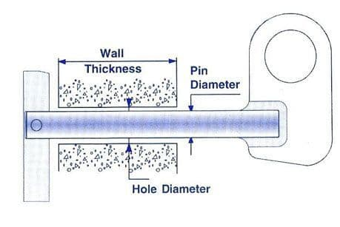  - Ensure the lifting pin is correctly sized for the Man-hole ring attachment holes and thickness of the structure.  - Use the lifting pin as per manufacturer’s instruction.  - During the test lift, check the underside of the ring for any adhered materials.  - Check entire structure of the Man-Hole ring for any cracks to the concrete. If any found consult the Lift supervisor/Appointed Person for advisement on how to proceed.

Loads description: – Precast concrete elements – Access chamber cover slabs
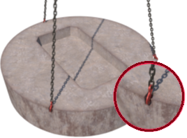 |  | Slinging methodology:  - 4 leg chain sling will be attached to hook block of the crane. Only 3 legs of the chain sling are required so hang the unused chain back up to the master ring.  - Attach the hooks of the chain sling directly to the embedded lifting points to the structure of the cover.
Lift Category: | Basic
Dimensions of load: | Various dimensions: Typically, 1050mm [d] x 675mm [l] x 150mm [h]
Weight of Load | Typically, 250 kg for dimensions given
Lifting accessories used with weights of accessories: | From hook block:  4 Leg chain slings WLL 8.4 t @ 103kg  Gross weight inc. 10% FOS: 389 kg [ru] – | WLL x Mode Factor | Resulting SWL
Lifting accessories used with weights of accessories: |  | 4 leg chain sling with 3 legs in use – As per design use | 8.4 t over accessories stated
Alternative methodology: | Be aware that some access chamber covers will have a different lifting methodology i.e., 4 legs of chain sling in use or a single precast/embedded lifting point. In these cases, check documentation of the access chamber cover and if still unclear consult the manufacturer for guidance.  Please note:  For precast or embedded lifting points a temporary works design check must be made to ensure integrity of the lifting point.
Safe lifting considerations: | - Prior to the lift check the hooks of the chain sling will fit onto the embedded lifting point and has free movement within the confines of the attachment point.  - During the test lift, check the underside of the ring for any adhered materials.  - Check the structure of the cover for any cracks that could affect the integrity of the lift.  - Check the attachment points for any deformation of the point that could mean it has been weakened

Loads description: Precast concrete elements – Vertical Concrete Barriers/Vehicle Crash Barriers (VCB’s)
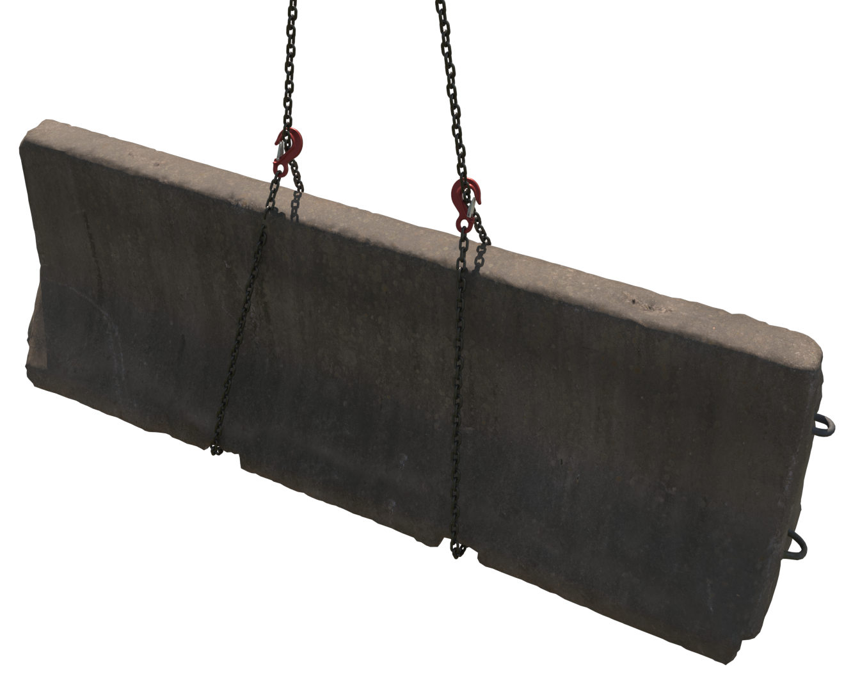 |  | Slinging methodology: - ‘Around’ the VCB  - Attach 4 leg chain sling to the hook block the crane.  - Only 2 legs are required so hang the unused chains back up on to the master ring.  - Attach the chains around the barrier in a single wrap ‘captured’ choke configuration.  Special note:  Only blocks with ‘slinging’ notches or fork points in the base of the barrier to be lifted this way as these notches/points form a captured choke.  Slinging methodology: – ‘Block’ Grab  - Attach single leg chain sling to hook block of the crane.  - Attach hook of chain sling to the attachment point of the grab.  - Utilise the grab on the barrier as per manufacturer’s instruction.  - Ensure all component parts of the grab are engaged and check the integrity of load.  Special note:  Block grabs are only to be used as a low-level lift for placing.  Slinging methodology: - Precast anchor point  - Attach single leg chain sling to hook block of the crane.  - Attach precast lifting accessory Min WLL 2.5 t. [ must be > than weight of VCB] to the cast in anchor point.  - Hook of chain sling will then be attached to the anchor point of the concrete block.  Slinging methodology: - Embedded anchor point  - Attach single leg chain sling to hook block of the crane.  - Attach hook of chain sling to the embedded anchor point.  Special note:  Temporary works verification of anchor point required in the last 2 methodologies.
Lift Category: | Basic
Dimensions of load: | Various dimensions but typically: 450mm [w] x 315 mm [l] x 800mm [h]
Weight of Load | Typically, 2.5 t for dimensions given
Lifting accessories used with weights of accessories: | Chain sling methodologies  Please note:  The following is for the worst-case scenario [wcs] mode factors used of the shown configurations utilising chain slings.  From hook block:  4 Leg chain slings WLL 8.4 t @ 103kg  Gross weight inc. 10% FOS: 2.864 t [ru] | WLL x Mode Factor | Resulting SWL
Lifting accessories used with weights of accessories: |  | 4 leg chain sling with 2 legs in use in ‘choke’ configuration – [WLL of one leg multiplied by 1.4] x .8 = 4.48 t | 4.48 t over accessories stated
Lifting accessories used with weights of accessories: | Block grab methodology:  Please note:  The following is for utilisation of the block grab with worst-case scenario [wcs] weights given for accessories.  From hook block:  4 Leg chain slings WLL 8.4 t @ 103kg  ---------------------------------------------  Block grab Min WLL 3 te. @ 235kg  Gross weight inc. 10% FOS: 3.122 t [ru] | 4 leg chain sling with 1 leg in use in – WLL of one leg = 4 t  --------------------------------------  Block grab as per designed use | 3 t over accessories stated
Alternative methodology: | Attachment to anchor points & block grab: Single leg of a multi leg chain sling can be used if of sufficient WLL. Hang unused chains back up to the master ring.  Please note:  Some manufacturers use 2no. anchor points to the top of the barrier structure. Adjust methodology, image, and accessory configurations to suit.  Choke attachment: Webbing slings can be employed in the same configuration of the chain slings.  If size of hook block allows, then the webbing slings can be directly attached.  DO NOT OVERCROWD THE BLOCK
Safe lifting considerations:  Safe lifting considerations contd. | - When lifting from a precast or embedded attachment point a Temporary Works check should be performed to ensure integrity of the lifting point.  - Ensure precast lifting attachment[s] are of the correct WLL.  - Check condition of the lifting point, check for any cracks around the immediate area.  - Check underside of the barrier in test lift for any adhered materials.  - If utilising webbing slings, ensure there is adequate protection of the webbing slings in case of sharp edges on the barrier that can affect the integrity of the attachment.  - When attaching ‘around’ the barrier, ensure the accessories are of sufficient length so that the angle of the chains doesn’t require a reduction of the SWL in the configuration being used.  - Check prior to lifting that any attachment ‘notches’ are of sufficient size to allow the hook of the chain sling to pass through without using excessive force.  - When using hydraulic grabs these should be of low-level lifts only. If required to lift over shoulder height then these operations are subject to a specific risk assessment being authored and should be performed in a sterile area i.e., restricted zones with physically barriered exclusion zones that are suitably marshalled, and sign posted.

Loads description: Template
Slinging methodology:

.
Lift Category: | Basic | Intermediate |  | Complex
Dimensions of load:
Weight of Load
Lifting accessories used with weights of accessories: | From hook block >  Gross weight inc. 10% FOS: t [ru] |  | WLL x Mode Factor |  | Resulting SWL
Lifting accessories used with weights of accessories: |  |  |  |  | over accessories stated
Alternative methodology:
Safe lifting considerations:

